

**LA GRANDEE INTERNATIONAL COLLEGE**

**Simalchaur – 8, Pokhara**

**LAB REPORT-4**

**DBMS**

**Name: Namrata Bastola**

**Semester: Fourth (B. C. A)**

**Roll. No: 14**

**Submitted By: Submitted To:**

**Namrata Bastola Amrit Lamsal**

1. Selecting table by id

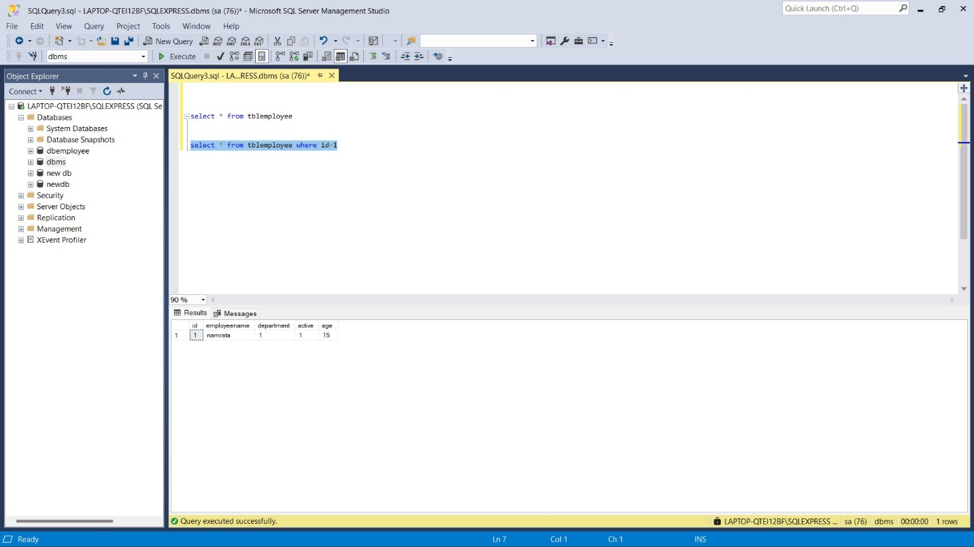

2. Select table where address start from letter ‘r’



3. Select table where address don’t start from letter ‘r’

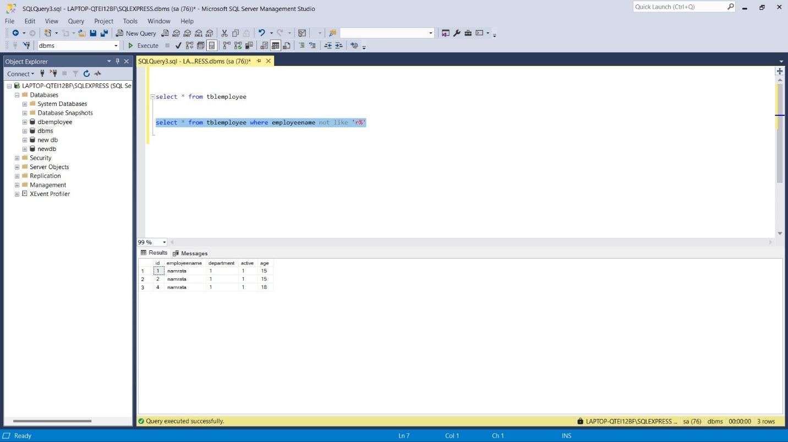

4. Selecting row where name end at ‘a’

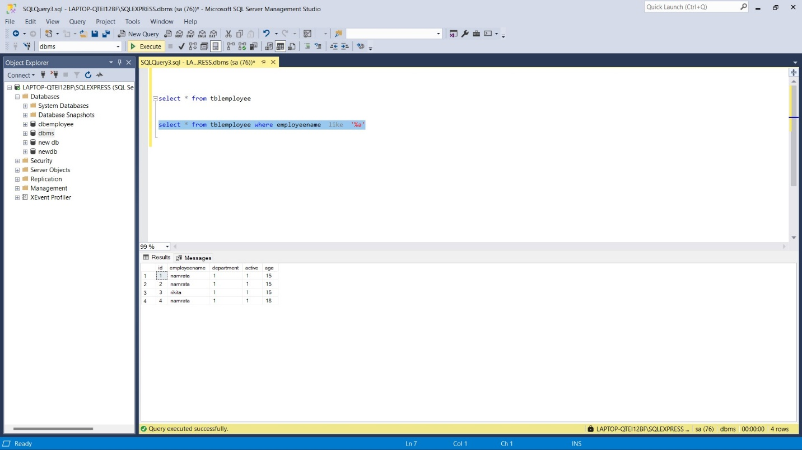

5. Selecting row where name doesn’t contain letter ‘nam’

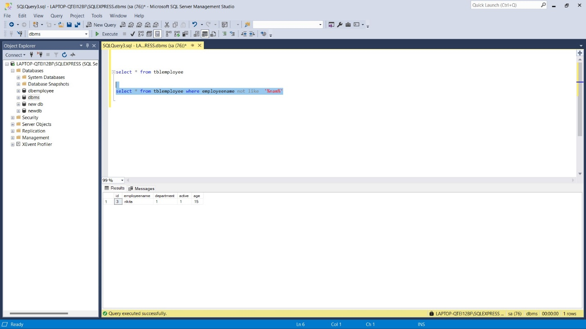

6. Selecting row where name contain letter ‘nam’

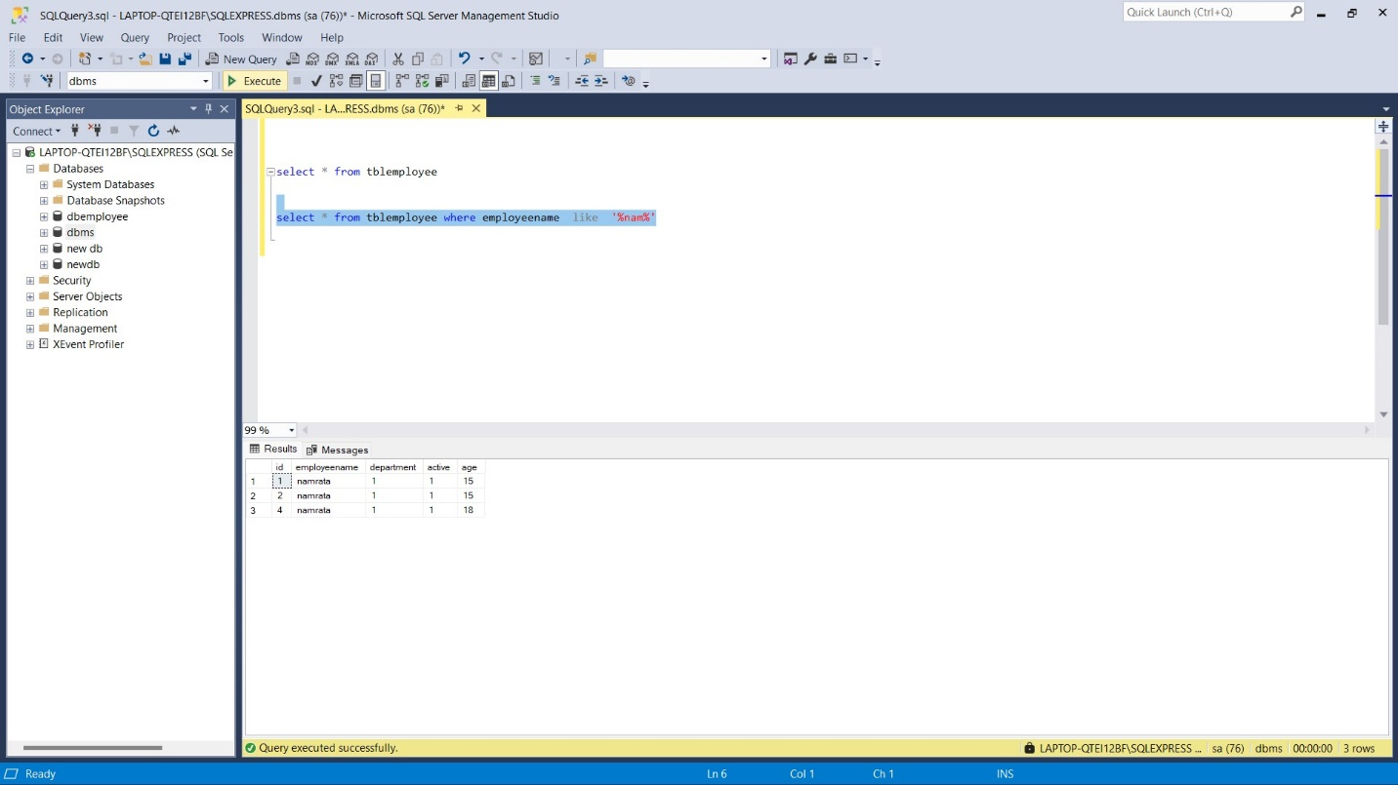

7. Address start from ‘p’ and end at ‘a’ (p%a)

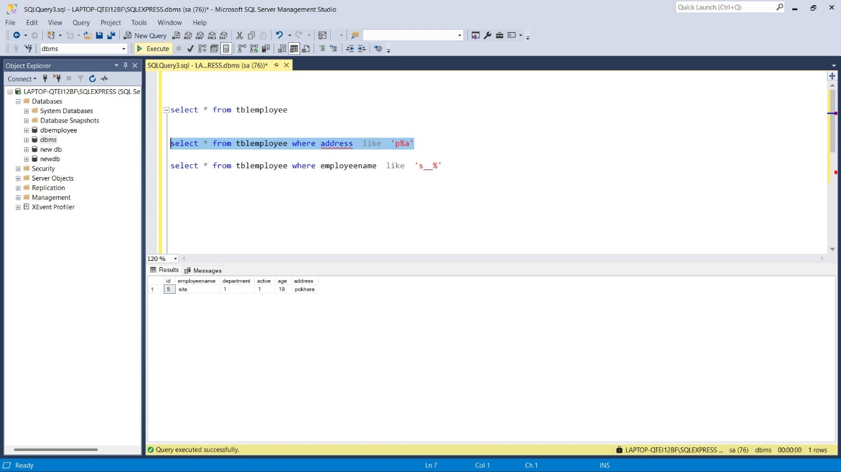

8. Updating address in table

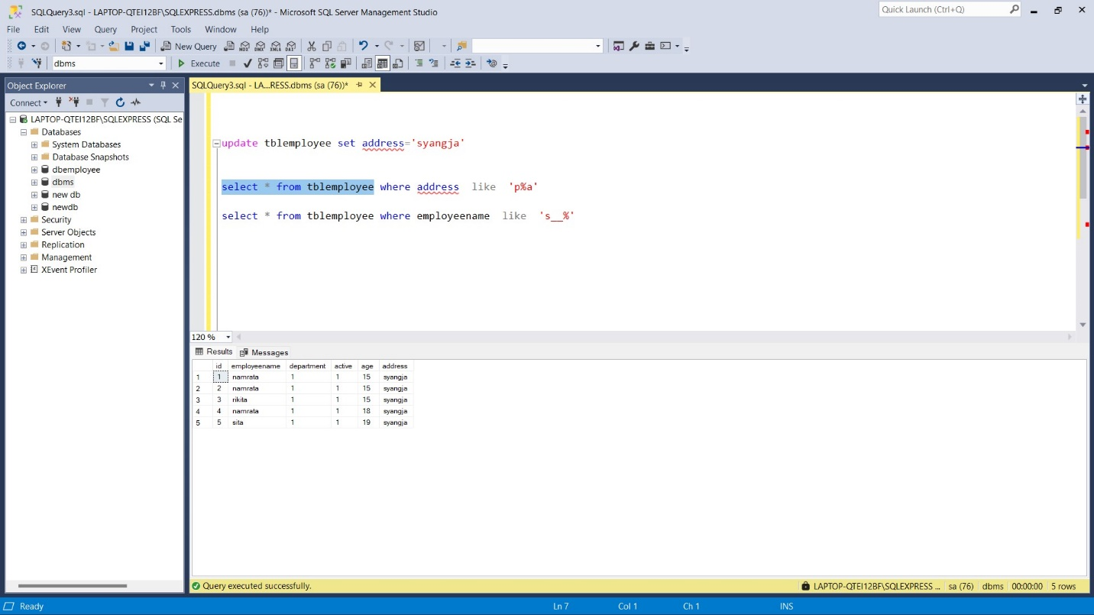

9. Table after updating address of id=1

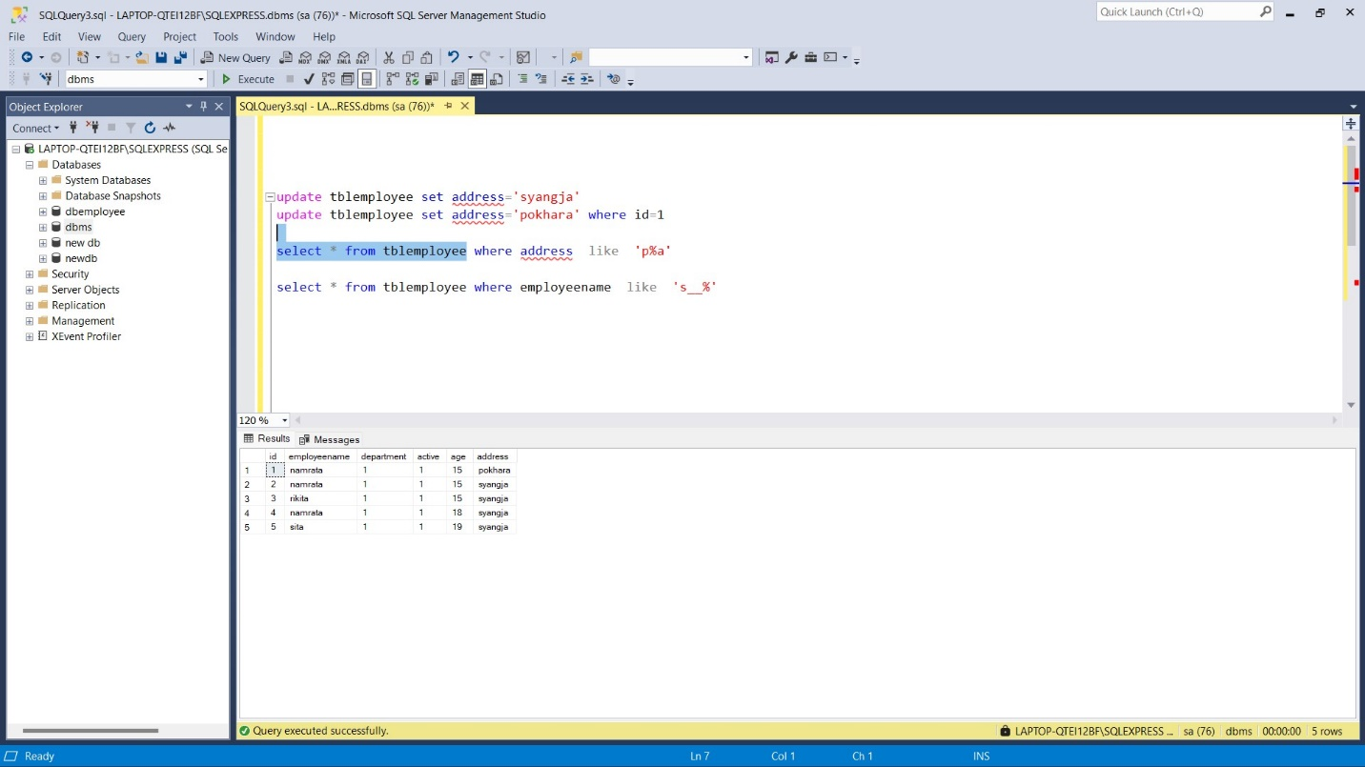

10.Updating address by name

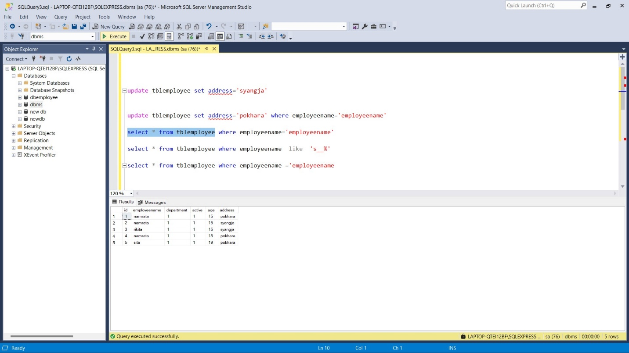

11. Updating address by id

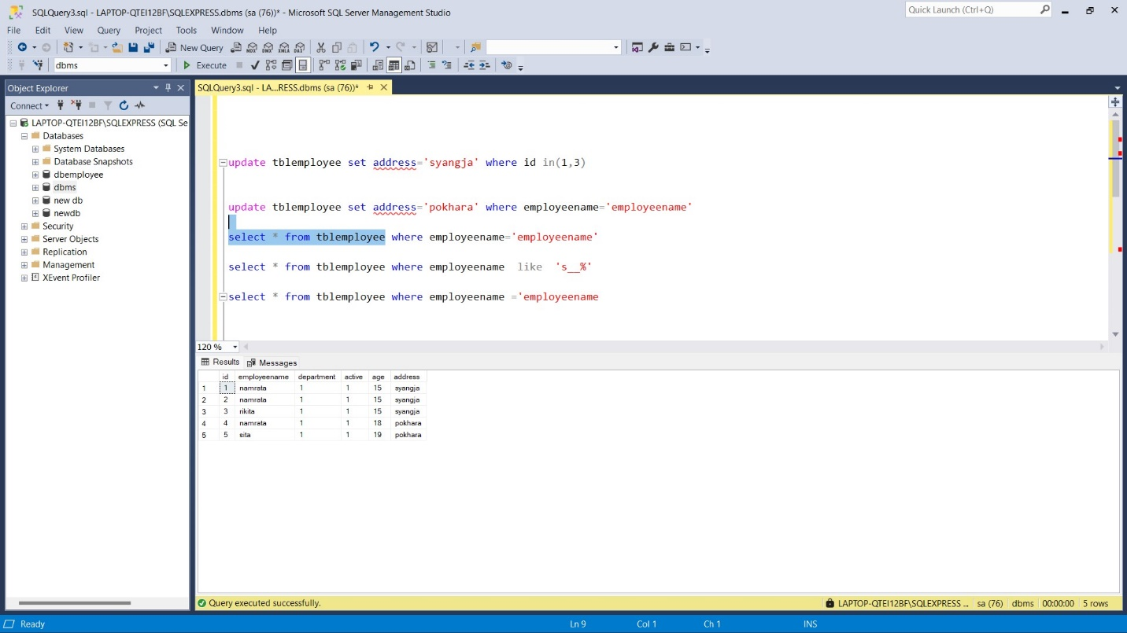

12. Deleting row by id

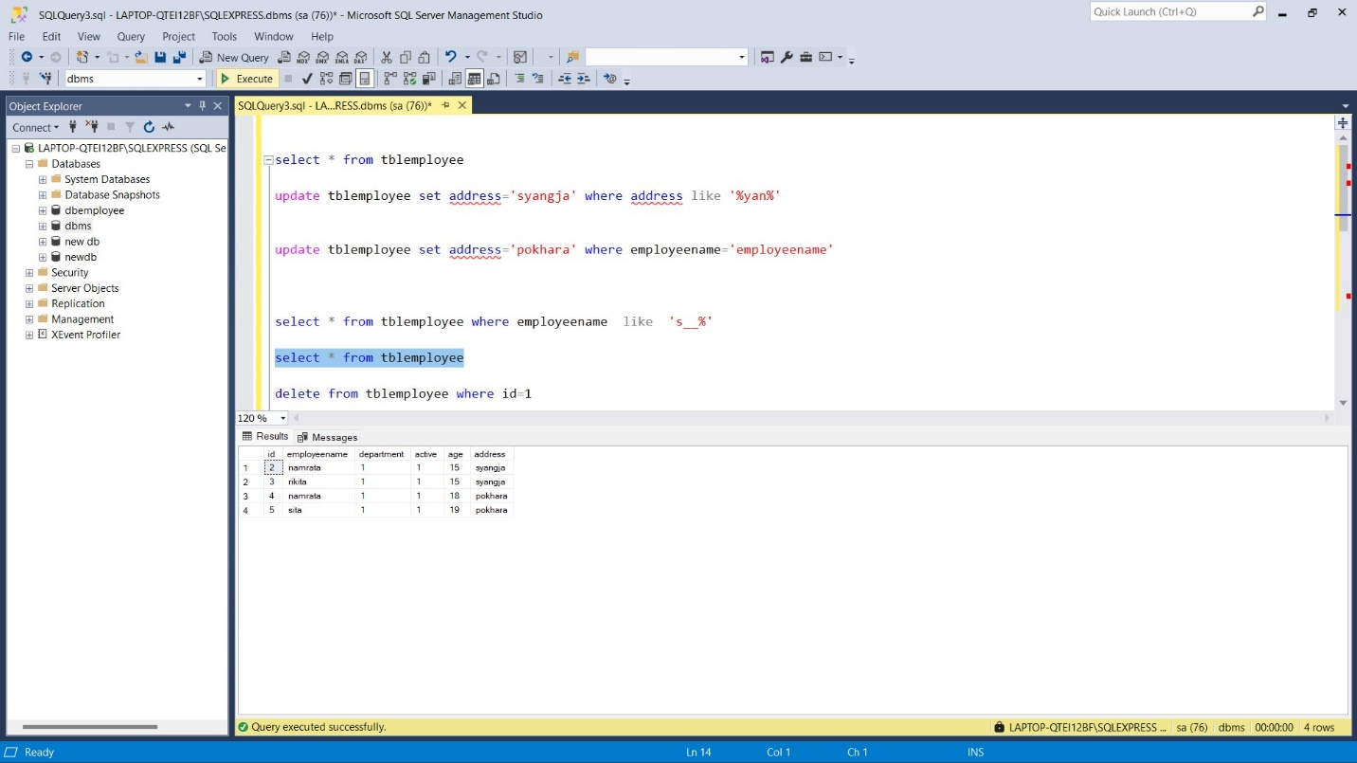

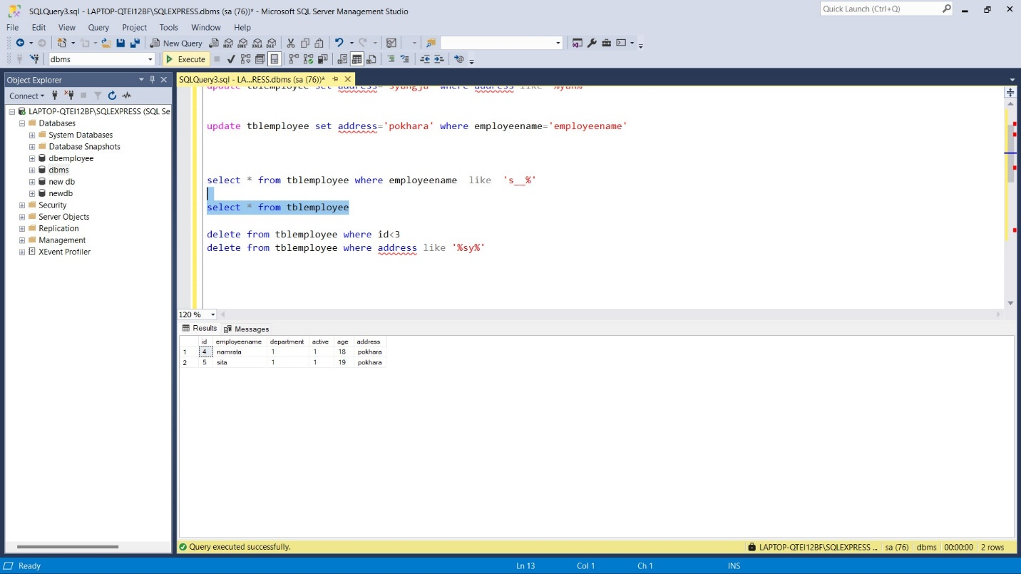

13. Delete where address like ‘%sy%’



14. Updating address where id in (7,8)

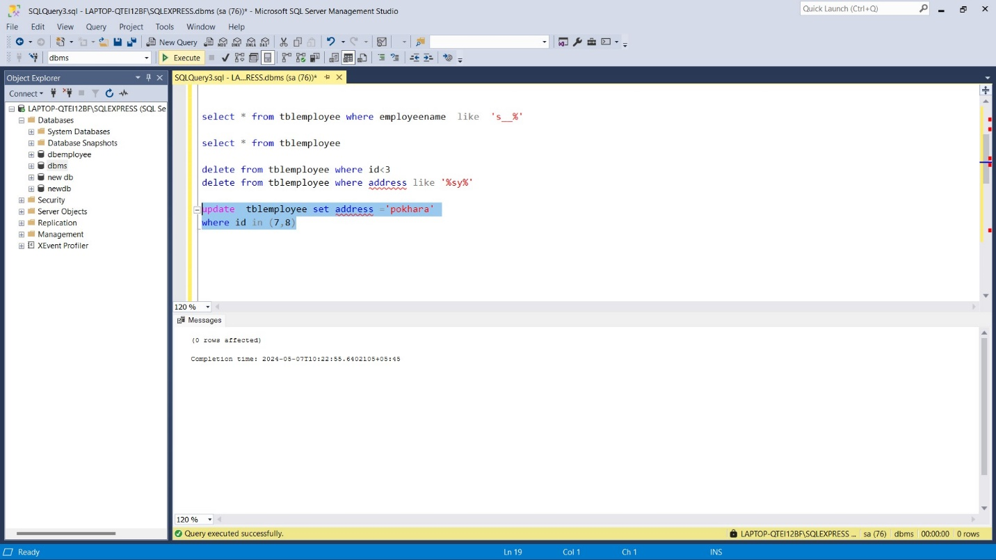

15. Selecting table where address not in (‘syanja’)

