

**LA GRANDEE INTERNATIONAL COLLEGE**

**Simalchaur, Pokhara, Nepal**

Assignment I

**Submitted to**

Mr.Ashwin Poudel

La Grandee International College

Bachelor of Computer Application (BCA) Program

In partial fulfillment of the requirements for the degree of Program Name under

Pokhara University

**Submitted by**

|  |  |  |  |
| --- | --- | --- | --- |
| **Name:** | **Course** | **Semester** | **P.U. Registration Number** |
| R.a.mohan Tiwari | BCA | 6th | 2022-1-53-0136 |

**Date: 4th May 2025**

**Question:**

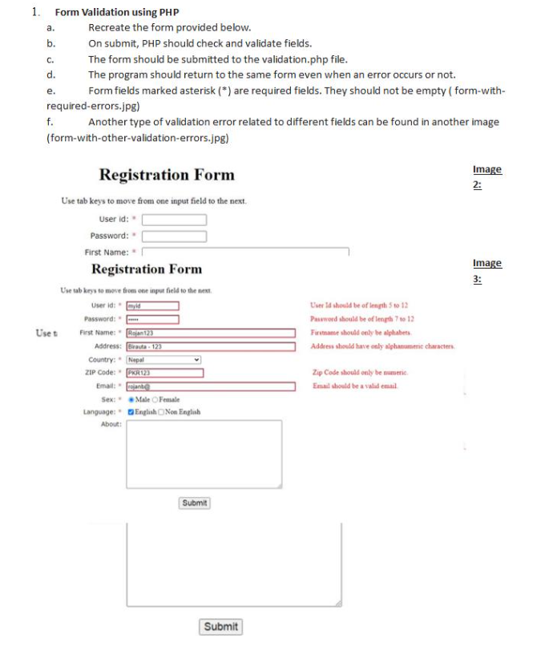

1. **Introduction**

This is a PHP backend description of a registration form with field validation using regular expressions, password hashing, and safe insertion into a MySQL database using prepared statements.

1. **Database schema**

CREATE TABLE users (

id INT AUTO_INCREMENT PRIMARY KEY,

userid VARCHAR(50),

password VARCHAR(255),

fname VARCHAR(50),

address VARCHAR(100),

country VARCHAR(50),

zip VARCHAR(10),

email VARCHAR(100),

gender VARCHAR(10),

language VARCHAR(100),

about TEXT

);

1. **Connect.php file code**

<?php

$conn = mysqli_connect("localhost", "root", "", "assignment1");

if (!$conn) {

    die("Connection failed: " . mysqli_connect_error());

}

**4.form.php**

<!DOCTYPE html>

<html lang="en">

<head>

    <meta charset="UTF-8">

    <title>Assignment1</title>

</head>

<body>

    <h1>Registration Form</h1>

    <p>Use tab keys to move from one input field to the next.</p>

    <form method="POST" action="validation.php">

        <label for="userid">User ID: <span style="color: red;"> * </span></label>

        <input type="text" id="userid" name="userid" required><br><br>

        <label for="password">Password: <span style="color: red;"> * </span></label>

        <input type="password" id="password" name="password" required><br><br>

        <label for="fname">First Name:<span style="color: red;"> * </span></label>

        <input type="text" id="fname" name="fname" required><br><br>

        <label for="address">Address:</label>

        <input type="text" id="address" name="address"><br><br>

        <label for="country">Country: <span style="color: red;"> * </span></label>

        <select id="country" name="country">

            <option value="Nepal">Nepal</option>

            <option value="India">India</option>

            <option value="USA">USA</option>

        </select><br><br>

        <label for="zip">ZIP Code: <span style="color: red;"> * </span></label>

        <input type="text" id="zip" name="zip"><br><br>

        <label for="email">Email: <span style="color: red;"> * </span></label>

        <input type="email" id="email" name="email"><br><br>

        <label>Sex: <span style="color: red;"> * </span></label>

        <input type="radio" name="gender" value="Male" id="male"><label for="male">Male</label>

        <input type="radio" name="gender" value="Female" id="female"><label for="female">Female</label><br><br>

        <label>Language: <span style="color: red;"> * </span></label>

        <input type="checkbox" name="language[]" value="English">English

        <input type="checkbox" name="language[]" value="Non English">Non English<br><br>

        <label for="about">About:</label><br>

        <textarea name="about" id="about" rows="4" cols="40"></textarea><br><br>

        <button type="submit">Submit</button>

    </form>

</body>

</html>

**5.Validation.php code**

<?php

include 'connect.php';

$errors = [];

if ($_SERVER["REQUEST_METHOD"] == "POST") {

    $userid = $_POST['userid'] ?? '';

    $password = $_POST['password'] ?? '';

    $fname = $_POST['fname'] ?? '';

    $address = $_POST['address'] ?? '';

    $country = $_POST['country'] ?? '';

    $zip = $_POST['zip'] ?? '';

    $email = $_POST['email'] ?? '';

    $gender = $_POST['gender'] ?? '';

    $language = $_POST['language'] ?? [];

    $about = $_POST['about'] ?? '';

    // *Regex patterns*

    $Regex_id = "/^[a-zA-Z0-9]{5,12}$/";

    $RegexPass = "/^[a-zA-Z0-9]{7,12}$/";

    $RegexName = "/^[a-zA-Z]{2,}$/";

    $RegexAddress = "/^[a-zA-Z0-9\s]{2,}$/";

    $RegexZip = "/^[0-9]{5,6}$/";

    $RegexEmail = "/^[a-zA-Z0-9._%+-]+@[a-zA-Z0-9.-]+\.[a-zA-Z]{2,}$/";

    if (!preg_match($Regex_id, $userid)) {

        $errors['userid'] = "User ID must be 5-12 characters (letters/numbers only).";

    }

    if (!preg_match($RegexPass, $password)) {

        $errors['password'] = "Password must be 7-12 characters (letters/numbers only).";

    }

    if (!preg_match($RegexName, $fname)) {

        $errors['fname'] = "First name must be at least 2 letters.";

    }

    if (!empty($address) && !preg_match($RegexAddress, $address)) {

        $errors['address'] = "Address must be at least 2 alphanumeric characters.";

    }

    if (!empty($zip) && !preg_match($RegexZip, $zip)) {

        $errors['zip'] = "ZIP must be 5 or 6 digits.";

    }

    if (!preg_match($RegexEmail, $email)) {

        $errors['email'] = "Invalid email format.";

    }

    if (empty($gender)) {

        $errors['gender'] = "Please select a gender.";

    }

    if (empty($language)) {

        $errors['language'] = "Please select at least one language.";

    }

    if (empty($errors)) {

        $hashedPassword = password_hash($password, PASSWORD_DEFAULT);

        $langString = implode(", ", $language);

        //*Here we are Convert array to comma-separated string*

        $stmt = $conn->prepare("INSERT INTO users (userid, password, fname, address, country, zip, email, gender, language, about)

                                VALUES (?, ?, ?, ?, ?, ?, ?, ?, ?, ?)");

        $stmt->bind_param("ssssssssss", $userid, $hashedPassword, $fname, $address, $country, $zip, $email, $gender, $langString, $about);

        if ($stmt->execute()) {

            echo "<h2 style='color: green;'> New record created successfully</h2>";

        } else {

            echo "<h2 style='color: red;'> Error: " . $stmt->error . "</h2>";

        }

        $stmt->close();

        $conn->close();

    } else {

        include 'form.php';

        echo "<h2 style='color: red;'>Please correct the following errors:</h2><ul style='color:red;'>";

        foreach ($errors as $msg) {

            echo "<li>$msg</li>";

        }

        echo "</ul>";

    }

} else {

    header("Location: form.php");

    exit;

}

**6.Snapshots**

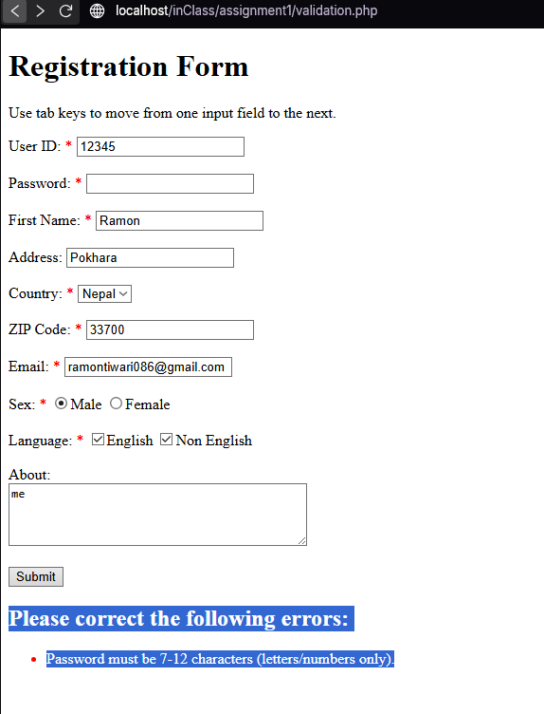

**7. Results**





**8. Conclusion**

While completing this Assignment, I became even more specific about Regular expressions, when inserting into the database, I learned how to hash credentials, and MySQL prepared statements to avoid SQL injection.