

**LA GRANDEE INTERNATIONAL COLLEGE**

**Simalchaur, Pokhara, Nepal**

Assignment III

**Submitted to**

Mr. Ashwin Poudel

La Grandee International College

Bachelor of Computer Application (BCA) Program

In partial fulfillment of the requirements for the degree of Program Name under

Pokhara University

**Submitted by**

|  |  |  |  |
| --- | --- | --- | --- |
| **Name:** | **Course** | **Semester** | **P.U. Registration Number** |
| R.a.mohan Tiwari | BCA | 6th | 2022-1-53-0136 |

**Date: 19th May 2025**

**Question 1:**

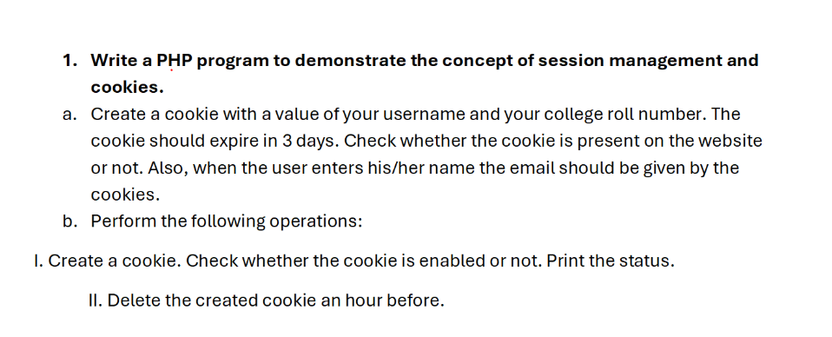

**Set_cookie.php**

<?php

$username = "ramohan";

$roll = "Bca6th";

$email = "ramohan@mail.com";

// *Set cookie for 3 days*

setcookie("user_data", "$username|$roll|$email", time() + (3 * 24 * 60 * 60));

// *Check if cookie is set*

if(isset($_COOKIE['user_data'])) {

    echo "Cookie is enabled. Value: " . $_COOKIE['user_data'];

} else {

    echo "Cookie is not set (yet). Refresh to check again.";

}

?>

**Get_email_from_cookie.php**

<?php

if(isset($_POST['username'])) {

    $inputName = $_POST['username'];

    if(isset($_COOKIE['user_data'])) {

        list($name, $roll, $email) = explode("|", $_COOKIE['user_data']);

        if(strtolower($name) === strtolower($inputName)) {

            echo "Welcome $name! Your email is: $email";

        } else {

            echo "Username doesn't match cookie.";

        }

    } else {

        echo "No cookie found.";

    }

}

?>

<form method="POST">

  Enter your name: <input type="text" name="username" required />

  <input type="submit" value="Check Email" />

</form>

**Delete_cookie.php**

<?php

// *Set cookie with past time to delete it*

setcookie("user_data", "", time() - 3600);

echo " Cookie deleted (expired 1 hour ago).";

?>

**Question 2:**

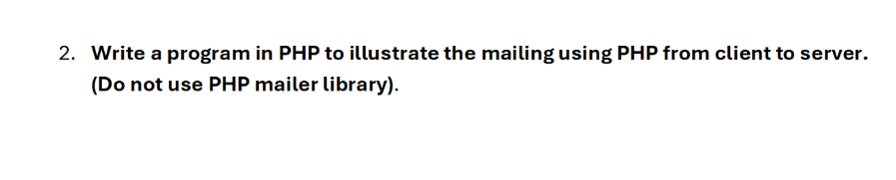

**Send_mail.php**

<?php

if(isset($_POST['send'])) {

    $to = $_POST['to'];

    $subject = $_POST['subject'];

    $message = $_POST['message'];

    $headers = "From: ramontiwari086@gmail.com";

    if(mail($to, $subject, $message, $headers)) {

        echo " Mail sent successfully.";

    } else {

        echo " Mail sending failed.";

    }

}

?>

<form method="POST">

  To: <input type="email" name="to" required /><br>

  Subject: <input type="text" name="subject" required /><br>

  Message:<br>

  <textarea name="message" rows="5" cols="30" required></textarea><br>

  <input type="submit" name="send" value="Send Mail" />

</form>

**3.Snapshots**

**1.**

**i.**

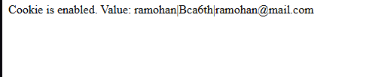

**ii.**

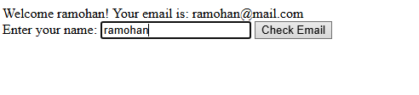

**iii.**

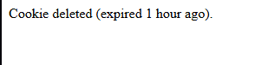

**2.**

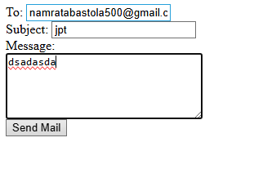

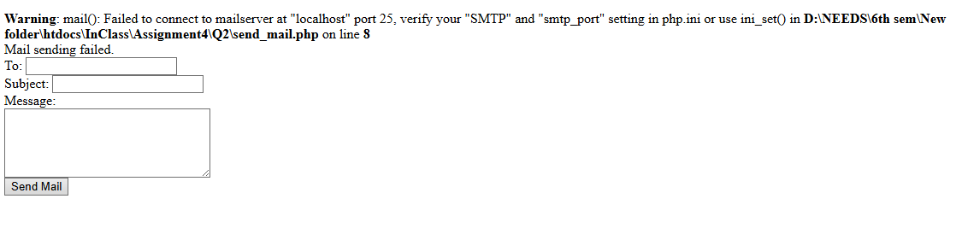

**6.Github Repo (**https://github.com/Ramoniswack/PhpClass**)**

