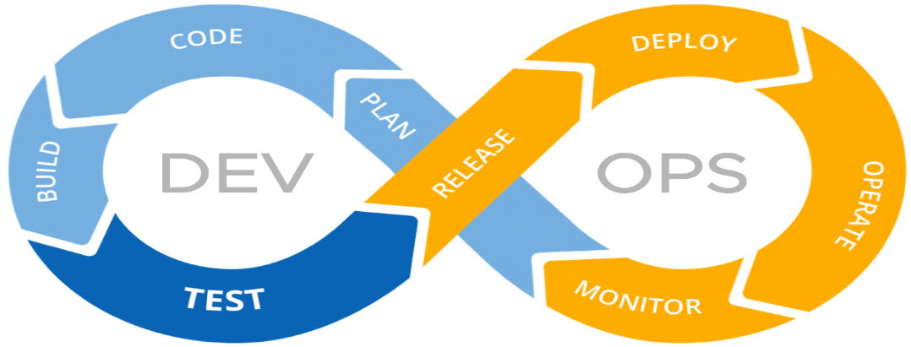

**Version Control System:**

**- Record/Track the changes**

**- Collaboratively developement**

**- who made what changes**

**- Revert the changes**

**Types of SCM/VCM**

**1. Local Repository**

**- Code located locally no central system to distribute the code**

**2. Central repository**

**- Code located only at central repo**

**3. Distributed Architecture**

**- Maintaining local repo and Central repo**

**- Code will be distributed to everyone**

**Install Git on Windows**

**https://git-scm.com/downloads**

**latest (2.36.1) 64-bit version of Git for Windows.**

**64-bit Git for Windows Setup.**

**Install Git on Linux**

**Debian/Ubuntu:**

**For the latest stable version for your release of Debian/Ubuntu**

**# apt-get install git**

**For Ubuntu, this PPA provides the latest stable upstream Git version**

**Amzon Linux/RedHat Linux:**

**# yum install git**

**Git Initialization:**

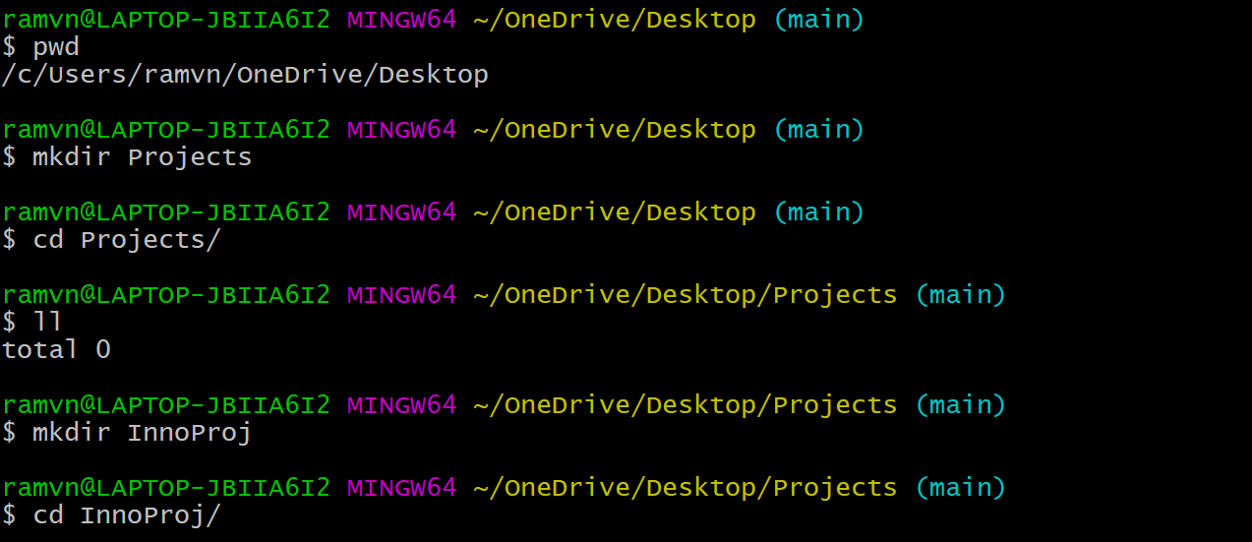



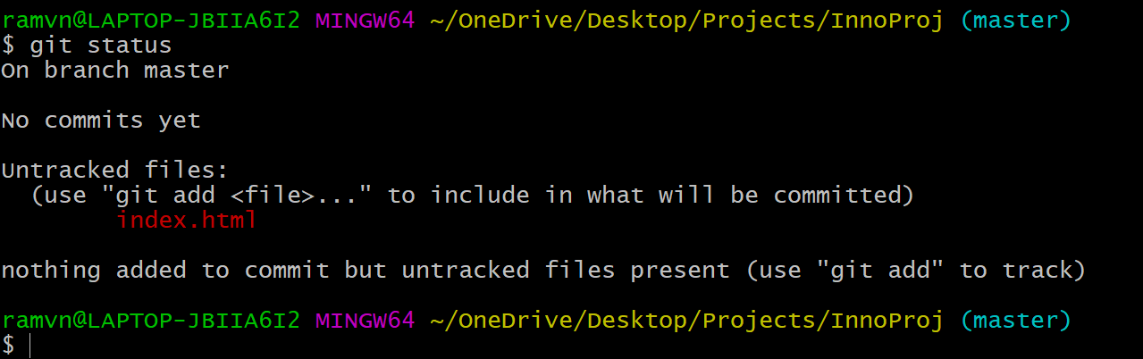

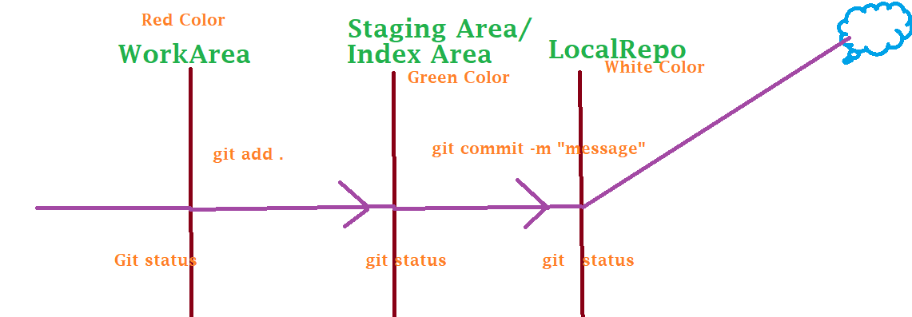

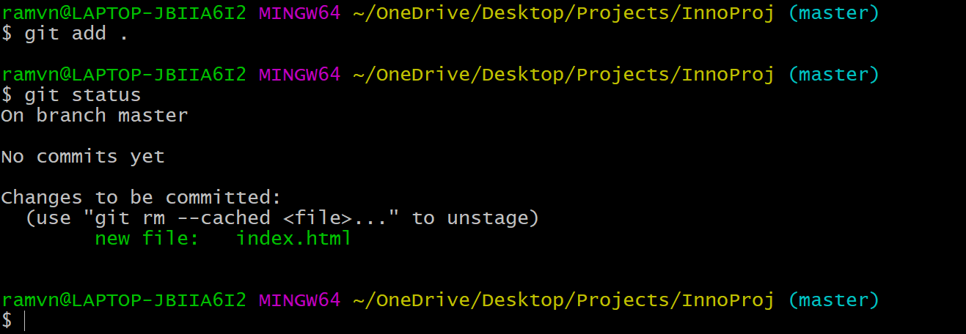

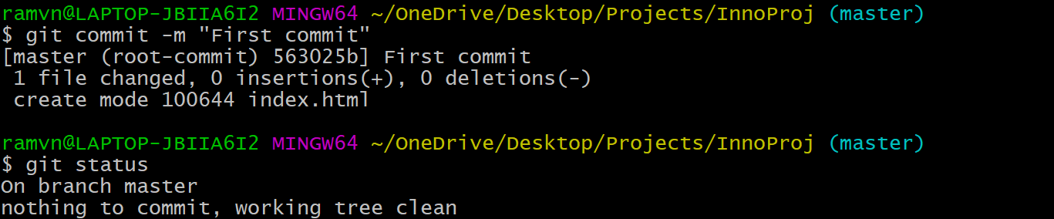

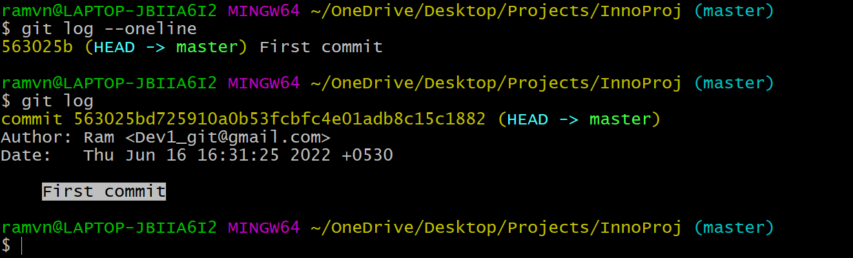

**Install GIT on Linux:**



**Git Initialization:**

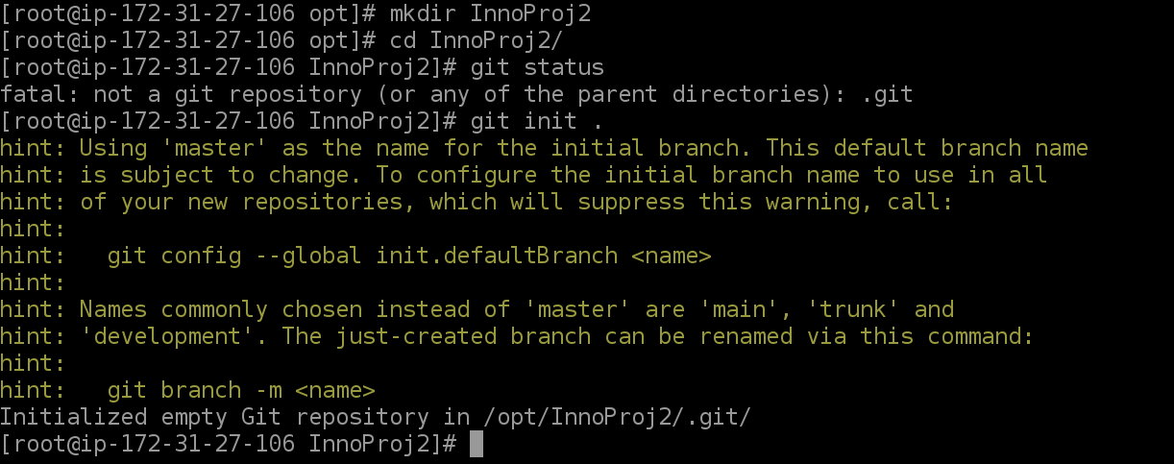

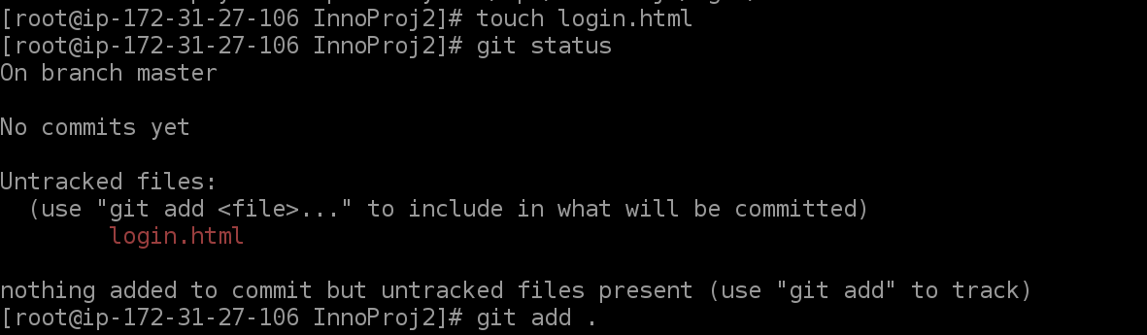

**Before commit ,Register your name and email to move to local repo:**

**git config –-global –-edit**

**OR**

**git config –global user.name “ram”**

**git config –global user.email** [**ram99@gmail.com**](mailto:ram99@gmail.com)

**To display user details:**

**git config –global user.name**

**git config –global user.email**

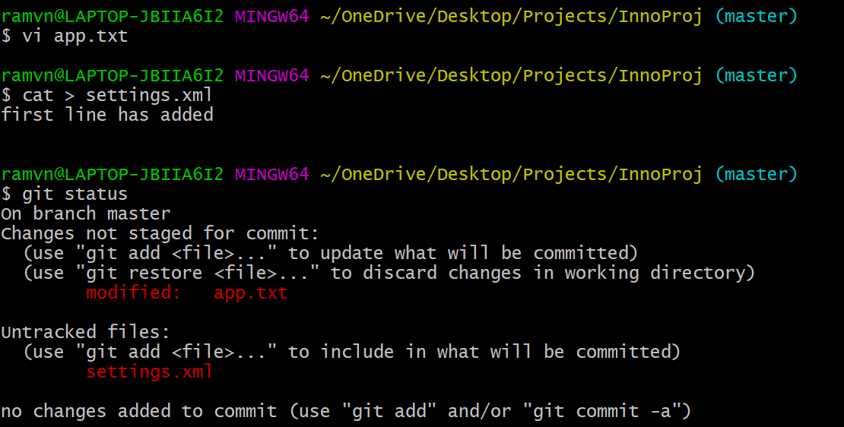

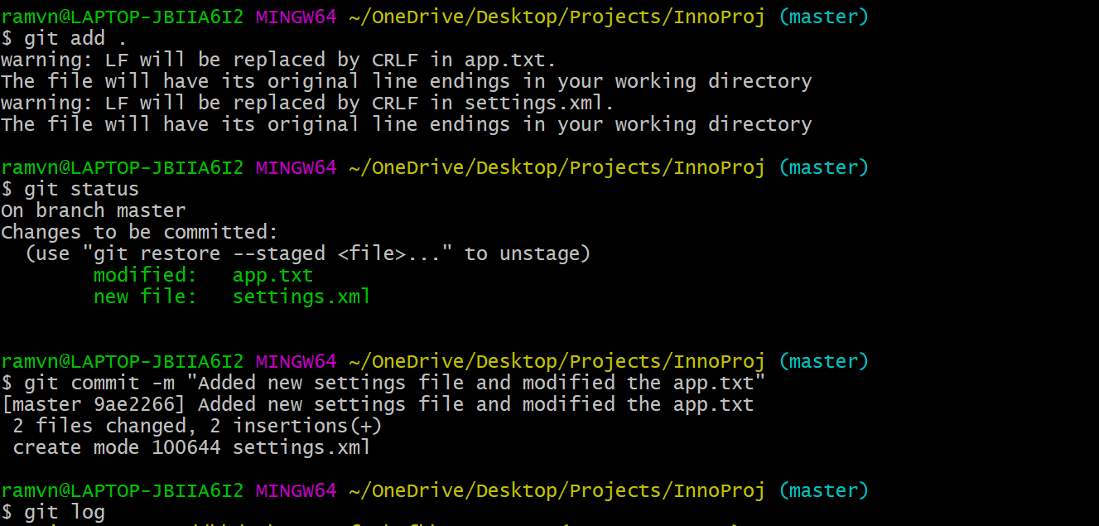

**Explaining about code changes between different stages:**

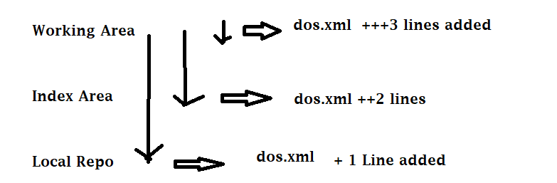

**Step1: Create a new file and move to local repository**

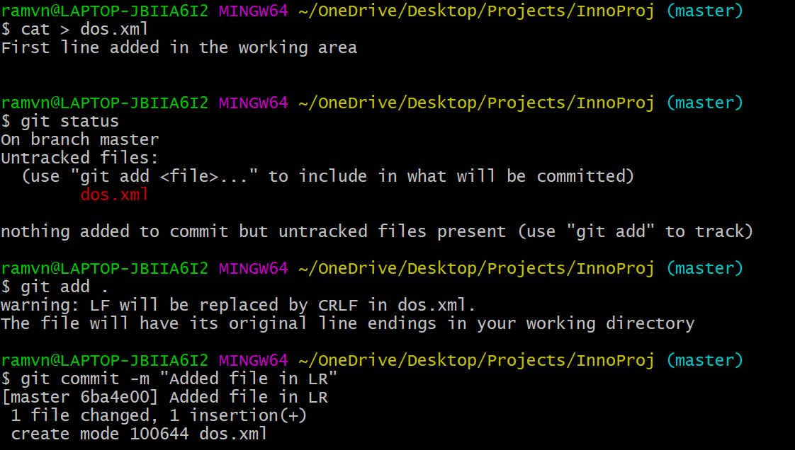

**Step 2: Modify the local repository file and move to stage area**

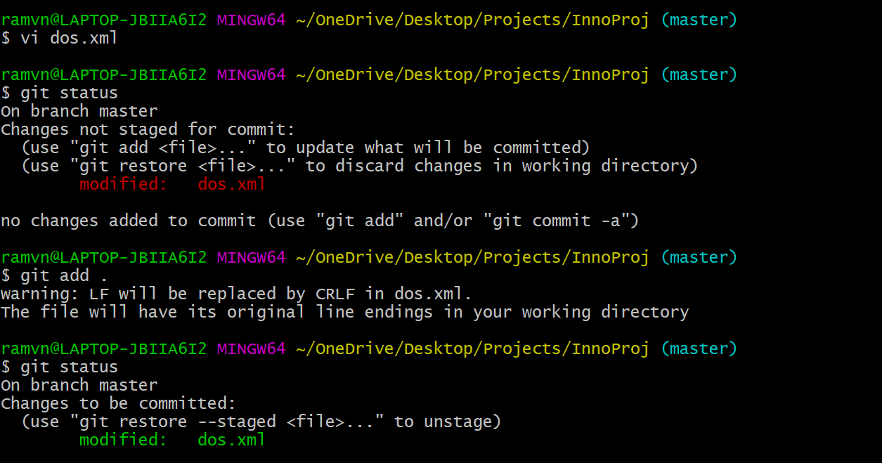

**Step 3: Modify the file which is there in stage area and keep it in Working area:**

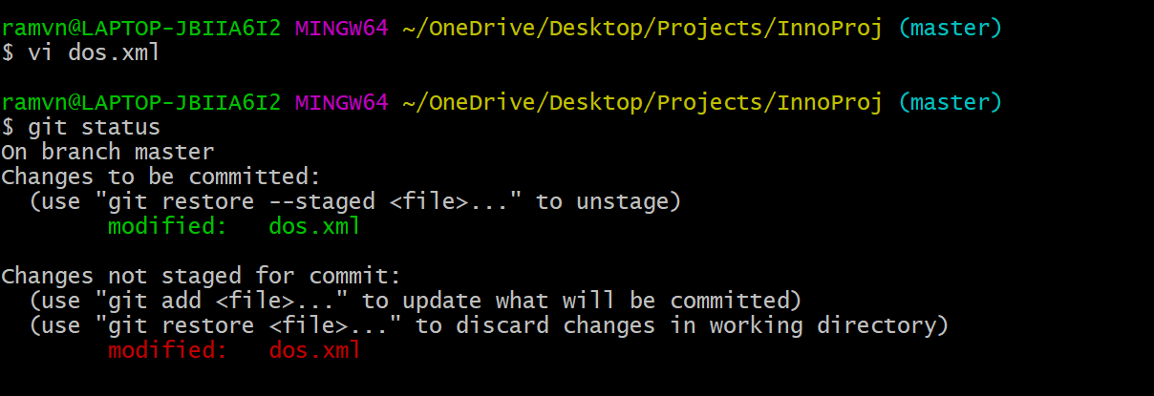

**Difference between Working Area To Staging Area:**

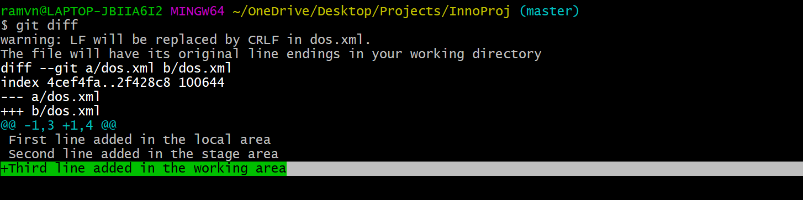

**Difference between Staging Area To Local Repo:**

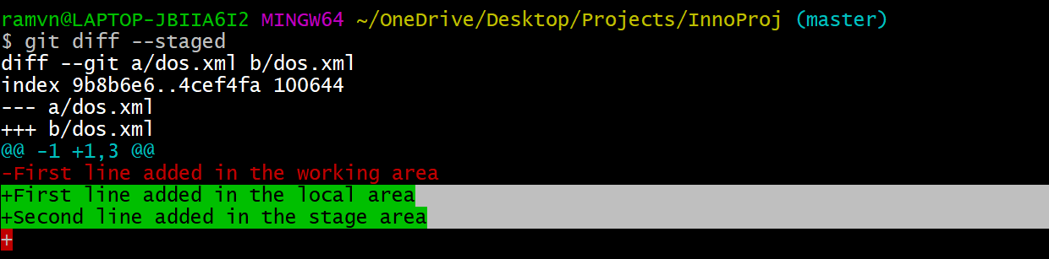

**Difference between Working Area To Local Repo:**

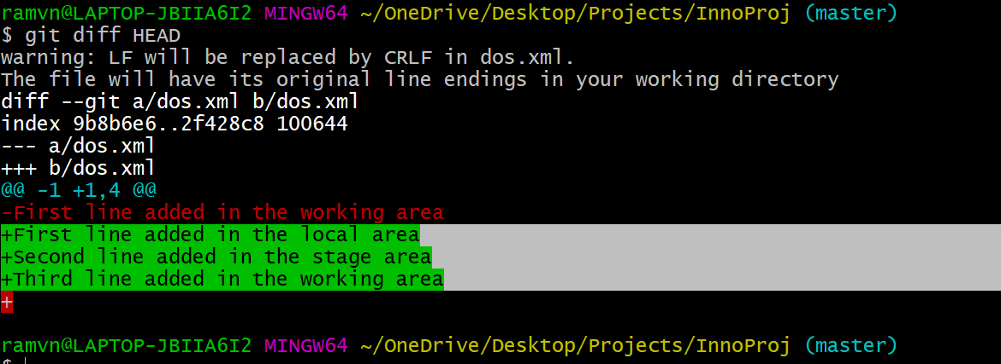

**GIT Commits:**

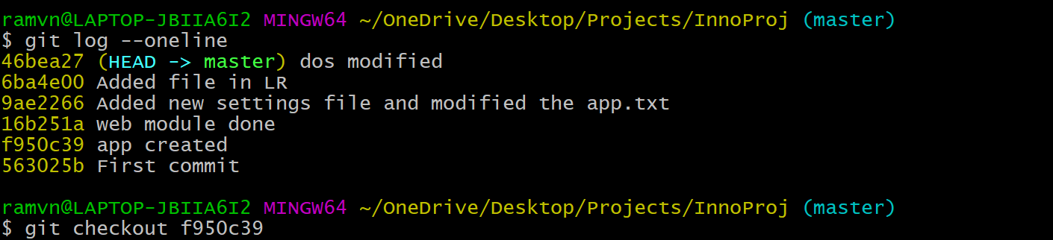



**Cloning the Remote repo and pushing back to Remote Repo:**

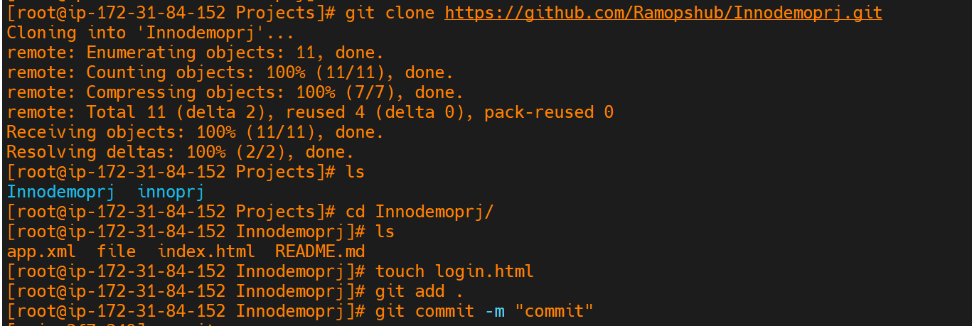

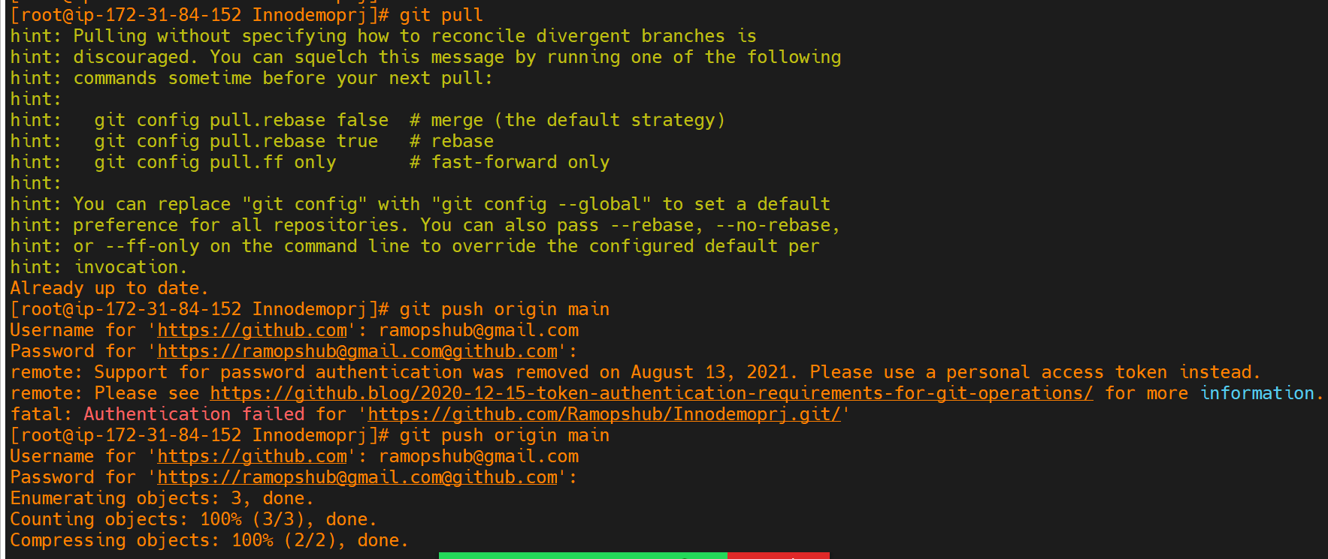

**Associate Local Repo to Remote repository:**

**Step:1 Create a repo in Remote repository (GitHub)**

**Step:2 Following procedure in Local repo.s**

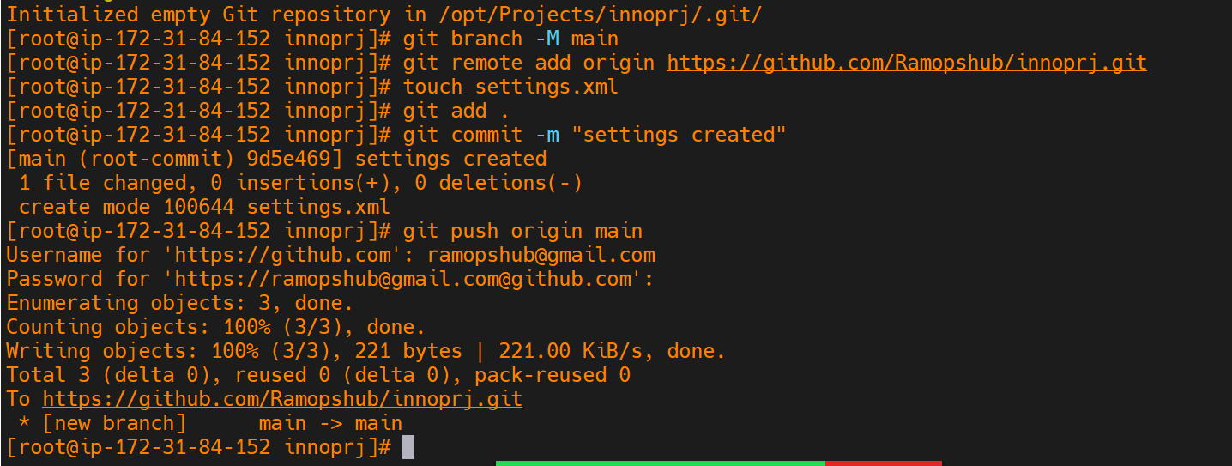

**Merge Conflict :**

**When Dev1 and Dev2 works on same file and trying to push the code to Remote repo then whosoever pushes the code first that will be pushed successfully and other Dev’s code will be stopped by saying Merge conflict so need to resolve merge conflict manually by opening the file and fix the issue.**

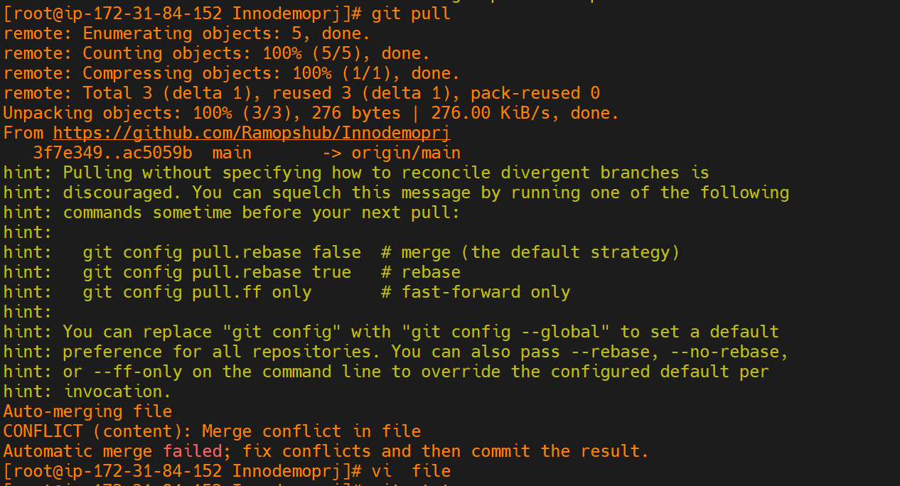

**Git Branches:**

