Ramos, Maria Karina T

2ECE-D

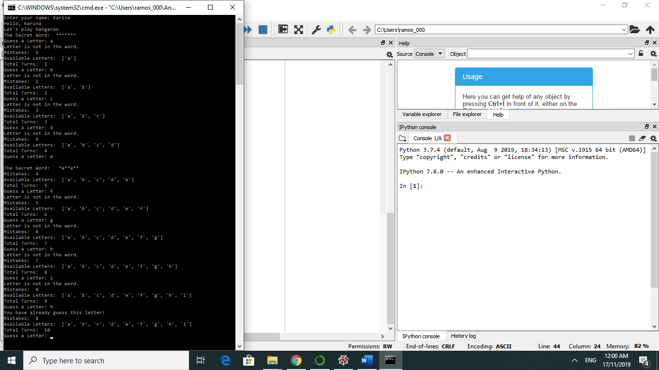

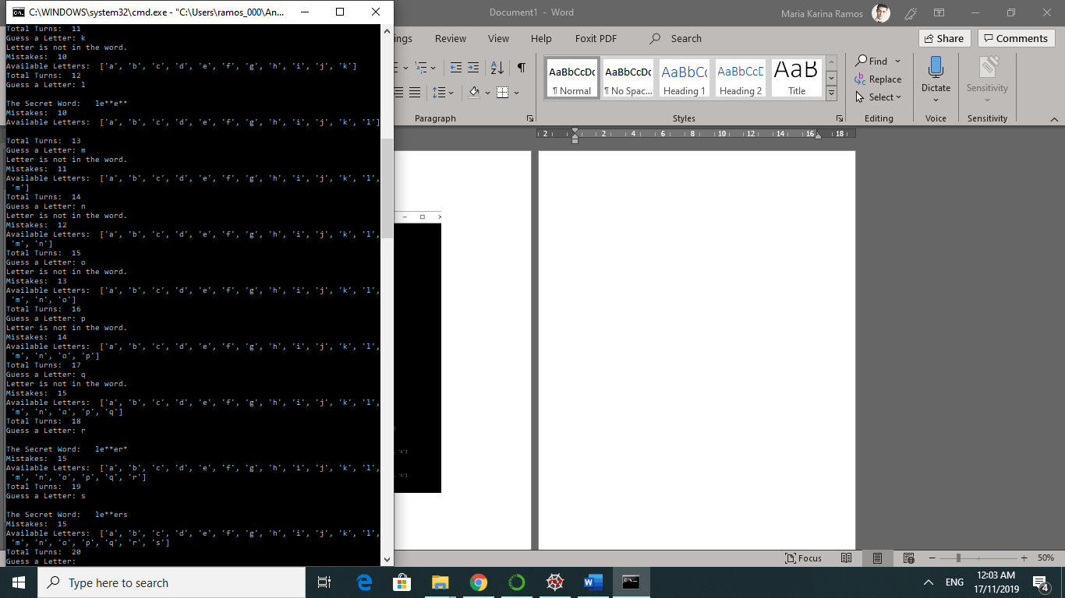

Word is Letter

Guessing “t” would congratulate the user then exit the program.