Ramos, Maria Karina T.

Cabasal, Xiaren Eizyneth

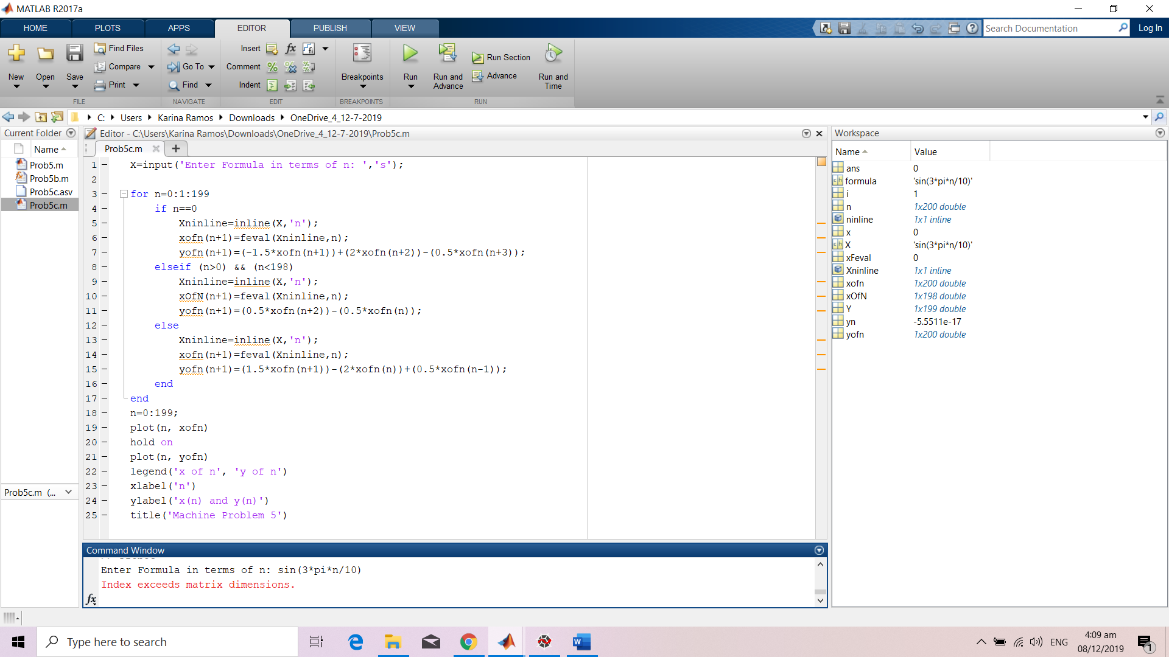

**Testing for x(n) = sin(3\*pi\*n/10)**

