Ramos, Maria Karina T

Cabasal, Xiaren Eizyneth

**PYTHON PROBLEM #1**

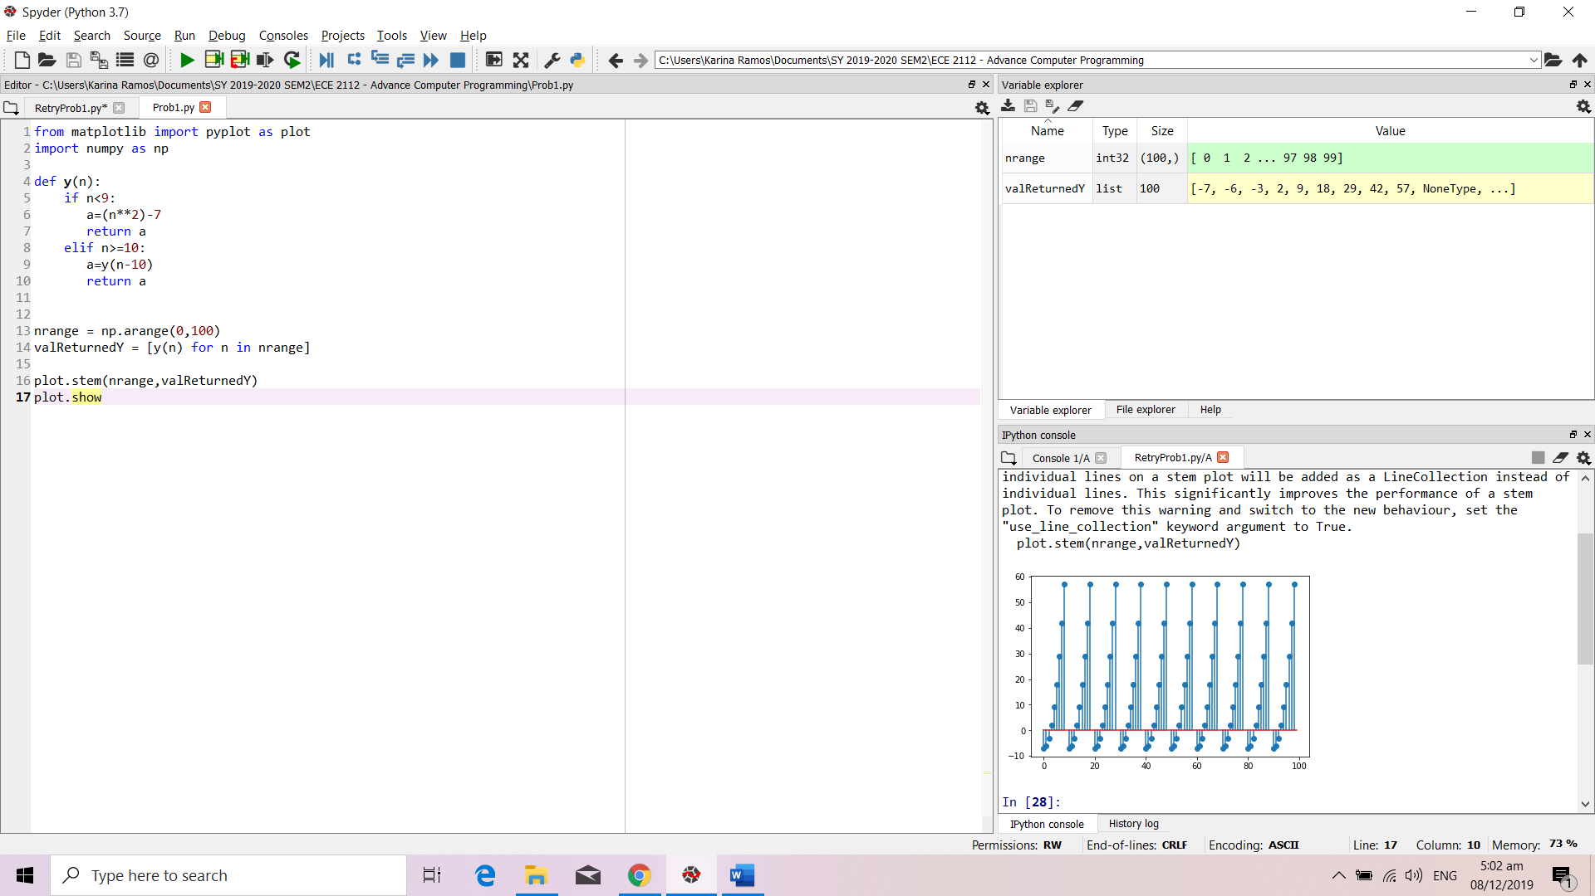

**Results**



**Results**

