Ramos, Maria Karina T.

Cabasal, Xiaren Eizyneth

**PROBLEM 5:**

Testing the program with x(n) = sin(3*pi*n/100)

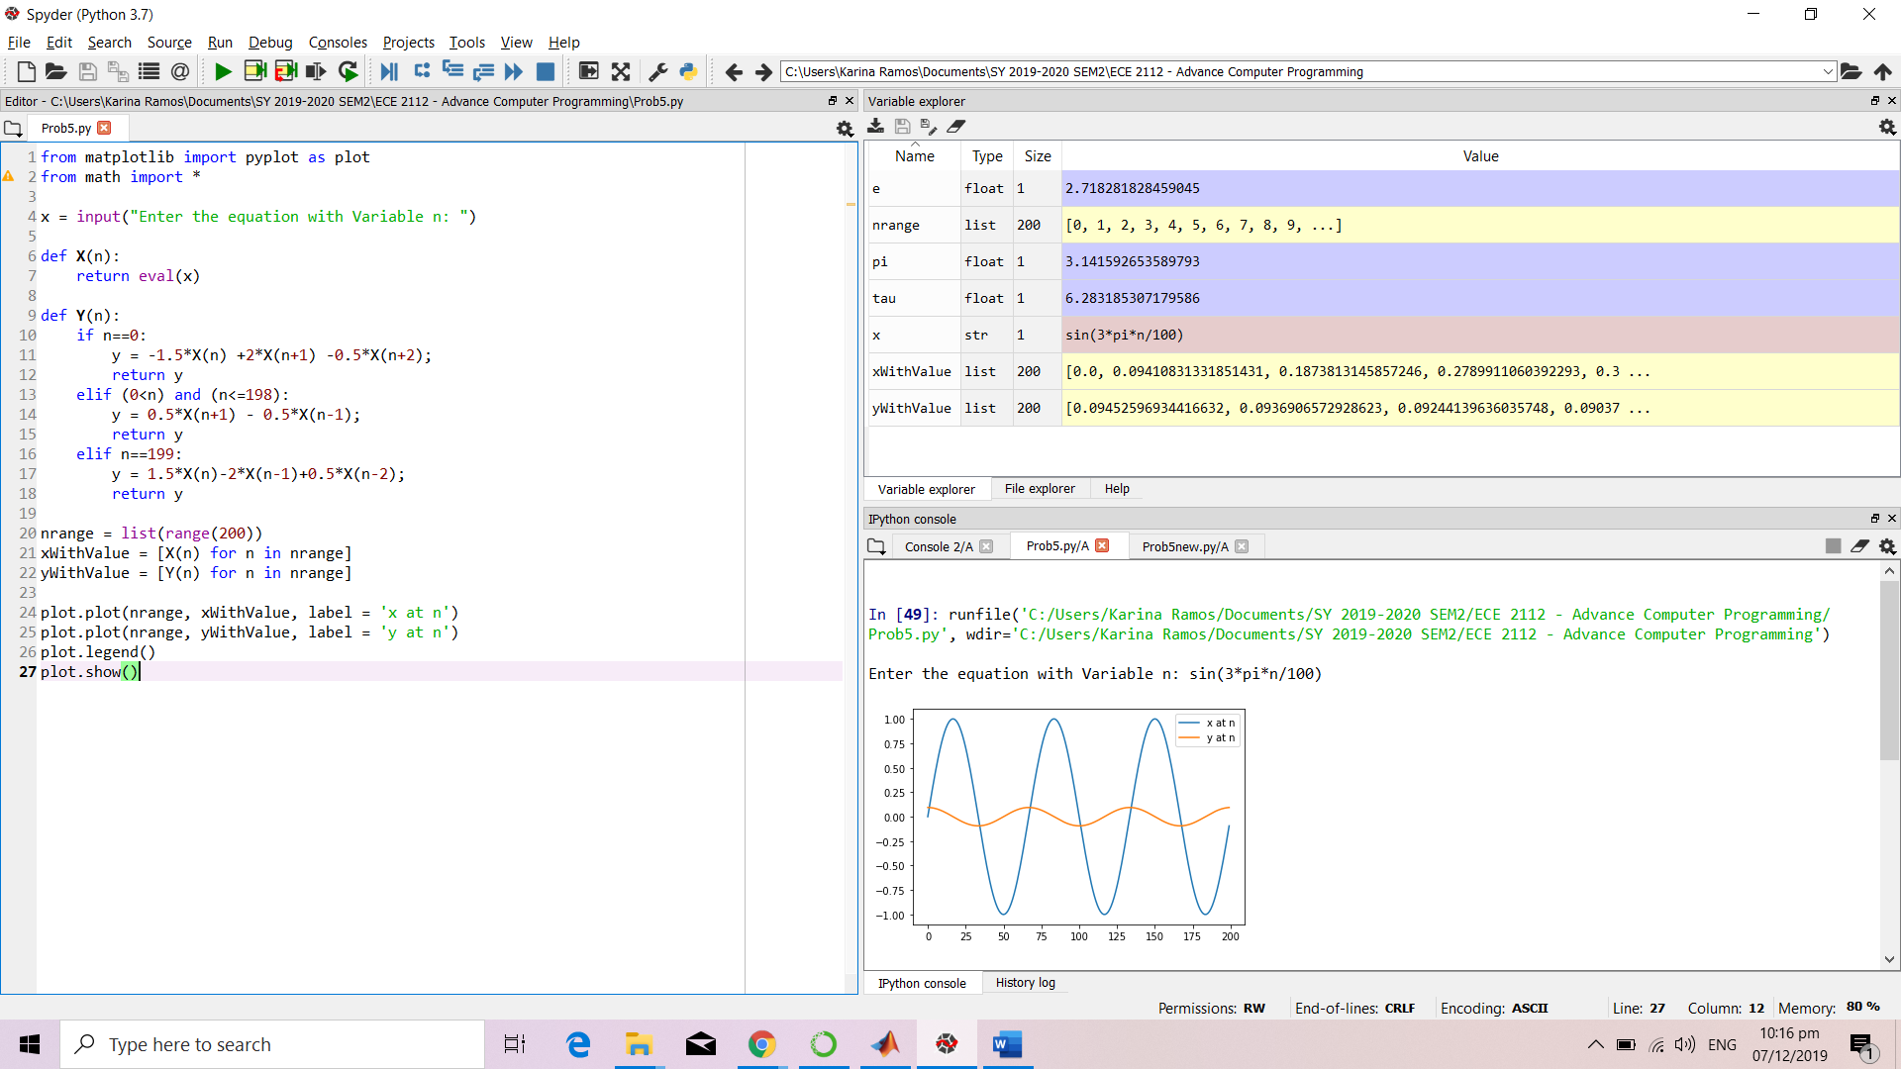

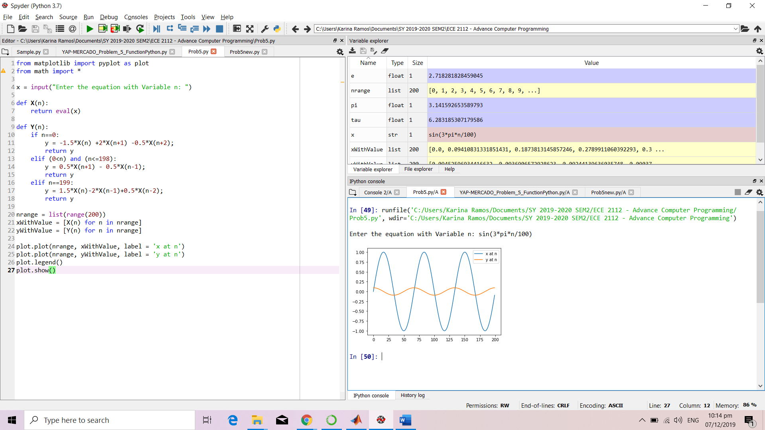

Testing the program at x(n) = tan(4*pi*n/100)

