Foxers Team Backlog
Jira link: https://proman.atlassian.net/jira/software/projects/SCRUM/boards/1/backlog
Screenshots:
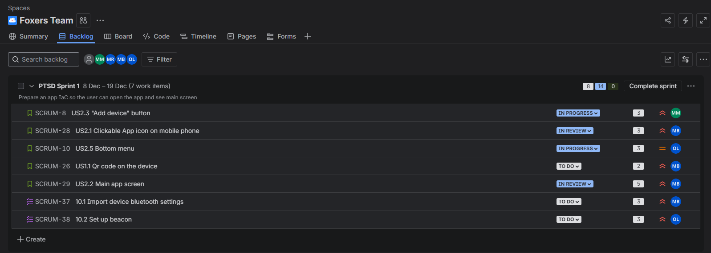
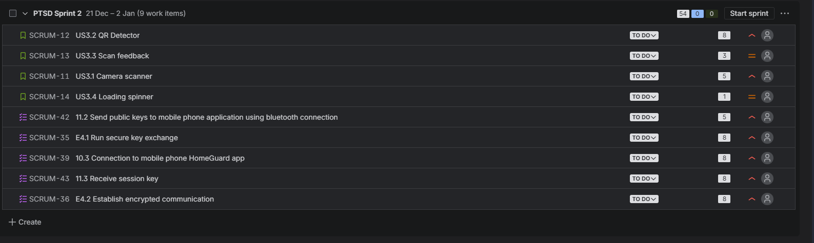
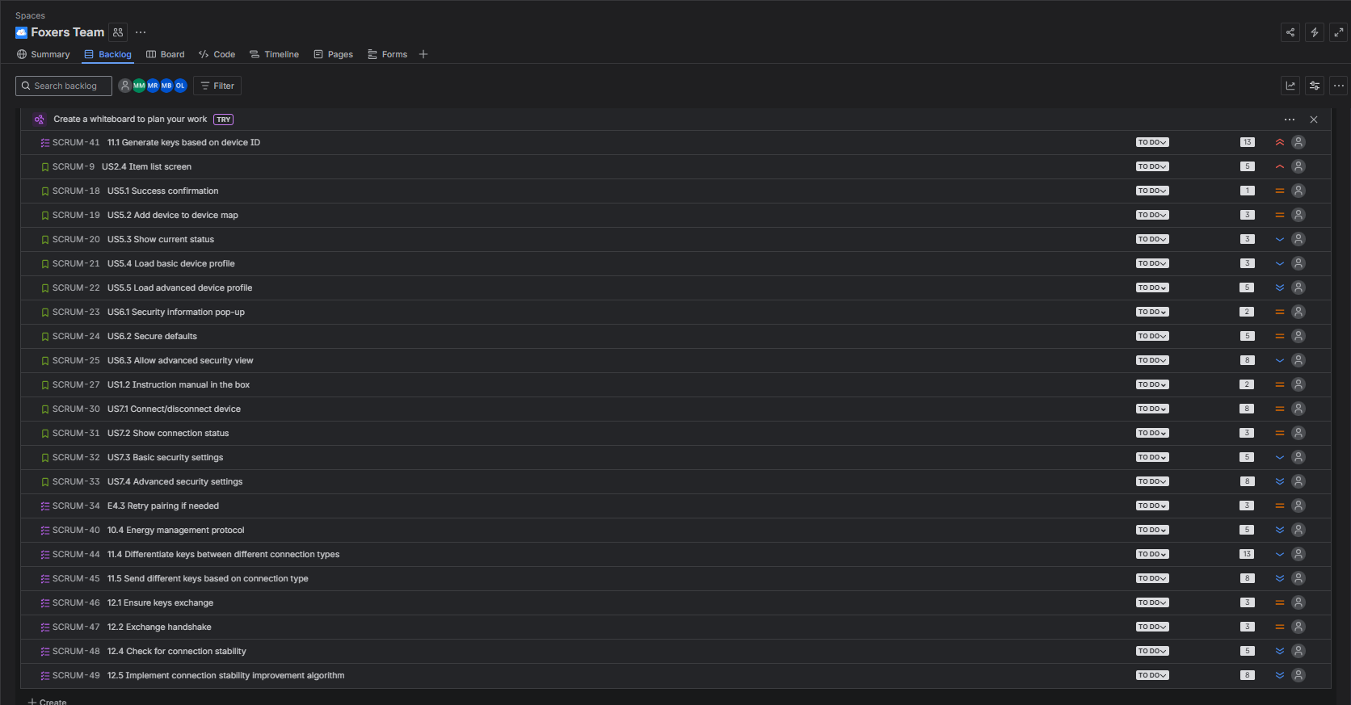

Current Sprint 1 board:
