**Proximity Detection Analyzer**

*Project Synopsis Submitted*

*to*

**MANIPAL ACADEMY OF HIGHER EDUCATION**

*For Partial Fulfillment of the Requirement for the*

*Award of the Degree*

*Of*

**Bachelor of Technology**

*in*

**Information Technology**

*by*

**Nishka Kulshrestha Shreyas BS Rishabh Jain**

**210953068 210953078 210953080**

*Under the guidance of*

Mrs. Sameena Begum Pathan

Associate Professor Assistant Professor

Department of I&CT Department of I&CT

Manipal Institute of Technology, Manipal Institute of Technology,

Manipal, Karnataka, India Manipal, Karnataka, India



**April 2024**

**TABLE OF CONTENTS**

I. Abstract --------------------------------------------------------------ii

II. Introduction ---------------------------------------------------------1

2.1. Scope

2.2. Project Description

2.3. Problem Statement

2.4. Objective

III. System Requirements ---------------------------------------------3

IV. Functionality -------------------------------------------------------4

V. Code -----------------------------------------------------------------6

VI. Results -------------------------------------------------------------11

VII. Conclusion -------------------------------------------------------12

VIII. References--------------------------------------------------------13

**ii**

1. **ABSTRACT**

Our project, the "Proximity Distance Analyzer" aims to introduce a solution to improve

parking safety through cutting-edge technology. It uses an ARM microcontroller kit and

ultrasonic sensors to create a parking distance monitoring system. This project addresses the

need for a dependable, user-friendly solution to ensure secure parking practices in crowded

environments.

Using ultrasonic sensors to measure precise distances between parked cars, implementing an

intelligent alert system with LED indicators for distances less than three feet, and creating an

easy-to-use user interface to provide users with real-time feedback are some of the main goals

of the " Proximity Distance Analyzer”. The system demonstrates its reliability and usability

across various parking scenarios through meticulous testing and calibration.

Sustainable Development Goal (SDG):

Aligned with Sustainable Development Goal 11: "Sustainable Cities and Communities," the

" Proximity Distance Analyzer " creates safer and more sustainable urban environments. By

promoting secure parking practices and minimizing the risk of vehicle damage in congested

areas, it supports efficient utilization of parking spaces, reduces congestion, and enhances

overall safety in city settings. This endeavour towards safer parking solutions aligns with

creating sustainable and resilient cities for all.

**II. INTRODUCTION**

**2.1 Scope:**

The project aims to design a parking distance monitoring system utilizing an ultrasonic

sensor, providing real-time parking distance information displayed on an LCD screen. A

built-in LED indicator will signal when distances fall below 3 feet, endorsing safe parking

and ensuring public safety in congested parking environments.

**2.2 Project Description:**

The "Proximity Detection Analyzer" is an innovative parking distance monitoring system

meticulously engineered to optimize the parking experience in busy parking scenarios. The

device uses advanced ultrasonic sensor technology to accurately measure the distance

between parked vehicles in real time. The obtained parking distance data is immediately

exhibited on an LCD screen, offering users immediate insights. An intelligent alert system

featuring an LED indicator activates when the measured distance between vehicles

descends below the recommended 3 feet, promoting secure parking practices. This system

supports continuous monitoring, making it suitable for various applications, including

commercial parking lots, public garages, and residential parking spaces. By streamlining

the utilization of parking spaces and guaranteeing that vehicles are parked at a secure

distance from one another, the "Proximity Detection Analyzer" improves both the

convenience and safety of parking, ultimately decreasing the risk of minor vehicle damage

and enhancing the overall parking experience.

**2.3 Problem Statement:**

Develop a "Proximity Detection Analyzer” with ultrasonic sensors for real-time parking distance

on an LCD screen. Include an LED alert for distances below 3 feet, ensuring safe parking and

preventing vehicle damage in crowded areas.

**2.4 Objective:**

The primary goal of the "Proximity Detection Analyzer” project is to establish a dependable

and user-friendly parking distance monitoring system. This system employs an ultrasonic

sensor to gauge the distance between parked vehicles in real-time precisely. The collected

distance data is promptly presented on the LCD screen of the ARM microcontroller kit,

delivering instantaneous feedback to users. Furthermore, the system is equipped with an

intelligent, alert system: an LED indicator activates whenever the measured distance dips

below the recommended safety threshold of 3 feet. By blending cutting-edge technology2

with user safety, the Proximity Monitor aims to encourage secure parking and

enhance the convenience and safety of parking in crowded situations.

**III. SYSTEM REQUIREMENTS**

**4.1 Hardware Requirements:**

The following components have been used:

1. **ALS-SDA-ARMCTXM3-01**: ARM Cortex-M3 Development Board - Utilized

as the central microcontroller for processing and controlling the Proximity Distance Analyzer system.

2. **Power supply (+5V)**: Provides the necessary voltage to power the ARM Cortex-

M3 board and associated components, ensuring proper functionality.

3. **Cross-cable:** Facilitates programming and serial communication between

devices, aiding in software uploads and data transfer.

4. **One working USB port on the host computer system and PC**: Essential for

software download and transfer from the host computer to the ARM Cortex-

M3 board.

5. **10 core FRC cables of 8-inch length**: Used for internal connections and wiring

within the Proximity Distance Analyzer system, ensuring efficient signal

transmission between components.

6. **HC-SR04 Ultrasonic Distance Sensor**: The HC-SR04 distance sensor

employs ultrasonic technology for precise non-contact distance measurements

in diverse sonar applications. Its optimal operating range is 2 cm to 400 cm,

with an accuracy level of up to 0.5cm.

7. **USB to B type cable**: Enables connectivity between devices and facilitates data

transfer, particularly useful for linking the ARM Cortex-M3 board with other

peripherals or the host computer system.

**4.2 Software Requirements:**

• **Language: Embedded C** : Used to program the microcontroller that controls

the Proximity Distance Analyzer.

• **IDE : Keil MicroVision** : Used to develop and debug the embedded C code for

the Proximity Distance Analyzer.

• **Application: Flash Magic** : Used to program the microcontroller with the

parksafe proximity monitor firmware4

**IV. FUNCTIONALITY [1]**

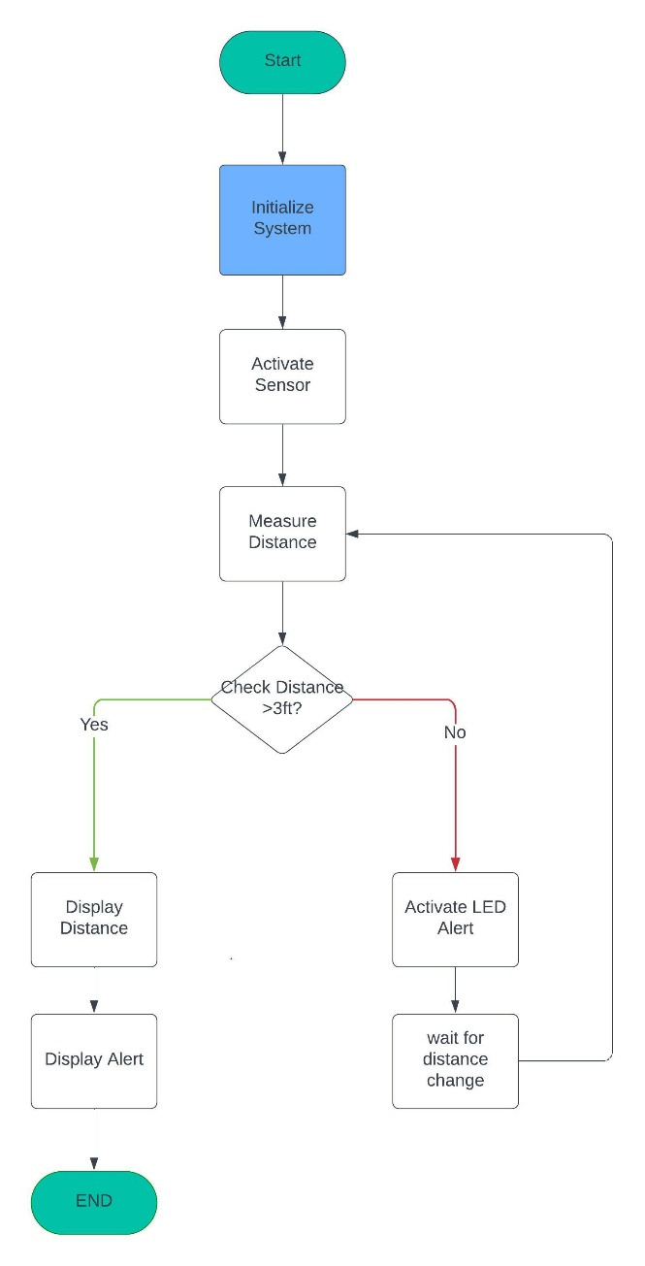

Based on the activities performed by the application the flow diagram to be made should look like this. This flowchart outlines the basic steps of the system, including initialization, sensor activation, distance measurement, checking if the distance is less than 3 feet, displaying the distance, activating the LED alert if necessary, and waiting for a change in distance before looping back to measure the distance again.

Block Diagram:

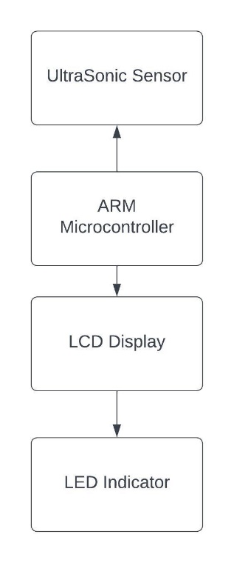

The "Proximity Detection Analyzer" technology uses an ultrasonic sensor to estimate the distance between automobiles, improving parking safety and ease. An ARM microcontroller processes this data and shows the distance in real time on an LCD panel. An LED indication alerts users if the distance is less than three feet, suggesting possible hazards. Immediate feedback is provided by this technological integration, guaranteeing safer and more effective parking in congested areas.

**Working Principle:**

The HC-SR04 Ultrasonic Distance/Ranging Sensor utilizes ultrasound to gauge the distance

to an object. Ultrasound, characterized by a frequency beyond the audible range (> 20 kHz),

forms the basis of its operation. With a detection range spanning 2 centimeters to 4 meters,

the HCSR04 module employs a 40 kHz ultrasound signal to measure the distance between

itself and any object within its field.

**Pinout:** In terms of pinout, the module features four pins: VCC (+5V), TRIG, ECHO, and

GND. Like SONAR, the ultrasonic sensor incorporates two transducers—one for transmitting

ultrasound and the other for receiving the echo. Distance calculation relies on the speed of

sound in the air, set at 343 m/s.

**Interfacing HC-SR04:**

1. The trigger pin is given a short pulse of 10us.

2. Upon receiving a trigger pulse, the HC-SR04 Module emits a burst of eight

ultrasonic pulses at 40 kHz.

3. Then, it outputs a HIGH for the time the sound waves take to reach back.

4. The duration of the high pulse is measured and subsequently utilized to

determine the distance.

**Circuit Diagram**

**Fig 2. Circuit Diagram: LPC1768 interfaced with HC-SR04 ultrasonic sensor, LEDs,**

**LCD, and buzzer, displaying the respective pin configurations.**

**Distance Measurement Calculations:**

The speed of sound in the air is typically 343 meters per second. To determine the distance

traveled by sound waves, we employ the formula: Distance traveled (DT) in centimeters

equals 0.00343 (mm/μs) multiplied by the time in microseconds (μs).

After obtaining the result in centimeters, we account for the round trip of the sound waves

by dividing the distance by 2. Therefore, the final formula is expressed as D = 0.0343 times

T/2 in centimeters.

In summary, this formula facilitates the calculation of the distance covered by a sound wave,

considering the speed of sound and the time taken for the sound to travel to a surface and

back. The division by 2 accommodates the round-trip nature of the distance. This method

is advantageous when measuring time in microseconds and expressing the distance in

centimeters.

**V. CODE**

#include <stdio.h>

#include <LPC17xx.h>

#include <string.h>

// Defining Constants

#define LED_Pinsel 0xff // P0.4-0.11 (LEDs)

#define TRIGGER_PIN (1 << 15) // P0.15 (Trigger Pin)

#define ECHO_PIN (1 << 16) // P0.16 (Echo Pin)

// Variable Declarations

char ans[20] = "";

int temp, temp1, temp2 = 0;

int flag = 0, flag_command=0;

int i, j, k, l, r, echoTime = 5000;

float distance = 0;

//Function Declarations

void lcd_wr(void);

void port_wr(void);

void delay(int r1);

void timer_start(void);

float timer_stop();

void timer_init(void);

void dealy_in_US(unsigned int microseconds);

void dealy_in_MS(unsigned int milliseconds);

void dealy_in_US(unsigned int microseconds){

LPC_TIM0->TCR = 0x02;

LPC_TIM0->PR = 0; // Set prescaler to the value of 0

LPC_TIM0->MR0 = microseconds - 1; // Set match register for 10us

LPC_TIM0->MCR = 0x01; // Interrupt on match

LPC_TIM0->TCR = 0x01; // Enable timer

while ((LPC_TIM0->IR & 0x01) == 0); // Wait for interrupt flag

LPC_TIM0->TCR = 0x00; // Stop the timer

LPC_TIM0->IR = 0x01; // Clear the interrupt flag

}

void dealy_in_MS(unsigned int milliseconds){ // Using Timer0{

dealy_in_US(milliseconds * 1000);

}

void timer_init(void){

// Timer for distance

LPC_TIM0->CTCR = 0x0;

LPC_TIM0->PR = 11999999; //To maintain 12Mhz as per specified for LPC 1768

LPC_TIM0->TCR = 0x02; // Reset Timer

}

void timer_start(void){

LPC_TIM0->TCR = 0x02; // Reset Timer

LPC_TIM0->TCR = 0x01; // Enable timer

}

float timer_stop(){

LPC_TIM0->TCR = 0x0;

return LPC_TIM0->TC;

}

void delay(int r1){

for (r = 0; r < r1; r++);

}

void port_wr(){

int j;

LPC_GPIO0->FIOPIN = temp2 << 23;

if (flag_command == 0){

LPC_GPIO0->FIOCLR = 1 << 27;

}

else{

LPC_GPIO0->FIOSET = 1 << 27;

}

LPC_GPIO0->FIOSET = 1 << 28;

for (j = 0; j < 50; j++);

LPC_GPIO0->FIOCLR = 1 << 28;

for (j = 0; j < 10000; j++);

}

void lcd_wr(){

temp2 = (temp1 >> 4) & 0xF;

port_wr();

temp2 = temp1 & 0xF;

port_wr();

}

// Main Program

int main(){

int ledflag = 0;

int command_init[] = {3, 3, 3, 2, 2, 0x01, 0x06, 0x0C, 0x80};

SystemInit();

SystemCoreClockUpdate();

timer_init();

LPC_PINCON->PINSEL0 &= 0xfffff00f; // Interface LEDs P0.4-P0.11

LPC_PINCON->PINSEL0 &= 0x3fffffff; // Interface TRIG P0.15

LPC_PINCON->PINSEL1 &= 0xfffffff0; // Interface ECHO P0.16

LPC_GPIO0->FIODIR |= TRIGGER_PIN | 1 << 22; // Direction for TRIGGER pin and Buzzer

LPC_GPIO1->FIODIR |= 0 << 16; // Direction for ECHO PIN

LPC_GPIO0->FIODIR |= LED_Pinsel << 4; // Direction for LED

LPC_PINCON->PINSEL1 |= 0;

LPC_GPIO0->FIODIR |= 0XF << 23 | 1 << 27 | 1 << 28; // Direction For LCDs

flag_command = 0;

for (i = 0; i < 9; i++){

temp1 = command_init[i];

lcd_wr();

for (j = 0; j < 30000; j++);

}

i = 0;

flag = 1;

LPC_GPIO0->FIOCLR |= TRIGGER_PIN;

while (1){

LPC_GPIO0->FIOSET = 0x00000800;

// Output 10us HIGH on the TRIGGER pin

LPC_GPIO0->FIOMASK = 0xFFFF7FFF;

LPC_GPIO0->FIOPIN |= TRIGGER_PIN;

dealy_in_US(10);

LPC_GPIO0->FIOCLR |= TRIGGER_PIN;

LPC_GPIO0->FIOMASK = 0x0;

while (!(LPC_GPIO0->FIOPIN & ECHO_PIN)){

// Wait till ECHO PIN becomes high

}

timer_start();

while (LPC_GPIO0->FIOPIN & ECHO_PIN); // Wait till ECHO PIN becomes low

echoTime = timer_stop(); // Store the time taken on stopping the timer

distance = (0.00343 * echoTime) / 2; //Calculations of Distance in cm

sprintf(ans, " Distance: %.3f", distance);

flag_command = 1;

i = 0;

flag_command = 0;

temp1 = 0x01;

lcd_wr();

flag_command = 1;

while (ans[i] != '\0'){

temp1 = ans[i];

lcd_wr();

for (j = 0; j < 300; j++);

i++;

}

if (distance < 7){

LPC_GPIO0->FIOSET = LED_Pinsel << 4;

LPC_GPIO0->FIOSET = 1 << 22;

}

else{

LPC_GPIO0->FIOCLR = LED_Pinsel << 4;

LPC_GPIO0->FIOCLR = 1 << 22;

}

delay(5000);}}

**VI. RESULTS**

When the ultrasonic sensor detects a distance > 7 inches (20cm), the system measures the distance between sensor and the object and displays it on the LCD screen, as depicted in Figure 3.

Conversely, when the detected distance is < 7 inches (20cm), the system promptly measures the distance and displays it on the LCD screen. Additionally, as an alert mechanism, the system initiates a continuous beeping sound from the buzzer as long as the object remains within this proximity.

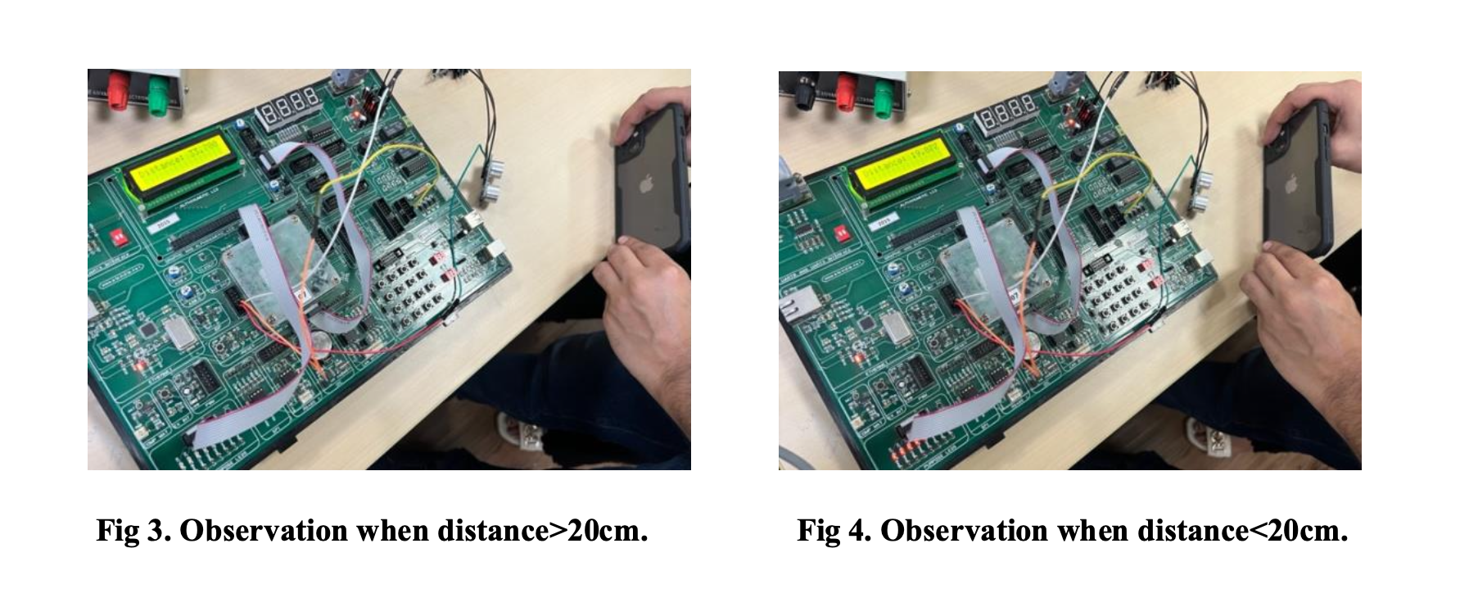

**VII. CONCLUSION**

The successful implementation of the "ParkSafe Proximity Monitor" project signifies a notable advancement in addressing the critical issue of secure and efficient parking in congested areas. Utilizing cutting-edge technology such as ARM microcontroller kits and ultrasonic sensors, the system offers real-time monitoring of parking distances, thereby enhancing safety for both vehicles and pedestrians.

With the incorporation of an intelligent LED alert system triggered by distances below the recommended safety threshold, the project proactively prevents potential collisions and vehicle damage. Its user-friendly interface, presented on the LCD screen of the ARM microcontroller kit, ensures drivers receive immediate feedback, promoting informed and safe parking practices.

The project's alignment with Sustainable Development Goal 11 underscores its commitment to fostering safer and more sustainable urban environments. By optimizing parking space utilization and reducing collision risks, the "Proximity Distance Analyzer" contributes to the development of resilient and secure cities.

In summary, the "Proximity Distance Analyzer" represents a significant leap in parking distance monitoring technology, offering a concrete solution to challenges associated with crowded parking scenarios. This innovation not only improves the overall parking experience but also diminishes the likelihood of minor vehicle damage, fostering a safer and more sustainable urban landscape for all.

**VIII. REFERENCES**

**[1]** Robocraze. (n.d.). What is Ultrasonic Sensor: Working Principle & Applications. No

Author info. Retrieved from https://robocraze.com/blogs/post/what-is-ultrasonic-sensor -

header-15

Referred on: 30th October, 2023

**[2]** Aliew, F. (2022). An Approach for Precise Distance Measuring Using Ultrasonic Sensors.

*Eng. Proc.*, *24*(1), 8. Retrieved from https://doi.org/10.3390/IECMA2022-12901

Referred on: 9th November, 2023

**[3]** Sahoo, Biren & Shahjad, & Tanwar, Prakash. (2021). Real-Time Smart Parking:

Challenges and Solution using Machine learning and IoT. International Journal of Scientific

Research in Computer Science, Engineering and Information Technology. 451-458.

10.32628/CSEIT217295.Retrived from https://doi.org/10.32628/CSEIT217295 Referred

on: 10th November, 2023