**RAM BANKING APPLICATION**

**PROJECT REPORT**

**BY:RAMPRASAD**

**TO:PRABHA MA’AM**



**CONTENTS**

**1.INTRODUCTION**

**2.SYSTEM ANALYSIS**

**3.FEASIBILITY ANALYSIS**

**4.HARDWARE CONFIGURATION**

**5.SOFTWARE CONFIGURATION**

**6.SYSTEM REQUIREMENT**

**7.DATA FLOW DIAGGRAM**

**8.SYSTEM DESIGN**

**9.FORMS USED**

**10.TABLE USED**

**11.AUTO GENERATED EMAIL**

**12.SYSTEM IMPLEMENTATION**

**13.SOFTWARE TESTING**

**14.CONCLUSION**

**INTRODUCTION**

Ram-Banking Application is a software which would be of great help to process secure banking with facilities of Withdrawing, Depositing. This software is built of the latest versions of both JAVA JDK AND JRE and is capable of running on any platform either 32 or 64 bit operating system/processor as application built on java are platform independent.

There are mainly five modules in this software

* Login
* Create Account
* Process Transaction
* Update Details
* Delete Account

In this Ram-Banking Application we can create a account by providing the following information Username ,Password ,Email ,Phone number, and after completion of the registration, a unique account id number is provided by which the account holder can login.

This software can be considered anti-theft and completely secure as a automatic algorithm keeps track of the invalid login against a account and if that count exceeds 3, a mail will be sent to the account stating the invalid logins issue. Therefore making full use of the database.

After logging in with the respective account id, the account holder can perform various types of transaction such a withdrawing, depositing.

This software provides user with the facility to update their account and the updatable fields are Username ,Password ,Email ,Phone number ,in the main transaction window after which the user will be directed to a new update details windows.

The account holder can also delete his/her account at any instance of time, therefore in terms of privacy ,security and accessibility this software is quite advanced.

There is a provision to logout from the account so that ,other users could re-login with their accounts.

**SYSTEM ANALYSIS**

**EXISTING SYSTEM:**

System Analysis is a detailed study of the various operations performed by a system and their relationships within and outside of the system. Here the key question is-what all problems exist in the present system? What must be done to solve the problem? Analysis begins when a user or manager begins a study of the program using existing system.

During analysis, data collected on the various files, decision points and transactions handled by the present system. The commonly used tools in the system are Data Flow Diagram, interviews, etc. Training, experience and common sense are required for collection of relevant information needed to develop the system. The success of the system depends largely on how clearly the problem is defined, thoroughly investigated and properly carried out through the choice of solution. A good analysis model should provide not only the mechanisms of problem understanding but also the frame work of the solution. Thus it should be studied thoroughly by collecting data about the system. Then the proposed system should be analysed thoroughly in accordance with the needs.

System analysis can be categorized into four parts.

* System planning and initial investigation
* Information Gathering
* Applying analysis tools for structured analysis
* Feasibility study
* Cost/ Benefit analysis

In this existing system a new user can create his account by providing necessary details and then by the provided account id ,he/she can use it to login to their account and their conduct transaction such a withdrawing and depositing, users can also update their details, options to delete the account is also provided.

Advantages in the current system :-

1.User friendly

2.Account security

3.Users Privacy

4.Full use of database

5.Platform independent.

6.Can run on 32,64 bit Processors and operating system.

But in the current system there are some features lacking such as a user can only conduct transaction with his account only, he cannot transfer amount to his another account or other account. And a dedicated help windows or interface is lacking, which also include the forums, YouTube channel, blogs which can be used for user education of this software. Where the users can better know the software and also file complaint, and developers can report bugs and error in the software. Through YouTube channel use can better know the interface and get their doubts clarified.

This system only security options are password and the auto trigger system, but to make this software more secure we could use biometrics to enhance the security..

All these can be added into the software as future updates/versions by the proposed system.

**PROPOSED SYSTEM**

The proposed system is very useful for the company as well as the end user as well as bankers. As this enables them with more exposure to the latest features and makes the transaction more secure and helps fill up all the deficiency in the existing system here is how:-

1. Biometrics like iris, heartbeat, finger print scanner can be used to make transaction more secure.
2. Blogs, Youtube channels, Forum can be created to enable user to get their clarified, report the users with latest advances, enable the developers to report bugs and error to the development team ,and a common forum where users can get answers to their question, and a in built software help windows.
3. Transaction across two or more accounts.
4. Better GUI(Graphical User Interface) to make the software look and feel better.
5. More user friendly
6. Less bugs/errors
7. Faster access to database and better use of it.
8. Better implantation in ATM’S, Malls, Bankers Computer and for Online Banking.
9. Quick transaction

There the future of the project lies in the implementation of the exiting system and for that to happen and for the software to be used in the real world banking the clauses in the proposed system have to be adopted and should be regularly updated and strive to make the software more better and user friendly.

**FEASIBILITY ANALYSIS**

Whatever we think need not be feasible .It is wise to think about the feasibility of any problem we undertake. Feasibility is the study of impact, which happens in the organization by the development of a system. The impact can be either positive or negative. When the positives nominate the negatives, then the system is considered feasible. Here the feasibility study can be performed in two ways such as technical feasibility and Economical Feasibility.

**Technical Feasibility:**

We can strongly says that it is technically feasible, since there will not be much difficulty in getting required resources for the development and maintaining the system as well. All the resources needed for the development of the software as well as the maintenance of the same is available in the organization here we are utilizing the resources which are available already.

As this application is built on java therefore developers need not spend additional time and energy to create the same application for another platform, the same application can run on all platform running JAVA 2 Runtime Environment. And that time can be used to improve the application. As this application is built on java it does not need any installation except that the machine is running a runtime environment. Therefore this application is very technically feasible.

**Economical Feasibility**

Development of this application is highly economically feasible .The organization needed not spend much money for the development of the system already available. The only thing is to be done is making an environment for the development with an effective supervision. I f we are doing so , we can attain the maximum usability of the corresponding resources .Even after the development , the organization will not be in a condition to invest more in the organization .

As stated above this application can run on all platform, therefore developers need not develop another instance of the same application ,therefore the company need not pay the developers for developing another instance of the application ,therefore this application is Economically feasible.

**HARDWARE CONFIGURATION**

**Processor : Intel i7 Quadcore @2.7 GHz**

**RAM : 6 GB**

**Hard Disk : 1TB**

**Monitor : 1336x720 16M Color**

**Keyboard : Microsoft Wireless 2000**

**SOFTWARE CONFIGURATION**

**Operating System : Windows XP**

**Windows Vista**

**Windows 7**

**Windows 8,8.1**

**Language : JAVA SE**

**JDK Version : 1.7**

**JRE Version : 1.7**

**IDE : NetBeans 8.0**

**Database : Apache Derby**

**SYSTEM REQUIREMENT**

This Banking Application can run on 32 bit as well as 64 bit processors and platform such as Windows XP ,Windows Vista ,Windows 7,Windows 8.,8.1,Mac OSx,and other platforms running Java 2 Runtime Environment. Therefore this software is platform independent, but both the Java SE Development Kit (JDK) and Java SE Runtime Environment (JRE) require at minimum a Pentium 2 266 MHz processor.

**Disk Space Requirements**

|  |  |
| --- | --- |
| **Disk Space Requirements for JRE** | |
| **JRE** | **Installed Image** |
| Java Runtime Environment, including JavaFX Runtime | 124 MB |
| Java Update | 2 MB |

|  |  |
| --- | --- |
| **Disk Space Requirements for JDK** | |
| **JDK** | **Installed Image** |
| Development Tools, including JavaFX SDK | 245 MB |
| Source Code | 27 MB |
| Public Java Runtime Environment | See the table, "Disk Space Requirements for JRE" |

* The JDK features available for 64-bit platforms are the same as those for Windows 32-bit operating systems.
* The disk requirement for development tools for 64-bit platforms is 181 MB. The disk space requirements for source code and the public JRE are the same as those for Windows 32-bit operating systems, except for the JavaFX SDK (68 MB) and the JavaFX runtime (32 MB).

**Memory Requirements**

|  |  |
| --- | --- |
| **Version** | **Memory** |
| Windows 8 | 128 MB |
| Windows 7 | 128 MB |
| Windows Vista | 128 MB |
| Windows Server 2008 | 128 MB |

**Note**: The minimum physical RAM is required to run graphically based applications. More RAM is recommended for applets running within a browser using the Java Plug-in. Running with less memory may cause disk swapping, which has a severe effect on performance. Very large programs may require more RAM for adequate performance.

**DATA FLOW DIAGRAM**

**Context Diagram**

System

Database

User

* **Level 1**

Login

Create Account

Bank

(Database)

Process Transaction

Update Account

Delete Account

**SYSTEM DESIGN**

**INPUT DESIGN**

Input design is the process of converting user-oriented input to a computer based format. Input design is a part of overall system design, which requires very careful attention .Often the collection of input data is the most expensive part of the system. The main objectives of the input design are :-

1. Produce cost effective method of input

2. Achieve highest possible level of accuracy

3. Ensure that the input is acceptable to and understood by the staff. Input Data

The goal of designing input data is to make entry easy, logical and free from errors as possible. The entering data entry operators need to know the allocated space for each field; field sequence and which must match with that in the source document. The format in which the data fields are entered should be given in the input form .Here data entry is online; it makes use of processor that accepts commands and data from the operator through a key board. The input required is analysed by the processor. It is then accepted or rejected. Input stages include the following processes

* Data Recording
* Data Transcription
* Data Conversion
* Data Verification
* Data Control
* Data Transmission
* Data Correction

One of the aims of the system analyst must be to select data capture method and devices, which reduce the number of stages so as to reduce both the changes of errors and the cost .Input types, can be characterized as.

* External
* Internal
* Operational
* Computerized
* Interactive

Input files can exist in document form before being input to the computer. Input design is rather complex since it involves procedures for capturing data as well as inputting it to the computer.

**OUTPUT DESIGN**

Outputs from computer systems are required primarily to communicate the results of processing to users. They are also used to provide a permanent copy of these result for latter consultation .Computer output is the most important and direct source of information to the users. Designing computer output should proceed in an organized well through out the manner. The right output must be available for the people who find the system easy o use. The outputs have been defined during the logical design stage. If not, they should defined at the beginning of the output designing terms of types of output connect, format, response etc.

Various types of outputs are

* External outputs
* Internal outputs
* Operational outputs
* Interactive outputs
* Turn around outputs

**DATABASE DESIGN**

The general theme behind a database is to handle information as an integrated whole. A database is a collection of interrelated data stored with minimum redundancy to serve many users quickly and effectively. After designing input and output, the analyst must concentrate on database design or how data should be organized around user requirements. The general objective is to make information access, easy quick, inexpensive and flexible for other users. During database design the following objectives are concerned:-

* Controlled Redundancy
* Data independence
* Accurate and integrating
* More information at low cost
* Recovery from failure
* Privacy and secure
* Performance
* Ease of learning and use

**FRAMES USED**

**Login**

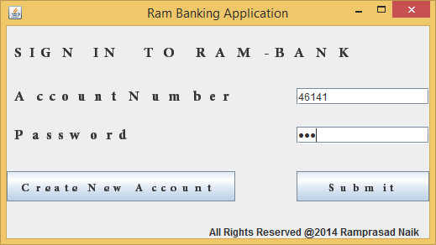

**Create Account**

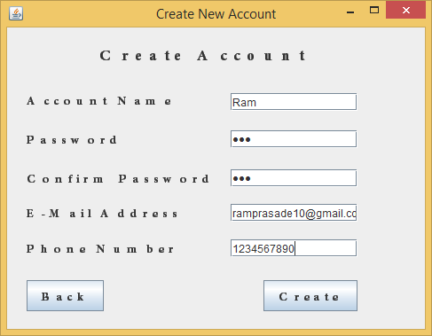

**Process Transaction**

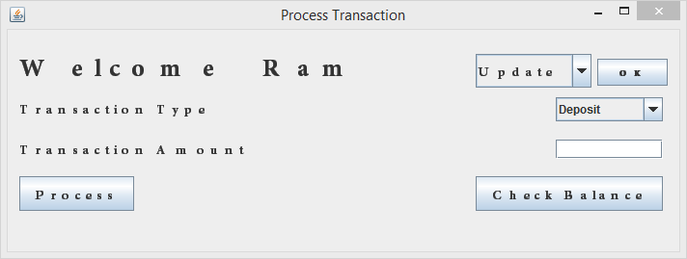

**Deposit Amount**

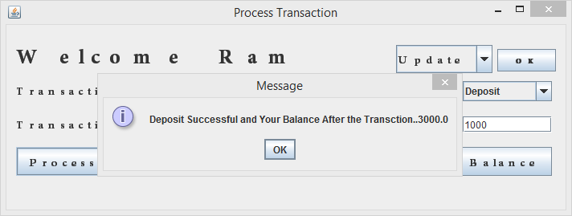

**Withdraw Amount**

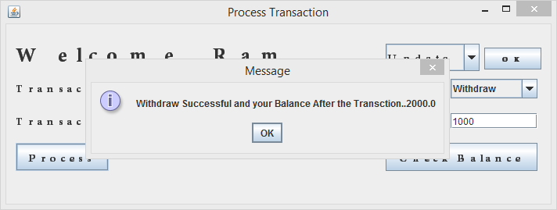

**Update details**

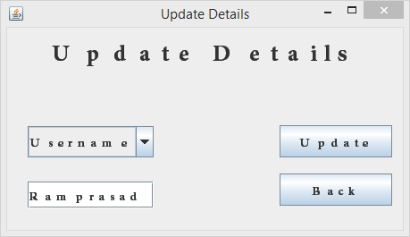

**TABLE USED**

|  |  |  |  |
| --- | --- | --- | --- |
| **Field Name** | **Data Type** | **Size** | **Key** |
| Account ID | NUMERIC | 10 | Primary |
| Username | VARCHAR | 20 | - |
| Password | VARCHAR | 20 | - |
| E-mail | VARCHAR | 30 | - |
| Phone Number | NUMERIC | 10 | - |
| Balance | DOUBLE | 52 | - |

**AUTO GENERATED EMAIL**

Software security and user’s security is a big concern this software has a auto trigger system built into the interface ,where 3 invalid logins made against a account triggers the system and the system fetches the account id’s mail address and sends a mail warning them about the 3 invalid logins. Therefore making full use of the database

Here is an snapshot the mail sent after 3 invalid logins:-

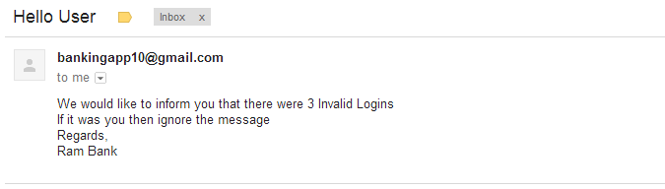

This feature has been made available in the software by the **MAIL API** provided by Oracle Inc.

The API is a free set of bundles of methods and constructors built for adding mailing capabilities to our java programs by using the necessary methods, constructors, and other important details such as mail address ,port number, smtp address ,etc.

The following API can be downloaded free of cost by the following link

http://www.oracle.com/technetwork/java/javamail/javamail-138606.html

Specifications used to achieve this task are:-

Incoming Mail (POP3) Server - Requires SSL:

pop.gmail.com

Use SSL: Yes

Port: 995

Outgoing Mail (SMTP) Server - Requires TLS or SSL

smtp.gmail.com

Port: 465 or 587

Requires SSL: Yes

Requires authentication: Yes

**SYSTEM IMPLEMENTATION**

Implementation is the stage in the project where the theoretical design is turned into a working system. The implementation phase constructs, installs and operates the new system. The most crucial stage in achieving a new successful system is that it will work efficiently and effectively.

There are several activities involved while implementing a new project. They are

* End user training
* End user Education
* Training on the application software
* System Design
* Parallel Run And To New System
* Post implementation Review

And this software can be put into great use in:

* Online Banking
* Bankers Computer
* ATMS’S
* Instant checkouts in malls
* Stand alone application in computer to conduct transaction.

**End user Training:**

The successful implementation of the new system will purely upon the involvement of the Bankers working in that department. The Bankers will be imparted the necessary training on the new technology.

As the bank managers and the development team with the employees shall hold a joint meeting over the advances in the system and system to brief them of the latest features.

**End User Education:**

The education of the end user start after the implementation and testing is over. When the system is found to be more difficult to under stand and complex, more effort is put to educate the end used to make them aware of the system, giving them lectures about the new system and providing them necessary documents and materials about how the system can do this.

For doing this the company can set up **Youtube channels** where users can understand the interface and working of the software in a better manner by seeing videos, and can get their doubts clarified by posting it in the comments field.

They can also setup **Blogs** the users can be notifies of the latest advances in the software for example a important feature that could be added such as transfer of amount from one account to another can be posted in the blog or removal of some outdated features can be added here.

The most important of all is the feedback, error debugging, complaint lodging, and help and support all this can be achieved by forming a new forum where users can post their question and get answers either by the development team or other fellow users, uses should also be able to give their feedback on the software on the user friendly nature ,user interface, etc. And developers should also be able to report any outstanding bugs or errors to the developers team so as to make the software better. And through this forum users should also be able to report any feature that they would like in the software in the future versions.

A help window would help the user to get quick response and answers to some of the FAQ, and commonly asked questions.

**Training of application software:**

After providing the necessary basic training on the computer awareness, the users will have to be trained upon the new system such as the screen flows and screen design type of help on the screen, type of errors while entering the data, the corresponding validation check at each entry and the way to correct the data entered. It should then cover information needed by the specific user or group to use the system.

**Post Implementation View:**

The department is planning a method to know the states of the past implementation process. For that regular meeting will be arranged by the concerned officers about the implementation problem and success. So as to improve the performance of the software, and make it much better.

**SOFTWARE TESTING**

Is the menu bar displayed in the appropriate contested some system related features included either in menus or tools? Do pull —Down menu operation and Tool-bars work properly? Are all menu function and pull down sub function properly listed ?; Is it possible to invoke each menu function using a logical assumptions that if all parts of the system are correct, the goal will be successfully achieved .? In adequate testing or non-testing will leads to errors that may appear few months later.

This create two problem

1. Time delay between the cause and appearance of the problem.

2. The effect of the system errors on files and records within the system

The purpose of the system testing is to consider all the likely variations to which it will be suggested and push the systems to limits.

The testing process focuses on the logical intervals of the software ensuring that all statements have been tested and on functional interval is conducting tests to uncover errors and ensure that defined input will produce actual results that agree with the required results. Program level testing, modules level testing integrated and carried out.

There are two major type of testing they are

1. White Box Testing.

2. Black Box Testing.

**White Box Testing**

White box some times called "Glass box testing" is a test case design uses the control structure of the procedural design to drive test case.

Using white box testing methods, the following tests where made on the system

a) All independent paths within a module have been exercised once. In our system, ensuring that case was selected and executed checked all case structures. The bugs that were prevailing in some part of the code where fixed

b) All logical decisions were checked for the truth and falsity of the values. Black box Testing

Black box testing focuses on the functional requirements of the software. This is black box testing enables the software engineering to derive a set of input conditions that will fully exercise all functional requirements for a program. Black box testing is not an alternative to white box testing rather it is complementary approach that is likely to uncover a different class of errors that white box methods like..

* Interface errors
* Performance in data structure
* Performance errors
* Initializing and termination errors

**CONCLUSION**

This project is a attempt to satisfy all the needs for safe and secure banking. Several codes have been adopted and suggestions from websites like stackoverflow. This software is a powerful package for a banking employee, ATMS’s ,etc satisfying both the company and the end user in all terms ,database usage, security ,privacy.

This software can be used in various places like ATM’s ,bankers computer and also in online banking. But without constant updating and debugging of all errors and bugs this package would be incomplete and to do the same several terms and clauses have to adopted which have listed in the proposed system. And by all that will this be fit to be used in practical world and be of a great use to banking for now and in future.

This project would be incomplete without thanking all the elements that helped me to complete this project which include valuable suggestion of Prabha ma’am, several websites like oracle, stackoverflow and their fellow members, and finally the almighty **GOD**.

**BIBLIOGRAPHY**

1. JDK:http://www.oracle.com/technetwork/java/javase/downloads/index.html?ssSourceSiteId=otnjp
2. JRE:http://www.oracle.com/technetwork/java/javase/downloads/jre7-downloads-1880261.html
3. Minimum requirement:http://docs.oracle.com/javase/7/docs/webnotes/install/windows/windows-system-requirements.html
4. JDBC Guide: http://www.javatpoint.com/jdbc-tutorial
5. Sample Mail program:crunchify.com/java-mailapi-example-send-an-email-via-gmail-smtp/
6. Java Mail API:http://www.oracle.com/technetwork/java/javamail/javamail-138606.html
7. Queries and debugging: http://stackoverflow.com/