**1. Write a Blog on Difference between HTTP1.1 vs HTTP2**

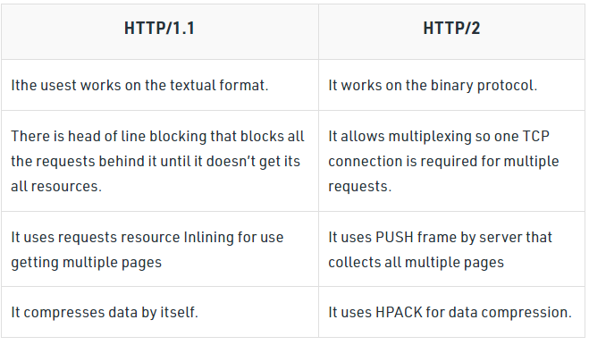

HTTP stands for hypertext transfer protocol & it is used in client-server communication. By using HTTP user sends the request to the server & the server sends the response to the user. There are several stages of development of HTTP but we will focus mainly on HTTP/1.1 which was created in 1997 & the new one is HTTP/2 which was created in 2015.

**HTTP/1.1:** For better understanding, let’s assume the situation when you make a request to the server for the geeksforgeeks.html page & server responds to you as a resource geeksforgeeks.html page. before sending the request and the response there is a TCP connection established between client & server. again you make a request to the server for image img.jpg & the server gives a response as an image img.jpg. the connection was not lost here after the first request because we add a keep-alive header which is the part of the request so there is an open connection between the server & client. there is a persistent connection which means several requests & responses are merged in a single connection. These are the drawbacks that lead to the creation of HTTP/2: The first problem is HTTP/1.1 transfer all the requests & responses in the plain text message form. The second one is head of line blocking in which TCP connection is blocked all other requests until the response does not receive. all the information related to the header file is repeated in every request.

**HTTP/2:** HTTP/2 was developed over the SPDY protocol. HTTP/2 works on the binary framing layer instead of textual that converts all the messages in binary format. it works on fully multiplexed that is one TCP connection is used for multiple requests. HTTP/2 uses HPACK which is used to split data from header. it compresses the header. The server sends all the other files like CSS & JS without the request of the client using the PUSH frame.

**2 .Write a Blog about Objects and its Internal Representation in Javascript?**

Objects, in JavaScript, is it’s most important data-type and forms the building blocks for modern JavaScript. These objects are quite different from JavaScript’s primitive data-types(Number, String, Boolean, null, undefined and symbol) in the sense that while these primitive data-types all store a single value each (depending on their types).

Objects are more complex and each object may contain any combination of these primitive data-types as well as reference data-types.  
An object, is a reference data type. Variables that are assigned a reference value are given a reference or a pointer to that value. That reference or pointer points to the location in memory where the object is stored. The variables don’t actually store the value.

Loosely speaking, objects in JavaScript may be defined as an unordered collection of related data, of primitive or reference types, in the form of “key: value” pairs. These keys can be variables or functions and are called properties and methods, respectively, in the context of an object.  
An object can be created with figure brackets {…} with an optional list of properties. A property is a “key: value” pair, where a key is a string (also called a “property name”), and value can be anything.