What is a Memory Leak in Java?
when objects are no longer being used by the application, but the Garbage Collector is unable to remove them from working memory – because they’re still being referenced. As a result, the application consumes more and more resources – which eventually leads to a fatal OutOfMemoryError.
For a better understanding of the concept, here’s a simple visual representation:
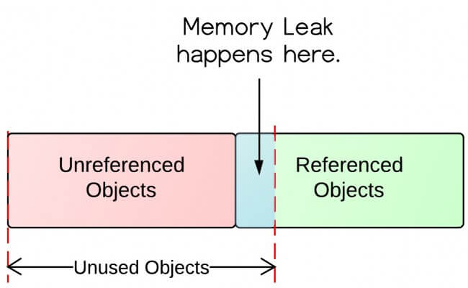

Note: We can specify the initial and maximum heap size for the application. There are the two parameters (options) for setting up the heap size:
- -Xms<size>m
- -Xmx<size>m

Preventing Memory Leak
While writing code, remember the following points that prevent the memory leak in Java.
- Do not create unnecessary objects.
- Avoid String Concatenation.
- Use String Builder.
- Do not store a massive amount of data in the session.
- Time out the session when no longer used.
- Do not use the System.gc() method.
- Avoid the use of static objects. Because they live for the entire life of the application, by default. So, it is better to set the reference to null, explicitly.
- Always close the ResultSet, Statements, and Connection objects in the finally block.

PermGen | MetaSpace
It is removed from java 8. | It is introduced in Java 8.
PermGen always has a fixed maximum size. | Metaspace by default auto increases its size depending on the underlying OS.
Contiguous Java Heap Memory. | Native Memory(provided by underlying OS).
Inefficient garbage collection. | Efficient garbage collection.

