|  |
| --- |
| Riverhawk Café |
| Mile Stone 3 |
| [Document subtitle] |

|  |
| --- |
| - Ramrasik Raman |

**Systems Analysis and Design Milestone II Grade Sheet**

Project Title: __________________________________________________________________

# Students: _____________________________________________________________________

|  |  |
| --- | --- |
| _____ 1.0 | Data Flow Diagrams |
|  | _____ 1.1 Context Diagram |
|  | _____ 1.2 Level-0 Diagram |
|  | _____ 1.3 Leveled Diagrams |
|  | _____ 1.3.1 Naming standard for process (Action Verb + Noun Phrases) |
|  | _____ 1.3.2 Naming standard for data flow |
|  | _____ 1.3.3 Data consistence for data flows |
|  | _____ 1.3.4 Data conservation for data flows |
|  | _____ 1.3.5 Data consistence for data stores |
|  | _____ 1.3.6 Data conservation for data stores |
|  | _____ 1.3.7 Data miracle and black hole |
| _____ 2.0 | Entity Relationship Diagrams |
|  | _____ 3.1 Entity related to data store in DFD |
|  | _____ 3.2 Entity related to data flow in DFD |
|  | _____ 3.3 Relationships clearly defined |
|  | _____ 3.4 Cardinalities clearly defined |
|  | _____ 3.5 Primary key clearly defined |
|  | _____ 3.6 Attributes appropriately defined |
| _____ 3.0 | Data Dictionary |
|  | _____ 4.1 Entities specified in ER diagrams |
|  | _____ 4.2 Attributes related to entity |
|  | _____ 4.3 Data type clearly defined. |
|  | _____ 4.4 Data length clearly defined |
|  | _____ 4.5 Domain value clearly defined |
| _____ 4.0 | Milestone II Report (in ONE Word file) submitted to the Blackboard |

# Note: ________________________________________________________________________

_______________________________________________________________________

1. **Data Flow Diagram**

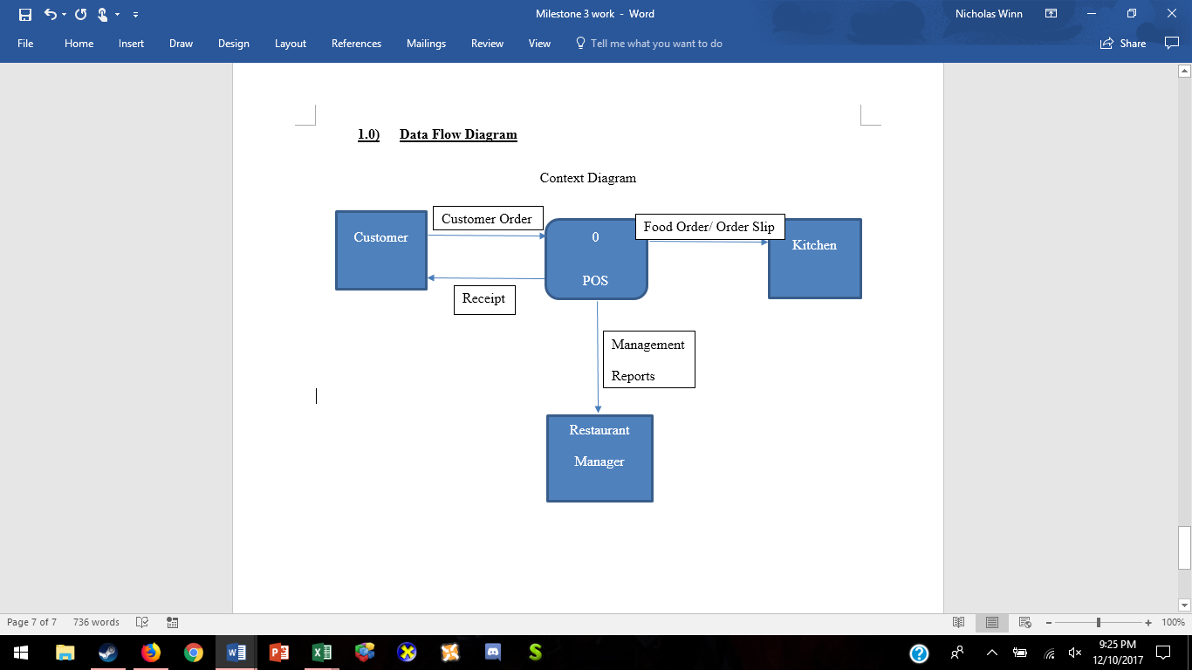

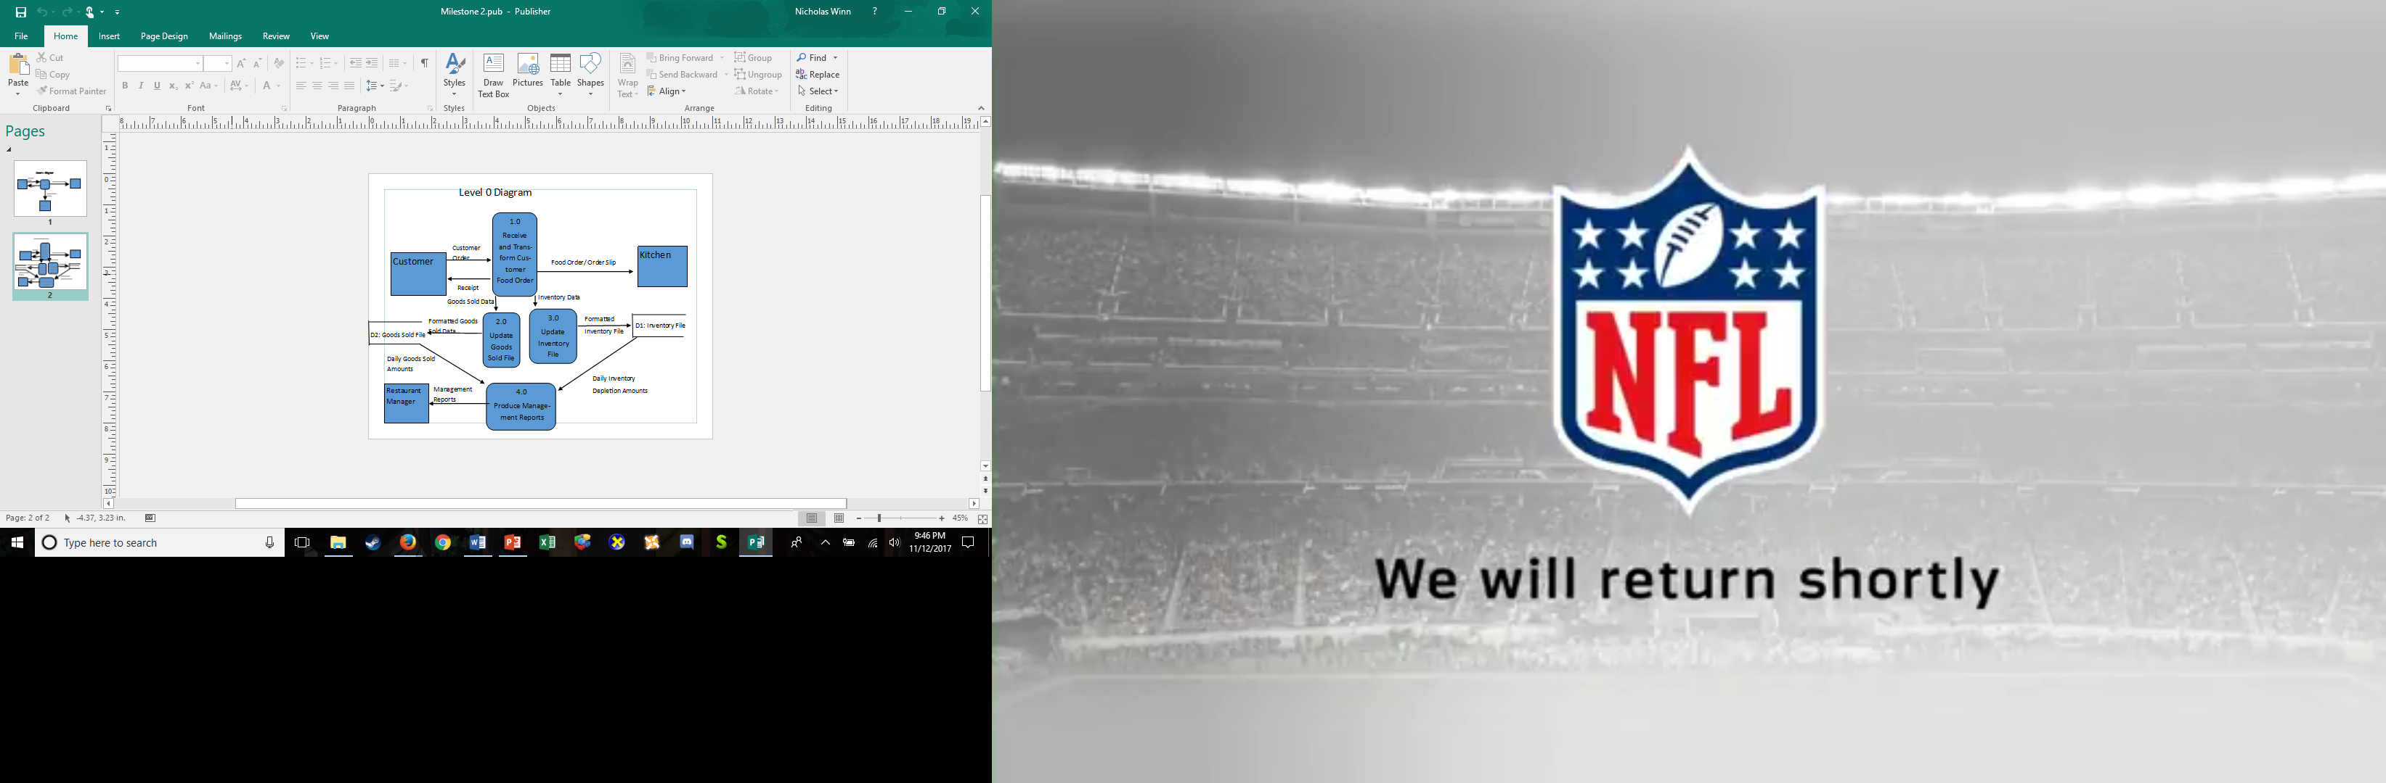

1. **Entity Relationship Diagram**

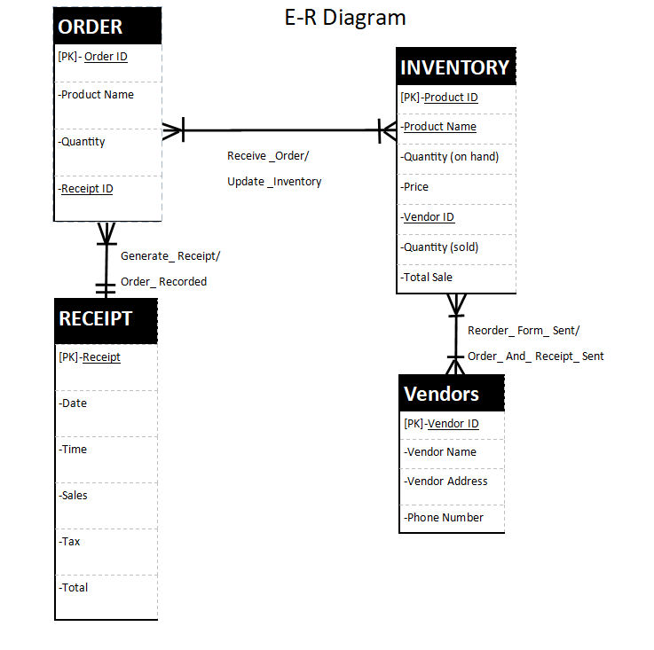

1. **Data Dictionary**

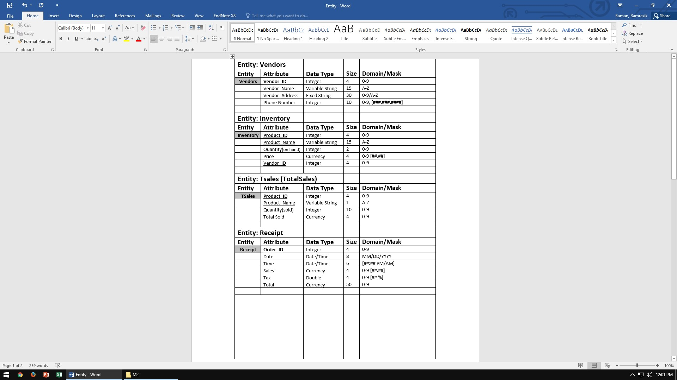

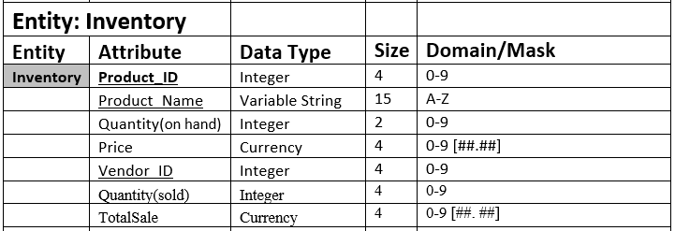

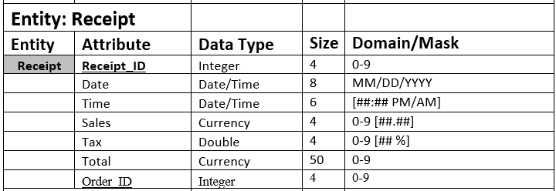

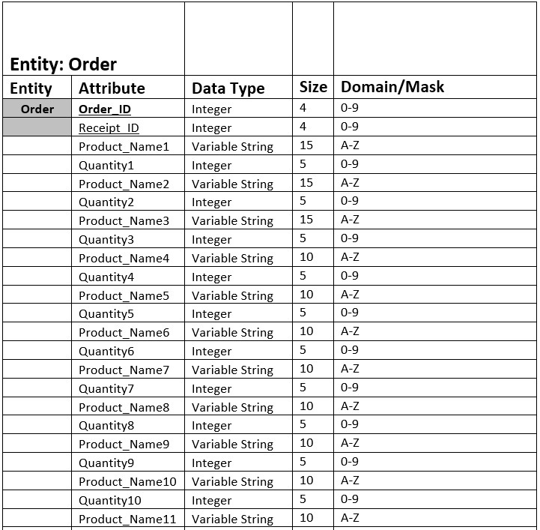



**Milestone 3:**

**__ 1.0 Form and Report Designs**

**__­_ 1.1 Specifications-deliverables and outcomes**

|  |
| --- |
| 1.1.1A Narrative overview  Form: Print Receipt  Users: Employee  Task: Record customer order as Receipt ID including order quantity, date, time, and amount total. Then the receipt is printed for customer viewing.  System: Microsoft Windows  Environment: River Hawk Cafe |
| 1.1.2A Sample Design  Inserting image... |
| 1.1.3A Testing and Usability Assessment    User-Rated Perceptions (Average 15 Users):  Consistency [1 = consistent and 5 = inconsistent]: 1.66  Sufficiency [1 = sufficient and 5 = insufficient]: 1.23  Accuracy [1 = Accurate and 5 = inaccurate]: 1.68 |

|  |
| --- |
| 1.1.1B Narrative overview  Form: Total Sales  Users: All Employees and Management  Task: Display each product sold for the day and the revenue generated from each product followed by a sum of all numbers equaling the Total Sales for the day.  System: Microsoft Windows  Environment: River Hawk Cafe |
| 1.1.2B Sample Design  Inserting image... |
| 1.1.3B Testing and Usability Assessment    User-Rated Perceptions (Average 15 Users):  Consistency [1 = consistent and 5 = inconsistent]: 1.20  Sufficiency [1 = sufficient and 5 = insufficient]: 1.73  Accuracy [1 = Accurate and 5 = inaccurate]: 1.57 |

|  |
| --- |
| 1.1.1C Narrative overview  Form: Most Sold Item  Users: All Employees and Management  Task: Display each item along with quantity of the item sold for the day/week. User will then identify the item with the highest quantity sold.  System: Microsoft Windows  Environment: River Hawk Cafe |
| 1.1.2C Sample Design  Inserting image... |
| 1.1.3C Testing and Usability Assessment    User-Rated Perceptions (Average 15 Users):  Consistency [1 = consistent and 5 = inconsistent]: 1.41  Sufficiency [1 = sufficient and 5 = insufficient]: 1.11  Accuracy [1 = Accurate and 5 = inaccurate]: 1.10 |

|  |
| --- |
| 1.1.1D Narrative overview  Form:  Users:  Task:  System: Microsoft Windows  Environment: River Hawk Cafe |
| 1.1.2D Sample Design |
| 1.1.3D Testing and Usability Assessment    User-Rated Perceptions (Average 15 Users):  Consistency [1 = consistent and 5 = inconsistent]: 1.20  Sufficiency [1 = sufficient and 5 = insufficient]: 1.55  Accuracy [1 = Accurate and 5 = inaccurate]: 1.51 |

|  |
| --- |
| 1.1.1E Narrative overview  Form:  Users: All Employees and Management  Task:  System: Microsoft Windows  Environment: River Hawk Cafe |
| 1.1.2E Sample Design |
| 1.1.3E Testing and Usability Assessment    User-Rated Perceptions (Average 15 Users):  Consistency [1 = consistent and 5 = inconsistent]: 1.99  Sufficiency [1 = sufficient and 5 = insufficient]: 1.56  Accuracy [1 = Accurate and 5 = inaccurate]: 1.57 |

____ **2.0 Interface and Dialogue Designs**

**____ 2.1 Specifications-deliverables and outcomes**

|  |
| --- |
| 2.1.1A Narrative overview  Form: Main Menu  Users: All employees and management  Task: Sends employees to User Form1, the main POS part of the system, to do normal work. This includes inputting orders for customers. Sends managers to the management part of the system.  System: Microsoft Windows  Environment: River Hawk Cafe |
| 2.1.2A Sample Design |
| 2.1.3A Testing and Usability Assessment    User-Rated Perceptions (Average 15 Users):  Consistency [1 = consistent and 5 = inconsistent]: 1.75  Sufficiency [1 = sufficient and 5 = insufficient]: 1.36  Accuracy [1 = Accurate and 5 = inaccurate]: 1.53 |

|  |
| --- |
| 2.1.1B Narrative overview  Form: Management  Users: Members of the management team.  Task: Allows management to view sales information, vendor information, and product information. The main inventory control part of the system.  System: Microsoft Windows  Environment: River Hawk Café |
| 2.1.2B Sample Design |
| 2.1.3B Testing and Usability Assessment    User-Rated Perceptions (Average 15 Users):  Consistency [1 = consistent and 5 = inconsistent]: 1.28  Sufficiency [1 = sufficient and 5 = insufficient]: 1.62  Accuracy [1 = Accurate and 5 = inaccurate]: 1.49 |

|  |
| --- |
| 2.1.1C Narrative overview  Form: User Form1  Users: Employees  Task: Allows employees to take customers’ order, adds the total price of order for customer to pay. The main POS part of the system.  System: Microsoft Windows  Environment: River Hawk Café |
| 2.1.2C Sample Design |
| 2.1.3C Testing and Usability Assessment    User-Rated Perceptions (Average 15 Users):  Consistency [1 = consistent and 5 = inconsistent]: 1.93  Sufficiency [1 = sufficient and 5 = insufficient]: 1.71  Accuracy [1 = Accurate and 5 = inaccurate]: 1.24 |

**____ 2.2 Guidelines**

**____ 2.2.1 Structure data entry fields**

|  |  |
| --- | --- |
| Entry | Do not request data that can be computed or already available; do not request data on form if it can be retrieved from database |
| Defaults | Provide default values when needed; example: use standard product price unless order is customized |
| Units | Clearly identify units for each data type; example: money in dollars, weight in pounds or ounces |
| Replacement | Use character replacement when needed |
| Captioning | Place a caption next to fields when necessary |
| Format | Provide formatting examples when necessary; example: dollar signs and decimal points when dealing with money |
| Justify | Automatically justify entries; numbers right justified and aligned on decimal points, text left justified |
| Help | Provide help to user when needed; provide hot key that sends user to help system that provides basic help information for the system |

**____ 2.2.2 Control data input**

|  |  |
| --- | --- |
| Class or Composition | Ensure data is of proper type; e.g., numbers are numeric values, alphabetic are alphanumeric |
| Combination | Ensure value combinations make sense; e.g., does quantity sold value make sense for product |
| Expected Values | Ensure data amounts are what would be expected with inputs |
| Missing Data | Ensure data has been input in areas that needs data; e.g., is there a quantity |
| Pictures/Templates | Ensure data conforms to standard format |
| Range | Ensure data conforms to proper range; |
| Reasonableness | Ensure data are reasonable for each situation |
| Self-checking Digits | Technique by which extra digits are added to numeric field |
| Size | Test for too few or too many digits |
| Values | Ensure values are from standard set of values |

**____ 2.2.3 Provide feedback**

**____ 2.2.3.1 Status information**

System will show user that their inputs have been accepted while it is calculating to display outputs. When performing an especially large calculation system will display that it is working while the user waits for the output.

**____ 2.2.3.2 Prompting cues**

When system is ready for input by users it will show a display saying so. It will have different prompting cues depending on what the user is being prompted to input.

**____ 2.2.3.3 Error and warning messages**

Error messages are written in a way that the average user will be able to understand. The message tries to guide user to what they should input in this situation. It appears in same format and area each time so that they are recognized as an error message.

**____ 2.2.4 Provide help and online assistance**

|  |  |
| --- | --- |
| Simplify | System will use short wording and use few technical terms so average user will not become confused. |
| Organize | Make system organized so users can quickly and easily find information. |
| Show | Give examples so every possible scenario is covered in the help section. |

**____2.2.5 Design the Dialogue Sequence Diagram**

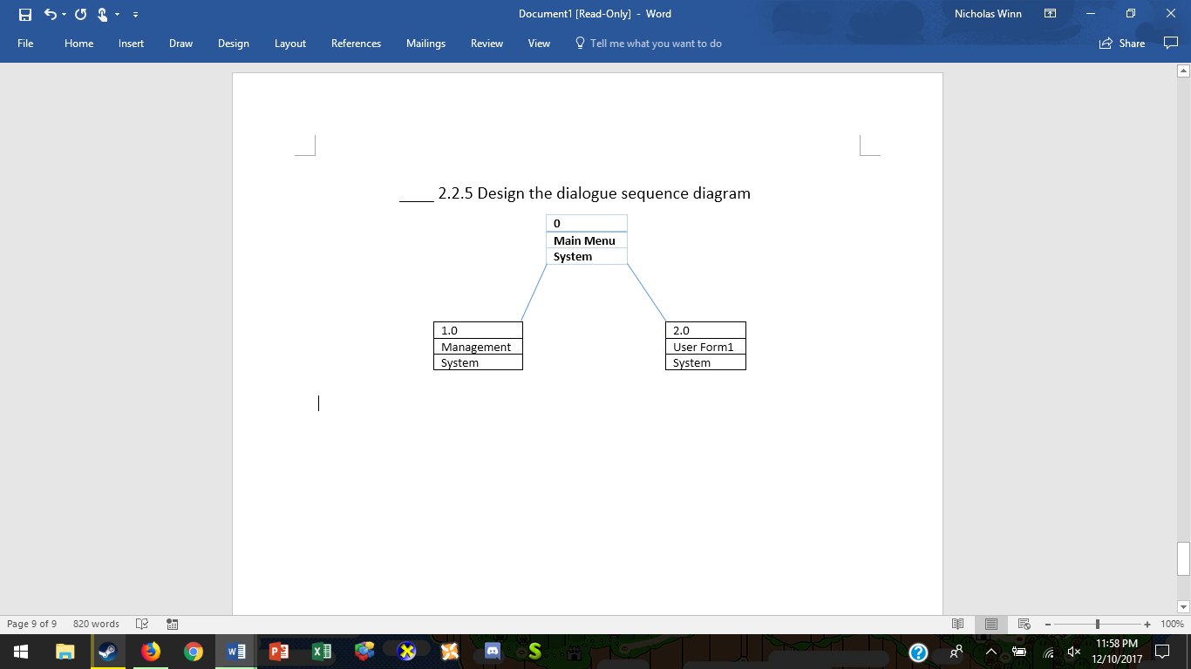

____3.0 System Completed

______4.0 Documentation

_____4.1 User Manual, User Reference, User Training Materials

User Manual: The first interface to pop up is RiverHawkCafe: Main. There are two buttons: either employee or manager and each will require a password.

If you hit employee button the main RiverHawkCafe:POS will pop up. This is the interface where the employee will take the customer order. Each button represents an inventory item/order and once clicked it will generate a count of how many each item is ordered/clicked and display to a label next to it. Once the order is taken the total button will calculate the order price without tax. If a button or item is clicked and the item is not in the inventory an error message will pop up alerting the user that the item is not in stock. Once the Pay Bill button is selected the employee will tell the price the order total, the employee will also be prompted a cash amount to calculate change. A message box will be brought up to notify the employee of the amount of change to give back to the customer. This button will also update Quantity (on Hand), Quantity (Sold) which will simultaneously update the TotalSales and the Inventory table. This will also generate a customer receipt. Once all this is done it will reset all the data to be ready for the next order. If the customer wants to change their order the employee can hit the reset button to reset the inventory to retake the order.

If the employee hits the second button in the RiverHawkCafe:Main, which is management, once the password is entered the Management form will pop up, which allows this to only be viewed by managers. This form has three frames, Sales, Vendors, and Products. The Sales frame contains two buttons, a report for Total Sales, and a report for Most Items Sold. The Vendor frame has two buttons, a report for View Vendors, and a form for Add Vendors. The Product frame has two buttons, a report to View Products, and a form to Add Products.

_____4.2 System Documents-Technical Report, Maintenance Manual

Technical Report: Before we make the system live we have had the system go through Alpha and Beta stages. We have had end-users test out the system so we can make the system as user-friendly as possible and make the system applicable to our needs. We have also made the system into both a POS System and an inventory management system

Maintenance Manual: Maintenance after launch is extremely important for this type of system. For the first six months of the system's life we will do maintenance once a month. This will include cleaning the system and making sure we have enough storage in the system. After six months we will be performing maintenance every two months or as needed, ensuring that the system remains user friendly. We will also increase the storage in the system when needed, and update the features of the system to suit our future needs.