**Systems Analysis and Design Milestone I Grade Sheet**

Project Name: The River Hawk Café

Group Members: Ramrasik Raman

____ 1.0 System Planning and Selection

____ 1.1 Service Request Form

____ 1.2 Scenario

____ 1.2.1 Describing the project scope

____ 1.2.2 Describing the project alternatives

____ 1.2.3 Describing the project feasibility

____ 1.2.3.1 Economic feasibility

____ 1.2.3.2 Operational feasibility

____ 1.2.3.3 Technical feasibility

____ 1.2.3.4 Schedule feasibility

____ 1.2.3.5 Legal and contractual feasibility

____ 1.2.3.6 Political feasibility

____ 1.3 Dividing the project into manageable tasks (Gantt/PERT)

____ 1.4 Estimating tangible costs and benefits and creating a resource plan

____ 1.5 Developing a preliminary plan and a preliminary budget

____ 1.6 Developing a communication plan

____ 1.7 Determining project standards and procedures

____ 1.8 Identifying and assessing risk

____ 1.9 Setting up a Baseline Project Plan

____ 1.10 Preparing a project scope statement

____ 2.0 User Requirements

____ 3.0 Systems Requirements

____ 4.0 Digital Files of Milestone I (in ONE Word file)

Note: **________________________________________________________________________**

**River Hawk Café**

*System Service Request*

REQUESTED BY Ramrasik Raman, DATE__9/24/2017___________

DEPARTMENT Purchasing, Inventory______________________________________________

LOCATION Headquarters,143__________________________________________________

CONTACT Tel- (978) 876-7335 Fax: (978)345-1234 e-mail: riverhawk@cafe.com

TYPE OF REQUEST URGENCY

[X]New System [ ] Immediate—Operations is impaired or opportunity lost

[ ] System Enhancement [ ] Problem exists, but can be worked around

[ ] System Error Correction [ X ] Business losses can be tolerated until new system

Installed

PROBLEM STATEMENT

A retail point of sale(POS) system is needed for the new River Hawk Café on campus. This POS system will not only work as a cash register but will also track items purchased, keep a running tab of our inventory in stock, reports on high demand items, and a noted area to list our supplier’s contacts information. We have decided to create this system for the Cafe our self in order to ensure the specific requirements are met, and to avoid extra costs of hiring someone or purchasing a premade software.

SERVICE REQUEST

We request a new system to be created specifically tailored to our new Café needs. This system will track orders placed and create a high demand product reports. This system will also have a menu for the Cafe, in which it will store/track orders by every customer, and calculate their total bill with the printed receipt for the customers. A computer or hand-held tablet will be used to run this system.

IS LIAISON ____________________________

SPONSOR DR CHEN__________________________ _______________________________

------------------------ TO BE COMPLETED BY SYSTEMS PRIORITY BOARD ------------------

[ ] Request approved

Assigned to __________________________

Start date_____________________________

[ ] Recommended revision

[ ] Suggest User Development

[ ] Reject for reason _____________________________________________________________

**Scenario (1.2):**

The Rive Hack Café is a new Café opening on January 1st of 2018. The café will be located on north campus ran by three individuals, Ramrasik Raman, Nicholas Winn and Jamie Vengren who recently graduated from UMASS Lowell. River Hawk Café will have a traditional café style inventory which include items such as various types of coffees, teas and different bakery goods. For coffee, which we specialize in, we will offer three different style, a traditional drip, french press, vacuum pot, either can be served on ice as well. We will also offer a classic expresso/americano, macchiato, latte, cappuccino, mocha and then an option to add an extra shot. We will also be offering a wide variety of teas such as green, jasmine, oolong, cardamom, black etc. Our bakery will be limited to only a few items, bagels, pastries, muffins, biscotto, hot oatmeal. In order to be successful, we know that we need a successful system designed catered to our specific needs; to track and process information in an orderly fashion. The system for our store will need the following components:

Point of Sale System (POS)

Inventory

Suppliers & Contact Info

Purchase price/Selling prices

Percent Profit

Customer Receipt

**Project Scope (1.2.1):**

The opportunities that the system provides include: a traditional point of sale system, an update date modern, easy to work with interface to take customer orders and provide a receipt. Some extra features our system will have are, manageable ways to track inventory, and orders, full supplier contact list with contact information, formulas for calculating necessary reorder points and profit margins. The results that will come from the new system will be an easy to work with, modern, point of sale system (customer orders and receipt) with an effective way to track information within the organization and a reliable way to track inventory/orders, and profits. To keep costs low, we, Ramrasik Raman, Nicholas Winn and Jamie Vengren have decided to execute and create above system ourselves. Success of the system will be measured by the efficiency, and accuracy that it is able to provide.

**Project Alternatives (1.2.2):**

**A)** We could hire a bunch of professionals and pay them to make the system for us.

**Advantages:** We could have the system made to our requirements.

We would not have to make the system ourselves therefore saving us that much time.

**Disadvantages**: We would have to pay them money to make our system. It can also cost more to be specific to our requirements.

**B)** We could buy a pre- made system that is already being used in the market.

**Advantages:** No hassle. Pre-made, usually error free, would cost less than hiring professionals and not very time consuming.

**Disadvantages:** Cannot be made to our specific needs.

**Alternate Decision:**

As our system is a very generic system (Point of Sale), we would easily be able to find a software that’s already out there and will fit our needs. And hence choose option B as our alternative solution. important data available when needed in an organized fashion. The system will be completed, once we are able to track, place, and receive customer orders, supplier contact information is updated, quantity of items on hand are known, MIN/MAX reorder points are set, and finally a formula is created to calculate profit/losses. Once we are able to create a project workbook and successfully use our system to track all the above listed components our system will be complete.

**Project Feasibility (1.2.3):**

**____ 1.2.3.1 Economic feasibility** 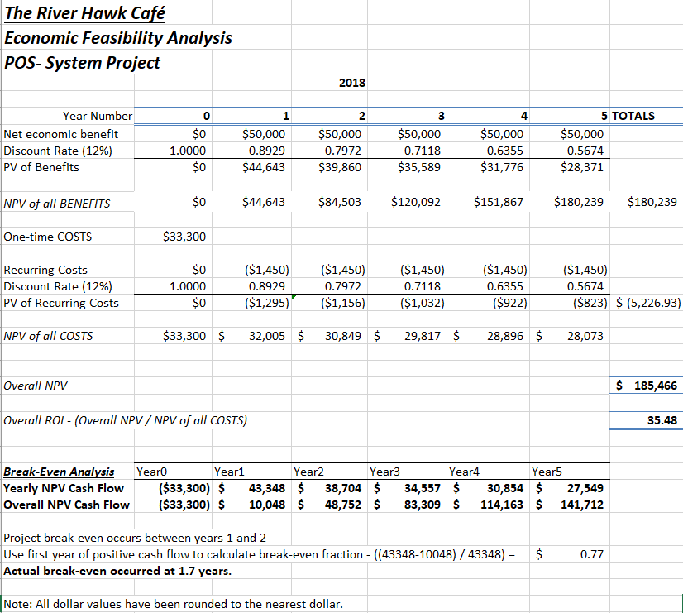

**____ 1.2.3.2 Operational feasibility**

The new POS system that we will be creating will help solve the of not having a POS system. The system will enable the employees to take orders quickly to ensure that our service is quick and up to industry standards.

**____ 1.2.3.3 Technical feasibility**

The system is a standard POS system that is not overly complex in design. The three managers are all well versed in information technology and have experience with these types of systems. Therefore, the organization will be able to construct the system in a timely fashion without any errors in the system.

**____ 1.2.3.4 Schedule feasibility**

The project is scheduled to take less than 3 months to complete, while the café itself is scheduled to open over a month after the system will be completed. This allows a long enough period of time for any delays in the project. The schedule is flexible enough to handle any delays that might arise.

**____ 1.2.3.5 Legal and contractual feasibility**

The legal ramifications of the new system are very unlikely to arise. As long as the system doesn't directly copy an existing system there won't be any legal trouble regarding the system. The contractual ramifications include having people who are already employed by our company do more in order to develop the system, so no new contracts will be developed.

**____ 1.2.3.6 Political feasibility**

Key stakeholders would like the project that is being proposed. This is because the system is being worked on by people who already have experience doing the work and the company doesn't have to spend extra money hiring out another firm to do the work, decreasing the time of the project and the overall cost.

**1.3 Dividing the project into manageable tasks (Gantt/PERT)**

**Task:**

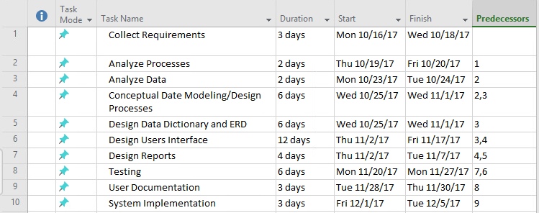

**Gantt Chart:**

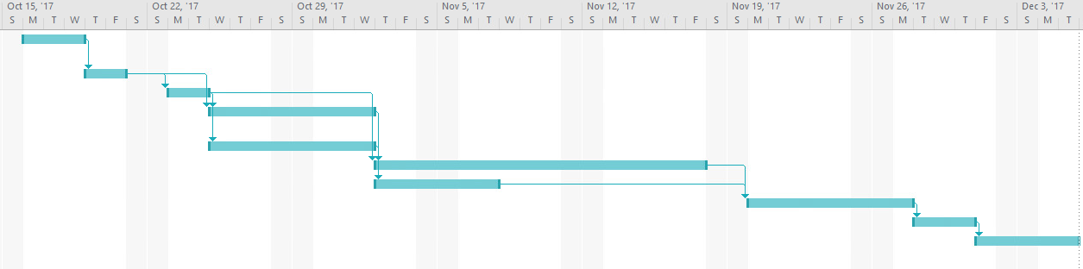

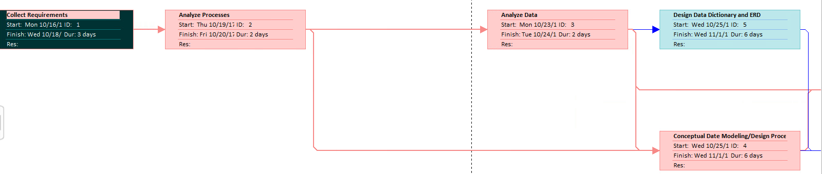

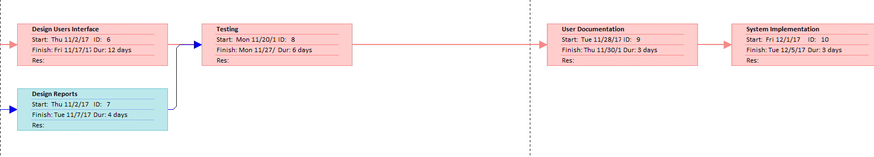

**PERT (Program Evaluation Review Technique):**

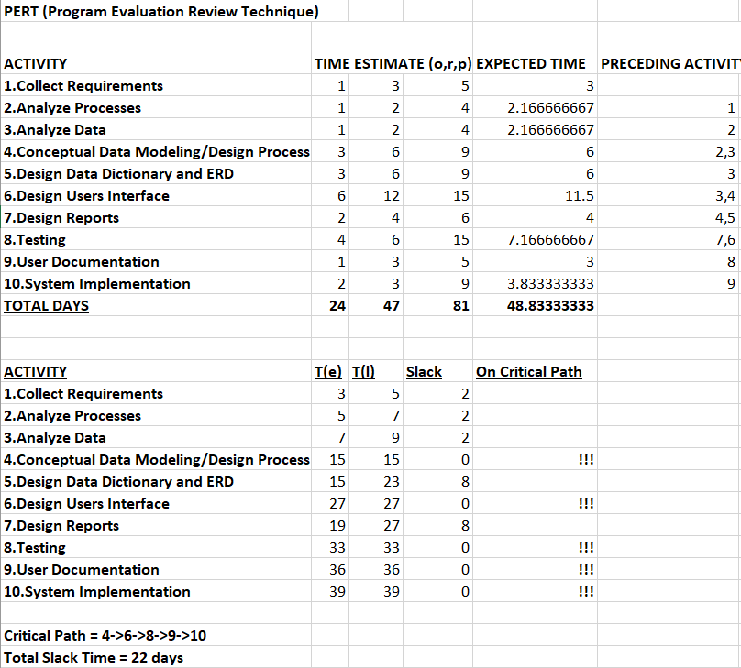

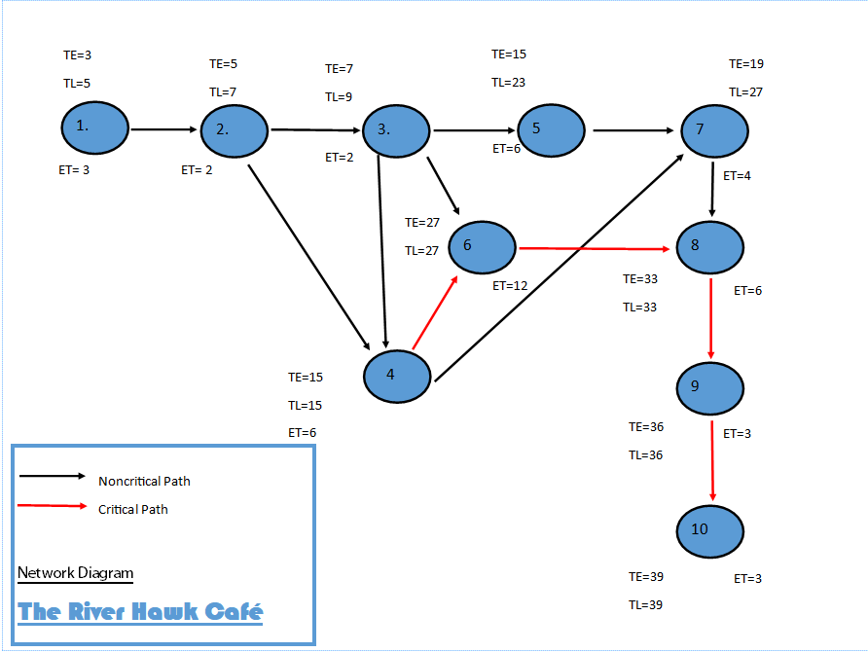

**1.4 Estimating tangible costs and benefits and creating a resource plan**

**TANGIBLE BENEFITS: 1-5 Years**

Cost reduction or avoidance- $4000

Error Reduction- $1000

Increased Flexibility- $1000

Increased speed of activity- $5000

Improvement in Management planning or control- $10000

Lower Labor cost- $4000

TOTAL: **$24,000**

**____________________________________________________________**

**ONE TIME COST: 0 Years**

Development cost- $30000

New Hardware- $3000

New (purchased) software:

Packaged application software- $0

Other- $0

User Training- $200

Site Preparation- $100

Other- $0

TOTAL: **33,300**

___________________________________________________________

**RECURRING COST: 1-5 Years**

Application software maintenance- $1000

Incremental data storage required ( 25 GB )- $50

Incremental Communication- $0

New software or hardware leases- $300

Supplies- $100

Other- $0

TOTAL: **$1,450**

**1.5 Developing a preliminary plan and a preliminary budget**

**Preliminary Plan:**

Our team's target start date for the project is Monday 10/16/17, starting with collecting requirements for the operations, this process will last 3 days. After this the team will begin analyzing processes and analyzing data, each task will last 2 days respectively. Then starting Wednesday 10/25/17, the team will simultaneously begin on conceptual date modeling as well as designing the data dictionary and ERD, both tasks will accumulate 6 days. Following these two tasks are two more beginning on Thursday 11/2/17, it will take our team 12 days to design the users interface and during this time we will also be designing our reports which will only take 4 days but testing cannot begin until our users interface is completed. Our team will then spend the next 6 days testing the system for errors. The next 3 days followed by testing will consist of user documentation. Finally we plan to begin the implementation of the system starting Friday 12/1/17 and ending the following Tuesday 12/5/17. Therefore our preliminary schedule estimates this project should last about a month and a half (10/16/17 - 12/5/17) before the River Hawk Café is ready for business.

**Preliminary Budget:**

The cost of development, new hardware, user training, and site preparation will result in a ONE TIME COST of $33,000.

The RECURRING COST to maintain this new system including, application software maintenance, incremental data storage, software or hardware leases, and misc. supplies totals $1,450.

After the implementation of the system we can expect certain TANGLIBLE BENEFITS including cost reduction or avoidance, error reduction, increased flexibility, increase speed of activity, improvement in management planning or control, and lower labor costs resulting in a $24,000 profit. This means that the company can expect to see positive profits during its second year in business with an estimated break even point of 1.7 years in business.

**1.6 Developing a communication plan**

A thorough schedule of opening tasks will be provided to each team member. Each member will be responsible for sending a formal completion notice of their tasks along with a weekly status report. Along with updates on project milestones, team members will also have a private project board to clarify any issues and to coordinate everyone's work with theirs. Employee training will be documented upon completion by team members. Updates on project progression will be provided by team members to the UML Management via email weekly. The following Project Communication Matrix will be provided to summarize out communications plan:

|  |  |  |  |  |
| --- | --- | --- | --- | --- |
| Stakeholder | Document | Format | Team Contact | Date Due |
| Team Members | Project Status Report | Project Intranet + Email | Ram  Nick  Jamie | Every Friday |
| Team Members | Implementation and Training Plan for Employees | Digital Copy + Hard Copy | Ram  Nick  Jamie | December 16th, 2017 |
| Customer | Feedback Review | Hard Copy | Ram  Nick  Jamie | Collected every Friday |
| Team Members | Project Status report | Email | UML Management | Every Friday |

**1.7 Determining project standards and procedures**

Standards and Procedures for Team Performance:

Team members are responsible for holding themselves to a high standard of professionalism during all aspects of working on the project and during any involvement with the company.

Standards and Procedures for Cost/Schedule Management:

Team members will monitor all aspects of the project thoroughly as well as review and record inventory to provide the most effective cost/schedule analysis.

Standards and Procedures for Data Management:

Team members will provide accurate data in an accessible format and respect the confidentiality of the companies’ information along with customer profiles.

Standards and Procedures for Quality Management:

Team members will conduct walk-throughs, audits and inspections, reviews of handling and storing, and come up with procedures for eliminating any problems periodically.

**1.8 Identifying and assessing risk**

Competition: Being one of the many local café's for students on campus, there will always be the aspect of losing revenue to similar competitors. (I.e. Dunking Donuts, Starbucks, etc.)

Accessibility: Due to the amount of construction UMASS Lowell is undergoing, there may be issues with low customer traffic as a result of certain walkways and normal class routes being blocked off.

New Worker Inexperience: Although our POS system is a generally user friendly software, local workers such as college students might be inexperienced in using our system and could result in some user-error related issues.

Seasonal Revenue: When the university is on break from classes there will be less customers during the summer months as well as a few weeks in winter. Meaning the decline of revenue during these times will need to be expected and accounted for.

**1.9 Setting up a Baseline Project Plan**

Introduction

1. This project is needed to create the POS system that our café will use. Every restaurant uses as system similar to what we will be creating, so it is a very necessary system for our company to use during daily functions. The system is justified in its creation, is extremely feasible in all facets, has very low resource requirements, and a very flexible schedule.
2. It is recommended that this project is started quickly so that any delays can use the extra time that there will be in the event of any delays.

System Description

1. Alternative systems would be any system that is currently sold on to other cafes and restaurants.
2. The inputs into the system will be what item each customer is ordering. The system will then take the dollar amount that goes with each item that has been selected and will add that to the bill. The system will then total that information for the bill that the customer will receive.

Feasibility Assessment

1. This project is economically feasible for two reasons. The first reason is that it will break-even at only 1.7 years, which is fairly short for a project like this. The second reason is because the project would be far more expensive if we bought the pre-made software from another company, or if we hired another company to customize software for our company for use. Creating the system ourselves is cheaper and just as, if not more, effective than any other alternative.
2. The relevant technical risk factors are risk factors that every system encounters. These include bugs in the code that have to be reprogrammed and computer crashes that are usually solved by simple reboots.
3. The proposed system solves the issue of taking orders and being able to store them on a computer. The system will drastically enhance the day-to-day activities of the organization and will allow employees to take and process orders faster than they would be able to is they had to do everything by hand.
4. There are no legal issues as long as the system is not stolen code or and other form of copying or stealing.
5. Key stakeholders within the organization will like the proposed system because it will speed up the ability to process orders and is a less expensive version of something that would otherwise be bought or produced at a more expensive price than what this project will cost.
6. The proposed project will take roughly a month and a half to complete and will be faster to complete than a system that is custom made by an outside company, but longer than a system that is already produced by another company.

Management Issues

1. The team members are all equal and major decisions will be made by the majority. The team members will report to each other based on what they have done on the project thus far and meeting will be held to discuss who will do what specifically due to everyone being able to fulfill every role.
2. Members of the team will communicate through email, phone, and face to face, depending on the two parties are willing to do.
3. We will make a prototype of the system for employees to try before the finishing touches are put onto the system to be used by the company. The employees will then provide feedback to us any changes will be made to the system based on the comments and suggestions by the employees.
4. No other relevant issues have been discovered during the planning period.

**1.10 Preparing a project scope statement**

**The River Hawk Café Prepared By: Nick Winn**

**Project Scope Statement** Date: October 9,2017

**General Project Information**

Project Name: The River Hawk Café

Sponsor: Dr. Chen

Project Manager: Ramrasik Raman

**Problem/Opportunity Statement:**

The café will be opening in four months and it needs a POS system in order to process order in a timely manner. A POS system will enable our company to shorten lines and lessen the wait time for customers which will make customers far more likely to leave happier.

**Project Objective:**

To supply our employees with a system that will make their jobs, and ability to provide customer service easier. The system will be customized to suite the exact wants and needs of our employees

**Project Description:**

A new POS system will be constructed based on the recommendations and requests of our employees. The system will take orders, add total bill amount, and display the orders of customers. The project will span a month and a half and will be very inexpensive due to the experience of current employees.

**Project Benefits:**

Increased customer service speed

Easier to use POS system for employees to use

**Project Deliverables:**

A customized POS system

Training for using the system

**Estimated Project Duration:**

1.5 months

**2.0 User Requirements**

A student at The University of Massachusetts Lowell.

Basic Computer Skills.

Customer Service with a smile.

**3.0 System Requirements**

**Hardware Requirement:**

Processor: - Intel ® Core ™ i5 -4510U CPU 2.00GHz 2.60 GHz

RAM: - 8.00 GB (7.89 GB usable)

Hard Disk: -20 GB or above.

Touch Screen Monitor: - 14” LCD.

Mouse.

Receipt Printer: To print customer receipt.

Printer: - To print reports.

**Software Requirement:**

Operating system: - Windows 10.

Microsoft Office:

Front End: - Visual Basic 6.0. (Professional Edition.)

Back end: - MS. Access.

(Some additional feature of VB like, Dtagrind, Data-Report)

**4.0 END**