|  |
| --- |
| University of Massachusetts Lowell |
| River Hawk Cafe |
| Point of Sale System: Milestone 2 |

|  |
| --- |
| - Ramrasik Raman |

**Systems Analysis and Design Milestone II Grade Sheet**

Project Title: __________________________________________________________________

# Students: _____________________________________________________________________

|  |  |
| --- | --- |
| _____ 1.0 | Data Flow Diagrams |
|  | _____ 1.1 Context Diagram |
|  | _____ 1.2 Level-0 Diagram |
|  | _____ 1.3 Leveled Diagrams |
|  | _____ 1.3.1 Naming standard for process (Action Verb + Noun Phrases) |
|  | _____ 1.3.2 Naming standard for data flow |
|  | _____ 1.3.3 Data consistence for data flows |
|  | _____ 1.3.4 Data conservation for data flows |
|  | _____ 1.3.5 Data consistence for data stores |
|  | _____ 1.3.6 Data conservation for data stores |
|  | _____ 1.3.7 Data miracle and black hole |
| _____ 2.0 | Entity Relationship Diagrams |
|  | _____ 3.1 Entity related to data store in DFD |
|  | _____ 3.2 Entity related to data flow in DFD |
|  | _____ 3.3 Relationships clearly defined |
|  | _____ 3.4 Cardinalities clearly defined |
|  | _____ 3.5 Primary key clearly defined |
|  | _____ 3.6 Attributes appropriately defined |
| _____ 3.0 | Data Dictionary |
|  | _____ 4.1 Entities specified in ER diagrams |
|  | _____ 4.2 Attributes related to entity |
|  | _____ 4.3 Data type clearly defined. |
|  | _____ 4.4 Data length clearly defined |
|  | _____ 4.5 Domain value clearly defined |
| _____ 4.0 | Milestone II Report (in ONE Word file) submitted to the Blackboard |

# Note: ________________________________________________________________________

_______________________________________________________________________

1. **Data Flow Diagram**

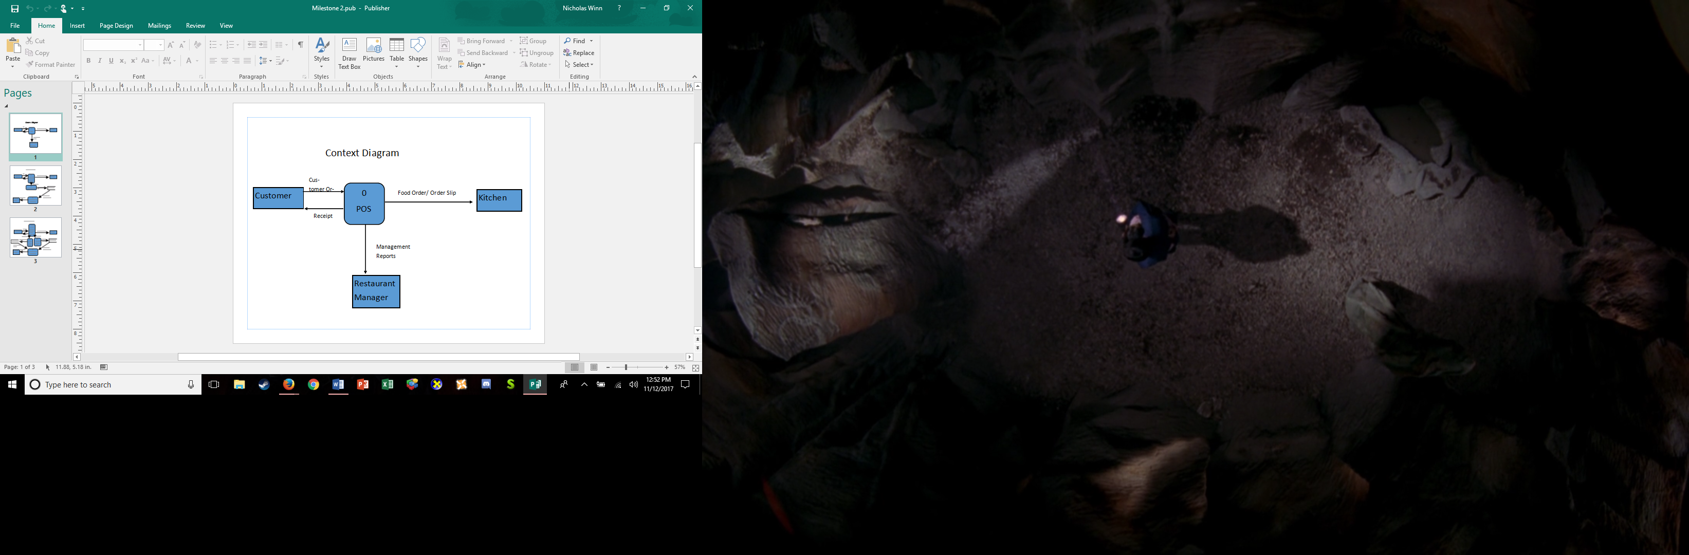

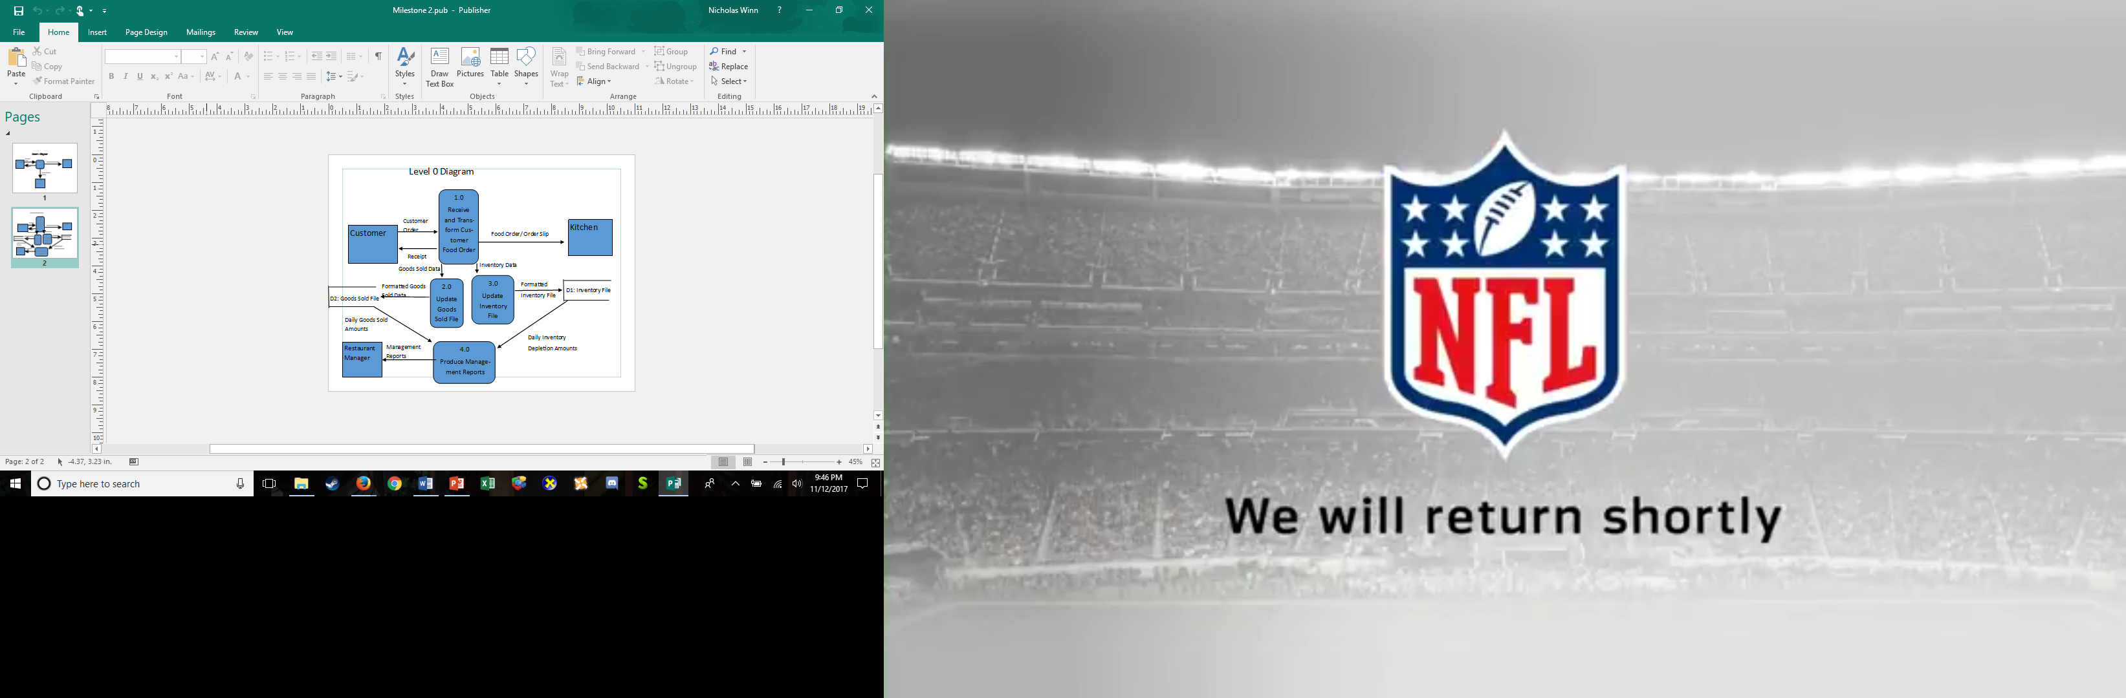

1. **Entity Relationship Diagram**

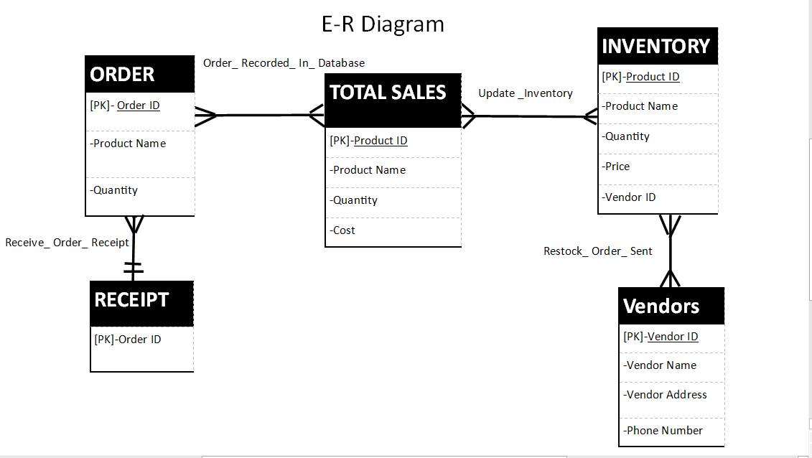

1. **Data Dictionary**

