Please design and code an inventory system. Please do the following:

- Design and implement API layer to model and support the below requirements. You do not need to develop a UI, unless it helps you.
[Rams] – ok, I am developing this as a C# class library which will be the API layer
- In memory data structure is okay (no database code needed)
[Rams] – I will use Dictionary class with the item class as elements – serves as in memory db here.

- Write tests
[Rams] – will do.

- Please write production-quality code and provide a runnable solution (at least from tests as entry points)
[Rams] – yes – it will be runnable from the unit test app and I should have test to exhibit and validate all the expected behaviors

- Provide a README file with instructions on how to run your application, as well as brief documentation about your design, code structure, assumptions, reasoning, and any notes you want to add for extensibility, maintainability, security, performance, etc, that you don't have time to implement.
[Rams] - I plan on providing this as it may need to be further enhanced with ‘Inversion of control’ pattern to keep it maintainable.

- Please post your solution on GitHub. We will may ask questions and/or comment in your code as part of code review.
[Rams] – will do.

- Feel free to email me questions or send me descriptions of your understand of the requirements for clarification/validation or if you want me to look over your initial design.

[Rams] – Please see my initial class library design as below with the above assumptions.
Let me know if you have any feedback on the design/notes so far. I’ll go ahead with coding the API and tests and send it to you soon.

Thanks
-Rams@outlook.com
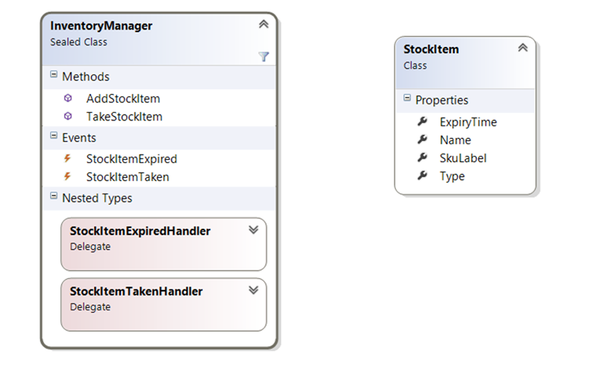

Requirements
1. Add an item to the inventory:
When I add a new item to the inventory
Then inventory contains information about the newly added item, such as Label, Expiration, Type.

2. Take an item from the inventory by Label:
When I took an item out from the inventory
Then the item is no longer in the inventory

3. Notification that an item has been taken out:
When I took an item out from the inventory
Then there is a notification that an item has been taken out.

4. Notification that an item has expired:
When an item expires
Then there is a notification about the expired item.

============== Readme file apart from Code comments ===============

Provide a README file with instructions on how to run your application, as well as brief documentation about your design:
[Rams] - Typically, I will have a design document written separately with important sections – overview, architecture, class diagrams, api methods and additional sections on the *ability – eg. Security, privacy, localizability, telemetry, dependencies

code structure:
[Rams] - The Api layer is a separate c# class library project and the tests are runnable within visual studio test explorer. For manual usage and testing, a Gui app may work better.

, assumptions, reasoning, extensibility, maintainability
[Rams] –
- Initially I thought the inventory items will need a sku id , name and quantity. However I see you have not requested them to keep the problem simple for this.
- Stock item type has been made an enum
- I’ve used some utility class for parameter null/empty checking – I haven’t researched into what better methods are out there now
- Coding style wise, some folks like to order the namespace alphabetically – I don’t think that’s useful as such.
- I write comments only if it makes good sense – bcoz many times comments go out of date soon.
- I have used Singleton pattern for keeping only one instance of InventoryManager.

and any notes you want to add for extensibility, maintainability,
[Rams] –
- I have made the in memory database structure to be cleared for testing purpose alone – making it internal visible. There may be other ways of doing this.
- Main extensibility item to be done: We could make the InventorySystem not depend directly on StockItem class by using an IStockItem interface and using the interface for all its methods/properties including the Dictionary which could be declared as ConcurrentDictionary<string, IStockItem> - this would go by inversion of control design pattern
- Similary InventoryManager could be used externally thru an interface IInventoryManager and access its method via the interface and construct via factory or use the newer pattern – Dependency Injection. This would really help with testing via Mock Inventory system or another type of InventoryManager which uses actual database for inventory. I could have started the project that way
- Another major factor is that if this will be deployed in a distributed fashion (typical) then we need to use libraries like MemCache or other distributed cache systems so that they distribute the cache database across servers.
- I have kept all literal strings as is without using constants – also localization should kept in mind for error strings.
- Logging/Telemetry should be done before this is deployed to production
- Expiry check timer should be made granular enough – ie. May be it only needs to check once a day or hour compared to the one I have here for every second – again this could be made as another interface based (inversion of control) so unit testing doesn’t have to wait for long timer periods
- And if the timer is per hour or day – it could use other ways to be notified for expiry checking instead of using a costly resource like timer.
- I have used the basic Unit testing features of Visual studio – I think there may be better ways to have test setup and test cleanup now compared to the one I have. Same goes with event notification checking since I depend on thread sleep – these are notorious for test timeout errors ..

security, performance, etc, that you don't have time to implement.
[Rams] –
- Security features depend on business logic – or just like traditional database require an user credential to use the inventory manager class. That could be implemented separately and used by the factory to verify that the caller has permission to create/use the inventory manager system?
- Performance should be measured and verified that it exceeds the requirement for the foreseeable future.

