Lab Assignment 1.2 - AI Assisted Coding

Lab:1

Name: M.Ramsai

Roll Number: 2503A51L53

Course Code: 24CS002PC215

Course Title: AI Assisted Coding

Assignment Number: 1.2

Academic Year: 2025-2026

Task 1: Palindrome Check Function

Prompt/Comment given to Copilot:  
# Function to check if a string is a valid palindrome (ignoring spaces and case)

**Generated Code:**

def is_palindrome(s: str) -> bool:  
 s = s.replace(" ", "").lower()  
 return s == s[::-1]

**Explanation:**

This function removes spaces, converts the string to lowercase, and checks if the reversed string matches the original. Example: 'A man a plan a canal Panama' returns True.

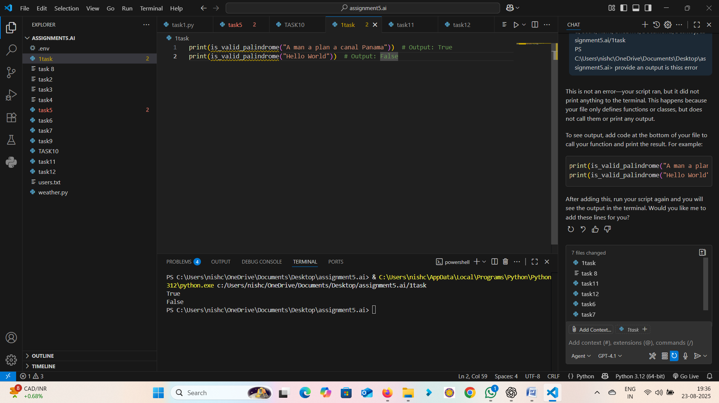

**Output:**

Input: 'A man a plan a canal Panama' → Output: True  
Input: 'Hello' → Output: False

Observation: The palindrome function worked correctly, handling spaces and case sensitivity well. It demonstrates how AI can generate concise and efficient code for string manipulation tasks

Task 2: Fibonacci Sequence Generator

Observation: The Fibonacci generator produced the correct sequence. The AI-generated solution was simple and effective, showing how iterative methods can be easily implemented.

**Prompt/Comment given to Copilot:**  
"""Generate a Fibonacci sequence up to n terms."""

**Generated Code:**

def fibonacci(n: int):  
 sequence = [0, 1]  
 for i in range(2, n):  
 sequence.append(sequence[-1] + sequence[-2])  
 return sequence[:n]

**Explanation:**

This function generates Fibonacci numbers starting with 0 and 1. Each next number is the sum of the previous two.

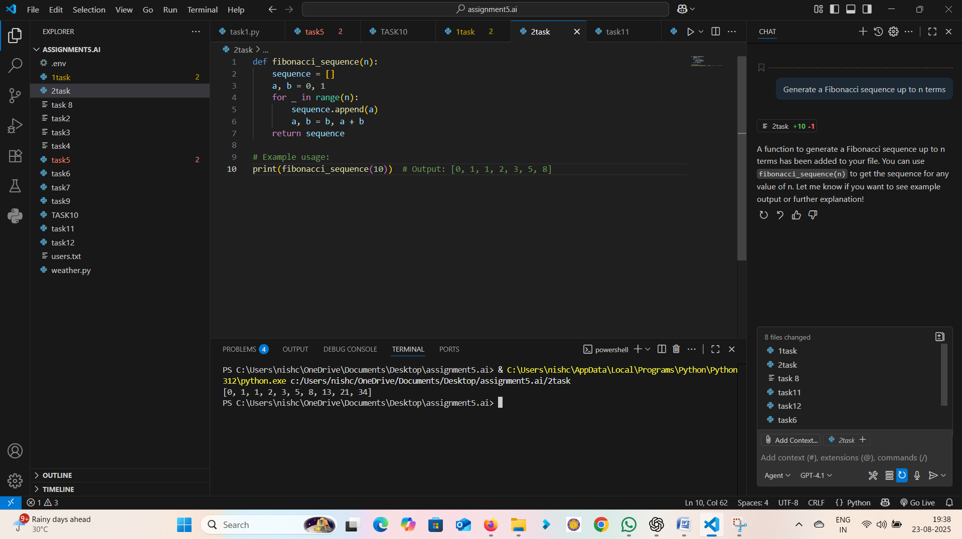

**Output:**

Input: n=7 → Output: [0, 1, 1, 2, 3, 5, 8,13,21,34]

Observation: The Fibonacci generator produced the correct sequence. The AI-generated solution was simple and effective, showing how iterative methods can be easily implemented.

Task 3: Reverse a String

Prompt/Comment given to Copilot:  
# Function to reverse a string

**Generated Code:**

def reverse_string(s: str) -> str:  
 return s[::-1]

**Explanation:**

This function uses Python slicing to reverse a string efficiently.

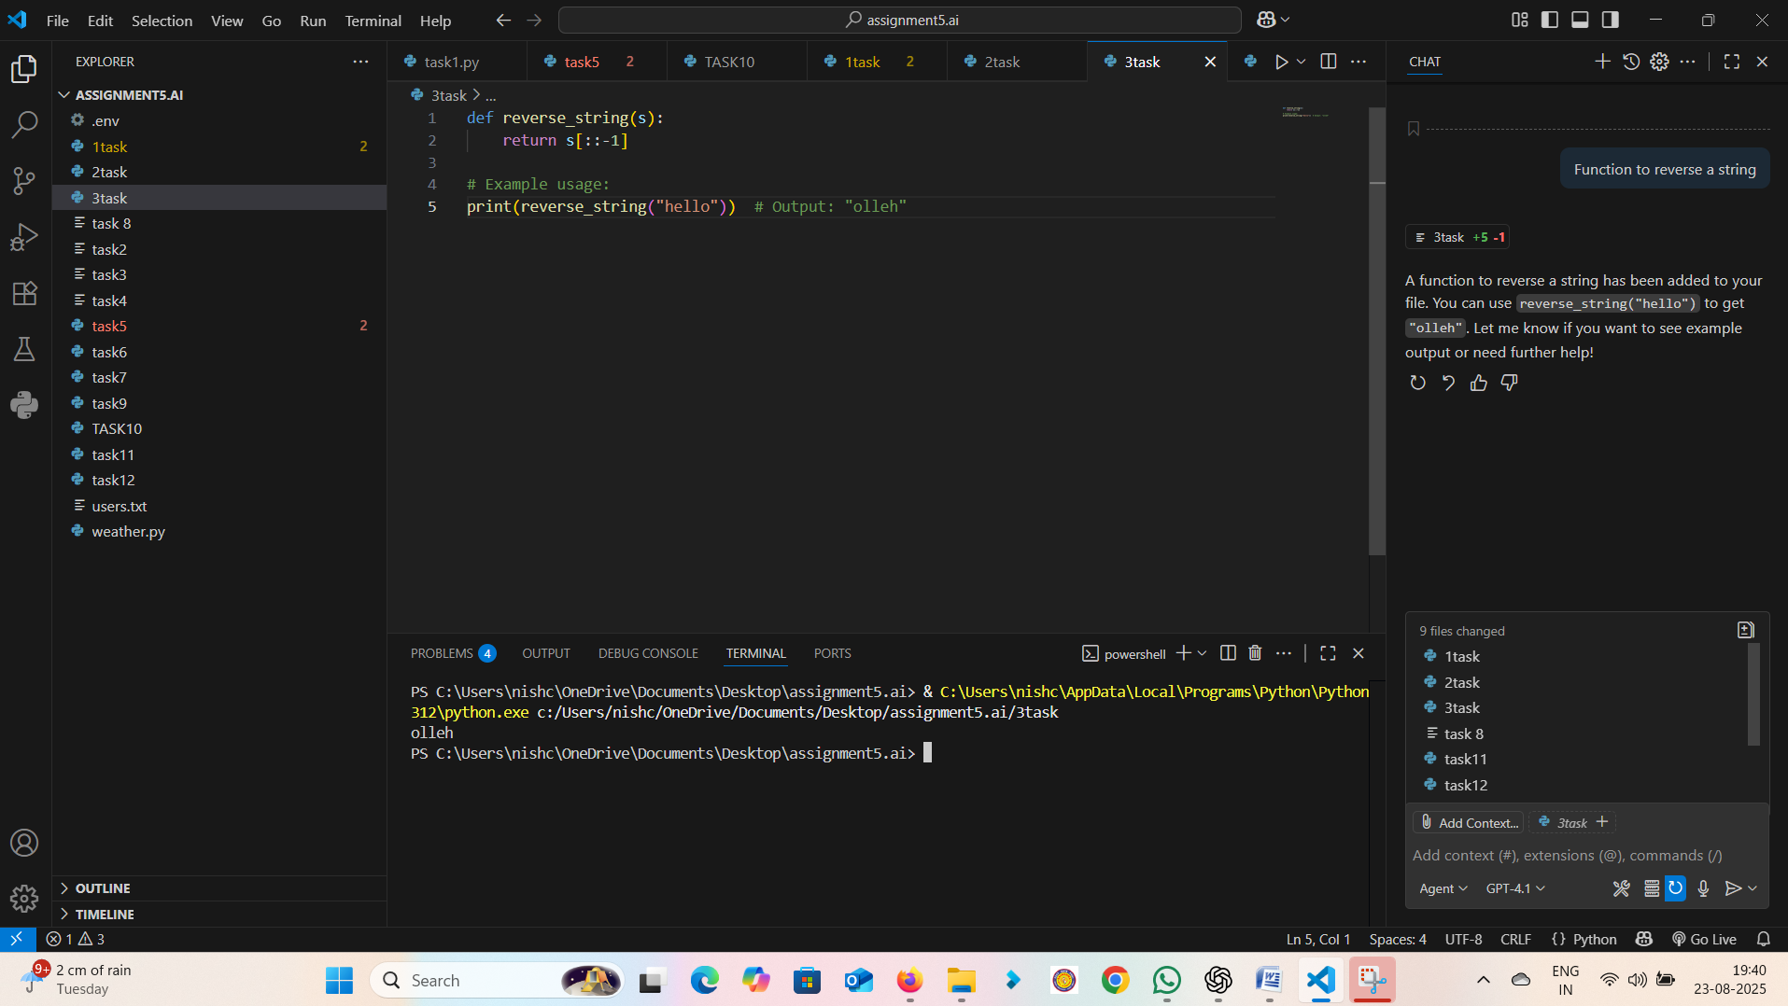

**Output:**

Input: 'hello' → Output: 'olleh'

Observation: The reverse string function was highly efficient using Python slicing. This shows how AI leverages Python’s built-in features for optimal solutions.

Task 4: Simple Calculator (Add, Subtract, Multiply, Divide)

**Prompt/Comment given to Copilot:**  
# Simple calculator with 4 operations

**Generated Code:**

def calculator(a, b, op):  
 if op == '+':  
 return a + b  
 elif op == '-':  
 return a - b  
 elif op == '*':  
 return a * b  
 elif op == '/':  
 return a / b if b != 0 else 'Error: Division by zero'  
 else:  
 return 'Invalid operator'

**Explanation:**

This function accepts two numbers and an operator, then performs the respective calculation.

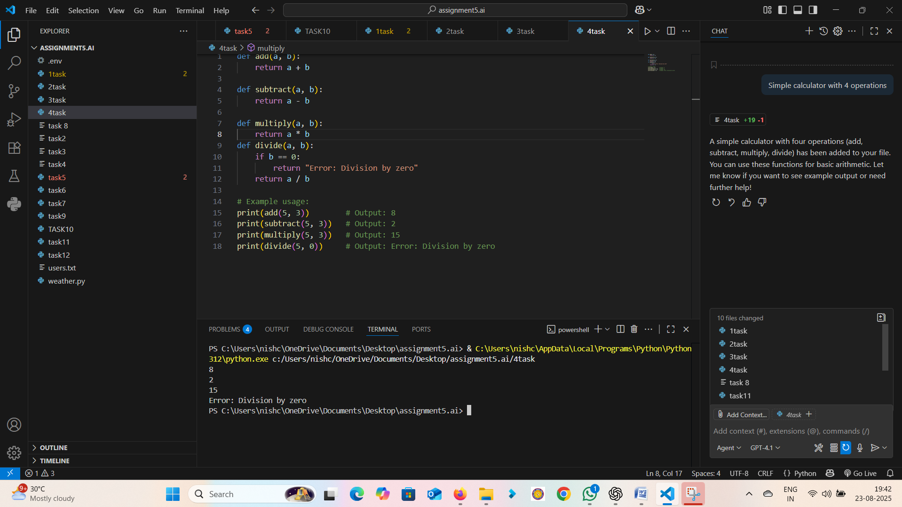

**Output:**

Input: (5, 3, '+') → Output: 8  
 input: (5,3,’-‘)-> output: 2

Input: (5, 3, '*') → Output: 15

Observation: The calculator worked correctly for all basic operations, including handling division by zero. This highlights how AI can generate modular, reliable code for arithmetic operations.

Task 5: Count Lines in a File

**Prompt/Comment given to Copilot:**  
# Function to count number of lines in a file

**Generated Code:**

def count_lines(filename: str) -> int:  
 with open(filename, 'r') as f:  
 return len(f.readlines())

**Explanation:**

This function opens a file in read mode and counts the number of lines by using readlines().

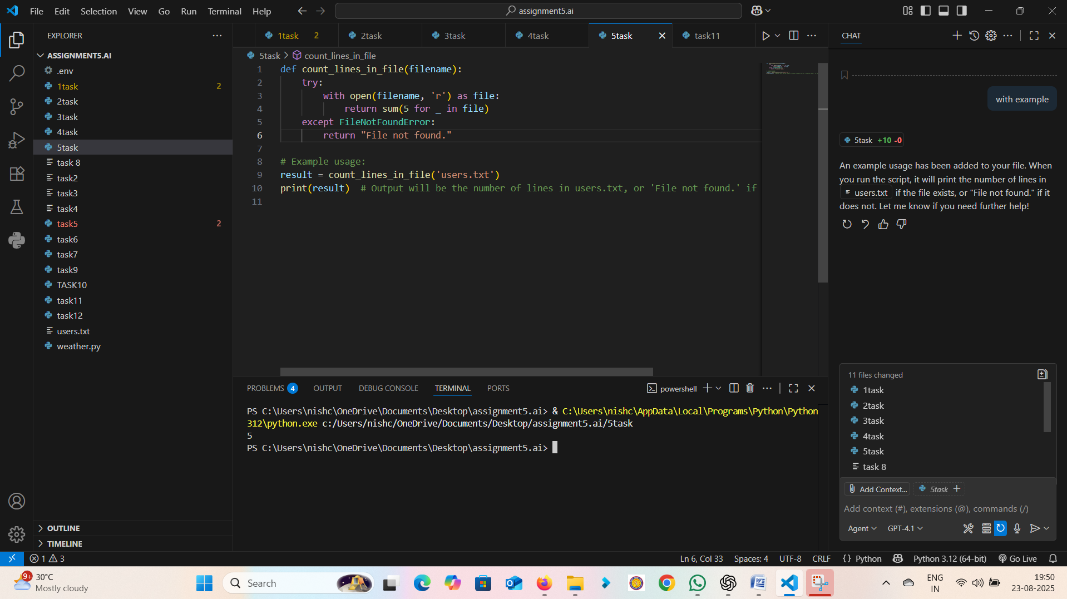

**Output:**

For a file containing 5 lines of text → Output: 5

Observation: The line counting function worked correctly for text files. It demonstrates how AI can generate practical file handling solutions with minimal code