**TASK1:**

* **PROMPT:** *"Generate code to fetch weather data securely without exposing API keys in the code."*
* **CODE GENERATED:**

Output:

Observation

**TASK 2**

* **Task:** Use an AI tool to generate a Python script that stores user data (name, email, password) in a file.
* **PROMPT:** To generate a Python script that stores user data (name, email, password) in a file. A screenshot of a computer program

  AI-generated content may be incorrect.
* **The file saved like=output:**

**TASK 3:**

* **Prompt:** Use AI to generate an Armstrong number checking function with comments and explanations.
* **code:**

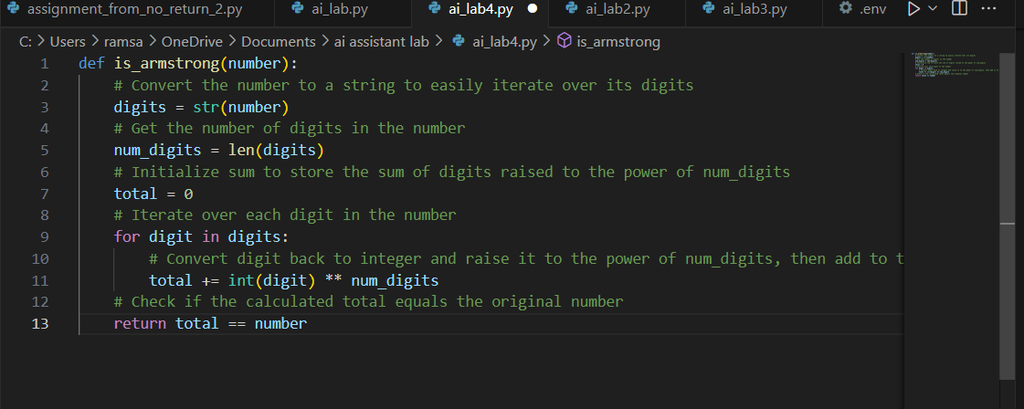

**Explanation of the code:**

Line-by-line explanation:

1. def is_armstrong(number):  
   Defines a function named is_armstrong that takes an integer number as input.
2. digits = str(number)  
   Converts the number to a string so we can easily access each digit.
3. num_digits = len(digits)  
   Calculates how many digits are in the number.
4. total = 0  
   Initializes a variable to keep the sum of each digit raised to the power of num_digits.
5. for digit in digits:  
   Loops through each digit in the string representation of the number.
6. total += int(digit) ** num_digits  
   Converts the digit back to an integer, raises it to the power of num_digits, and adds it to total.
7. return total == number

**TASK 4**

* **Task:** Use AI to implement two sorting algorithms (e.g., QuickSort and BubbleSort).
* **Prompt:**"Generate Python code for QuickSort and BubbleSort, and include comments explaining step-by-step how each works and where they differ."
* **OUTPUT:**
  1. code for QuickSort:

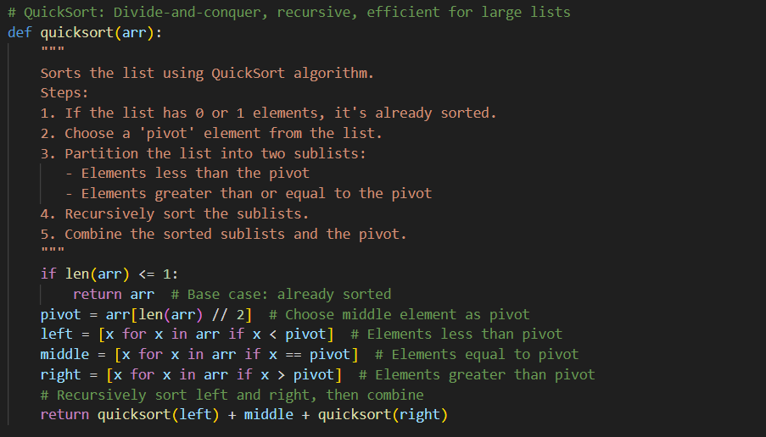

* 1. BubbleSort:

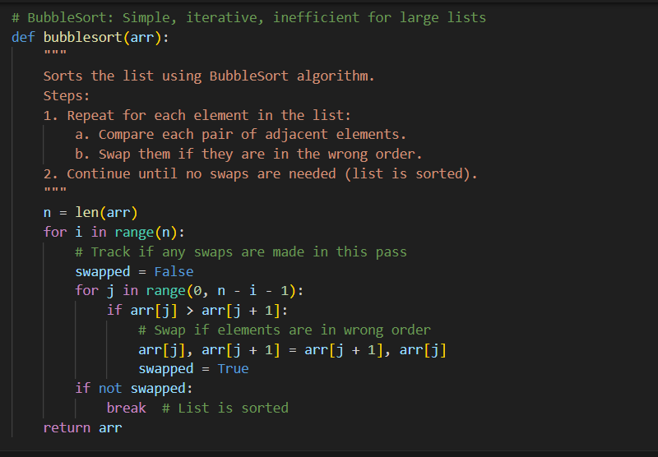

* **comparative explanation of their logic and efficiency.**

**TASK 5**

**Task:** Use AI to create a product recommendation system.

**Prompt:**  
"Generate a recommendation system that also provides reasons for each suggestion."

**Output:**

**Observation**