GROUP 61 | ASSIGNMENT 02
CollabBoard
Working REST APIs with In-Memory Data
Implementation, integration, verification, and submission evidence
Technical status: Frontend and REST implementation passed automated and live integration QA. Final Git tagging remains gated on human approval and genuine commits from all five members.

NSBM Green University
Group 61
31 August 2026

1. Introduction
CollabBoard is a responsive Kanban-style collaboration workspace for small project teams. Assignment 02 connects the completed React frontend to a modular Express REST API while preserving the frontend workflows, data field names, and derived selector logic established during the frontend campaign.
The implementation uses deterministic server-side in-memory data, JWT authentication, bcrypt password hashes, explicit CORS, allowlisted validation, stable service facades, and an executable Postman collection. MongoDB, realtime features, deployment, Docker, offline synchronization, and richer collaboration features are intentionally outside this assignment boundary.
Assignment outcome: The React application now performs authentication, membership-scoped project and task workflows, collaboration-aware Team reads, and Settings updates through protected REST endpoints without direct page-level fetch calls or automatic mock fallback.

2. Team Members and Roles
Student ID | Member | Assignment role
35762 | M N R Mudannayaka | Frontend, backend integration, and project coordination
35783 | M D J Prabashana | Frontend components and task API verification
33223 | K I S S Kariyawasm | UI/UX, responsive design, and integration verification
35934 | D M S P Bandara | Dashboard, supporting UI, API verification, and QA
30824 | C R Gammbheera | Common components, Postman, documentation, and Git

Contribution evidence must reflect work each person actually performed. At the time this report was generated, Git history did not yet contain verified individual commits from all five members, so the final Assignment 02 tag remains deliberately pending.

3. System Architecture
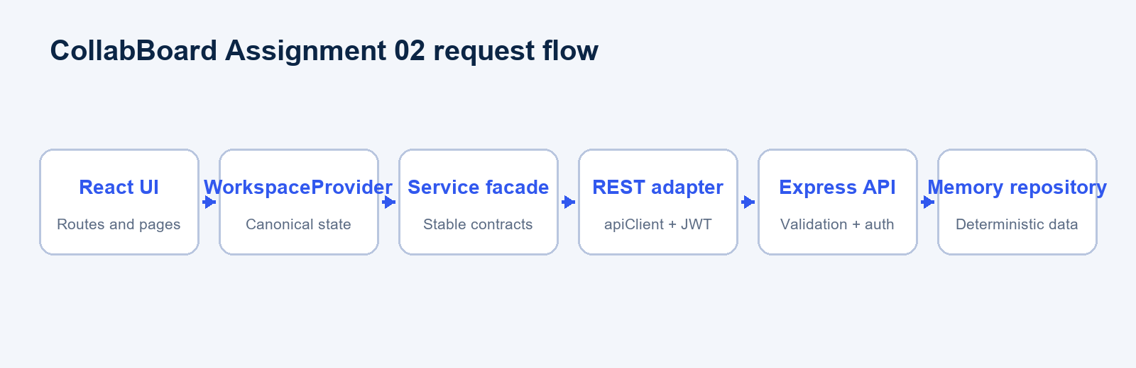
Figure 1. Assignment 02 frontend-to-backend request flow.
The stable frontend service layer is the architectural seam. Pages depend on authService, projectService, taskService, and userService. Each facade selects either the explicit mock adapter or the REST adapter. In API mode, apiClient owns JSON serialization, the Bearer header, 204 handling, normalized ApiError objects, and 401 session clearing.
- WorkspaceProvider loads users, projects, and tasks concurrently through service contracts.
- Express routes delegate to validation-aware controllers and an in-memory repository.
- Shared modules contain only public enums and public seed entities.
- Password hashes, JWT configuration, and authentication records remain backend-only.

4. Frontend-Backend Integration
The migration keeps existing root service imports stable, so page components did not need a second redesign. The REST adapters return the same entity shapes as the asynchronous mock adapters. After successful mutations, WorkspaceProvider refetches canonical collections, ensuring the UI reflects server state rather than optimistic local-only changes.
Frontend operation | HTTP request | UI result
authService.login | POST /api/auth/login | JWT session and protected dashboard
projectService.create | POST /api/projects | New project after canonical refresh
taskService.updateStatus | PATCH /api/tasks/:id/status | Task appears in the new Kanban column
userService.update | PATCH /api/users/:id | Shared current-user profile updates

5. REST API Design
The API is a small monolithic Express application organized by routes, controllers, services, repositories, middleware, data, and utilities. Success responses use bare entities or arrays. Deletions return 204 No Content. Errors use a single envelope with code, message, and details fields.
Error contract: {"error":{"code":"TASK_NOT_FOUND","message":"Task not found","details":[]}}

Correct HTTP semantics are used: 400 invalid input or immutable-field change, 401 missing or invalid JWT, 403 visible owner-only operation, non-disclosing 404 for inaccessible entities, 409 identity or member-assignment conflict, and 500 unexpected server errors.

6. Authentication
Seeded development users authenticate with the password password. The server stores only bcrypt hashes in memory. Successful login and registration return a JWT and a public user. Tokens contain sub, iat, and exp and expire after eight hours by default.
- The Login page calls authService.login with email, password, and Remember Me preference.
- The REST auth adapter posts credentials to /api/auth/login and stores the returned token in localStorage or sessionStorage.
- apiClient adds Authorization: Bearer <token> to protected requests.
- The Express middleware validates the token and attaches the public user to the request.
- A 401 clears the browser session and returns the application to Login.
Task creatorId and project ownerId are derived from the JWT. Profile updates are self-only. Projects are visible only to their owner and members; project management is owner-only, while project members may perform task CRUD inside accessible projects. Task projectId is immutable after creation.

7. API Endpoint Summary
Group | Public | Protected operations
Health | GET /api/health | None
Authentication | POST /api/auth/register; POST /api/auth/login | GET /api/auth/me
Users | None | List, read, self-profile patch
Projects | None | List, read, create, patch, delete
Tasks | None | List/filter, read, create, patch, status patch, delete

Task queries first restrict results to accessible non-archived projects and then accept projectId, assigneeId, status, priority, and label. Progress, workload, overdue totals, Dashboard counts, and project contribution remain frontend selector responsibilities. GET /api/users remains the registered account directory; the Team UI separately derives only shared-project collaborators.

8. GitHub Repository and Assignment 02 Tag
Repository: https://github.com/RamsaraNohan/CollabBoard
Frontend base commit: 4ac9e849c85dff5cca5a1c349771cf16b549b1a0
Implementation branch: codex/assignment02-rest-api
Planned final tag: assignment-02-working-rest-apis
Tag status: Not created. The approved process requires all five genuine member contributions and human approval of the final implementation commit before the annotated tag is created and pushed.

9. How to Run
- Run npm install in the repository root.
- Run npm --prefix server install for the separate backend package.
- Copy server/.env.example to server/.env and set a local JWT_SECRET of at least 16 characters.
- Run npm run dev:all.
- Open http://localhost:5173 and sign in with member1@example.com / password.
Frontend-only mock development remains explicit through npm run dev:mock. Complete commands, environment variables, testing scripts, API boundaries, and credentials are documented in README.md.

10. Postman Collection
The Postman v2.1 collection is stored at postman/CollabBoard_Assignment02.postman_collection.json. It defines baseUrl, ownerToken, userBToken, and deterministic entity variables. Its access-scoping sequence registers an unassigned user, verifies empty visibility, grants and revokes membership, checks non-disclosing 404 responses, validates member-removal conflicts, and restores seeded state.
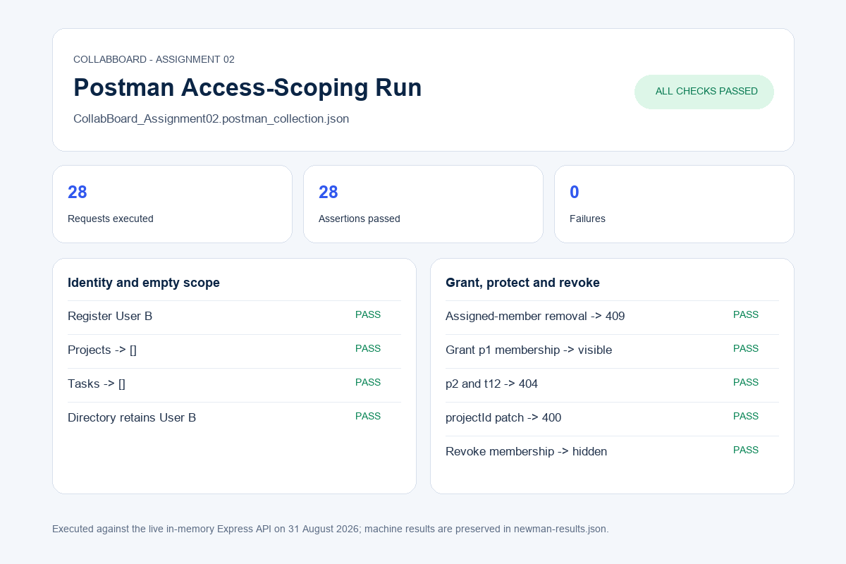
Figure 2. Executable access-scoping collection result: 28 requests, 28 assertions, 0 failures.

11. Frontend Screenshots
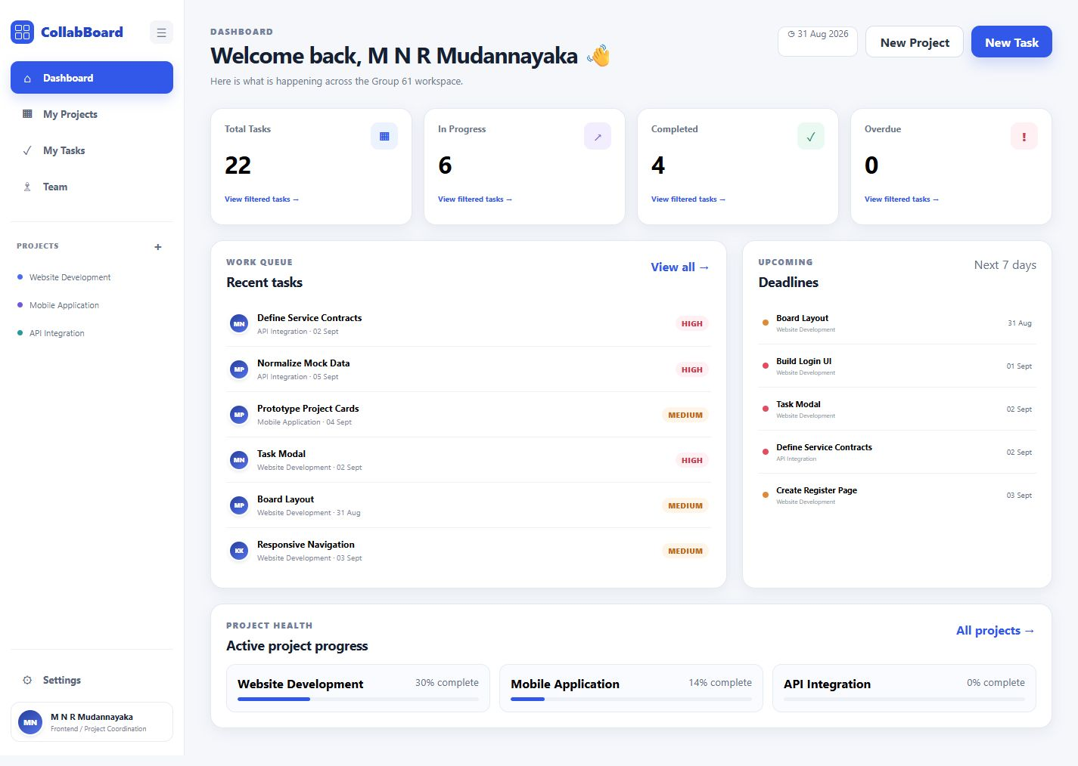
Figure 3. API-backed Dashboard with derived task counts and deadlines.

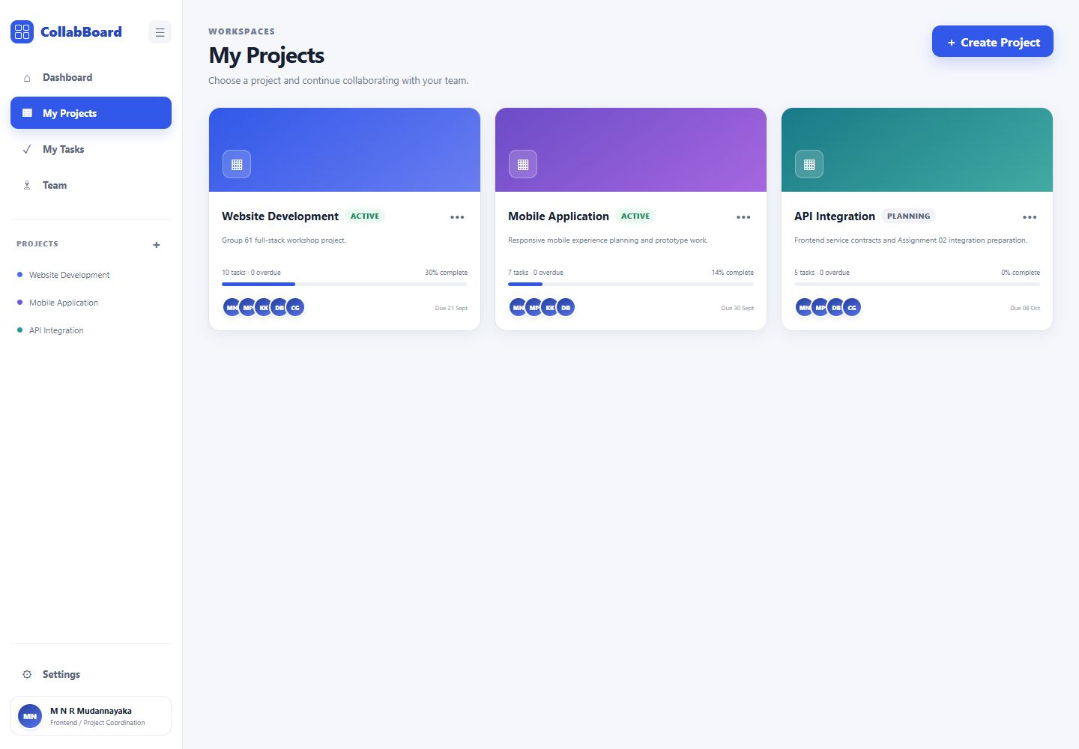
Figure 4. Canonical project list loaded from the REST API.
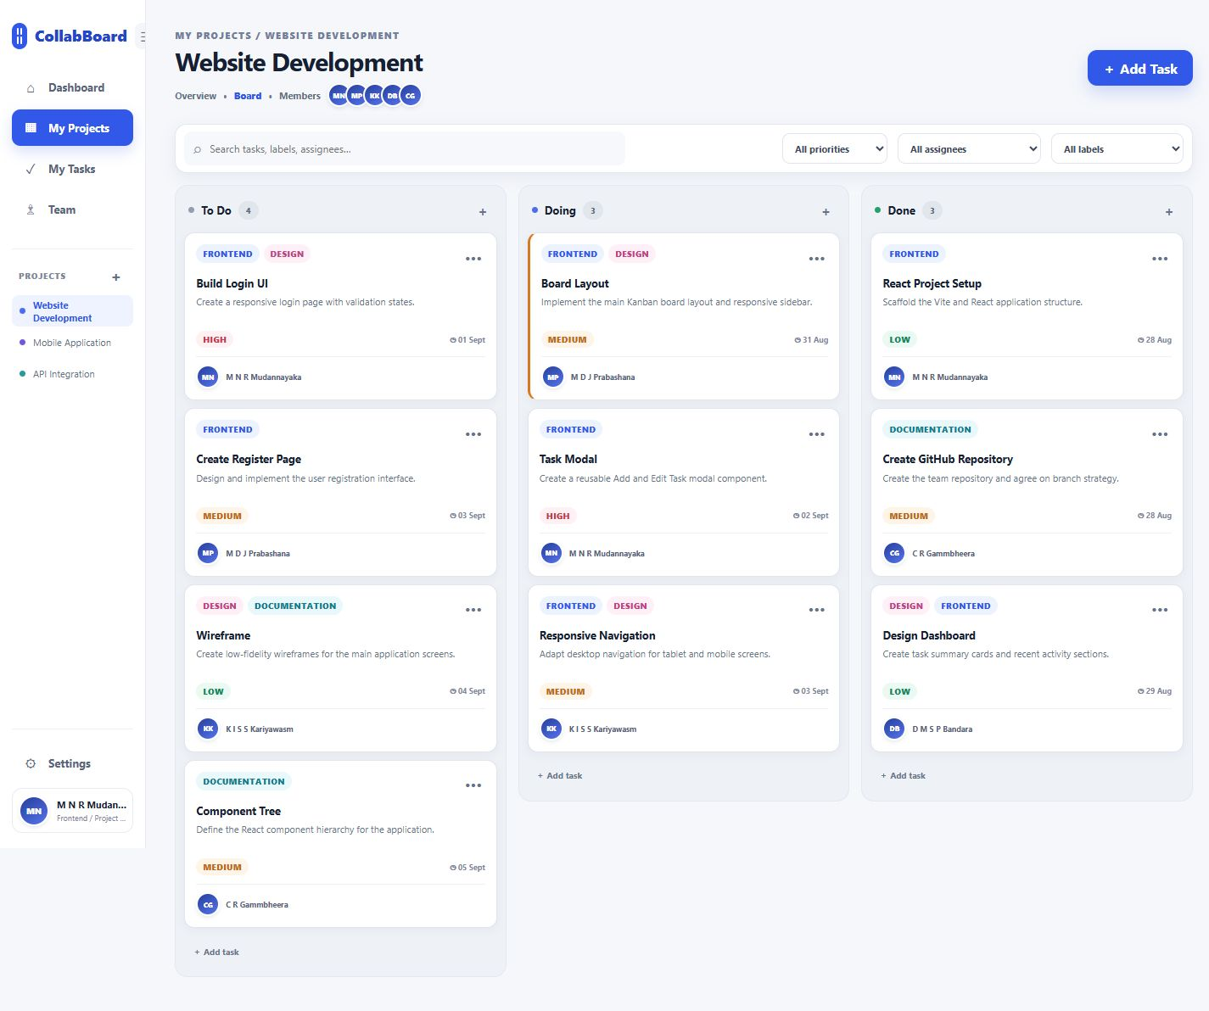
Figure 5. Project-specific Website Development Kanban board.

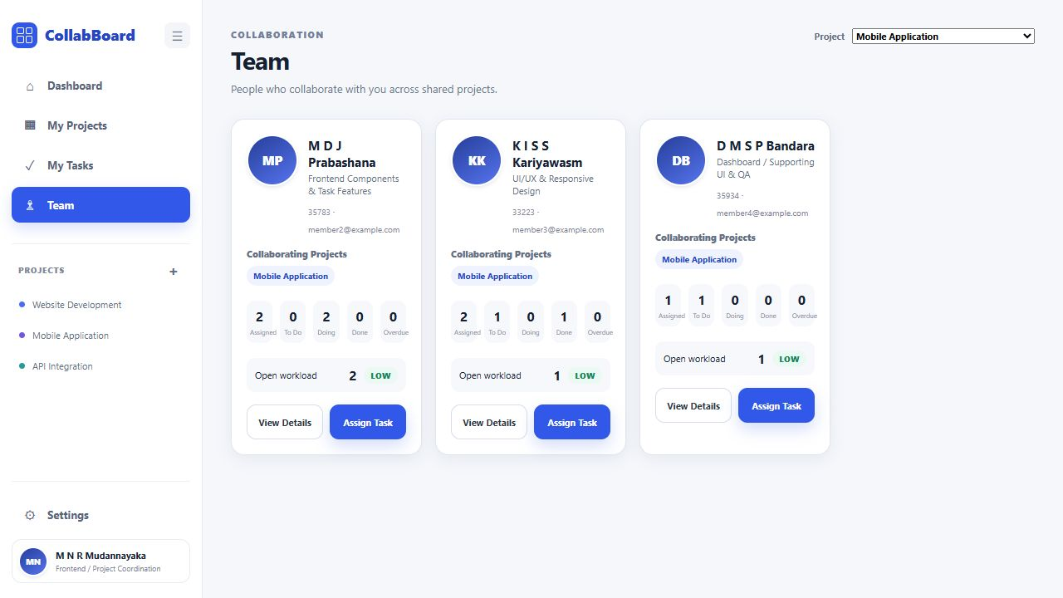
Figure 6. Shared-project Team collaborators and project-scoped metrics.
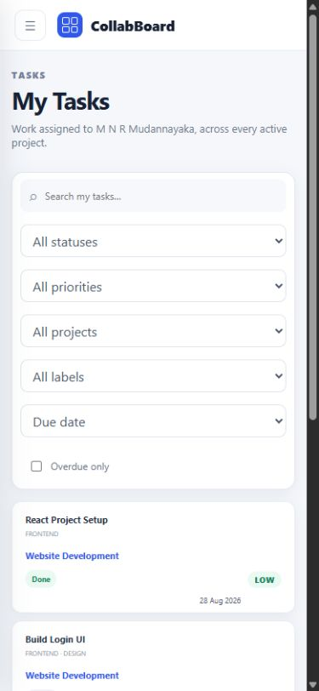
Figure 7. Mobile My Tasks card layout at 390 px.

12. Backend/API Screenshots
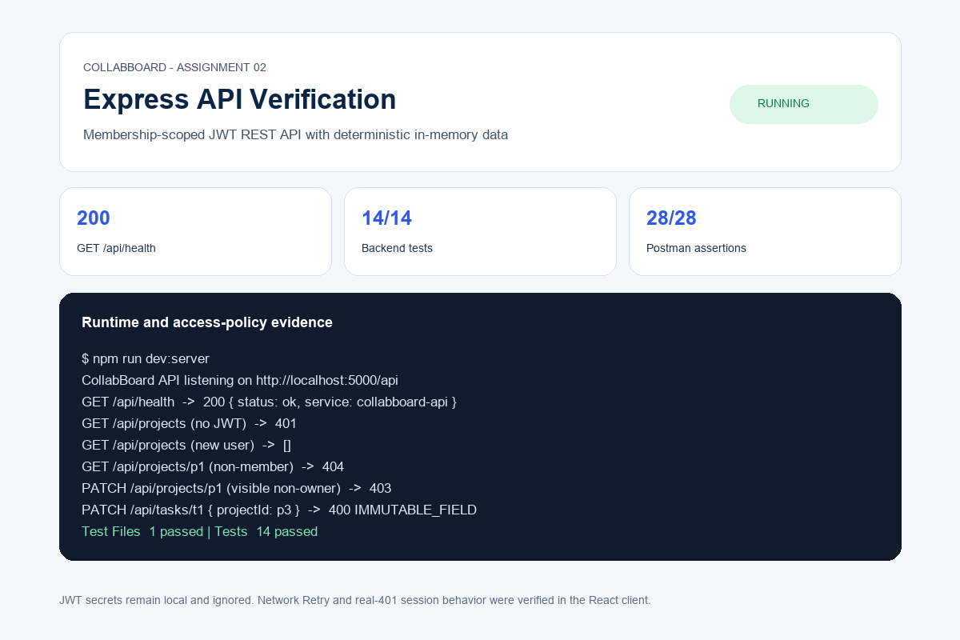
Figure 8. Express startup, health response, protected-route 401, and test summary.
Figure 9. Postman/Newman request and assertion summary.

13. Testing and Verification
Gate | Result | Evidence
Frontend tests | PASS | 9 files, 20 tests
Backend tests | PASS | 1 file, 14 tests
Postman/Newman | PASS | 28 requests, 28 assertions, 0 failures
Production build | PASS | Vite transformed 104 modules
Responsive browser QA | PASS | 390, 768, 1024, and 1440 px
Console audit | PASS | Offline, Retry, 401, and 409 flows had no unhandled rejection

Live browser QA used real API mode. It verified startup, login and JWT restoration, offline error handling and Retry, invalid-token clearing, zero-project empty states, project-scoped Sidebar data, Team union and project filters, assignment project choice, owner-only controls, direct route refreshes, and responsive layouts.
Backend tests additionally verified user-scoped project and task lists, archive semantics, access grant and revocation, the member-removal 409 sequence, non-disclosing entity reads, member task CRUD, invalid assignees, immutable projectId, self-only user updates, and normalized 400/401/403/404/409 errors.

14. Known Limitations
- In-memory mutations reset whenever the Express server restarts.
- The JWT design intentionally omits refresh tokens and account recovery for this coursework milestone.
- MongoDB, realtime updates, offline queues, comments, notifications, attachments, and deployment are deferred.
- The final Git tag is pending human approval and verified genuine contributions from all five members.
- Registered users are not automatically added to existing projects.
- Archived projects remain directly readable to members but have no archive-center UI in this campaign.

15. Conclusion
CollabBoard now satisfies the technical Assignment 02 objective: a completed React frontend communicates through stable asynchronous service contracts with a JWT-protected Express REST API using deterministic in-memory backend data. Project and task visibility is enforced by ownership and membership on the server, while Team collaboration is derived only from shared active projects and presentation metrics remain frontend-owned.
The implementation has passed automated frontend and backend tests, an executable Postman collection, production build, live integration checks, responsive browser QA, and visual evidence review. Submission tagging must wait for the remaining people-dependent contribution and approval gates; no artificial commits or premature tag are included.

