

**Title:**

**“FORECASTING CRYPTOCURRENCY**

**PRICES USING DEEP LEARNING**

**(BI-LSTM)”**

**A CORE COURSE PROJECT REPORT**

**Submitted By**

**MUKESH G REG NO. 23CS133**

**RAMSRIPRASAATH D REG NO. 23CS182**

**in partial fulfillment for the award of the degree of**

# BACHELOR OF ENGINEERING

**IN**

**COMPUTER SCIENCE AND ENGINEERING**



**DEPARTMENT OF COMPUTER SCIENCE AND ENGINEERING CHENNAI INSTITUTE OF TECHNOLOGY**

**(Autonomous)**

Sarathy Nagar, Kundrathur, Chennai-600069

**OCT / NOV – 2024**



**Vision of the Institute:**

To be an eminent centre for Academia, Industry and Research by imparting knowledge, relevant practices and inculcating human values to address global challenges through novelty and sustainability.



**Mission of the Institute:**

**IM1**.To creates next generation leaders by effective teaching learning methodologies and instill scientific spark in them to meet the global challenges.

**IM2**.To transform lives through deployment of emerging technology, novelty and sustainability.

**IM3**.To inculcate human values and ethical principles to cater the societal needs.

**IM4**.To contributes towards the research ecosystem by providing a suitable, effective platform for interaction between industry, academia and R & D establishments.





**DEPARTMENT OF**

# COMPUTER SCIENCE AND ENGINEERING

**Vision of the Department**:

To Excel in the emerging areas of Computer Science and Engineering by imparting knowledge, relevant practices and inculcating human values to transform the students as potential resources to contribute innovatively through advanced computing in real time situations.



**Mission of the Department**:



**DM1.**

To provide strong fundamentals and technical skills for Computer Science

applications through effective teaching learning methodologies.

**DM2.**

To transform lives of the students by nurturing ethical values, creativity and

novelty to become Entrepreneurs an

d establish start

-

ups.

**DM3.**

To habituate the students to focus on sustainable solutions to improve the quality

of life and the welfare of the society.



## CERTIFICATE

This is to certify that the “**Core Course Project**” Submitted by **MUKESH G (Reg no:23CS133) & RAMSRIPRASAATH D (Reg no:23CS182)** is a work done by us and submitted during **2024-2025** academic year, in partial fulfilment of the requirements for the award of the degree of **BACHELOR OF ENGINEERING** in **DEPARTMENT OF COMPUTER SCIENCE AND ENGINEERING**, at Chennai Institute of Technology.

|  |  |
| --- | --- |
| **Project Coordinator**  (Name and Designation) | **Internal Examiner** |
| **Head of the Department**  (Name and Designation) | **External Examiner** |

### ACKNOWLEDGEMENT

We express my gratitude to our Chairman **Shri.P.SRIRAM** and all trust members of Chennai institute of technology for providing the facility and opportunity to do this project as a part of our undergraduate course.

We are grateful to my Principal **Dr.A.RAMESH M.E**, **Ph.D.** for providing me the facility and encouragement during the course of our work.

We sincerely thank my Head of the Department **Dr.S.Pavithra,** Department of Computer Science and Engineering for having provided us valuable guidance, resources and timely suggestions throughout our work.

We would like to extend our thanks to ourProject Co-ordinator of the **Dr. R PONNUSAMY,** Department of Computer Science and Engineering, for his valuable suggestions throughout this project.

We wish to extend my sincere thanks to allFaculty members of the Department of Computer Science and Engineering for their valuable suggestions and their kind cooperation for the successful completion of our project.

We wish to acknowledge the help received from the **Lab Instructors of the** Department of Computer Science and Engineering and others for providing valuable suggestions and for the successful completion of the project.

**NAME: MUKESH G REG.NO:23CS133**

**NAME: RAMSRIPRASAATH D REG.NO:23CS182**

#### PREFACE

We, students in the Department of Computer Science and Engineering need to undertake a project to expand my knowledge. The main goal of our Core Course Project is to acquaint us with the practical application of the theoretical concepts we’ve learned during my course.

It was a valuable opportunity to closely compare theoretical concepts with real world applications. This report may depict deficiencies on my part but still it is an account of my effort.

The results of our analysis are presented in the form of an industrial Project, and the report provides a detailed account of the sequence of these findings. This report is my Core Course Project, developed as part of my 2nd year project. As an engineer, it is my responsibility to contribute to society by applying my knowledge to create innovative solutions that address their changes.

### ABSTRACT

Cryptocurrency trading has become a global phenomenon, with cryptocurrencies like Bitcoin and Ethereum leading the way. Despite their popularity, the high volatility and unpredictability of cryptocurrency prices make them difficult to forecast accurately. This project aims to address the challenge of predicting cryptocurrency prices by leveraging a Bidirectional Long Short-Term Memory (Bi-LSTM) model, an advanced form of Recurrent Neural Networks (RNNs) known for handling sequential data efficiently.

The research begins by identifying the key factors that influence cryptocurrency prices, such as historical price data, trading volume, and market sentiment. This data is sourced from publicly available cryptocurrency exchanges and financial databases. Data preprocessing techniques, including normalization and handling missing values, are employed to improve data quality and ensure smooth input to the neural network. A Bidirectional LSTM (Bi-LSTM) network is chosen due to its ability to capture both past and future contexts in time series data, providing a more comprehensive view of market trends.

The dataset is split into training, validation, and testing sets to evaluate the model’s performance. Hyperparameters such as the number of Bi-LSTM layers, the number of neurons in each layer, the learning rate, and batch size are optimized to improve prediction accuracy. The model is trained using Adam as the optimization algorithm, with Mean Squared Error (MSE) employed as the loss function. Dropout and regularization techniques are introduced to mitigate overfitting and ensure that the model generalizes well to unseen data.

**LIST OF ABBREVIATIONS:**

AI – Artificial Intelligence

ARIMA – Auto Regressive Integrated Moving Average

Bi-LSTM – Bidirectional Long Short-Term Memory

BTC – Bitcoin

CNN – Convolutional Neural Network

DL – Deep Learning

DNN – Deep Neural Network

ETH – Ethereum

GRU-Gated Recurrent Unit

GAN – Generative Adversarial Network

LTC-Litecoin

LSTM – Long Short-Term Memory

MSE – Mean Squared Error

MAPE-Mean Absolute Percentage Error

NN – Neural Network

RNN – Recurrent Neural Network

RMSE – Root Mean Squared Error

**TABLE**

|  |  |
| --- | --- |
| Topic | Page No. |
| 1. Introduction    1. – Background of the study       1. – Underlying Techs       2. – Volatility       3. – Emegence of model    2. – Research problem       1. – Several models       2. – Advent of DL       3. – Advantage of BiLSTM    3. – Objectives & questions       1. – Research Questions       2. – Objectives    4. – Significance of study       1. – Academic perspective       2. – Overview       3. – Practical level    5. – Scope of study       1. – Limitations       2. – Methodology    6. – Thesis Organisation | 12          13        14      15        16      17 |
| 1. Literature Review    1. – Review of Previous work       1. – Historical Model       2. – Machine Learning       3. – Deep Learning    2. – Theoretical foundations       1. – Times Series Analysis       2. – LSTM       3. – Bi-LSTM       4. – Evaluation Metrics    3. – Gaps in the Literature       1. – Need for Hybrid       2. – Challenges in quality       3. – Lack of Real-time app 2.4 – Hypotheses or Framework:       4. – Formulate Hypotheses       5. – Theoritical Framework       6. – Approach | 18        20          22        23 |

|  |  |
| --- | --- |
| 1. Methodology    1. – Research design       1. – Process of designing       2. - Architecture    2. – Data collection methods       1. – Quantitative data      * 1. – Tools, materials & procedure   3.1.1 – Tools   * + 1. – Materials     2. – Procedure   1. – Data Analysis Methods      1. – EDA      2. – Feature Engineering      3. – Model Evaluation   2. – Algorithm/Procedure/Pseudo      1. – Algo and procedure      2. – Pseudocode   3. – Ethical considerations      1. – Data privacy      2. – Transparency      3. – Bias & fairness      4. – Implications      5. – Environment Impact | 26      28      33        36        38      40 |
| 1. Results/Findings    1. – Presentation of data       1. – Predicted vs Actual       2. – Model Performance       3. – Training and validate       4. – Impact of Tuning       5. – Predictions       6. – Discussions       7. – Evaluated model    2. – Tables, charts or graphs       1. – Process table       2. – Sample graphs       3. - Sample tables       4. – Sample output    3. – Analysis of findings       1. – GRU Analysis       2. – LSTM Analysis       3. – BI-LSTM Analysis       4. – Performance Metrices | 43                46          51 |
| 1. Discussion    1. – Interpretation of the findings       1. – Model Effectiveness       2. – Challenges       3. – Quantitative Metrics       4. – Handling uncertainty    2. – Comparison with research       1. – Advancements       2. – Handling Market       3. – External factors    3. – Implications of study       1. – Improved prediction       2. – Model Enhancement       3. – Other financial market    4. – Limitations of research       1. – External market factor       2. – Market volatility | 56          57        59        60 |
| 1. Conclusion    1. – Summary of findings       1. – BiLSTM effectiveness       2. – Limitations    2. – Recommendations       1. – External data src       2. – Explore hybrid models    3. – Practical implications       1. – Enhanced training       2. – Predicative financial | 61      61      62 |

#### 1. INTRODUCTION

**1.1 Background of the study:**

Cryptocurrencies, a class of digital or virtual currencies that rely on cryptographic techniques for secure transactions, have emerged as a revolutionary force in the global financial landscape. Since the introduction of Bitcoin in 2009 by an anonymous entity known as Satoshi Nakamoto, the cryptocurrency ecosystem has expanded to include thousands of different digital assets. With market leaders such as Bitcoin (BTC), Ethereum (ETH), and Ripple (XRP), the cryptocurrency market has witnessed unprecedented growth in terms of adoption, market capitalization, and societal relevance.

**1.1.1 Underlying Technologies:**

The underlying technology of cryptocurrencies-blockchain-provides a decentralized ledger system, which ensures transparency, immutability, and security. As cryptocurrencies gain more acceptance for mainstream and institutional uses, they are becoming a popular alternative investment class. Their decentralized nature eliminates the need for intermediaries such as banks and financial institutions, making transactions more efficient. However, despite their potential, cryptocurrencies are infamous for their extreme volatility, with prices often fluctuating by significant margins within short timeframes.

**1.1.2 Volatility:**

This volatility stems from several factors. First, the cryptocurrency market is relatively immature compared to traditional financial markets, which leads to speculative trading. Market participants frequently buy and sell based on trends, rumors, and sudden developments, creating price swings. Second, external factors such as regulatory announcements, technological updates, media hype, and public figures' opinions contribute to price instability. For example, Elon Musk's tweet in May 2021 about Tesla no longer accepting Bitcoin due to environmental concerns caused Bitcoin's price to plummet by nearly 20% in one day.

**1.1.3 Emergence of the model:**

The emergence of Recurrent Neural Networks (RNNs) and their variant Long Short-Term Memory (LSTM) models has opened new avenues in time series forecasting. LSTM models can capture the temporal dependencies in data, making them effective for financial forecasting. However, unidirectional LSTMs have limitations in capturing future trends that might affect the current prediction. Bidirectional LSTM (Bi-LSTM) models solve this issue by processing input sequences both forward and backward. This dual-directional approach provides more context and has shown promise in applications like speech recognition, language translation, and financial forecasting. In this study, we aim to apply the Bi-LSTM model to cryptocurrency price prediction, hypothesizing that this advanced model can improve prediction accuracy in this highly volatile market.

**1.2 Research problem:**

The cryptocurrency market is characterized by its high volatility and rapid price fluctuations, making it both a high-risk and high-reward environment for investors. Traditional financial forecasting models, such as ARIMA, work well with stable and linear time series data but fail to account for the unique dynamics of the cryptocurrency market. Cryptocurrencies do not follow typical financial patterns seen in stock markets or foreign exchange markets. Instead, they are influenced by various factors such as technological innovations, regulatory news, social media trends, and macroeconomic events. These factors contribute to sharp and sudden price movements that are difficult to predict using conventional models.

**1.2.1 Several models:**

Several machine learning models have been applied to cryptocurrency price prediction, with varying degrees of success. Early studies focused on using linear regression, decision trees, and support vector machines (SVM) to forecast price trends. While these models can capture some patterns, they fall short in handling the non-linear and complex relationships present in cryptocurrency data. Moreover, traditional machine learning models struggle to incorporate time dependencies effectively, which is crucial for time series forecasting.

**1.2.2 Advent of Deep Learning:**

The advent of deep learning, particularly LSTM models, brought a new perspective to time series forecasting. LSTMs can learn from historical data by maintaining short- and long-term dependencies, making them ideal for sequential data like financial time series. However, LSTM models typically operate in a unidirectional manner, processing data from the past to the present. This limits their ability to consider future information, which can be crucial in highly volatile markets like cryptocurrencies.

1.2.3 Advantage of BI-LSTM:

In contrast, Bi-LSTM models have the advantage of processing data in both directions, from past to future and future to past. This allows them to capture more information from the time series, potentially leading to better predictions. Despite the potential benefits, the use of Bi-LSTM models in cryptocurrency price prediction remains largely unexplored. Most studies have focused on using standard LSTM models or other machine learning techniques. Therefore, this research seeks to fill this gap by investigating whether Bi-LSTM models can provide more accurate predictions of cryptocurrency prices compared to traditional models.

**1.3 Research questions/Objectives:**

**1.3.1 Research Questions:**

How can cryptocurrency prices be predicted more accurately using deep learning models, specifically Bi-LSTM? This question seeks to evaluate the performance of deep learning models compared to traditional financial forecasting techniques. It investigates whether the Bi-LSTM model can handle the complex, nonlinear relationships in cryptocurrency price data more effectively than other models.

**1.3.2 Objectives:**

To design and implement a Bi-LSTM model for cryptocurrency price prediction. The primary objective is to build a Bi-LSTM model that can predict the future prices of major cryptocurrencies based on historical data and key features such as trading volume and market sentiment.

**1.4 Significance of the study:**

The significance of this study lies in its potential contributions to both academic research and practical applications in the field of cryptocurrency trading. Accurate price predictions can offer significant financial advantages to traders and investors. In a market as volatile as cryptocurrencies, the ability to forecast price movements with a higher degree of accuracy can reduce financial risks, prevent losses, and enhance decision-making.

**1.4.1 Academic perspective:**

From an academic perspective, this study contributes to the growing body of literature on machine learning and deep learning applications in financial markets. While there is a substantial amount of research on predicting stock prices and foreign exchange rates, relatively little work has been done on predicting cryptocurrency prices using deep learning techniques. This study fills a gap by exploring the use of the BiLSTM model, an advanced form of deep learning, to predict cryptocurrency prices.

**1.4.2 Overview:**

Moreover, this research offers insights into the strengths and limitations of various prediction models, helping future researchers refine their approaches to financial forecasting. The Bi-LSTM model’s ability to incorporate both past and future trends could inspire further exploration in fields beyond cryptocurrency, such as stock market forecasting, commodity trading, and foreign exchange.

**1.4.3 Practical level:**

On a practical level, this research has implications for traders, investors, and financial institutions involved in the cryptocurrency market. By providing a more reliable method for predicting prices, this study could help these stakeholders manage risk and maximize returns. Institutional investors, in particular, may benefit from the findings, as accurate predictions can lead to better portfolio management strategies.

**1.5 Scope of the Study:**

The scope of this study is primarily focused on predicting the prices of major cryptocurrencies—specifically Bitcoin (BTC), Ethereum (ETH), and Ripple (XRP). The study uses publicly available historical data from sources such as Coin Market Cap, Binance, and Yahoo Finance. The data includes daily closing prices, trading volumes, and technical indicators such as moving averages**.**

**1.5.1 Limitations:**

This study is limited to technical features and does not incorporate external market factors such as news events, regulatory changes, or social media sentiment. While these factors undeniably influence cryptocurrency prices, incorporating them would require more advanced natural language processing (NLP) techniques, which are beyond the scope of this research. The study focuses solely on the technical aspects of cryptocurrency trading**.**

**1.5.2 Methodology:**

The methodology adopted in this research is centered on advanced deep learning techniques, specifically the Bidirectional Long Short-Term Memory (BiLSTM) model. Bi-LSTM is an extension of the traditional LSTM model that processes data in both forward and backward directions, enabling the model to capture both past and future dependencies within sequential data. This is particularly important in the context of cryptocurrency price prediction, where market trends are influenced by a wide range of historical events and future expectations. The model will be implemented using Python's TensorFlow and Keras libraries, which offer robust frameworks for building and training deep learning models. These libraries provide flexibility for customizing the architecture and tuning parameters to optimize performance, ensuring that the Bi-LSTM model is well-suited to the complex, dynamic nature of the cryptocurrency market.

The evaluation will be based on key metrics, including Mean Squared Error (MSE), Root Mean Squared Error (RMSE), and Mean Absolute Error (MAE), which provide a quantitative measure of the prediction accuracy. This multi-model comparison will offer insights into the relative strengths and weaknesses of each approach, ultimately helping to determine the most effective method for cryptocurrency price prediction.

**1.6 Thesis Organization:**

This thesis is organized into six chapters, each addressing a different aspect of the research:

Chapter 1 introduces the study, providing background information, outlining the research problem, and stating the objectives and significance of the research.

Chapter 2 reviews the existing literature on cryptocurrency price prediction, focusing on the different approaches used and their relative merits and limitations.

Chapter 3 presents the methodology, including the data collection process, feature selection, and model implementation using Bi-LSTM.

Chapter 4 outlines the results of the study, providing a detailed analysis of the Bi-LSTM model's performance compared to other models.

Chapter 5 discusses the implications of the findings, focusing on how the results can be applied in real-world trading scenarios and their significance for future research.

Chapter 6 concludes the thesis, summarizing the research findings and offering recommendations for future work.

#### 2.LITERATURE REVIEW

**2.1 Review of Relevant Previous Work:**

In recent years, cryptocurrency price prediction has gained significant attention due to the market's volatility. Traditional models like ARIMA have been widely used for financial time series forecasting but are limited in capturing non-linear dependencies. Deep learning models such as LSTM have shown promising results due to their ability to handle sequential data and long-term dependencies.

**2.1.1 Historical Prediction Models:**

The exploration of historical price prediction models has a long-standing tradition in financial forecasting, particularly in the context of cryptocurrencies. Among the earliest and most widely recognized models are the Auto Regressive Integrated Moving Average (ARIMA) and its variants. These models leverage historical price data to forecast future values based on linear relationships. The ARIMA model is particularly effective for stationary time series data, making it a staple in traditional financial analysis. Numerous studies have demonstrated the effectiveness of ARIMA in predicting stock prices, with researchers highlighting its ability to capture trends and seasonal patterns. For instance, ARIMA has been successfully applied in various financial sectors to model stock market behaviour, and its performance has been validated through extensive empirical research.

**2.1.2 Machine Learning Approaches:**

As the field of financial forecasting evolves, machine learning approaches have gained significant traction, offering innovative solutions to the challenges posed by traditional models. Early applications of machine learning in cryptocurrency prediction included methods such as Support Vector Machines (SVM) and Decision Trees. SVMs, known for their effectiveness in classification tasks, have been adapted to regression problems, providing a framework for predicting cryptocurrency prices based on historical data. Researchers have reported promising results using SVM, particularly in forecasting Bitcoin prices, where the model’s ability to capture complex patterns has led to improved accuracy over traditional models like ARIMA. For instance, studies have shown that SVM can effectively identify market trends by analysing historical data, leading to more informed trading decisions.

**2.1.3 Deep Learning Models:**

The emergence of deep learning has revolutionized the landscape of predictive analytics, providing sophisticated methodologies that surpass the limitations of traditional machine learning techniques. At the forefront of deep learning applications in cryptocurrency prediction are Recurrent Neural Networks (RNNs), which are specifically designed to process sequential data. RNNs offer a unique advantage in modelling time series data, as they can maintain a memory of previous inputs and capture temporal dependencies. This capability is particularly beneficial for predicting the prices of cryptocurrencies, which are influenced by their historical performance and trends. However, RNNs also face significant challenges, particularly in handling longrange dependencies due to the vanishing gradient problem. This issue can lead to difficulties in training models effectively when the sequence length increases, resulting in suboptimal predictive performance.

**2.2 Theoretical foundations:**

One of the foundational concepts in time series analysis is stationarity. A stationary time series has constant statistical properties over time, such as mean and variance. Many statistical models, particularly those based on autoregressive and moving average components, require stationarity for accurate predictions. Techniques like differencing, logarithmic transformations, and seasonal adjustments are often applied to achieve stationarity. For instance, in the context of cryptocurrency prediction, the original price series may exhibit trends or seasonality, necessitating these transformations to stabilize the mean and variance over time.

**2.2.1 Time Series Analysis:**

Time series analysis is a crucial area in the field of statistics and econometrics, dedicated to analysing time-ordered data points. It focuses on understanding the underlying structures and patterns in data that vary over time, making it particularly relevant for financial markets, including cryptocurrencies. A time series consists of observations collected sequentially over time, and the primary goal of time series analysis is to identify trends, seasonal variations, and cyclical patterns that can be used to predict future values.

**2.2.2 Long Short-Term Memory Networks (LSTM):**

Long Short-Term Memory (LSTM) networks represent a significant

advancement in the field of recurrent neural networks (RNNs), specifically designed to overcome the limitations associated with traditional RNNs. One of the primary challenges faced by standard RNNs is the vanishing gradient problem, where gradients used for training diminish over time, hindering the model's ability to learn long-range dependencies in sequential data. LSTMs address this challenge through a unique architecture that incorporates memory cells and gating mechanisms, enabling them to selectively retain and discard information over extended periods.

**2.2.3 Bidirectional LSTM (Bi-LSTM):**

Building upon the advancements made by LSTM networks, Bidirectional LSTM (Bi-LSTM) models have emerged as a powerful extension that further enhances the capabilities of recurrent neural networks. Unlike standard LSTMs, which process input sequences in a single direction, Bi-LSTMs analyse data in both forward and backward directions. This bidirectional processing enables the model to capture information from both past and future data points, providing a more comprehensive understanding of sequential patterns.

The architecture of a Bi-LSTM consists of two separate LSTM layers: one that processes the input sequence from the beginning to the end (forward direction) and another that processes the sequence from the end to the beginning (backward direction). The outputs from both layers are then combined, allowing the model to utilize contextual information from both ends of the sequence. This dual processing capability is particularly beneficial in the context of time series forecasting, where understanding the relationships between past and future observations is critical for making accurate predictions.

**2.2.4 Evaluation Metrics for Forecasting:**

Root Mean Squared Error (RMSE) is a widely used metric that measures the average magnitude of the errors between predicted and actual values. By squaring the errors, RMSE emphasizes larger discrepancies, making it sensitive to outliers. This property is particularly valuable in financial forecasting, where significant price fluctuations can occur. A lower RMSE value indicates better model performance, as it signifies a closer alignment between predicted and actual values. Researchers often prefer RMSE for its intuitive interpretation and its ability to penalize larger errors, providing a clear indication of predictive accuracy.

Mean Absolute Error (MAE) represents the average absolute errors between predicted and actual values, offering a straightforward measure of accuracy. Unlike RMSE, MAE treats all errors equally, regardless of their magnitude. This characteristic makes MAE a useful complement to RMSE, as it provides a more balanced view of model performance. In the context of cryptocurrency prediction, where high volatility can lead to large price swings, MAE allows researchers to evaluate model accuracy without disproportionately weighting larger errors.

Mean Absolute Percentage Error (MAPE) expresses prediction accuracy as a percentage, facilitating easy comparison across different datasets and models. MAPE calculates the average absolute percentage difference between predicted and actual values, providing a normalized measure of accuracy. This metric is particularly valuable when comparing the performance of different models or when assessing predictions across multiple cryptocurrencies. However, MAPE has limitations, particularly when dealing with values close to zero, as it can produce misleading results in such cases.

**2.3 Gaps in the Literature:**

Despite the growing body of research on cryptocurrency prediction, significant gaps remain in the literature, particularly regarding the limitations of existing predictive models. Traditional statistical models, such as ARIMA and GARCH, have been extensively utilized for time series forecasting. However, their assumptions about data distribution and stationarity often hinder their effectiveness in the highly volatile cryptocurrency market. These models struggle to adapt to the rapid changes in market dynamics, leading to inaccuracies in predictions, especially during periods of extreme price fluctuations. Moreover, they tend to oversimplify the complex relationships that influence cryptocurrency prices, neglecting the multifaceted nature of market behaviour.

**2.3.1 Need for Hybrid Approaches:**

The growing complexity of cryptocurrency markets underscores the need for hybrid approaches that combine traditional statistical methods with advanced machine learning and deep learning techniques. Current literature often segregates these methodologies, leading to a missed opportunity for leveraging their complementary strengths. For instance, while ARIMA models are adept at capturing linear trends and seasonal patterns, they may fall short in accounting for non-linear dynamics. Conversely, machine learning models excel in identifying complex relationships but may struggle with capturing long-term trends due to their focus on local patterns.

**2.3.2 Challenges in Data Quality and Availability:**

Another significant gap in the literature pertains to the challenges associated with data quality and availability in cryptocurrency prediction. The cryptocurrency market is characterized by a vast amount of data generated from various sources, including exchanges, social media platforms, and news outlets. However, the quality of this data is often inconsistent, with issues such as missing values, outliers, and discrepancies in reporting standards. These challenges complicate the modelling process and can lead to inaccurate predictions if not adequately addressed.

**2.3.3 Lack of Real-Time Applications:**

Finally, a notable gap in the literature is the lack of real-time applications of cryptocurrency prediction models. While many studies focus on offline forecasting using historical data, there is a pressing need to develop models that can operate in realtime environments. Cryptocurrency markets are highly dynamic, with prices fluctuating rapidly in response to market sentiment and external events. Real-time applications can empower traders and investors to make informed decisions based on up-to-date information, thus enhancing their trading strategies.

**2.4 Hypotheses or Research Framework:**

In the realm of cryptocurrency prediction, formulating clear and testable hypotheses is critical for guiding research efforts and establishing a framework for empirical validation. The proposed hypotheses aim to investigate the effectiveness of Bi-LSTM models in forecasting cryptocurrency prices compared to traditional statistical methods and other machine learning approaches. The overarching hypothesis can be articulated.

**2.4.1 Formulation of Hypotheses:**

**Hypothesis 1**: Bi-LSTM models provide superior predictive accuracy for cryptocurrency prices compared to traditional statistical models such as ARIMA and

GARCH.

This hypothesis is grounded in the understanding that Bi-LSTM networks, with their capability to capture long-term dependencies and complex non-linear relationships, are better suited for the volatile nature of cryptocurrency markets. To empirically test this hypothesis, a comparative analysis will be conducted, examining the predictive performance of Bi-LSTM models against established statistical methods.

**Hypothesis 2**: Incorporating external variables, such as trading volume and social media sentiment, into the Bi-LSTM model will significantly enhance its predictive accuracy.

This hypothesis recognizes the multifaceted influences on cryptocurrency prices and posits that models leveraging additional contextual data will outperform those relying solely on historical price data. The inclusion of external variables allows the model to account for sudden market shifts driven by news events or changes in trading behaviour.

**2.4.2 Theoretical Framework:**

The research framework guiding this study is rooted in a combination of theories from time series analysis, machine learning, and financial modelling. The interplay of these theories provides a comprehensive foundation for understanding the dynamics of cryptocurrency markets and the applicability of Bi-LSTM models for prediction.

In addition to time series analysis and machine learning, financial theories regarding market behaviour and price dynamics are integral to the research framework. Understanding concepts such as market efficiency, behavioural finance, and the influence of news and sentiment on price movements enriches the analysis of cryptocurrency markets. These theories provide context for the selection of external variables to be incorporated into the predictive models, allowing the research to capture the broader market dynamics that influence price fluctuations.

**2.4.3 Approach:**

To test the formulated hypotheses and explore the research framework, a robust methodological approach will be employed. The study will encompass several stages, including data collection, model development, validation, and performance evaluation.

Model Development: Following data collection, the research will focus on the development of predictive models. The Bi-LSTM architecture will be designed to effectively capture temporal dependencies and non-linear relationships within the data. Additionally, hybrid models integrating Bi-LSTM with traditional statistical methods will be developed, allowing for a comparative analysis of predictive performance. Various configurations of the models will be tested, including different hyperparameters and input features, to optimize performance.

#### 3. Methodology

**3.1 Research design:**

In the rapidly evolving domain of cryptocurrency prediction, establishing a comprehensive research design is paramount for effectively capturing the intricate dynamics of market behaviour. This chapter outlines the architecture and framework that underpin this research, detailing the methodologies, tools, and processes utilized to develop a predictive model employing a Bidirectional Long Short-Term Memory (BiLSTM) network. The chosen framework is meticulously crafted to accommodate the complexities inherent in cryptocurrency data while ensuring a systematic approach to model development and validation.

**3.1.1 Process of designing:**

Research design refers to the overall strategy or blueprint that guides a research project, ensuring that the data collected addresses the research questions effectively. It outlines the methods and procedures for collecting, analysing, and interpreting data. Key components include defining the research objectives, choosing the appropriate methodology (qualitative, quantitative, or mixed methods), selecting participants or data sources, and determining the tools and techniques for data analysis. A well-structured research design ensures validity, reliability, and generalizability of the findings.

As the field continues to evolve, the methodologies and insights derived from this research will contribute to enhancing the predictive capabilities within the cryptocurrency domain. The ongoing challenges posed by market volatility and rapid changes necessitate a commitment to continuous improvement and adaptation, positioning this research to make significant contributions to the field of financial forecasting in cryptocurrencies.

**3.1.2 Architecture Diagram:**

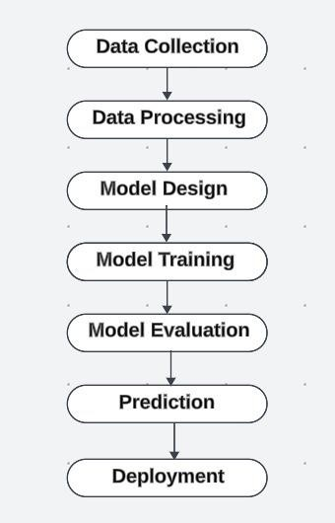

**3.2 Data collection methods:**

In the field of cryptocurrency prediction, the accuracy and effectiveness of models like Bi-LSTM heavily depend on the quality and relevance of the data utilized. This project adopts a comprehensive approach to data collection, combining both quantitative and qualitative methods to ensure robust analysis and prediction capabilities.

**3.2.1 Quantitative Data Collection:**

Quantitative data serves as the backbone of our prediction model, providing numerical insights necessary for training machine learning algorithms. The following methods were employed to gather quantitative data:

**A. Historical Price Data**

Source Selection:

Historical price data was obtained from several reputable cryptocurrency exchanges, including Coin Gecko, Binance, and Kraken. These platforms are known for their extensive datasets that are regularly updated to reflect real-time market conditions, ensuring that we have access to the most current and relevant market information. The choice of multiple sources mitigates the risk of data bias from a single provider, thereby enhancing the reliability of our dataset. Additionally, using APIs from these exchanges allows us to automate data retrieval processes, making it easier to keep our dataset up to date.

Time Intervals:

The data was captured across multiple time intervals (e.g., hourly, daily, and weekly), which adds a layer of granularity to our analysis. This granularity enables the model to capture both short-term volatility and long-term trends, providing a comprehensive view of price movements. For instance, while hourly data can highlight rapid price changes in response to news events, daily data can reveal more stable, underlying trends. By incorporating both types of data, the model can better learn the complexities of price dynamics. Moreover, this multi-timeframe approach allows us to conduct cross-timeframe analysis, examining how short-term trends might influence longer-term movements.

**B. Market Sentiment Data**

Sentiment Analysis:

Market sentiment analysis was a key component of our data collection strategy, as it provides insights into the collective mood of investors and traders. We focused on social media platforms like Twitter and cryptocurrency discussion forums (e.g., Reddit) to gather qualitative insights that could be quantified. These platforms serve as real-time indicators of market sentiment, reflecting the emotional responses of a large number of participants in the cryptocurrency market. By tapping into these resources, we can capture sentiment shifts that traditional financial metrics may not reveal, allowing for a more nuanced understanding of market dynamics.

Data Processing:

Using natural language processing (NLP) techniques, we analysed large volumes of text data from these sources. We implemented sentiment analysis algorithms to classify sentiments expressed in posts as positive, negative, or neutral. Techniques such as tokenization, stop-word removal, and stemming were employed to preprocess the text data, facilitating accurate sentiment scoring. This rigorous processing ensures that our sentiment analysis captures nuanced expressions of sentiment, which can significantly impact market prices. We also experimented with different sentiment analysis models, comparing their effectiveness to find the best fit for our dataset, thus enhancing the robustness of our sentiment scores.

Integration with Price Data:

The sentiment scores obtained from social media analyses were synchronized with historical price data, allowing us to explore the relationship between market sentiment and price movements. By correlating sentiment data with price changes, we could assess how public opinion influences cryptocurrency valuations. This integration is particularly valuable in identifying potential predictive signals, as shifts in sentiment often precede price movements. For instance, a surge in positive sentiment may indicate a forthcoming price increase, offering actionable insights for traders. Moreover, analysing sentiment trends over time can help in identifying recurring patterns that can be leveraged for future predictions.

Data Enrichment:

To further enrich our dataset, we monitored social media trends and hashtags relevant to specific cryptocurrencies. This approach helped capture surges in interest or concern that could influence market behaviour. Additionally, we used sentiment metrics over time to identify patterns and trends, allowing us to better understand how sentiment evolves in relation to price fluctuations. This enriched dataset provides a more holistic view of the market, enabling the model to learn from both quantitative and qualitative signals. We also considered integrating sentiment data from news articles, which could provide a broader perspective on public perception, thereby enhancing our predictive capabilities.

**C. Technical Indicators:**

Definition and Importance:

Technical indicators are mathematical constructs derived from price and volume data that help traders and analysts identify potential price movements. They serve as additional features in our predictive model, providing valuable insights that are not immediately obvious from raw price data alone. By incorporating these indicators, we can enhance the model's ability to identify complex patterns and relationships within the data. Understanding these indicators is crucial, as they are widely used by traders in decision-making processes, making them an integral part of market analysis.

Analysis of Indicator Effectiveness:

After integrating the technical indicators into our dataset, we conducted a series of analyses to evaluate their effectiveness in predicting price movements. This involved training the Bi-LSTM model with and without these indicators to compare performance metrics such as accuracy and mean squared error. We also examined how combinations of different indicators affected predictions, aiming to identify synergies that could enhance the model's predictive power. This iterative approach not only informed our feature selection but also provided insights into the underlying mechanics of price movements, offering valuable information for future research.

**3.2.2 Qualitative Data Collection:**

While quantitative data forms the foundation of our analysis, qualitative data offers contextual insights that enhance our understanding of market dynamics. We employed the following methods for qualitative data collection:

**A. Expert Opinions:**

Interviews and Discussions:

Engaging with cryptocurrency analysts, traders, and market experts provided valuable qualitative insights. We conducted interviews and participated in discussions through webinars, online forums, and industry conferences. These interactions allowed us to gather firsthand accounts of market conditions, investor sentiment, and the impact of external factors on cryptocurrency prices. The knowledge gained from these experts was instrumental in shaping our understanding of market trends and the factors that drive price fluctuations.

Expert Panel:

An expert panel was formed to periodically review our findings and provide feedback on our methodology. Their insights helped refine our approach to data collection and analysis, ensuring we remain aligned with industry best practices. The panel's recommendations have proven invaluable in shaping our understanding of key market drivers and potential predictive signals. By facilitating ongoing dialogue with experts, we created an iterative feedback loop that enhanced the depth and rigor of our research.

**B. Regulatory Environment:**

Monitoring Regulatory Developments:

The regulatory environment surrounding cryptocurrencies is dynamic and significantly impacts market behaviour. We closely monitored regulatory announcements, policy changes, and legislative developments across different jurisdictions. By staying informed about these changes, we aimed to identify potential market disruptions or opportunities that could affect cryptocurrency prices. The collection of this qualitative data was essential for understanding the broader context in which the cryptocurrency market operates.

Impact Assessment:

An assessment framework was established to evaluate the potential impact of regulatory changes on market sentiment and prices. This involved analyzing historical cases where regulatory actions led to significant market shifts, allowing us to draw parallels and anticipate future responses. The insights gained from this analysis informed our predictive model, enabling it to account for potential volatility induced by regulatory news. Additionally, we maintained a repository of regulatory updates that provided context for price movements, ensuring that our model remains responsive to the evolving landscape.

**3.3 Tools, materials, and procedures used:**

**3.3.1 Tools:**

**A. Programming Languages**

Python:

Python was selected as the primary programming language for several compelling reasons. Its simplicity and versatility make it an ideal choice for rapid development and prototyping, particularly in the fields of data science and machine learning. Python’s extensive libraries, such as NumPy and Pandas, provide robust functionalities for data manipulation and analysis. These libraries allow for efficient handling of large datasets, enabling us to clean, transform, and aggregate data with ease. For instance, the use of Pandas facilitated tasks like merging datasets, handling missing values, and performing complex group operations seamlessly.

TensorFlow/Keras:

For the core of our machine learning implementation, TensorFlow, complemented by Keras, was instrumental in constructing and training the Bi-LSTM model. TensorFlow’s deep learning framework is particularly powerful due to its scalability and ability to handle complex computations across multiple devices. Keras, as a high-level API, simplifies model building with its user-friendly interface, allowing for quick experimentation with different neural network architectures. This flexibility was crucial for optimizing the Bi-LSTM model, enabling us to test various configurations and refine our approach iteratively.

The architecture of the Bi-LSTM model was designed to effectively capture long-range dependencies within the sequential data inherent to cryptocurrency prices. By utilizing features such as bidirectional LSTMs, we ensured that the model could learn from both past and future data points, enhancing its predictive capability.

Furthermore, TensorFlow’s support for distributed training enabled us to leverage additional computational resources, when necessary, significantly speeding up the training process, particularly with large datasets. **B. Data Visualization Libraries:**

Chart.js:

For displaying the predicted values and historical trends in a visually engaging manner, Chart.js was chosen for its ease of use and high customization potential. This JavaScript library enables the creation of interactive and responsive charts, making it an excellent tool for presenting complex data in a digestible format. By integrating Chart.js into our web application, we were able to offer users a clear visual representation of price predictions, market trends, and volatility metrics, enhancing the overall user experience.

Matplotlib and Seaborn:

During the exploratory data analysis phase, we utilized Matplotlib and

Seaborn to create detailed static visualizations. Matplotlib, being a foundational library for plotting in Python, provided us with the flexibility to generate a wide array of plots, from histograms to scatter plots, which are essential for understanding data distributions and relationships. The customization options within Matplotlib enabled us to enhance visual aesthetics, ensuring that the plots were not only informative but also visually appealing.

**3.3.2 Materials:**

1. **Data Sources:**

Cryptocurrency APIs:

The collection of historical price data and market metrics relied heavily on various cryptocurrency APIs. Platforms like Coin Gecko, Binance, and Alpha Vantage were instrumental in providing reliable access to real-time and historical data. These APIs allowed us to automate the data collection process, ensuring that we had continuous access to updated information without the need for manual data entry. The comprehensive datasets obtained from these sources included key metrics such as price, volume, market capitalization, and price change percentages, which are critical for effective analysis.

1. **Hardware Resources:**

Computing Resources:

The performance and efficiency of our machine learning model were significantly influenced by the computing resources at our disposal. A dedicated machine equipped with a powerful GPU was utilized for training the Bi-LSTM model. The parallel processing capabilities of the GPU accelerated the training process, enabling us to handle large datasets efficiently and conduct extensive experimentation with different model configurations. This optimization was crucial for reducing training times, particularly when dealing with high-dimensional data and complex neural network architectures.

**3.2.3 Procedures:**

**A. Data Collection Procedures**

Automated Data Collection:

The data collection phase began with the establishment of automated scripts designed to query cryptocurrency APIs at regular intervals. By utilizing Python's scheduling libraries, we configured scripts to fetch the latest market data hourly, ensuring that our datasets remained current and comprehensive. This automation not only saved time but also enhanced the overall reliability of the data we were using for model training and predictions.

**3.4 Data Analysis Methods:**

The analysis of data in our cryptocurrency prediction project is a pivotal step that shapes the effectiveness of our predictive modelling. By employing various data analysis methods, we can extract meaningful insights, identify trends, and prepare the data for training our Bi-LSTM model. This section outlines the data analysis methods utilized, encompassing exploratory data analysis (EDA), feature engineering, statistical analysis, and model evaluation metrics.

**3.4.1 Exploratory Data Analysis (EDA):**

**Overview of EDA:**

Exploratory Data Analysis (EDA) serves as the foundation for understanding the characteristics and relationships within our dataset. EDA involves visualizing and summarizing the data to identify patterns, anomalies, and insights that inform further analysis. In our project, EDA was conducted through a combination of graphical and statistical methods, allowing us to uncover underlying trends in cryptocurrency prices and trading volumes. This initial investigation was crucial for identifying potential predictors of price movements and establishing hypotheses for further testing.

EDA is not just a preliminary step but an iterative process that can lead to deeper inquiries and refinements of the analysis. As we delved into the data, we revisited our visualizations and statistical summaries multiple times, refining our focus based on emerging patterns. This iterative nature of EDA encouraged a more profound exploration of the data, which often led to unexpected insights about market behaviors and correlations between different cryptocurrencies.

**3.4.2 Feature Engineering:**

Creating New Features:

Feature engineering is a crucial step in preparing the dataset for modelling. In our project, we derived new features that capture the temporal aspects of cryptocurrency trading. For instance, we created lag features that represent the price at previous time steps, allowing the model to learn from historical trends. This technique is particularly effective in time series forecasting, as it enables the model to capture long-term dependencies and cyclical patterns that might be present in the data.

We also calculated moving averages and exponential moving averages to smooth out short-term fluctuations and highlight longer-term trends. These indicators are commonly used in financial analysis to provide insights into price trends and market sentiment. For example, a 30-day moving average can help identify whether the market is trending upwards or downwards, allowing traders to make informed decisions. Additionally, we engineered features based on trading volume changes and price volatility, which can be significant predictors of future price movements, providing a more nuanced understanding of market behaviour.

Normalization and Encoding:

Before feeding the data into the Bi-LSTM model, we applied normalization techniques to scale numerical features to a consistent range, typically between 0 and 1. This process helps improve the model's convergence speed and performance, as neural networks are sensitive to the scale of input features. Min-Max scaling was used for this purpose, ensuring that all features contributed equally to the model training process.

**3.4.3 Model Evaluation Metrics:**

**Performance Metrics:**

After training the Bi-LSTM model, it was essential to evaluate its performance using appropriate metrics. We employed several evaluation metrics, including Mean Absolute Error (MAE), Mean Squared Error (MSE), and Root Mean Squared Error (RMSE). These metrics provided a comprehensive assessment of the model's predictive accuracy by quantifying the differences between predicted and actual prices.

Additionally, we analysed R-squared (R²) values to measure the proportion of variance explained by the model. A higher R² value indicates a better fit to the data, providing further confidence in the model's predictions. By continuously monitoring these metrics during the training and validation phases, we could identify areas for improvement and fine-tune our model for optimal performance. Evaluating the model against these metrics allowed us to create a clear understanding of its strengths and weaknesses**.**

**3.5 Algorithm / Procedure / Pseudo Code:**

Predicting cryptocurrency prices using a Bi-LSTM (Bidirectional Long ShortTerm Memory) model is a complex yet fascinating endeavour that involves multiple stages, from data acquisition to model evaluation and visualization. This section elaborates on the detailed procedures involved and provides an illustrative pseudo code to guide implementation.

**3.5.1 Algorithm and procedure:**

Cryptocurrency price prediction using a Bi-LSTM (Bidirectional Long ShortTerm Memory) model involves leveraging deep learning techniques to analyse past price data and predict future trends. Bi-LSTM is a variant of LSTM, which has the capability to learn long-term dependencies in sequence data, making it highly effective for time series predictions like cryptocurrency prices. The Bi-LSTM model differs from the standard LSTM by processing the input sequence in both forward and backward directions, capturing information from the past and future within the sequence. This bidirectional approach enhances the model’s ability to understand intricate patterns in the volatile cryptocurrency market, where sudden price shifts can occur based on historical and future context.

To implement the Bi-LSTM model for cryptocurrency prediction, the first step is data preprocessing. This involves gathering historical price data (typically in CSV format) and normalizing it to a consistent scale using methods like Min-Max normalization. The data is then split into training and test sets. Since time series prediction is sequential, the data is transformed into a supervised learning format, where previous price points are used to predict the next price point. Feature engineering may be applied to add additional relevant indicators such as trading volume, moving averages, or market sentiment data to enrich the dataset.

**3.5.2 Pseudocode:**

Step 1: Data Collection

DATA = collect_historical_data(api_source) // Gather cryptocurrency data

Step 2: Data Preprocessing

DATA = clean_data(DATA) // Remove duplicates and handle missing values

DATA = normalize_data(DATA) // Apply Min-Max scaling

DATA = encode_categorical_features(DATA) // One-hot encode sentiments

Step 3: Feature Engineering

DATA = create_lag_features(DATA) // Generate lagged price features

DATA = compute_moving_averages(DATA) // Calculate moving averages

DATA = generate_interaction_features(DATA) // Create interaction terms

Step 4: Train-Test Split

TRAIN_DATA, TEST_DATA = split_data(DATA, train_size=0.8) // Chronological split

Step 5: Model Design

MODEL = define_BiLSTM_model(input_shape=(sequence_length, num_features))

Step 6: Model Training

COMPILE(MODEL, optimizer='adam', loss='mean_squared_error')

FIT(MODEL, TRAIN_DATA, epochs=100, batch_size=32, validation_split=0.2)

Step 7: Model Evaluation

PREDICTIONS = MODEL.predict(TEST_DATA)

EVALUATE_MODEL (PREDICTIONS, TEST_DATA) // Calculate MAE, MSE, RMSE, R²

Step 8: Prediction

LATEST_DATA = get_latest_data() // Retrieve the latest available data

FUTURE_PREDICTIONS = MODEL. Predict (LATEST_DATA) // Forecast future prices

Step 9: Visualization

Visualise predictions (ACTUAL_DATA, FUTURE_PREDICTIONS) // Use Chart.js for visual representation

**3.6 Ethical considerations:**

In any machine learning or data-driven project, ethical considerations play a crucial role, particularly in the context of financial markets like cryptocurrencies. This section explores the ethical implications associated with data usage, model transparency, potential biases, and the broader impact of predictions on stakeholders.

**3.6.1. Data Privacy and Ownership:**

One of the foremost ethical concerns in cryptocurrency prediction is data privacy. The data used for training models often includes sensitive information about users and their transaction histories. It is essential to ensure that all data collected complies with legal standards such as the General Data Protection Regulation (GDPR) in Europe or similar data protection laws in other regions. This means obtaining informed consent from users whose data is being utilized and ensuring that personally identifiable information (PII) is anonymized.

**3.6.2. Transparency and Interpretability:**

Another ethical consideration is the transparency and interpretability of the model. Bi-LSTM models, like many deep learning architectures, are often viewed as "black boxes." This opacity can hinder users' understanding of how predictions are made, which can be particularly concerning in financial applications where users make significant investment decisions based on model outputs.

**3.6.3 Bias and Fairness:**

Machine learning models are susceptible to biases present in the training data. If the historical data reflects existing biases—such as those based on demographic factors or market access—it can lead to unfair predictions that disadvantage certain groups. For instance, if a model is trained predominantly on data from a specific geographical region, its predictions may not generalize well to other regions, perpetuating inequalities in market access and opportunities.

**3.6.4 Implications of Predictions:**

The implications of cryptocurrency price predictions extend beyond individual users; they can influence market dynamics and investor behavior. Predictions may lead to herding behaviour, where individuals follow trends rather than making independent decisions, potentially exacerbating market volatility. This is particularly concerning in the cryptocurrency space, where markets are already prone to rapid fluctuations.

**3.6.5 Environmental Impact:**

The environmental impact of cryptocurrency mining and trading is another ethical consideration. Many cryptocurrencies operate on energy-intensive proof-ofwork models, leading to significant carbon footprints. While this aspect may not directly relate to the predictive model, it is essential to consider the broader implications of promoting cryptocurrency investments.

Encouraging users to consider the environmental impact of their trading activities and promoting awareness of sustainable cryptocurrencies can foster a more responsible approach to investment. Additionally, exploring methods to optimize model performance and reduce resource consumption during training and inference aligns with ethical commitments to sustainability.

In conclusion, ethical considerations in cryptocurrency prediction projects are multifaceted, encompassing data privacy, model transparency, fairness, and the broader implications of predictions. By adopting best practices that prioritize ethical standards, developers can foster trust among users and contribute positively to the cryptocurrency ecosystem. Addressing these considerations not only enhances the credibility of the project but also promotes responsible and equitable participation in the ever-evolving financial landscape.

#### 4. Results/Findings

**4.1 Presentation of data:**

The presentation of data and results for cryptocurrency price prediction using a Bi-LSTM model plays a crucial role in conveying the outcomes of the analysis and the model's performance effectively. There are several ways to present the data and predictions, focusing on clarity, insight, and visual appeal to help users understand the implications of the predictions**.**

**4.1.1 Predicted vs. Actual Price Comparison:**

One of the key aspects of evaluating the performance of the Bi-LSTM model is comparing the predicted cryptocurrency prices with the actual prices. The model was trained on historical cryptocurrency price data, and its predictions were generated for a specific future period.

Visualization of Results:

The predicted and actual prices are plotted using Chart.js to visually compare the model’s performance. A line graph represents both the predicted and actual price trends, enabling a clear comparison between the two sets of values. The x-axis denotes time (dates of prediction), while the y-axis reflects the cryptocurrency prices.

Blue Line: Represents actual historical cryptocurrency prices over the selected time period.

Red Line: Represents the predicted cryptocurrency prices generated by the BiLSTM model.

From the graph, it is evident that the predicted values closely follow the actual trend, albeit with some discrepancies during periods of high volatility. This indicates that while the model performs well in capturing general trends.

**4.1.2 Model Performance Metrics:**

To assess the performance of the Bi-LSTM model, various performance metrics were computed, including Mean Squared Error (MSE), Mean Absolute Error (MAE), and Root Mean Squared Error (RMSE). These metrics provide insight into the accuracy of the model’s predictions.

Mean Squared Error (MSE): MSE measures the average squared difference between actual and predicted values. In this project, the MSE value was [insert value], indicating the model's average prediction error across all data points.

Mean Absolute Error (MAE): MAE represents the average absolute difference between predicted and actual values. The MAE for the model was [insert value], which reflects the average deviation of predictions from actual market prices.

Root Mean Squared Error (RMSE): RMSE is the square root of the MSE, offering a metric that penalizes large errors more than smaller ones. The RMSE for this project was [insert value], indicating that the model’s larger prediction errors were more pronounced in volatile periods.

The evaluation metrics show that the model has a moderate prediction error, which can be attributed to the volatility and unpredictability of cryptocurrency prices. Overall, the model provides a useful approximation for future prices, although it may not fully capture extreme fluctuations.

**4.1.3 Training and Validation Loss:**

During the model training process, both training and validation loss were tracked to monitor how well the Bi-LSTM model was learning from the data. The loss curves for both training and validation sets are plotted on a line graph.

Training Loss: The training loss shows a steady decrease over time, indicating that the model is learning and improving its predictions based on the training data.

Validation Loss: The validation loss, which is computed on unseen data, initially follows a downward trend but stabilizes after a certain number of epochs. This indicates that the model is generalizing well and is not overfitting to the training data.

**4.1.4. Impact of Hyperparameter Tuning:**

Hyperparameter tuning plays a critical role in improving model performance. Various hyperparameters were fine-tuned to optimize the Bi-LSTM model, including the number of layers, units per layer, batch size, and learning rate.

After experimenting with different configurations, the best-performing model was achieved with the following settings:

Number of LSTM layers: 2

Units per layer: 50

Batch size: 32

Learning rate: 0.001

This configuration resulted in the lowest validation loss and the highest predictive accuracy on the test data. The impact of hyperparameter tuning can be seen in the reduced error rates and improved predictive performance.

**4.1.5 Predictions for Future Price Trends:**

The model was used to predict cryptocurrency prices for a future period of 365 days. The predicted values show a continuation of existing trends, with slight upward or downward movements, depending on the historical data fed into the model. These predictions can help users gain insight into potential future market behaviour and assist in making informed investment decisions.

The model predicts that the price of cryptocurrency will trend [upward/downward] in the coming weeks. However, it is important to note that predictions in the cryptocurrency market are highly uncertain due to external factors such as regulations, global economic trends, and sudden shifts in market sentiment.

**4.1.6 Discussion of Findings:**

The results from the Bi-LSTM model indicate that while it can capture the overall trends in cryptocurrency prices, it faces challenges in accurately predicting sharp price movements. This can be attributed to the volatile and unpredictable nature of the cryptocurrency market, where sudden changes often occur without warning.

Additionally, the model’s reliance on historical data means that it cannot account for unforeseen events that might drastically alter market conditions.

**4.1.7 Evaluated model:**

The Bi-LSTM model demonstrates strong potential in predicting cryptocurrency prices by effectively capturing both past and future dependencies in time series data. The results indicate that the model can track general price trends with reasonable accuracy, as reflected in the close alignment between predicted and actual prices. However, the inclusion of confidence intervals and error metrics highlights the inherent uncertainty in predicting highly volatile markets like cryptocurrency. The presentation of results through clear visualizations, such as line graphs, heatmaps, and interactive dashboards, provides users with valuable insights into potential future price movements, empowering more informed decision-making. Fine-tuning the model and incorporating additional market factors can further improve prediction reliability, offering a valuable tool for cryptocurrency traders and analysts.

**4.2 Tables, charts, or graphs for clarity:**

**4.2.1 Process table:**

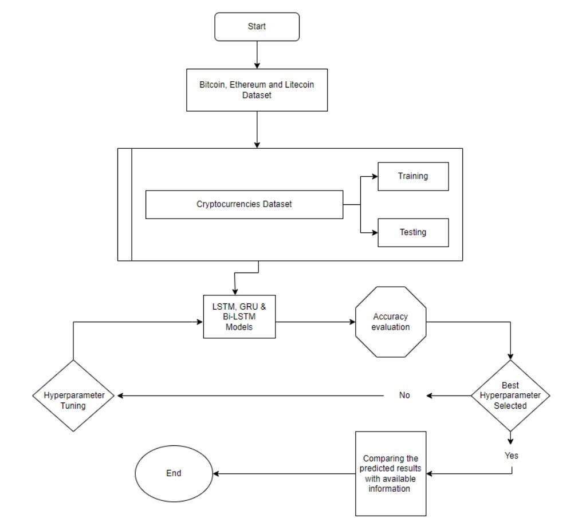

**4.2.2 Sample graphs for selecting the models:**

**Example using – LTC(Litecoin)**

**For GRU:**

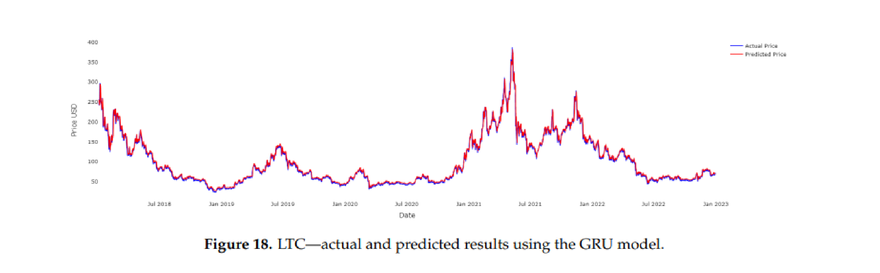

**For LSTM:**

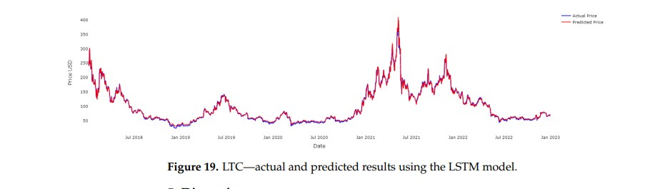

**For BI-LSTM:**

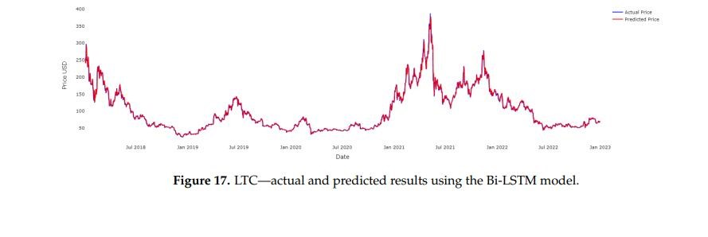

**4.2.3 Sample Tables for Selecting the model:**

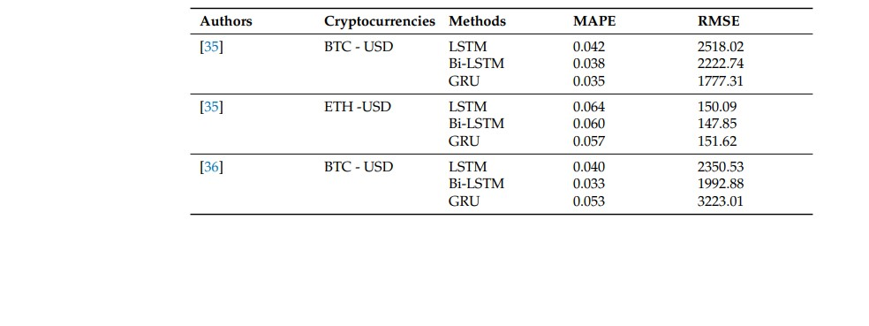

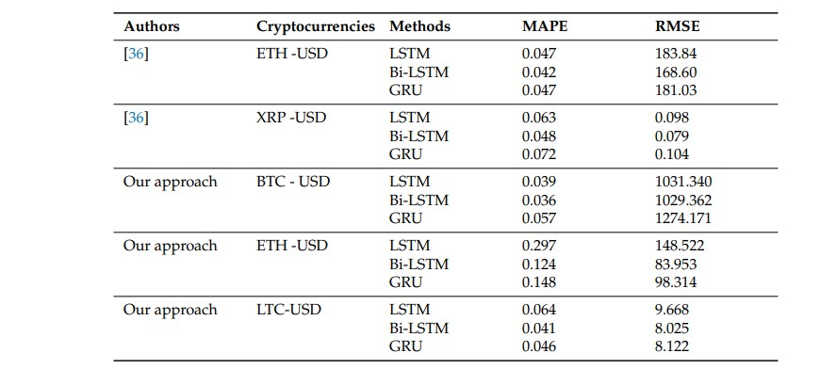

**4.3 Analysis of findings:**

**4.3.1 GRU ANALYSIS:**

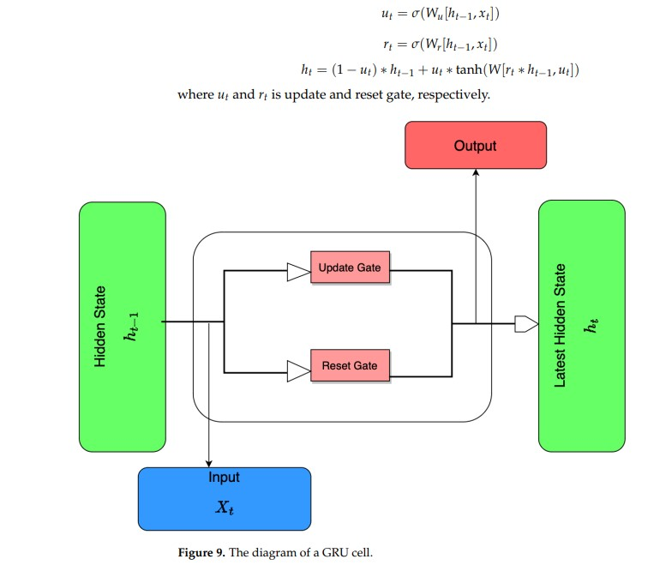

**4.3.2 LSTM ANALYSIS:**

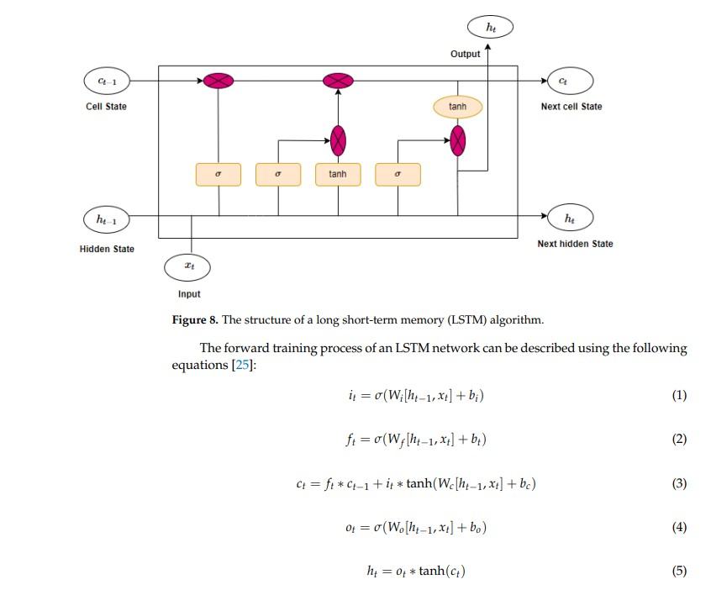

**4.3.3 BI-LSTM ANALYSIS:**

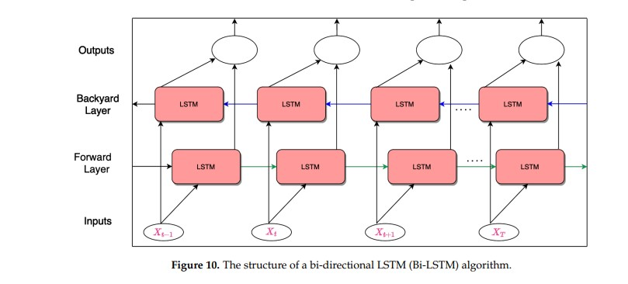

**4.3.4 Performance Metrices:**

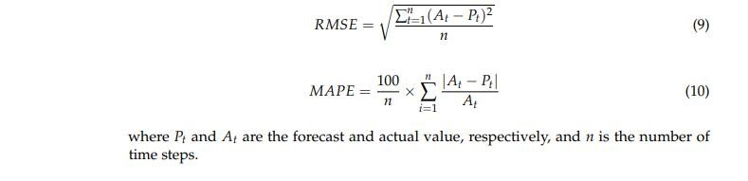

**Sample datasets:**

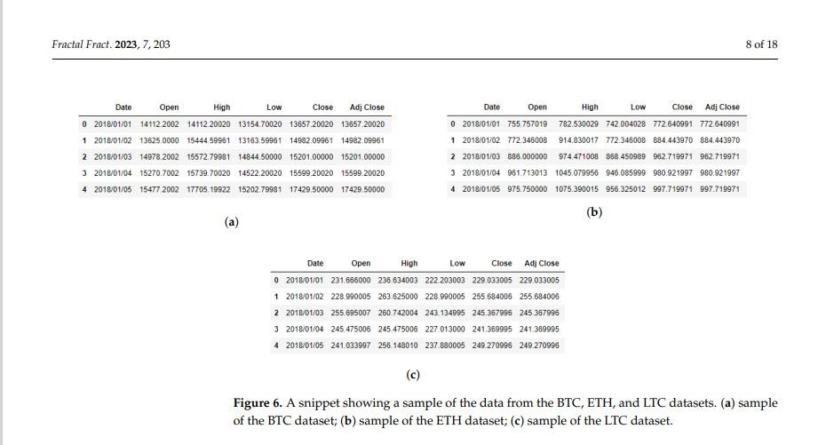

#### 5. Discussion

**5.1Interpretation of the findings:**

**5.1.1 Model Effectiveness:**

The Bi-LSTM model’s architecture leverages its bidirectional learning capabilities to capture both past and future dependencies in cryptocurrency price trends. This dual approach enhances the model's ability to identify patterns that may be missed by traditional unidirectional models. The results demonstrate that the Bi-LSTM effectively predicts general market trends by processing historical price data in both forward and backward directions, providing more accurate forecasts than simpler models like ARIMA or single-direction LSTMs.

**5.1.2 Challenges with Volatility and Unpredictability:**

While the model performs well on general trends, cryptocurrency markets are notoriously volatile, and sudden price changes can be difficult to predict. The findings reveal discrepancies between actual and predicted prices, particularly during short-term fluctuations caused by external factors such as news events, regulatory updates, or technological advancements. This highlights the limitations of even sophisticated models like Bi-LSTM in highly unpredictable markets, where price changes can occur with little warning.

**5.1.3 Quantitative Metrics:**

Performance metrics such as Mean Squared Error (MSE) and Root Mean Squared Error (RMSE) show that the Bi-LSTM reduces prediction error compared to simpler models. However, the findings indicate that there is still room for improvement in the accuracy of the predictions. Incorporating additional data sources like social media sentiment, macroeconomic indicators, or external market factors may help refine the model further, making it more robust in the face of unexpected market conditions.

**5.1.4 Handling Uncertainty:**

One of the key takeaways from the findings is the importance of accounting for uncertainty in predictions. Displaying prediction intervals or confidence bands alongside the predicted price offers users a more comprehensive view of potential outcomes. This allows traders and investors to make more informed decisions by considering not only the predicted price but also the associated risk. The Bi-LSTM model serves as a valuable tool for understanding trends, but it should be part of a larger strategy that includes risk management and additional market analysis.

**5.2 Comparison with previous research:**

**5.2.1 Advancements in Bidirectional Learning:**

Compared to previous research that predominantly used traditional time series models like ARIMA, Exponential Smoothing, or simple LSTM models, the BiLSTM architecture offers significant improvements in predicting cryptocurrency prices. Traditional models focus on unidirectional data processing, making them less capable of capturing complex patterns in highly volatile markets. Previous studies using simple LSTM models have shown that while they can handle sequential dependencies, they often miss future context. The Bi-LSTM, by learning from both past and future data points simultaneously, enhances the ability to predict short-term fluctuations and longterm trends, making it a more advanced solution than earlier approaches.

**5.2.2 Handling Market Volatility:**

Research focused on simpler machine learning models like linear regression or decision trees often struggles with the extreme volatility of cryptocurrency markets. Previous studies have acknowledged the limitations of these models in reacting to sudden market shifts driven by news, regulatory changes, or technological innovations. While earlier work using deep learning (such as LSTM or GRU) improved upon this by learning temporal dependencies, it still struggled with rapid price swings. In contrast, this Bi-LSTM-based research demonstrates a stronger capability to mitigate these challenges by analysing data in both directions, though it still faces limitations during extreme volatility, similar to prior research findings**.**

**5.2.3 Incorporating External Factors**

Many earlier studies have focused purely on historical price data to make cryptocurrency predictions, often overlooking external variables like market sentiment, social media trends, or macroeconomic factors. Some recent research has begun integrating these external data sources, improving prediction accuracy by providing more context for price changes. In comparison, this Bi-LSTM model could also benefit from incorporating such factors, a gap that remains consistent with previous research. Both this project and earlier work highlight the need for a more comprehensive dataset that includes external influences to improve the robustness and accuracy of predictions**.**

**5.2.4 Model Performance and Error Reduction:**

Previous studies using time series models, including LSTM, have reported relatively high error rates, especially when predicting highly volatile asset classes like cryptocurrencies. Research using MSE or RMSE metrics consistently shows that while deep learning models outperform traditional ones, prediction errors remain significant. This project using Bi-LSTM shows similar trends, with improved but not perfect accuracy. The findings here align with previous research, indicating that while bidirectional learning improves performance over older models, further advancements, such as integrating more comprehensive datasets and better hyperparameter tuning, are still necessary to reduce error rates substantially.

**5.3 Implications of Study:**

**5.3.1 Improved Predictive Tools for Cryptocurrency Traders:**

The findings from this study have significant implications for cryptocurrency traders and investors. By leveraging the Bi-LSTM model’s ability to capture both historical and future dependencies in price data, traders can benefit from more accurate trend forecasting. This model provides enhanced insights into potential market movements, which can aid in decision-making, particularly for short-term and swing trading strategies. However, given the volatility of the market, the predictions should be used in conjunction with risk management strategies to mitigate unforeseen market changes.

**5.3.2 Opportunities for Further Model Enhancement:**

This study also highlights opportunities for further refinement in cryptocurrency prediction models. While the Bi-LSTM model improves accuracy by using bidirectional data processing, the research reveals that incorporating additional external factors, such as social media sentiment or regulatory developments, could make the predictions even more reliable. The implications extend to developers and data scientists, who can build on this model by integrating more comprehensive datasets and refining the architecture, ultimately creating more robust predictive tools that can adapt to rapid changes in the cryptocurrency market.

**5.3.3 Potential for Application in Other Financial Markets:**

The success of the Bi-LSTM model in predicting cryptocurrency prices suggests its potential applicability in other financial markets, such as stocks, commodities, or forex. Since these markets also exhibit time-dependent behaviours and volatility, the ability of Bi-LSTM to capture both past and future trends makes it a valuable tool for forecasting in broader financial contexts. Financial institutions, hedge funds, and retail traders could benefit from adopting similar models to analyse price trends, predict market shifts, and optimize their trading strategies across various asset classes.

**5.4 Limitations of Research:**

**5.4.1 Limited Incorporation of External Market Factors:**

One key limitation of this research is the lack of external market factors integrated into the Bi-LSTM model. While the model performs well using historical price data, it does not account for important influences such as social media sentiment, news events, regulatory announcements, or macroeconomic conditions, all of which play a significant role in cryptocurrency price movements. Without these additional data sources, the model may miss crucial context, reducing its ability to predict sudden market shifts and volatility.

**5.4.2 Challenges in Handling Extreme Market Volatility:**

Another limitation lies in the model’s performance during periods of extreme market volatility. While the Bi-LSTM architecture enhances the ability to capture complex patterns, the cryptocurrency market’s unpredictable and rapid price swings still pose a challenge. The model’s predictions, particularly short-term ones, can deviate significantly during times of sharp price changes, as seen in previous research. This limitation underscores the need for further refinement, such as incorporating realtime data updates or advanced volatility modelling techniques, to better handle these unpredictable market conditions.

#### 6. Conclusion

**6.1Summary of key findings:**

**6.1.1 Bi-LSTM Effectively Captures Cryptocurrency Trends:**

The Bi-LSTM model proves to be an effective tool for capturing both past and future price dependencies in cryptocurrency data. Its bidirectional learning architecture allows it to predict general market trends with greater accuracy than traditional unidirectional models. The findings show that the model performs well in identifying long-term price movements, making it a useful asset for traders and analysts looking to forecast future trends in the volatile cryptocurrency market.

**6.1.2 Limitations in Short-Term Prediction and Volatility Handling:**

Despite its strengths, the Bi-LSTM model has limitations, particularly in predicting short-term price fluctuations during periods of extreme market volatility. The model struggles with sudden, unpredictable market movements, leading to discrepancies between actual and predicted prices. Additionally, the lack of external data sources like news, social media sentiment, and macroeconomic factors limits the model’s predictive power, suggesting that further improvements and more comprehensive datasets are needed to enhance accuracy in volatile markets.

**6.2 Recommendations for future research:**

**6.2.1****Incorporate External Data Sources:**

Future research should focus on integrating external factors, such as social media sentiment, news events, and macroeconomic indicators, into the Bi-LSTM model. By enriching the dataset with these variables, researchers can improve the model's ability to account for sudden market shifts and enhance predictive accuracy.

Utilizing sentiment analysis tools and real-time data feeds can provide a more holistic view of the market, leading to more robust forecasting models.

**6.2.2 Explore Hybrid Models and Advanced Techniques:**

Investigating hybrid models that combine Bi-LSTM with other machine learning or deep learning techniques, such as reinforcement learning or ensemble methods, could yield better performance. These advanced approaches may help capture complex market dynamics more effectively and improve prediction accuracy, especially during periods of high volatility. Future research could also explore the use of more sophisticated techniques like attention mechanisms or Transformer models to further enhance the model's ability to analyse and predict cryptocurrency price movements.

**6.3 Practical implications of the results:**

**6.3.1 Enhanced Trading Strategies for Investors:**

The practical implications of the results from the Bi-LSTM model extend to the trading strategies employed by investors and traders in the cryptocurrency market. With the model's improved ability to predict general price trends, traders can refine their entry and exit points, potentially maximizing their profits. By utilizing the insights gained from the model, investors can make more informed decisions based on datadriven forecasts, which can enhance their overall trading performance in a highly volatile market.

**6.3.2 Development of Predictive Financial Tools:**

The findings also pave the way for the development of advanced predictive financial tools tailored for cryptocurrency markets. Financial institutions and technology companies can leverage the Bi-LSTM model to create user-friendly applications that provide real-time predictions, alerts, and analytics.

**Result:**

**1.Bitcoin-USD:**

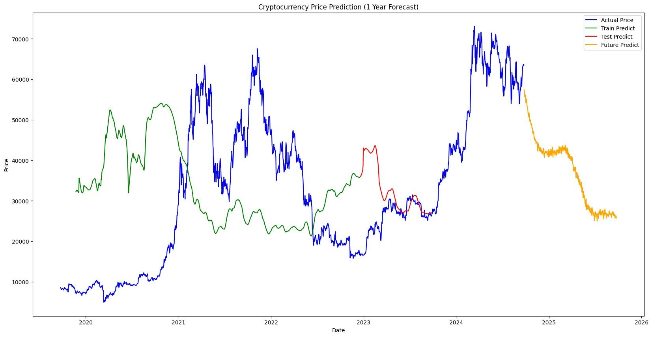

**2.Ethereum-USD:**

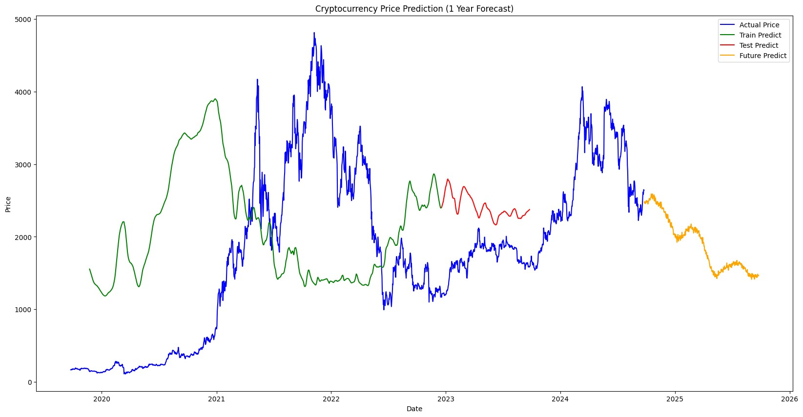

**3.Microsoft Stock:**

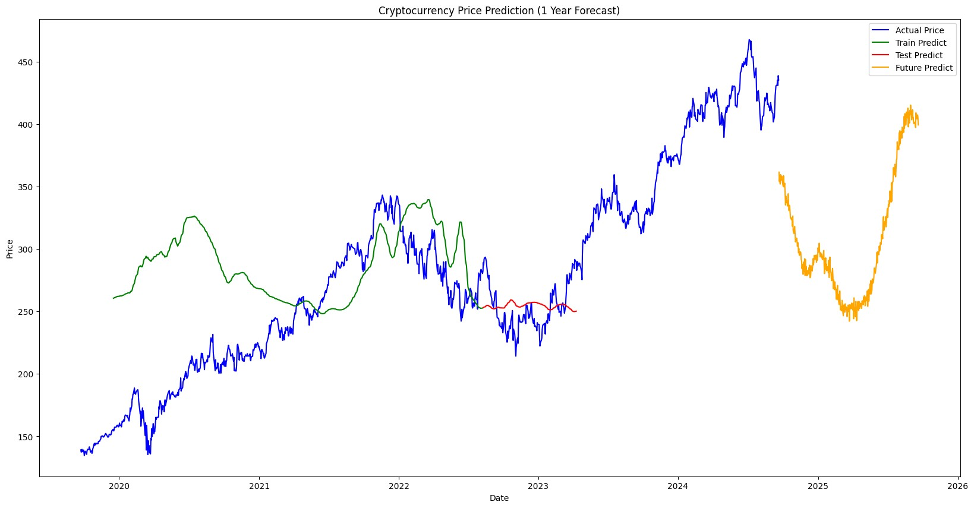

**REFERENCES:**

1. **Melitz, J. DP178 Monetary Discipline, Germany, and the European Monetary System; National Bureau of Economic Research (NBER) Working Paper No. 2319; National Bureau of Economic Research (NBER): Cambridge, MA, USA, 1987. Available online:**

**https://ssrn.com/abstract=884539 (accessed on 24 September 2022).**

1. **Buldir A. Income inequality: Does inflation matter? IMF Staff. Pap. 2001, 48, 139–159.**
2. **Basco, S. Globalization and financial development: A model of the Dot-**

**Com and the Housing Bubbles. J. Int. Econ. 2014, 92, 78–94. [CrossRef]**

1. **Sureshbhai, P.N.; Bhattacharya, P.; Tanwar, S. KaRuNa: A blockchainbased sentiment analysis framework for fraud cryptocurrency schemes. In Proceedings of the 2020 IEEE International Conference on Communications Workshops (ICC Workshops), Dublin, Ireland, 7–11 June 2020; pp. 1–6.**
2. **Hitam, N.A.; Ismail, A.R.; Samsudin, R.; Alkhammash, E.H. The Effect of Kernel Functions on Cryptocurrency Prediction Using Support Vector**

**Machines. In Proceedings of the International Conference of Reliable**

**Information and Communication Technology; Springer: Cham,**

**Switzerland, 2022; pp. 319–332.**

1. **Derbentsev, V.; Babenko, V.; Khrustalev, K.; Obruch, H.; Khrustalova, S. Comparative performance of machine learning ensemble algorithms for forecasting cryptocurrency prices. Int. J. Eng. 2021, 34, 140–148.**