

KGP-RISC PROCESSOR  
INSTRUCTION SET ARCHITECTURE

Computer Organization and Architecture Laboratory  
Autumn-2021

GROUP: 59  
Ramtej Doma (19CS10028)  
Vamshi Lavoori (19CS30026)

**Contents:**

1. Architecture Diagram
2. Instruction Set and Format
3. Control Signals and Data path
4. Modules/Hardware Components
5. Testing
6. How to RUN

**1. Architecture Diagram**

***Please refer **Architecture.png** and **ALU.png** for better visibility***

**2. Instruction Set and Format**

**Type 1:** Register-type instructions

|  |  |  |  |  |  |  |  |
| --- | --- | --- | --- | --- | --- | --- | --- |
| Instruction | usage | Action | Opcode  [31:26] | Register 1  [25:21] | Register 2  [20:16] | Shift Amount  [15:10] | Function Code  [9:0] |
| Class: Arithmetic | | | | | | | |
| Addition | **add rs,rt** | rs 🡨 (rs)+(rt) | 000000 | rs | rt | N.A | 0000000000 |
| Compliment | **comp rs, rt** | rs🡨2'scomplement (rt) | 000000 | rs | rt | N.A | 0000000001 |
| Class: Logic | | | | | | | |
| AND | **and rs, rt** | rs 🡨 (rs) & (rt) | 000000 | rs | rt | N.A | 0000000010 |
| XOR | **xor rs, rt** | rs 🡨 (rs) ^ (rt) | 000000 | rs | rt | N.A | 0000000011 |
| Class: Shift | | | | | | | |
| Shift left logical | **shll rs, sh** | rs 🡨 left-shifted by sh | 000000 | rs | N.A | sh | 0000000100 |
| Shift right  logical | **shrl rs, sh** | rs 🡨 right shifted by sh | 000000 | rs | N.A | sh | 0000000101 |
| Shift left logical variable | **shllv rs, rt** | rs 🡨 (rs) left-shifted by (rt) | 000000 | rs | rt | N.A | 0000000110 |
| Shift right logical  variable | **shrlv rs, rt** | rs 🡨 (rs) right-shifted by (rt) | 000000 | rs | rt | N.A | 000000111 |
| Shift right  arithmetic | **shra rs, sh** | rs 🡨(rs) arithmetic right-shifted by sh | 000000 | rs | N.A | sh | 0000001000 |
| Shift right  Arithmetic  variable | **shrav rs, sh** | rs 🡨(rs) arithmetic right-shifted by (rt) | 000000 | rs | rt | N.A | 0000001001 |

**No of instructions of this type:** 10 **No of instruction can be added further:** (max) 65,524, (min up to) 1014

**Type2:** Immediate-Type Instructions

|  |  |  |  |  |  |  |
| --- | --- | --- | --- | --- | --- | --- |
| Instruction | usage | Action | Opcode [31:26] | Register 1 [25:21] | Register 2 [20:16] | imm [15:0] |
| Class: Memory | | | | | | |
| Load Word | **lw rt, imm(rs)** | rt 🡨 [mem[(rs) + imm] | 000001 | rs | rt | Immediate value |
| Store Word | **sw rt, imm(rs)** | mem[(rs) + imm] 🡨 (rt) | 000010 | rs | rt | Immediate value |
| Class: Arithmetic | | | | | | |
| Addition  immediate | **addi rs, imm** | rs 🡨 (rs) + imm | 000011 | rs | N.A | Immediate value |
| Compliment  immediate | **compi rs, imm** | rs 🡨 2'sCompliment(imm) | 000100 | rs | N.A | Immediate value |

**No of instructions of this type:** 4 **No of instruction can be added further:** max up to 51  
**Immediate value range:** [-32768, 32767]

**Type3:** Branch_1

|  |  |  |  |  |
| --- | --- | --- | --- | --- |
| Instruction | usage | Action | Opcode  [31:26] | Label Address [25:0] |
| Class: Branch | | | | |
| Unconditional  Branch | **b L** | goto L | 000101 | L |
| Branch and  Link | **bl L** | goto L;  (31) 🡨 (PC)+4 | 000110 | L |
| Branch on  Carry | **bcy L** | goto L if Carry = 1 | 000111 | L |
| Branch on  No Carry | **bncy L** | goto L if Carry = 0 | 001000 | L |

**No of instructions used of this type:** 4 **No of instruction can be added further:** max up to 51  
**label address offset range:** [-33554432, 33554431]

**Type 4:** Branch_2

|  |  |  |  |  |  |
| --- | --- | --- | --- | --- | --- |
| Instruction | usage | Action | Opcode [31:26] | Register 1  [25:21] | Label Address [20:0] |
| Class: Branch | | | | | |
| Branch register | **br rs** | goto (rs) | 001001 | rs | N.A |
| Branch on less  than zero | **bltz rs, L** | if(rs) < 0 then goto L | 001010 | rs | L |
| Branch on flag  zero | **bz rs, L** | if(rs) = 0 then goto L | 001011 | rs | L |
| Branch on flag not zero | **bnz rs, L** | if(rs) != 0 then goto L | 001100 | rs | L |

**No of instructions used of this type:** 4 **No of instruction can be added further:** max up to 51  
**label address offset range:** [-1048576, 1048575]

Upon further modelling, no of instructions that can be further added increase at the cost of max value of L (label) address jump value

**3. Control Signals and Data path**

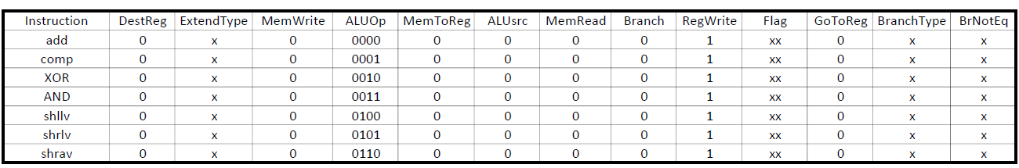

**Data Path:**  
fetch instruction   
read register’s data1, data2  
control unit outputs the respective ALUop, control signals  
input register data1, data2 to ALU  
ALU performs desired operation  
write ALUresult in desired register

--------------------------------------------------------------------------------------------------------------------------------------



**Data Path:**  
fetch instruction   
read register data1  
control unit outputs the respective ALUop and control signals  
input shift amount to ALU   
ALU performs desired shift operation   
write ALUresult in desired register

--------------------------------------------------------------------------------------------------------------------------------------  


**Data Path:**  
fetch instruction  
read register data 1  
control unit output the respective ALUop and control signal  
input imm value to Sign Extend module  
input 32bit extended value to ALUsrc mux (control signal = 1)  
input register1 data and sign extended imm value (32bit) to ALU  
ALU performs desired operation   
write ALUresult in desired register



**Data Path:**

|  |  |
| --- | --- |
| **sw** | **lw** |
| read instruction  read register data 1  control unit outputs the respective ALUop and  control signal  input imm value to Sign Extend module  input 32bit extended value to ALUsrc mux  (control signal =1)  Input register1 data and sign extended imm value (32bit) to ALU  ALU performs addition  pass ALUresult to Data Memory module as address  input register data 2 to Data Memory block as write data  write input data at input address (Data Memory block) | read instruction  read register data 1  control unit output the respective ALUop and  control signal  input imm value to Sign Extend module  input 32bit extended value to ALUsrc mux  (control signal =1)  input register1 data and sign extended imm value (32bit) to ALU  ALU performs addition  ALUresult is passed to Data Memory module as address  Data Memory output (data at memory location [ALUresult]) passed to MemToReg mux (control signal set to 1)  (set DestReg control signal to 01)  Write result in desired register |

------------------------------------------------------------------------------------------------------------------------

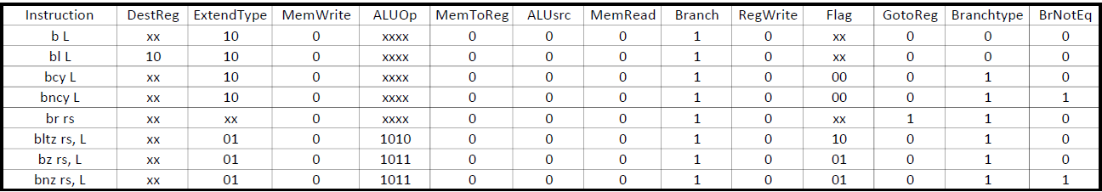  
  
**Data Path:**fetch instruction  
control unit output respective control signals  
input L (address) to sign extend module  
input sign extended label offset to ALU ADD  
ALU performs addition  
input ALUresult to branch condition mux  
perform Branch logic and decide next value of pc b/w label address and pc+4  
next PC 🡪 output of branch condition mux

**Data Path:** Goto Register Type  
fetch instruction  
control unit output respective control signals   
input L (label address) to Sign Extend Module  
signextended address stored in register 1 is passed to GoToReg decider MUX  
update PC with value of register 1

**4. Modules:**

**PC:** Increments the next program counter to either the jump value (L) or adds 4 to the current program counter. Works synchronously with clock.

**Instruction Memory:** Loads the instructions at the current program counter from the BROM instantiated for instructions only. 32-bit addressing is used.

**Instruction Decoder:** Segments the instruction into interpretable register addresses, sign extend values, immediate values, operation code and function code.

**Registers:** Stores 32 registers each of 32 bits. Outputs the values of registers read from instructions and writes in values of input registers on write enable signal(on posedge with certain delay) .

**Register Numbering and conventions:**

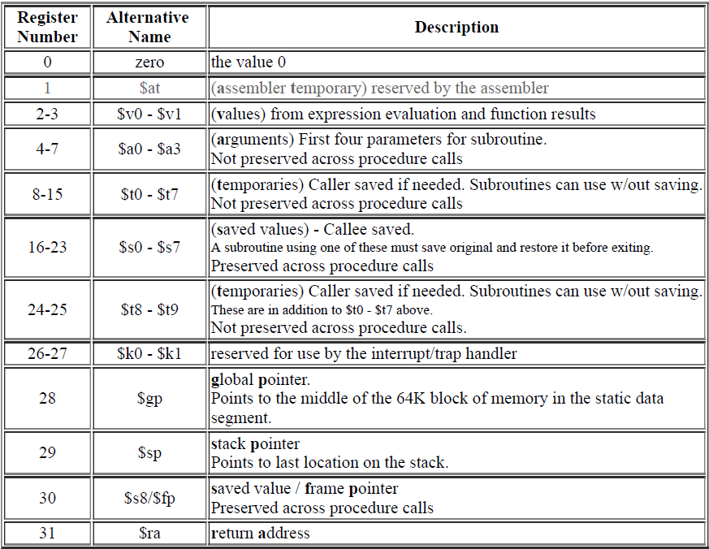

**Control Unit:** Depending on the operation it activates various modules/ hardware with different functionalities. Flags and controls discussed later.

**Sign Extend:** Depending on the operation, it sign-extends the segment of input data  
 (i.e., 16-bit/ 21-bit/ 26-bit to 32-bit)

**Sign Extend Type:** 00  
Immediate value (16 bits) is passed to Sign Extend module, desired extension is performed and   
output is given to ALUsrc mux as input to choose appropriate input data for ALU  
The opcode 00 is dedicated for this type of sign extension

**Sign Extend Type:** 10  
Branch jump distance (26 bits) is passed to Sign Extend Block module, desired extension is performed and output is given to PC ALU as input to choose next appropriate instruction address  
The opcode 10 is dedicated for this type of sign extension

**Sign Extend Type:** 01  
Branch Jump offset (21 bits) is passed to Sign Extend Block module, desired extension is performed and output is given to PC ALU as input to choose next appropriate instruction address  
The opcode 01 is dedicated for this type of sign extension

**Input Decider MUX:** Decides between sign extended and register values depending on the instruction type.

**Data Memory:** BRAM module instantiated for data memory. 32-bit addressing is used.

**Branch Logic:** Depending on the type of the branch instructions, returns the jump value( direct address of the next instruction).

**ALU:** Main arithmetic and logical unit of the processor, performs operations like addition, 2’s compliment, logical shift , arithmetic shift and controls carry, sign and zero flag signals

|  |  |
| --- | --- |
| operation | ALU opcode |
| Addition | 0000 |
| Compliment | 0001 |
| And | 0010 |
| Xor | 0011 |
| Shift left logical | 0111 |
| Shift right logical | 1000 |
| Shift left logical value | 0100 |
| Shift right logical value | 0101 |
| Shift right arithmetic | 1001 |
| Shift right arithmetic value | 0110 |
| Output sign flag | 1010 |
| Output zero flag | 1011 |

**4. Controls/Flags:**

1. branchType 🡪 decide b/w conditional and unconditional branching
2. memWrite 🡪 select line to data memory
3. memToReg 🡪 select b/w data memory output and ALU result to write in register
4. memRead 🡪 data memory read enable control
5. regwrite 🡪 write on register enable flag
6. brNotEq 🡪 control flag for branch not equal instructions
7. branch 🡪 branch instruction control flag
8. goToReg 🡪 jump to address stored in register control
9. flag 🡪 flag for conditional branching type
10. extendType 🡪 sign extend type control for three type of immediate and label address values
11. destReg 🡪 to decide destination register to write
12. ALUop 🡪 ALU operation type
13. ALUsrc 🡪 to decide second input for ALU

**5. Testing:**

**Binary Search: 20 elements (sorted) are loaded into the data memory using Bnary_Search_Data.coe file**

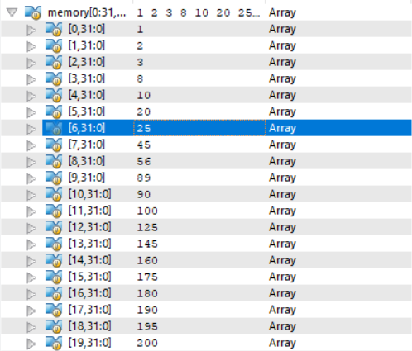

**Key = 25 is searched in the array of twenty elements and the result obtained is stored in $v0(also referred as $2) register (output as result in simulation)**

e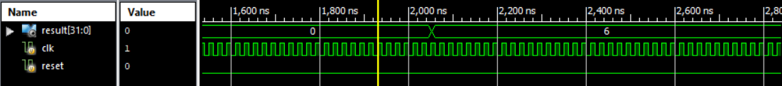

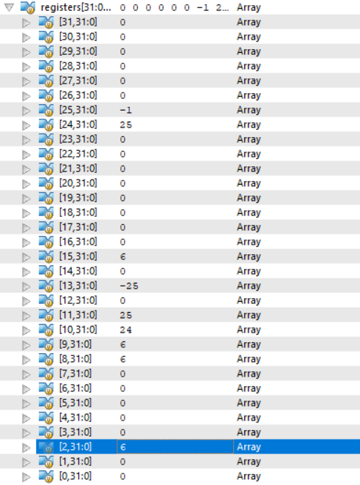

**GCD:**

Greatest common divisor of two numbers a=36 and b= 156 is computed and the result is stored in $v0 register

Values of a and b are loaded into the data memory using GCD_Data.coe file.

Values of a, b are loaded in registers $t0, $t1 from data memory for computation

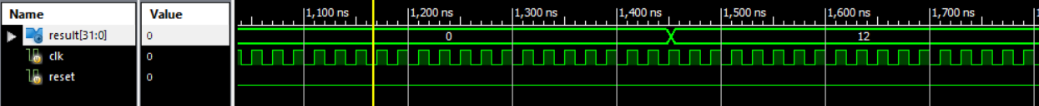

GCD of a(36) and (156) is stored in register $2 ($v0)

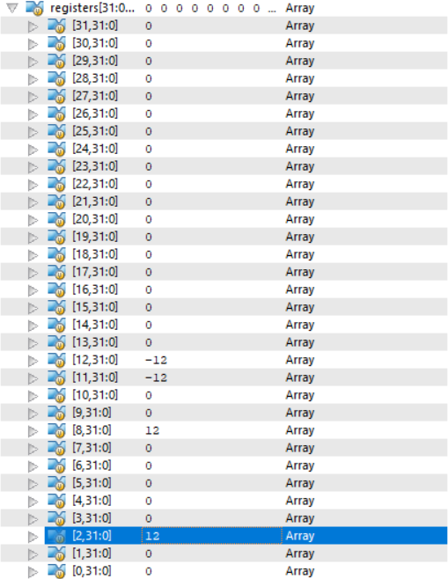

**Assumptions and Other Points to be Noted:**

* Block RAMs have a peculiar issue that they have significant delay in fetching data from the RAM. Hence, we have introduced two slower clocks (w.r.t primary clock). These slower clocks are used to fetch and write data on Block RAM. The primary clock is used for other modules.
* 32-bit addressing is used in Block RAMs. Hence, pc is updated as pc+4 for every clock cycle.
* For better comprehensibility of simulation and working of the design, the top-level module (Processor.v) outputs the $v0 register which stores the result of input program( GCD of two numbers, index of key in binary search)

**6. How to RUN:**

1. Import all the Verilog files into a new project
2. Load Instructions and Data Memory

a) Binary Search   
initialize the Instruction Memory with BinarySearch_Instruction.coe file   
initialize the Data Memory with BinarySearch_Data.coe file

b) GCD  
initialize the Instruction Memory with GCD_Instruction.coe file   
initialize the Data Memory with GCD_Data.coe file

1. Make the simulation run time sufficiently large( default = 1000ns) for the result to be computed, under the simulation properties make it 3000ns

Run the Processor_tb.v (Simulate Behavioural Model)

Incase there is an error, please load the .coe files properly and check whether the instruction and data are loaded properly

**Note:** No higher-level module is implemented for Instruction Memory and Data Memory. They are instantiated directly in Processor.v module. Also 32-addressing is used for both.

The Input Programs(instructions) are written in a way, so that they will self-loop after the computation of final result and the result(once computed) remains same till the end of simulation.