**Assertion in TestNG**

Assertions in TestNG are used for **validating** the test methods and to **verify** that the expected result and the actual result matched or not.

**Types of Assertions**

*1. Hard Assertion*

*2. Soft Assertion*

***1. Hard Assertion:-* Hard Assertion** means if an assertion fails, it will stop at that point, and further execution will not happen in that test method.ll the assertions in the test are checked, and at the end of the test, any failures are reported.

| **Sr No** | **Method Name** | **Syntax** |
| --- | --- | --- |
| 1 | AssertEquals | Assert.assertEquals(actual, expected, message) |
| 2 | AssertNotEquals | AssertNotEquals(actual, expected, message) |
| 3 | AssertTrue | Assert.AssertTrue(condition) |
| 4 | AssertFalse | Assert.AssertFalse(condition) |

***2. Soft Assertion:-*** A **Soft Assertion** in TestNG allows the test to continue running even if an assertion fails. All the assertions in the test are checked, and at the end of the test, all the failures are reported. To use **TestNG** soft assertion, you have to use TestNG **“SoftAssert class”.**

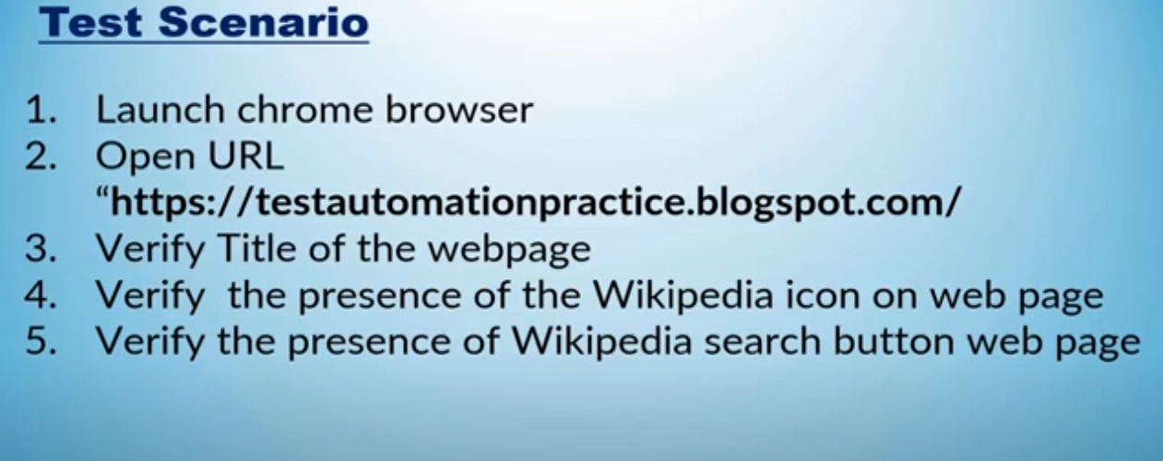

***1. Hard Assertion Code example;***

package tut11_AssertionDemo;

import org.openqa.selenium.By;

import org.openqa.selenium.WebElement;

import org.openqa.selenium.chrome.ChromeDriver;

import org.testng.Assert;

import org.testng.annotations.Test;

public class HardAssertDemo

{

@Test

public void testMethod() throws InterruptedException

{

ChromeDriver driver=new ChromeDriver();

driver.manage().window().maximize();

driver.get("https://testautomationpractice.blogspot.com/");

System.out.println("Verifying title..................");

String expectedTitle="Automation Testing Practice1";

String actualTitle=driver.getTitle();

// The test will stop here if the title doesn't match

Assert.assertEquals(expectedTitle, actualTitle,"Title verification failed");

System.out.println("verifying presence of wikipedia-icon");

WebElement wikipediaIcon=driver.findElement(By.className("wikipedia-icon"));

Assert.assertTrue(wikipediaIcon.isDisplayed());

System.out.println("verifying search icon button");

WebElement searchIcon = driver.findElement(By.className("wikipedia-search-button"));

Assert.assertTrue(searchIcon.isDisplayed());

Thread.sleep(2000);

driver.close();

}

}

***2. Soft Assertion Code example:-***

package tut11_AssertionDemo;

import org.openqa.selenium.By;

import org.openqa.selenium.WebElement;

import org.openqa.selenium.chrome.ChromeDriver;

import org.testng.annotations.Test;

import org.testng.asserts.SoftAssert;

public class SoftAssertDemo

{

@Test

public void testMethod() throws InterruptedException

{

ChromeDriver driver=new ChromeDriver();

driver.manage().window().maximize();

SoftAssert softVerify=new SoftAssert();

driver.get("https://testautomationpractice.blogspot.com/");

System.out.println("Verifying title..................");

String expectedTitle="Automation Testing Practice1";

String actualTitle=driver.getTitle();

// Although the expected and actual titles are not the same,

// the test will continue executing because we are using SoftAssert.

softVerify.assertEquals(expectedTitle, actualTitle,"Title verification failed");

System.out.println("verifying presence of wikipedia-icon");

WebElement wikipediaIcon=driver.findElement(By.className("wikipedia-icon"));

softVerify.assertTrue(wikipediaIcon.isDisplayed());

System.out.println("verifying search icon button");

WebElement searchIcon = driver.findElement(By.className("wikipedia-search-button"));

softVerify.assertTrue(searchIcon.isDisplayed());

Thread.sleep(2000);

driver.close();

// Report all failures collected during the test.

softVerify.assertAll();

}

}