PROJECT SYNOPSIS
PramaanSetu
AI-Based Document Authenticity Verification for Same-Day Certificate Services
A redesigned citizen dashboard and AI document-verification pipeline for
EWS, Domicile and Caste Certificate services on mpedistrict.gov.in
Prepared by
Ritish Pandey
Ram Vishwakarma
Kilby Studio
August 2026

Table of Contents
1. Abstract 3
2. Problem Statement 3
3. Objectives 4
4. Existing System and Its Limitations 4
5. Proposed System Overview 4
6. System Architecture 5
7. Document Verification Lifecycle 6
8. Module Breakdown 7
9. Technology Stack 8
10. AI Detection Approach and Known Limitations 8
11. Data Privacy and Security Considerations 8
12. Feasibility Study 9
13. Expected Outcomes 9
14. Prototype Scope — Built, Mocked, and Planned 10
15. Future Scope 11
16. Conclusion 11
References 11

1. Abstract
mpedistrict.gov.in offers Madhya Pradesh residents “same-day” certificate services — EWS, Domicile and Caste certificates among them — built around applicants uploading supporting documents and photographs online. Because nothing in that upload step checks whether an image is a real photograph or an AI-generated fabrication, the same-day promise can be exploited: a fabricated document looks no different to the system than a genuine one until a human happens to catch it, often long after the certificate has already been issued.
PramaanSetu proposes two connected changes: a simplified, service-first citizen dashboard, and an authenticity-verification pipeline that runs the moment a document is uploaded. A pretrained image-classification model, combined with file-metadata forensics, scores every upload in real time. Genuine applicants pass instantly and keep their same-day service. Suspicious uploads are rejected with a plain-language reason and up to three attempts to submit a genuine document. A fourth failure does not block the applicant outright — it raises a verification ticket for a human admin, who can override the AI's flag or confirm it. A confirmed fake routes the applicant to in-person verification at the office, or, where warranted, to a police complaint.
This document lays out the problem, the proposed system, its architecture, and an honest account of what a time-boxed prototype can realistically demonstrate versus what a production rollout would additionally require.

2. Problem Statement

2.1 Context
mpedistrict.gov.in is Madhya Pradesh's e-District portal, offering a catalogue of citizen services including EWS, Domicile and Caste certificates under a same-day service promise. Applicants fill an eligibility form and upload supporting documents/photographs as part of the application.

2.2 What is difficult today
- No authenticity check at upload. Any image file that satisfies basic format/size rules is accepted — there is no signal, automated or otherwise, distinguishing a real photograph from an AI-generated or digitally fabricated one.
- Fraud is caught late, if at all. Without a checkpoint at submission, a fabricated document is only caught if a back-office officer happens to notice it during manual review — inconsistent, slow, and easy to miss under same-day volume pressure.
- Honest applicants get no feedback loop. There is no equivalent of “this photo looks wrong, please try again” — problems surface as opaque delays or rejections well after submission.
- The dashboard itself is hard to navigate. Same-day services are listed with limited guidance on eligibility, required documents, or status tracking, adding friction that disproportionately affects less digitally-experienced applicants.

2.3 Who is affected
- Genuine applicants, who have no visibility into document requirements and no immediate feedback if something is wrong with their upload.
- Back-office verification staff, who currently carry the entire fraud-detection burden manually, after the fact.
- The issuing department, exposed to fraudulent certificates being issued under legitimate government letterhead.

3. Objectives
- O1 — Simplify the dashboard. Present same-day services (EWS, Domicile, Caste certificates) as clear, guided journeys rather than a dense form-first portal.
- O2 — Detect fabricated documents at upload. Score every uploaded document/photo in real time using an image-classification model plus metadata forensics.
- O3 — Give applicants a fair, bounded number of attempts. Up to three re-submissions with plain-language reasons before any escalation.
- O4 — Escalate to a human, not a wall. A fourth failure raises a verification ticket for admin review rather than terminating the application.
- O5 — Equip admins to decide, not just view. An admin console showing the document, the AI's signals, and a clear override-or-confirm decision.
- O6 — Define what happens after a confirmed fake. A named resolution path — in-person verification, or a police complaint where warranted — instead of an unresolved rejection.

4. Existing System and Its Limitations
Aspect | Current experience | Proposed change
Document upload | Accepted with no authenticity check | Real-time AI + metadata check on upload
Failure handling | Silent acceptance, or a much later manual rejection | Immediate, explained rejection with up to 3 attempts
Suspicious documents | Depends entirely on an officer noticing during manual review | Auto-escalated as a ticket to a dedicated admin queue
Admin tooling | No dedicated authenticity review workflow | Console with AI scores, document view, override/confirm actions
Repeat/confirmed fraud | No defined next step | Defined resolution path: in-person verification or police complaint
Dashboard navigation | Dense, form-first, limited guidance | Service-first cards, eligibility & document guidance up front

5. Proposed System Overview
PramaanSetu sits in front of the same-day certificate workflow as a verification layer, paired with a simplified citizen-facing dashboard. It does not attempt to replace mpedistrict.gov.in wholesale — it demonstrates how the document-upload step and the surrounding navigation could work if authenticity checking and clarity were designed in from the start.
Two audiences are served directly: applicants, who get a faster and more transparent path to a genuine certificate; and admins, who get a focused queue of only the applications that actually need human judgement, instead of reviewing every submission by hand.

6. System Architecture
The system is organised around a central backend that mediates between the citizen client, the AI authenticity engine, and the admin console, with every decision — automated or human — written to an audit log.
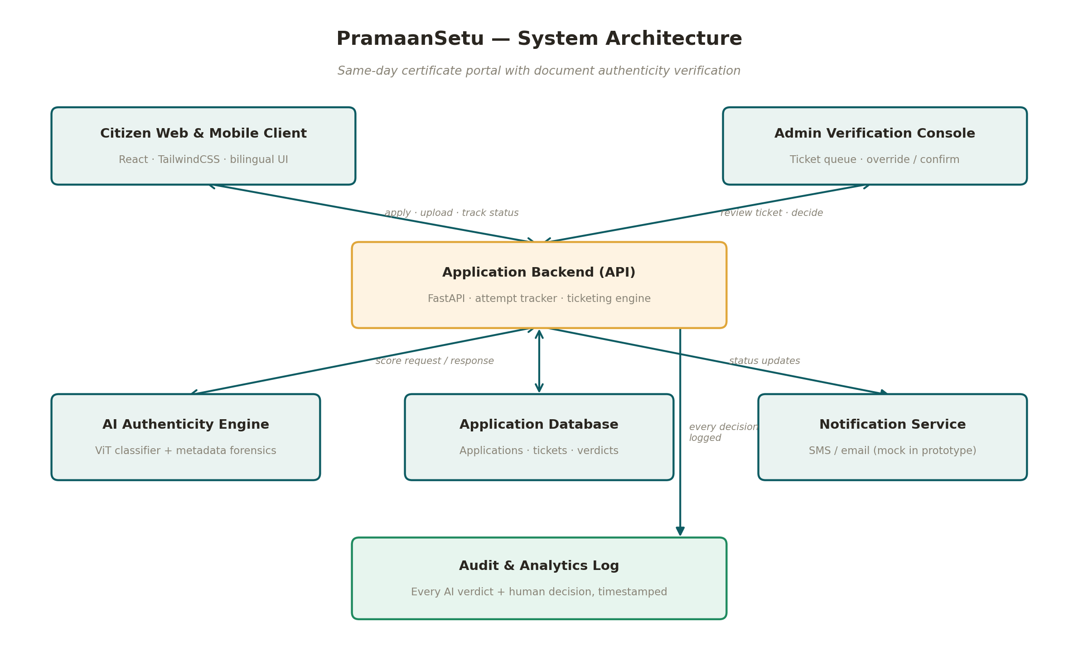
Figure 1 — System architecture

7. Document Verification Lifecycle
The verification flow is deliberately not a single automated gate. It is a bounded retry loop that only escalates to a human when the applicant has had a fair chance to correct an honest mistake, and it only escalates beyond the office when a human, not just the model, has confirmed a problem.
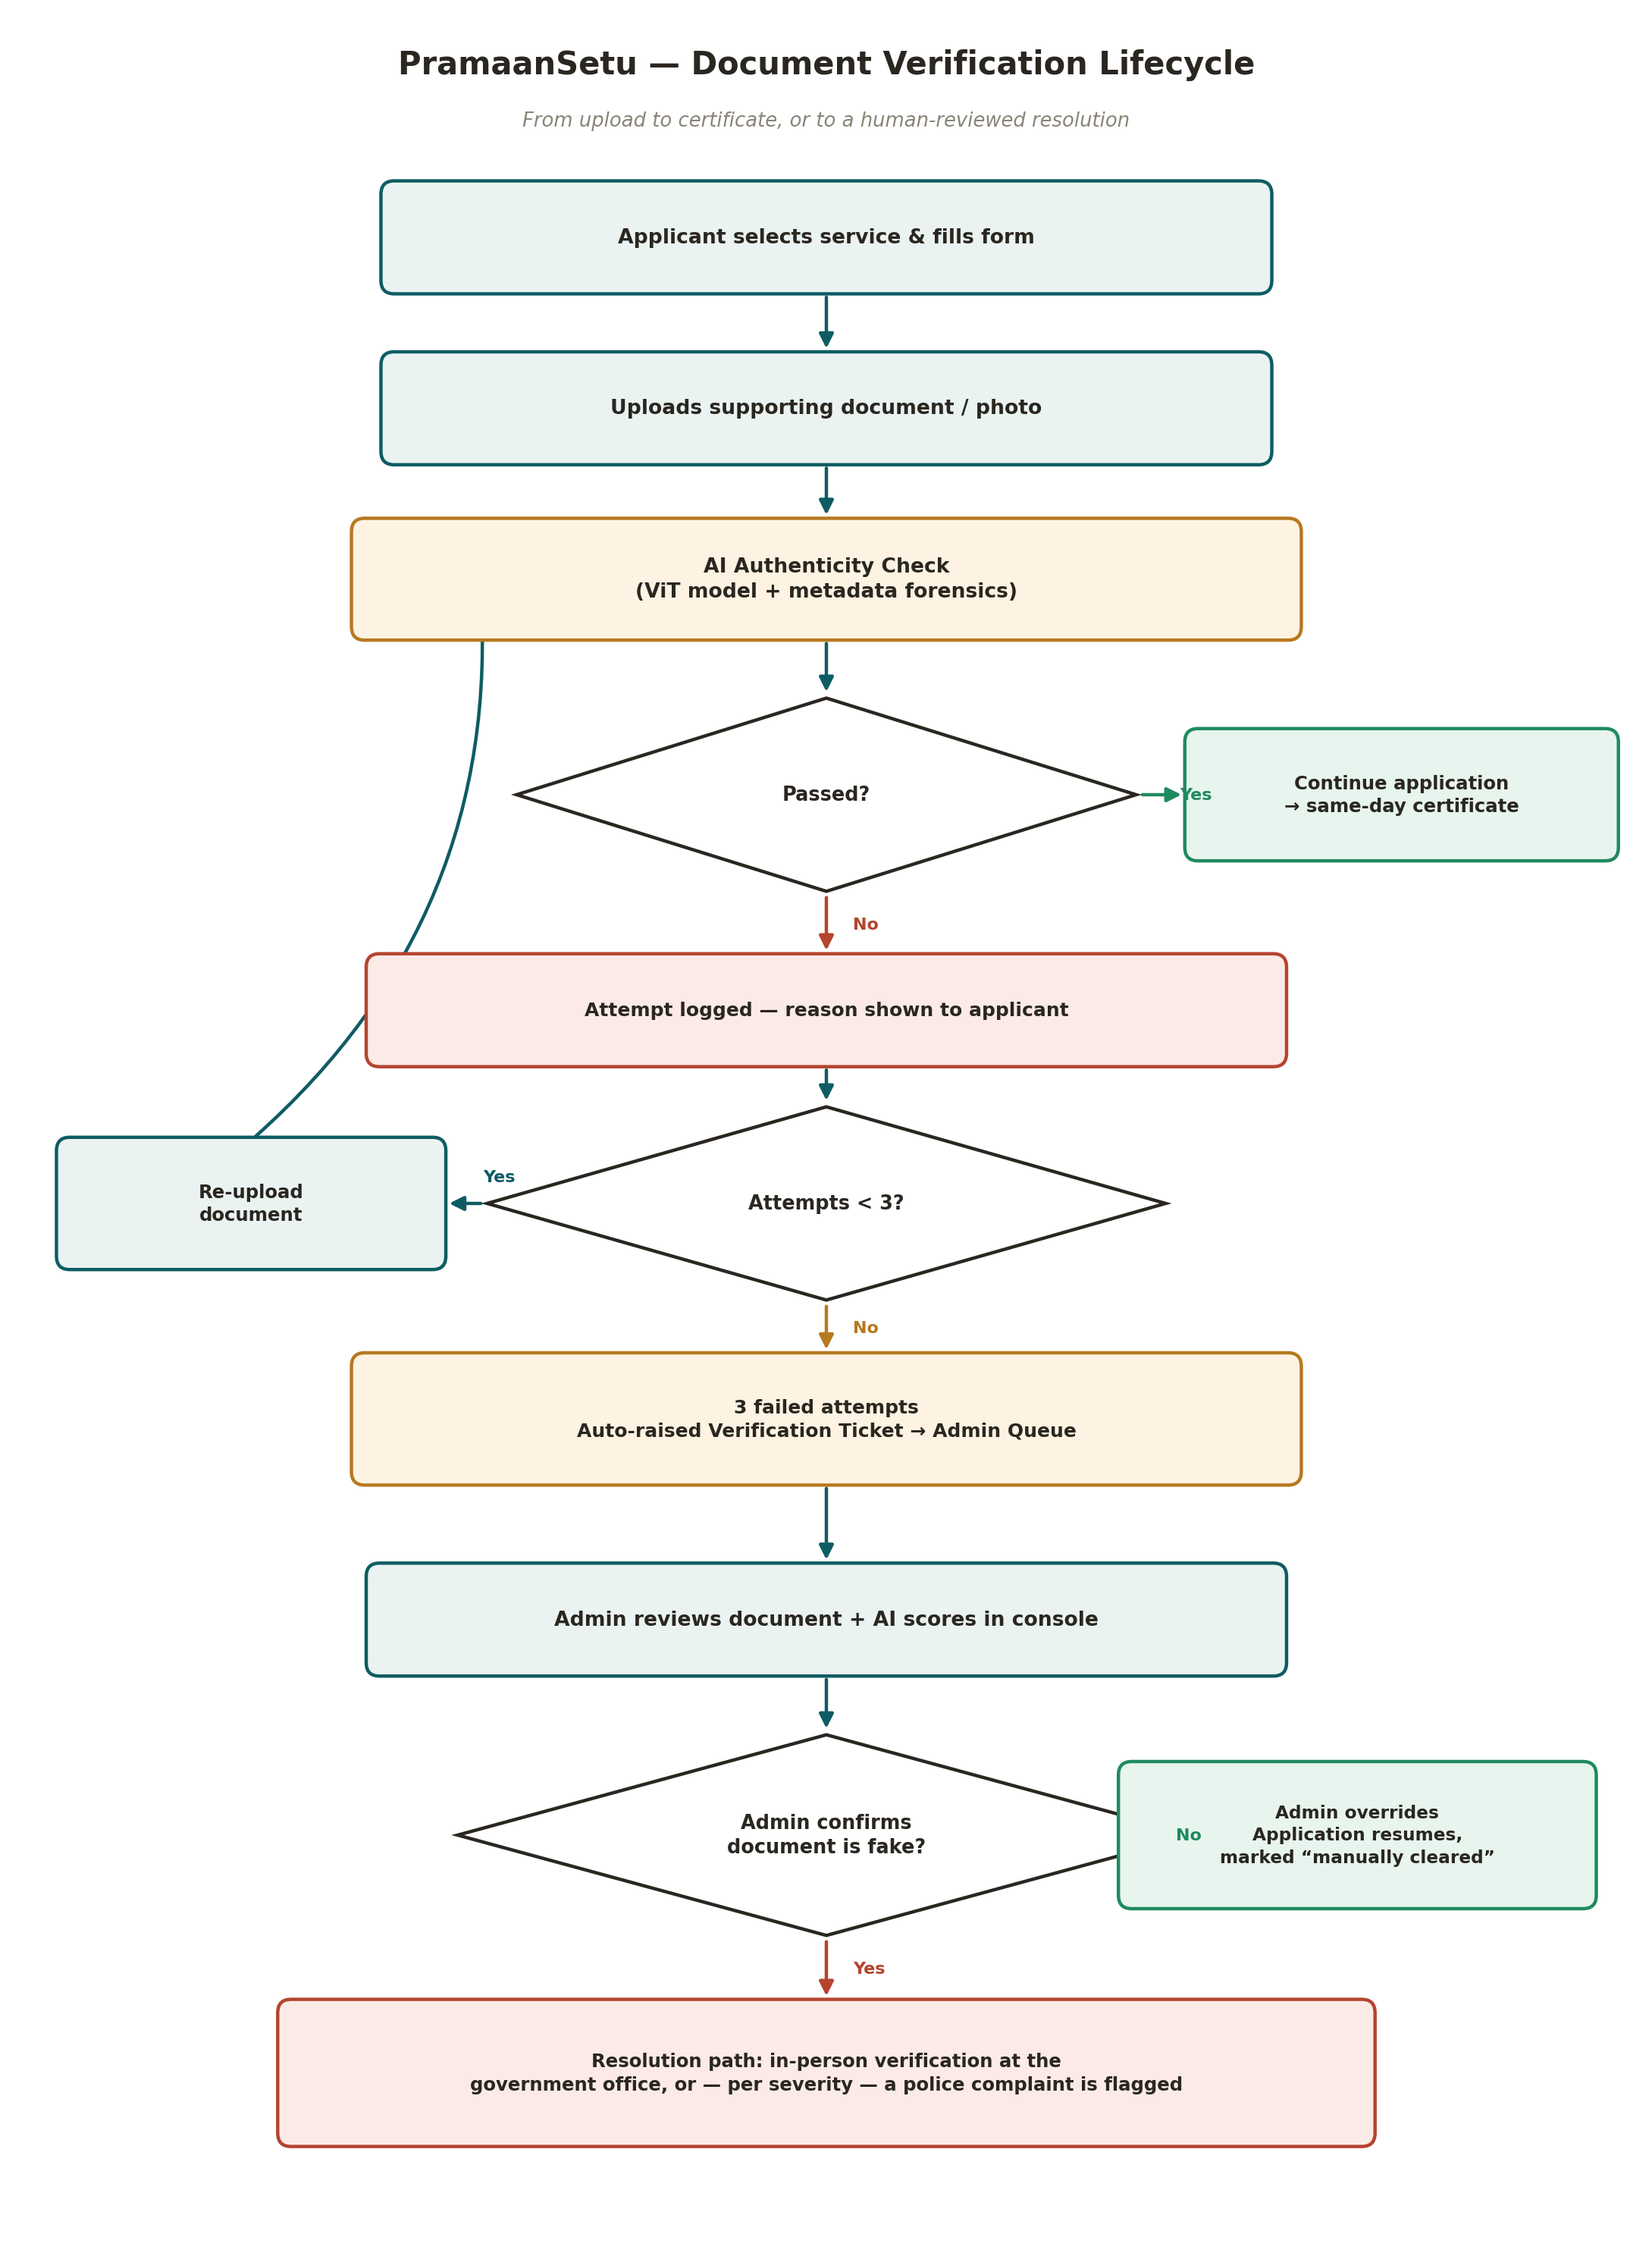
Figure 2 — Document verification lifecycle: retry loop, ticketing, and resolution paths

7.1 Step-by-step
Step | Description
1 | Applicant selects a service (EWS / Domicile / Caste) and completes the eligibility form.
2 | Applicant uploads the required supporting document or photograph.
3 | The AI Authenticity Engine scores the upload in real time (classification model + metadata forensics).
4 | If passed, the application proceeds immediately toward same-day issuance.
5 | If failed, the applicant sees a plain-language reason and may re-upload — up to 3 attempts total.
6 | On the 3rd failed attempt, a Verification Ticket is auto-raised to the admin queue; the application is paused, not rejected.
7 | An admin reviews the document alongside the AI's confidence signals in the Admin Verification Console.
8 | The admin either overrides the flag (application resumes, marked “manually cleared”) or confirms the document is fake.
9 | On a confirmed fake, the applicant is routed to a named resolution path: in-person verification at the government office, or — where severity warrants — a police complaint is flagged.
10 | Every automated score and every human decision is written to the audit log for accountability and appeal.

8. Module Breakdown
Module | Responsibility | Key technology
Citizen Dashboard & Service Catalog | Service-first browsing, eligibility guidance, application status tracking | React, TailwindCSS
Application & Document Upload | Form capture, file validation, upload handling | React, FastAPI
AI Document Authenticity Engine | Real-time classification + metadata/EXIF forensic scan | PyTorch, Transformers, Pillow
Attempt Tracking & Retry Manager | Tracks per-application attempt count, triggers ticket on the 3rd failure | FastAPI, database
Ticketing & Escalation Engine | Creates and routes verification tickets to the admin queue | FastAPI, database
Admin Verification Console | Document view, AI signal breakdown, override/confirm actions | React
Notification Module | Status updates to applicants at each stage (mocked in prototype) | SMS/email gateway
Audit & Analytics | Immutable log of every AI verdict and human decision | Database, reporting views

9. Technology Stack
Layer | Technology
Frontend | React, Vite, TailwindCSS — bilingual (English/Hindi), mobile-first
Backend | FastAPI (Python)
AI / ML | Pretrained image-classification model (Real vs AI-generated) + custom metadata/EXIF forensic checks
Database | MySQL / MongoDB — applications, attempts, tickets, audit log
Hosting (prototype) | Vercel (frontend), Hugging Face Spaces or equivalent container host (backend + model)
Identity (prototype) | Mock OTP/session — production would integrate the department's own authorised e-KYC flow

10. AI Detection Approach and Known Limitations

10.1 Approach
- A pretrained vision-transformer image classifier scores each upload as Real or AI-generated.
- A metadata scan checks for camera EXIF signatures (supports authenticity) and for embedded AI-generator signatures such as those some diffusion tools write into file metadata (strong evidence against authenticity).
- The two signals are combined into a single confidence score against which the pass/fail threshold is applied.

10.2 Known limitation — stated plainly
Publicly available detector models are generally trained on a mix of older and current generators. Accuracy on outputs from the newest generation of image models can be lower than on older, better-represented ones. This is exactly why the system does not treat a single AI verdict as final: the 3-attempt allowance and the mandatory human review before any adverse consequence both exist specifically to compensate for model imperfection, not just for user convenience.

11. Data Privacy and Security Considerations
Concern | Approach
Application data | Prototype uses synthetic applicant details only — no real Aadhaar, PAN, or payment data
Uploaded images | Processed for scoring; retention policy for production would follow the department's records rules, not indefinite storage by default
Admin access | Role-based — only authorised verification staff can view the admin console
Accountability | Every AI score and every human decision is timestamped and logged, so any outcome can be traced and appealed

12. Feasibility Study
- Technical. Built entirely on established, widely-documented open-source tools — pretrained classification models, FastAPI, React — with no dependency on unreleased technology.
- Operational. Adds a checkpoint that is invisible to genuine applicants who pass on the first attempt, so it does not slow down the same-day promise for the overwhelming majority of honest submissions.
- Economic. The prototype runs entirely on free-tier hosting and an open-source model. A production deployment's main added cost is dedicated inference hosting at government scale, which is small relative to the cost of fraud it prevents.

13. Expected Outcomes
- Fewer fraudulently issued certificates, without slowing down genuine same-day applicants.
- A transparent, appealable process — applicants get a reason and a retry, not a silent black-box rejection.
- A focused admin workload: officers review only the applications the system couldn't confidently clear, instead of every submission.
- A verification pattern (score → bounded retries → human ticket → named resolution) that is reusable across other document-upload services on the same portal.

14. Prototype Scope — Built, Mocked, and Planned
In keeping with the brief's requirement to be explicit about what a prototype actually demonstrates, this table separates what runs for real in the submitted build from what is represented but simulated.
Capability | Status in prototype
Simplified, service-first citizen dashboard (EWS / Domicile / Caste) | ✓ Built
Real-time document upload with AI classification + metadata forensics | ✓ Built
3-attempt retry flow with plain-language rejection reasons | ✓ Built
Auto-raised verification ticket after 3 failures | ✓ Built
Admin console: view document, AI signals, override/confirm | ✓ Built
Applicant identity, OTP, certificate issuance | ○ Mocked / synthetic
SMS/email notifications | ○ Mocked in prototype
In-person verification scheduling integration | ○ Represented as a defined next step, not a live office-booking system
Police complaint filing | ○ Represented as a flag/handoff point, not an integration with an actual filing system
Integration with mpedistrict.gov.in itself | ✗ Not attempted — independent prototype only, per challenge rules

15. Future Scope
- Periodic retraining/refreshing of the detection model as new image generators emerge.
- Voice-guided and further vernacular support for low-digital-literacy applicants.
- A shared verification microservice other departments' upload flows could call, rather than each rebuilding detection independently.
- A fraud-pattern analytics view for supervisors, built on top of the audit log.
- Formal integration with the department's actual identity (e-KYC) and office-scheduling systems, under proper authorisation.

16. Conclusion
PramaanSetu addresses a specific, real gap in a same-day government service: the absence of any check on whether an uploaded document is genuine. Rather than a blunt auto-reject, the design keeps a human in the loop for every consequential decision, gives honest applicants room to correct mistakes, and gives the department a defined, auditable path from a suspicious upload to a resolved outcome. The result aims to be a system that is simultaneously harder to defraud and easier to use.

References
- MP e-District Portal — https://mpedistrict.gov.in/ (reference for existing same-day service structure).
- Publicly documented open-source image-authenticity classification models and standard EXIF/metadata forensic techniques.

