**Assignment-2**

***By: Ramy Abdallah***

1. **Explain three-dimensional data indexing?**

Arrays in NumPy are high-performance data structures suitable for mathematical operations. Multi-dimensional arrays are defined as an "array of arrays" that store data in a tabular form. For example, an array list of data elements makes a 1D array, and an array of 1D arrays makes a 2D array, and 3D arrays are referred to as multi-dimensional arrays. The three levels of arrays nested inside one another represent the three-dimensional array in python, where each level represents one dimension.

1. **What is the difference between a series and a dataframe?**

DataFrame is several series organised to analyse data. However, a series can only contain a single list with an index. As a result, a DataFrame is one or more series.

For example:

The dataframe is:

pd.DataFrame(array)

while the series is:

pd.DataFrame(array)[0]

**3. What role do pandas play in data cleaning?**

Pandas provide easy methods to clean the data. For example, remove unwanted columns or rows from a DataFrame with the drop() function.

Pandas Dataframe can use the following techniques to clean the data:

* Changing the index of a DataFrame
* Dropping unnecessary columns in a DataFrame
* Using the DataFrame.applymap() function to clean the entire dataset, element-wise
* Skipping unnecessary rows in a CSV file
* Renaming columns to a more recognisable set of labels
* Using .str() methods to clean columns

**4. How do you use pandas to make a data frame out of n-dimensional arrays?**

As Pandas dataframe objects are already 2-dimensional data structures, it is quite easy to create a dataframe from a 2-dimensional array. Much like when converting a dictionary, to convert a NumPy array, we use the pd.DataFrame() constructor:

pd.DataFrame(array)

**5. Explain the notion of pandas plotting?**

Pandas use the plot() method to create diagrams.

We can use Pyplot, a submodule of the Matplotlib library, to visualise the diagram on the screen.

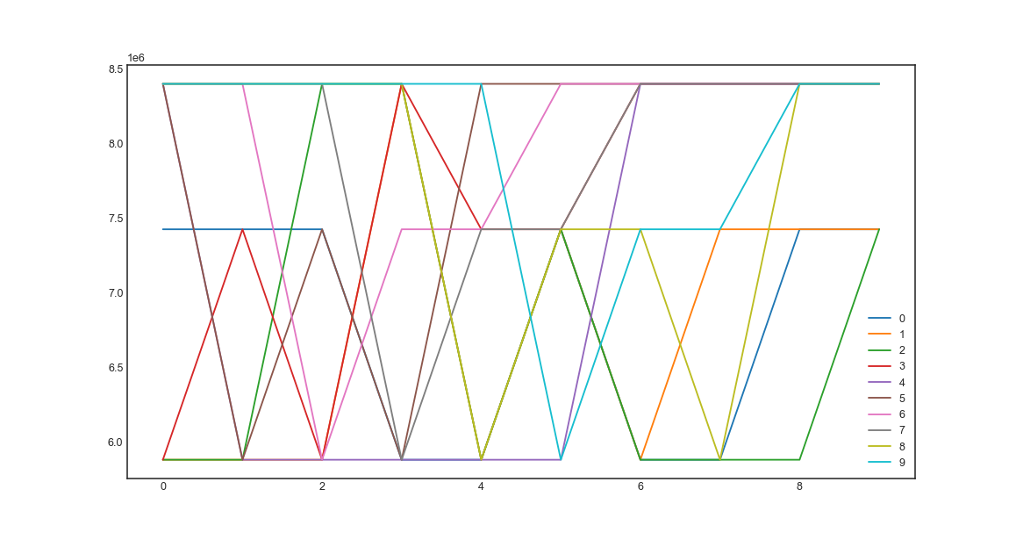

Or:

df.plot(kind = 'scatter', x = 1, y = 1)

plt.show()

