Name:B.Ramya
Reg.No:192424183
Course code:CSA1013
Course: Sofware Engineering
RAPTOR
- Greatest Among 3 Number
Aim:
To develop a RAPTOR flowchart program to find the greatest among three given numbers.
Flow chart:

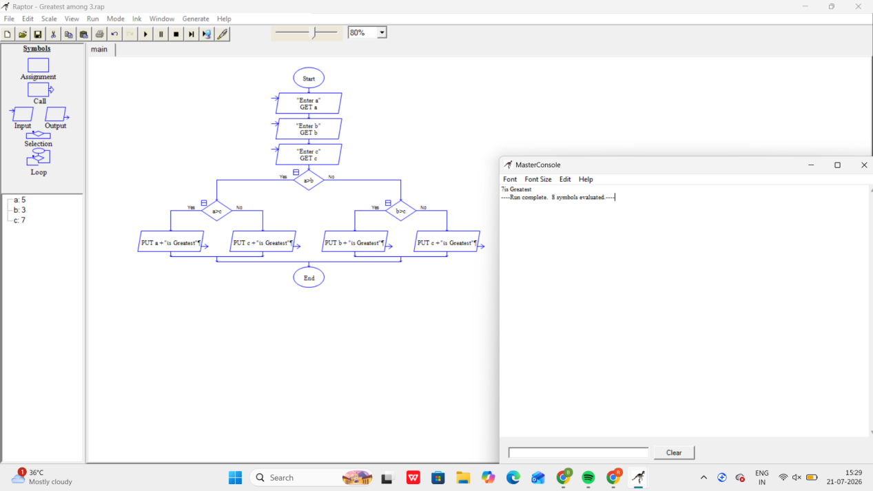

Simple input:
a=5
b=3
c=7
Simple output:
7 is Greatest
Result:
Thus, the RAPTOR program to find the greatest among three numbers was designed and executed successfully, and the greatest number was displayed correctly.

- Armstrong Number
Aim:
To develop a RAPTOR flowchart program to check whether a given number is an Armstrong number or not.
Flow Chart:
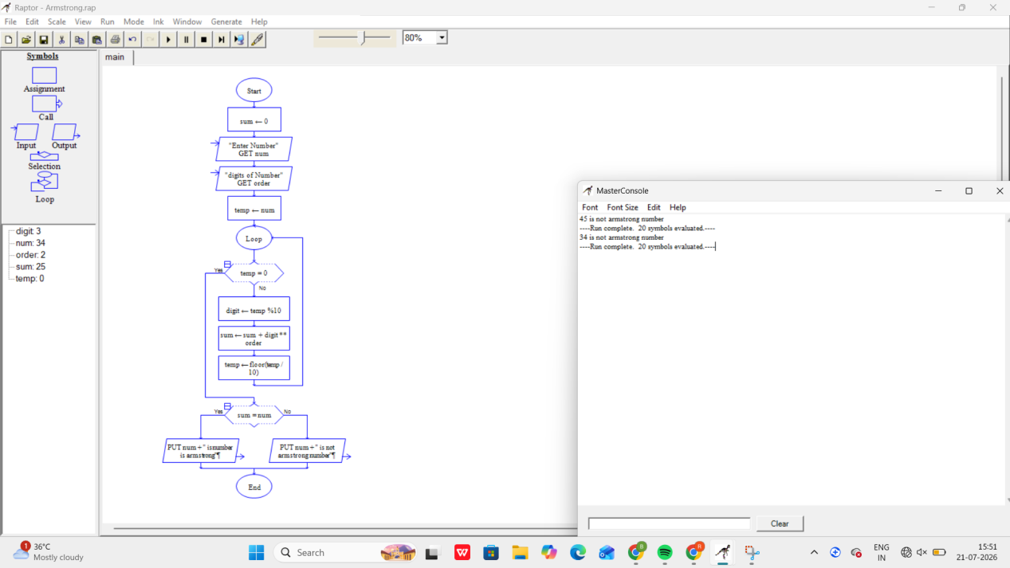

Simple Input:
Number = 45
Simple output:
45 is not armstrong number
Result:
Thus, the RAPTOR program to check whether a given number is an Armstrong number was designed and executed successfully, and the result was displayed correctly.

3.Find the Factorial of a Number Using RAPTOR
Aim:
To develop a RAPTOR flowchart program to find the factorial of a given number.

Flow Chart:
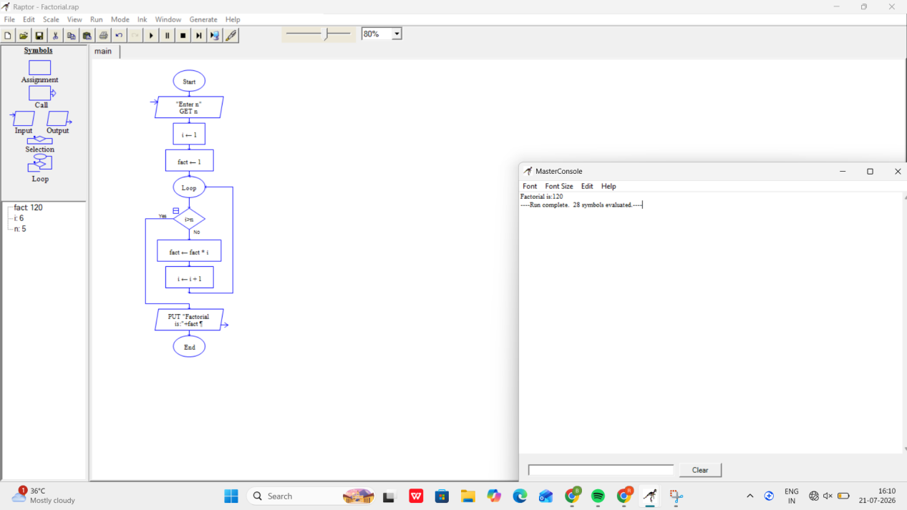

Simple Output:

n=5

Simple output:

Factorial is : 120

Result:
Thus, the RAPTOR program to find the factorial of a given number was designed and executed successfully, and the factorial value was displayed correctly.

4.The string is a sequence of characters placed in double quotes (” “). Performing different operations on string data is called String Handling. Strings are immutable. Whenever a change to a String is made, an entirely new String is created. If we want to store a group of characters we can use a char array. String provides various methods to perform different operations on strings. Using Raptor draw a flowchart to display the total number of characters in the string and returns it.

Aim:
To draw a Raptor flowchart to find and display the total number of characters in a given string.
FlowChart:
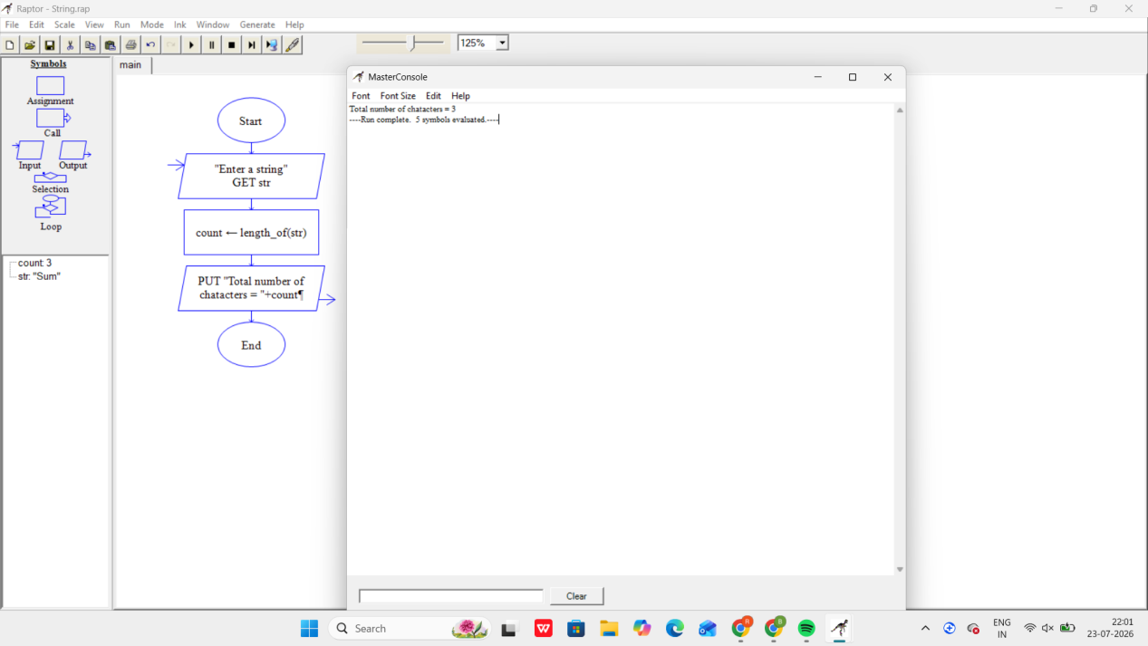

Simple input:
String: sum
Simple output:
The character of string:3
Result:
The Raptor flowchart was drawn and executed successfully to count and display the total number of characters in the given string.
- Using Raptor – Draw and validate a flowchart for a given string of lower case English alphabets. One can choose any two characters in the string and replace all the occurrences of the first character with the second character and replace all the occurrences of the second character with the first character. Using Raptor draw and validate the flowchart lexicographically smallest string that can be obtained by doing this operation at most once.
Aim:
To draw and validate a Raptor flowchart to obtain the lexicographically smallest string by swapping all occurrences of any two characters in the given lowercase English string at most once.
FlowChart:
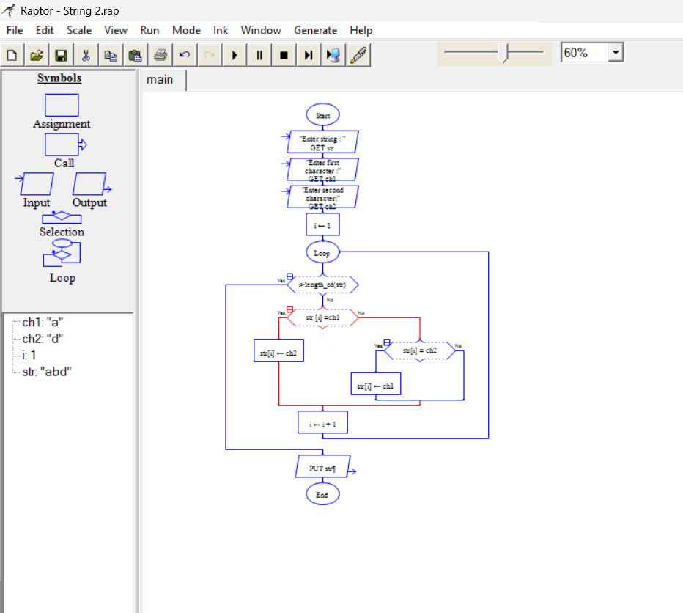

Input:
String = "ccad"

Output:
Lexicographically smallest string = "aacd"

Result:

The Raptor flowchart was drawn and validated successfully. It finds the lexicographically smallest string by performing at most one swap of all occurrences of two characters in the given string.

- Cyclomatic Complexity in Software Testing is a testing metric used for measuring the complexity of a software program. It is a quantitative measure of independent paths in the source code of a software program. Cyclomatic complexity can be calculated by using control flow graphs or with respect to functions, modules, methods or classes within a software program. Cyclomatic complexity for a flow graph G is V(G)=E-N+2. Cyclomatic complexity is a software metric (measurement), used to indicate the complexity of a program, Cyclomatic complexity = E - N + P where, E = number of edges in the flow graph, N = number of nodes in the flow graph, P = number of nodes that have exit points. Find Cyclomatic Complexity for a graph having number of edges as 17, number of nodes as 13 and number of predicate nodes in the flow graph as 5.

Aim: To draw and validate a Raptor flowchart to calculate the Cyclomatic Complexity of a flow graph.

FlowChart:

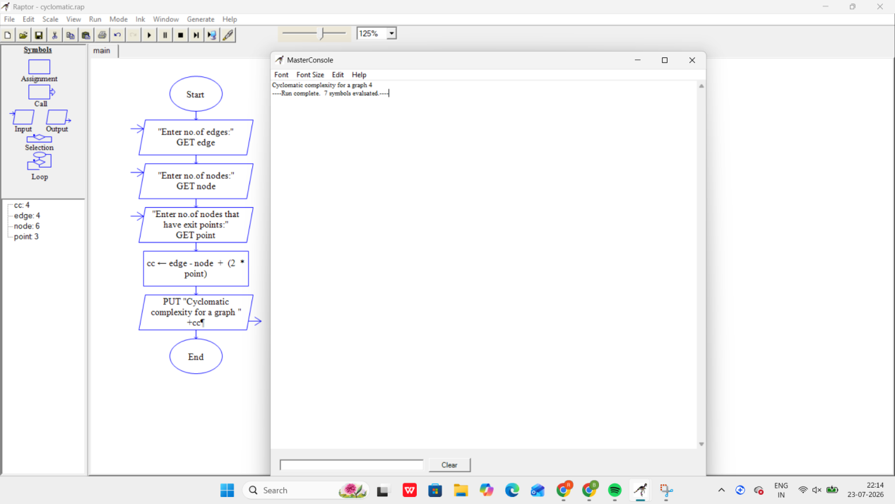

Simple input:
Number of Edges (E) = 17
Number of Nodes (N) = 13
Number of Predicate Nodes (P) = 5
Simple output:
Cyclomatic Complexity = 9
Result: The Raptor flowchart was drawn and validated successfully. The Cyclomatic Complexity of the given flow graph is 9.

