EXPT : 4 | EXPLORATORY DATA ANALYSIS (EDA) – DATA INSPECTION, FILTERING, STATISTICAL ANALYSIS AND CORRELATION
DATE :

AIM
To perform data inspection, filtering, grouping, aggregation, descriptive statistical analysis, and correlation analysis using Pandas and visualize the results using Matplotlib.
ALGORITHM 1
Dataset Inspection
- Import dataset
- Display dataset
- Check dimensions
- Display data types
- Generate summary
PROGRAM 1
import pandas as pd
df=pd.read_csv("C:/Users/ramya/Downloads/archive (4).zip")
print(df.head())
OUTPUT
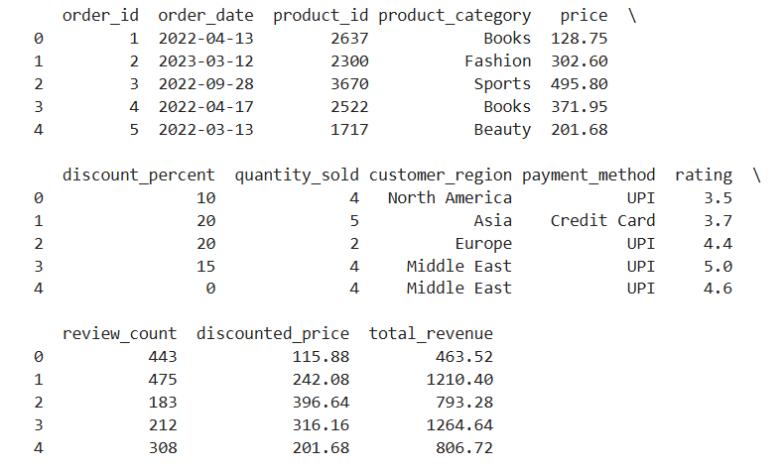
PROGRAM 2
print(df.shape)
OUTPUT


PROGRAM 3:
df.dtypes
OUTPUT
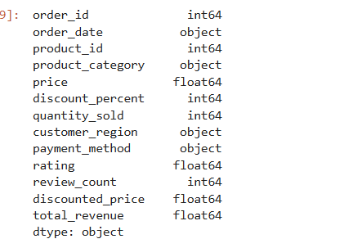

ALGORITHM 2
Filtering Data
- Specify condition
- Apply filter
- Display records

PROGRAM 4 :
high_price = df[df["price"] > 490]
print(high_price)

OUTPUT
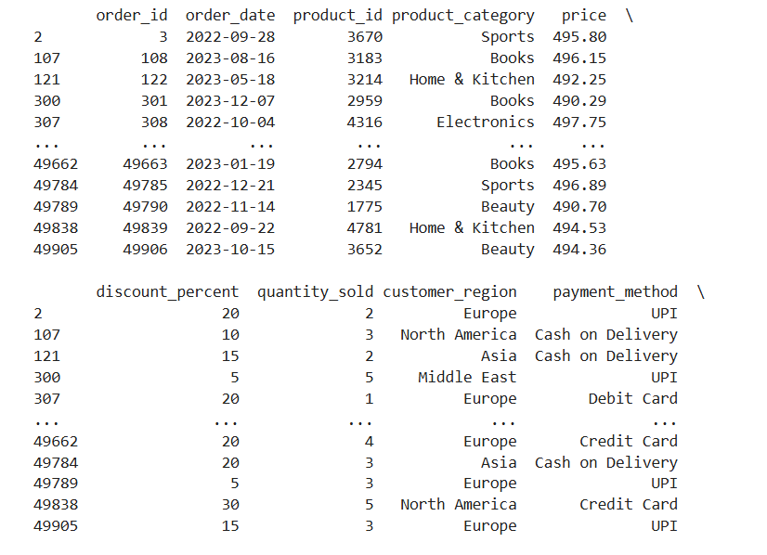
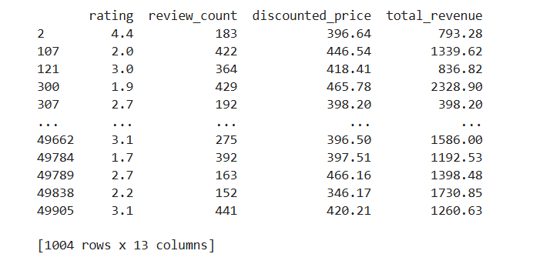

PROGRAM 5
electronics_products = df[df["product_category"] == "Electronics"]
print(electronics_products)
OUTPUT
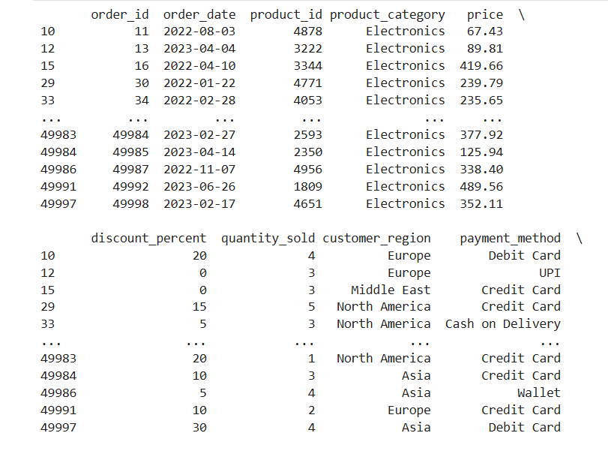
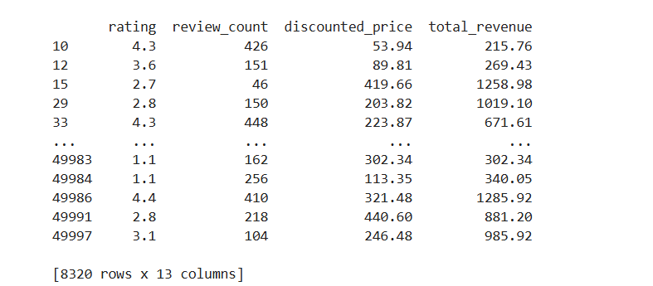

ALGORITHM 3
Sorting Data
- Select column
- Apply sort_values()
- Display sorted result
PROGRAM 6
sorted_df = df.sort_values(
by="rating",
ascending=False
)
print(sorted_df)
OUTPUT
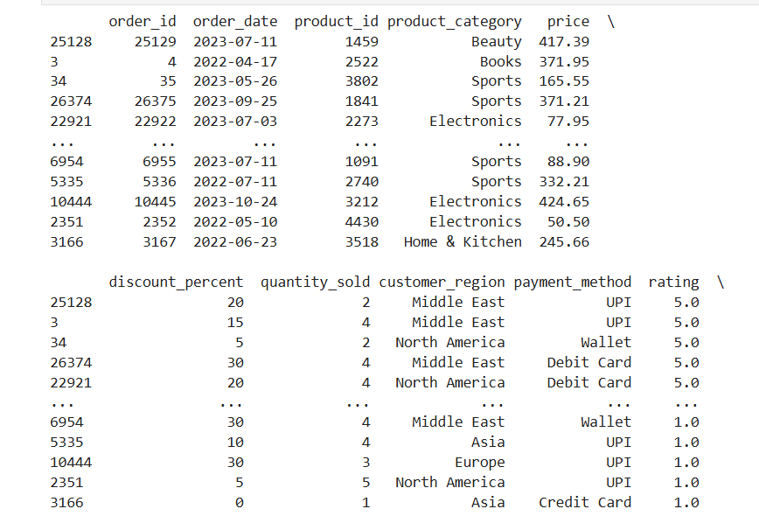
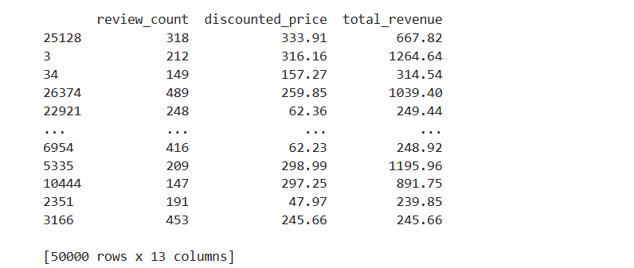

VISUALIZATION
import matplotlib.pyplot as plt
sorted_df = df.sort_values(by="rating", ascending=False)
plt.figure(figsize=(10,5))
plt.bar(sorted_df["product_id"].head(10).astype(str),
sorted_df["rating"].head(10))
plt.title("Top 10 Products by Rating")
plt.xlabel("Product ID")
plt.ylabel("Rating")
plt.xticks(rotation=45)
plt.show()
OUTPUT
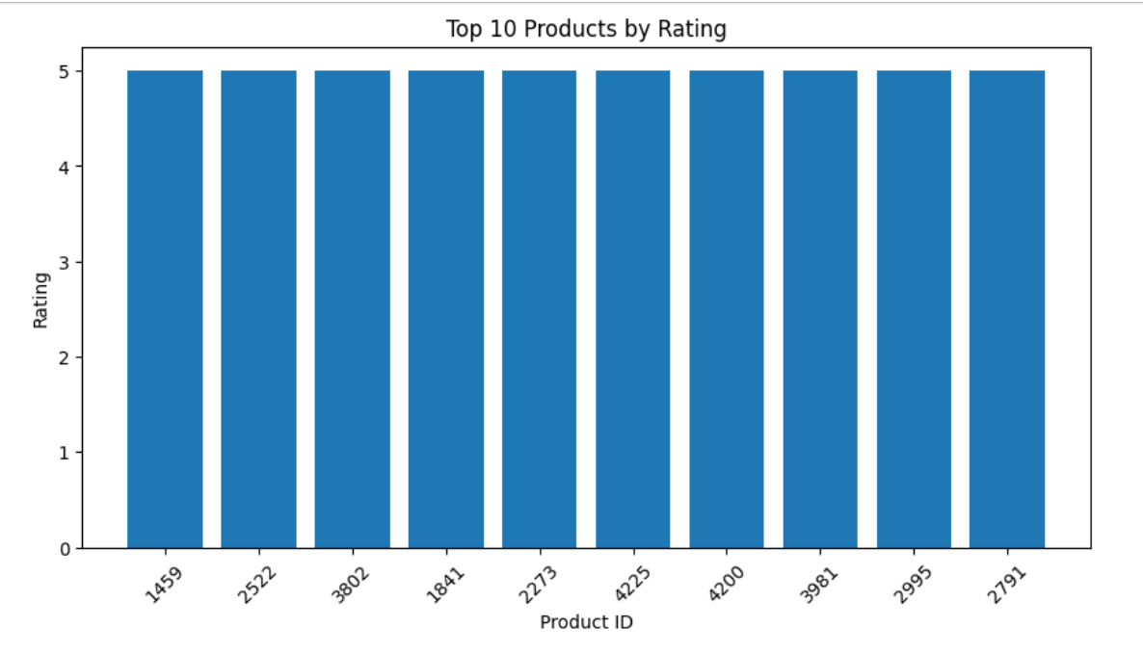
ALGORITHM 4
Statistical Analysis
- Select numerical column
- Calculate Mean
- Calculate Median
- Calculate Mode
- Calculate Standard Deviation
PROGRAM 7
print("Mean =", df["price"].mean())
print("Median =", df["price"].median())
print("Mode =", df["price"].mode())
print("Standard Deviation =", df["price"].std())
OUTPUT
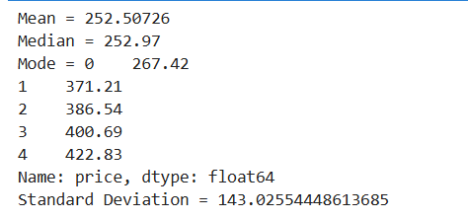
PROGRAM 8
df.describe()
OUTPUT
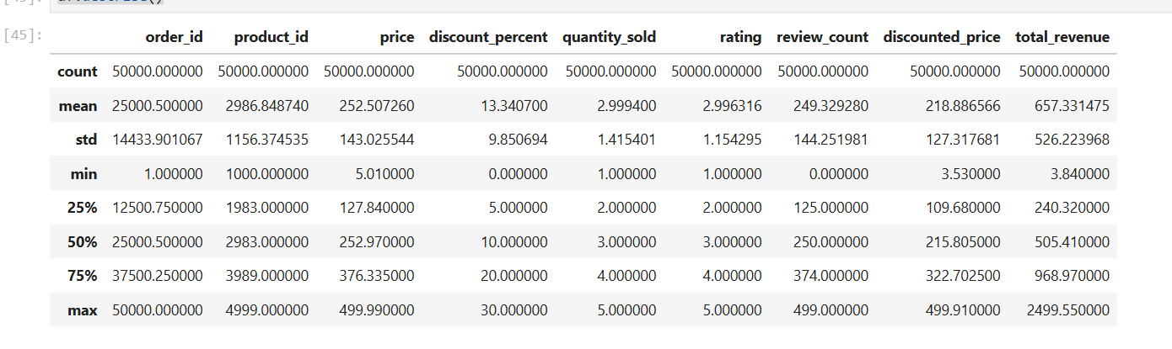
ALGORITHM 5
Grouping and Aggregation
- Select Department Column
- Apply groupby()
- Calculate Average Marks
- Display Result
PROGRAM 9
category_avg = df.groupby(
"product_category"
)["rating"].mean()
print(category_avg)
OUTPUT
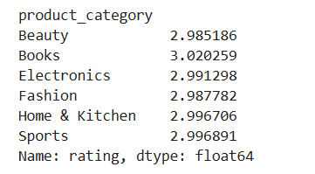

VISUALIZATION
category_avg = df.groupby("product_category")["rating"].mean()
plt.figure(figsize=(8,5))
plt.plot(category_avg.index, category_avg.values, marker='o', linewidth=2)
plt.title("Average Rating by Product Category")
plt.xlabel("Product Category")
plt.ylabel("Average Rating")
plt.xticks(rotation=45)
plt.grid(True)
plt.show()
OUTPUT
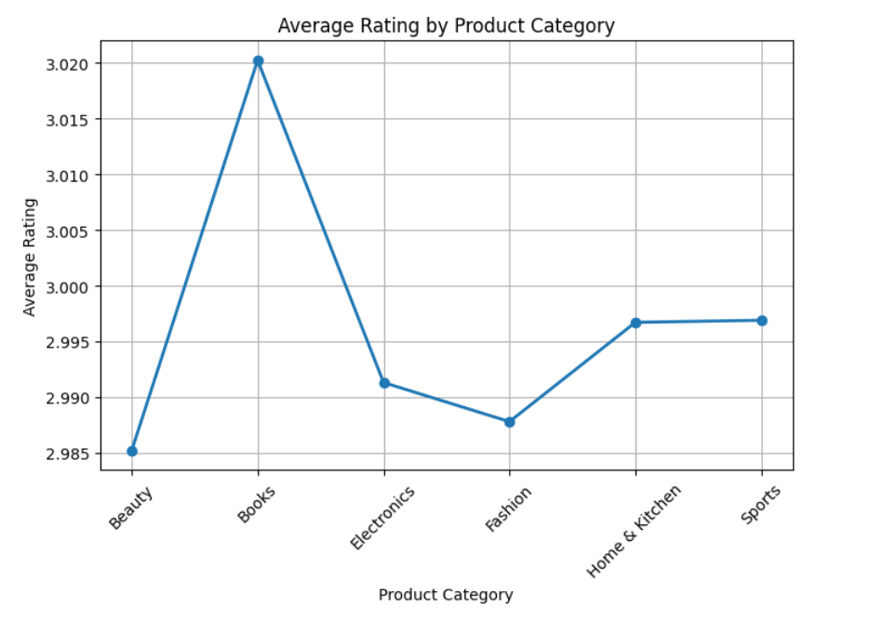ALGORITHM 6
Correlation Analysis
- Select numerical columns
- Apply corr()
- Interpret correlation coefficient
PROGRAM 10
corr = df[[
"rating",
"review_count"
]].corr()
print(corr)
OUTPUT
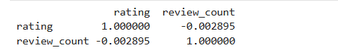

VISUALIZATION
plt.figure(figsize=(8,5))
plt.scatter(df["review_count"],
df["rating"],
s=5,
alpha=0.3)
plt.title("Rating vs Review Count")
plt.xlabel("Review Count")
plt.ylabel("Rating")
plt.show()
OUTPUT
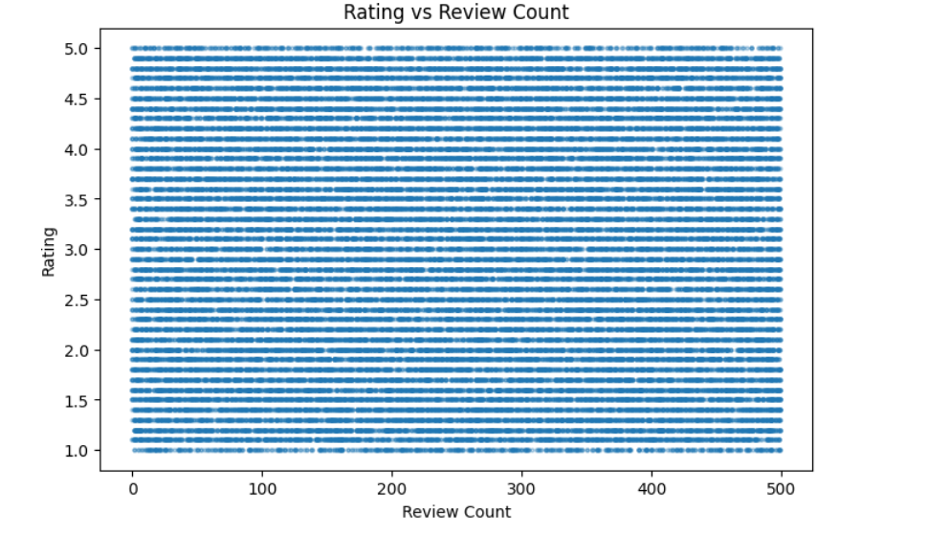

RESULT
Thus, data inspection, filtering, sorting, descriptive statistical analysis, grouping, aggregation, and correlation analysis were successfully performed using Pandas. The analytical results were visualized and interpreted successfully.

