EXPT :02
DATE :

AIM
To import data from various sources such as CSV, Excel, SQL, and Web, perform basic inspection using Pandas, and export the processed data into different file formats.

ALGORITHM 1:
- Import Pandas library
- Load CSV file using read_csv()
- Display first few records
- Check data structure
- Analyze imported data

Code and Output:
import pandas as pd
df=pd.read_csv("C:/Users/ramya/Downloads/archive (4).zip")
print(df)
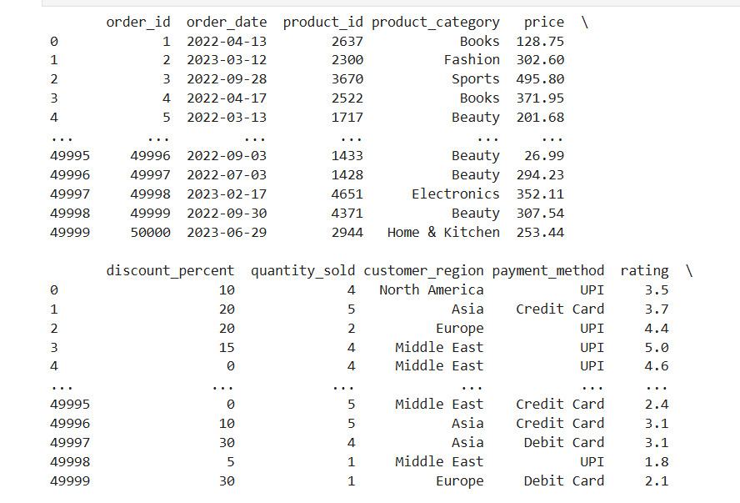
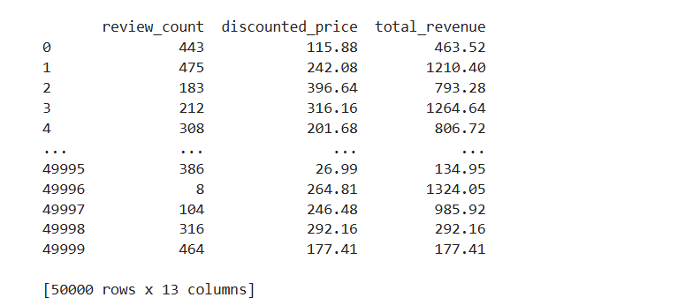

df.head()
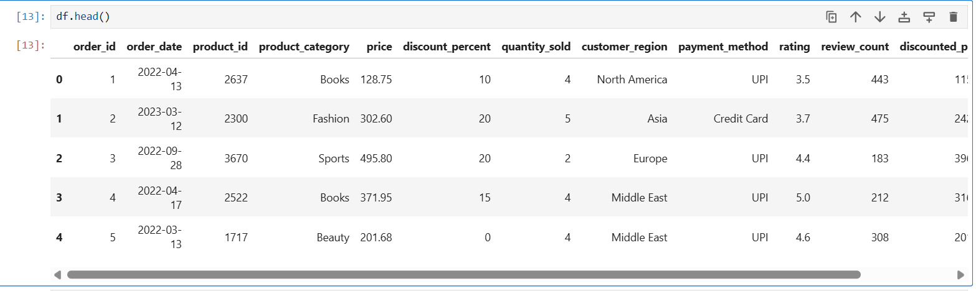

df.info()
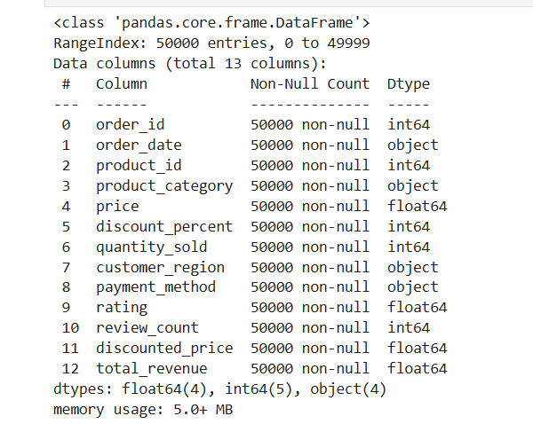
df.describe()

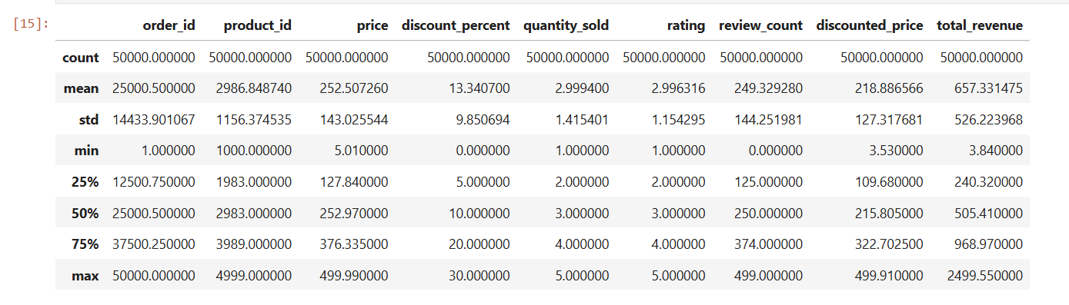

ALGORITHM 2:
- Create Excel file
- Use read_excel()
- Display records
- Verify imported data

Code and Output:
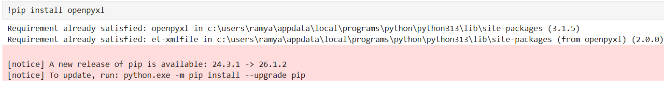
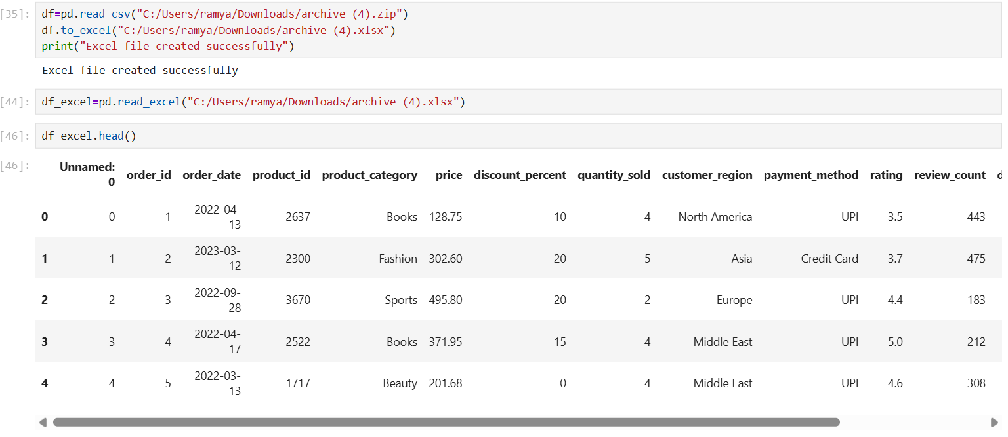
ALGORITHM 3:
- Create SQLite Database
- Insert records
- Retrieve records using SQL Query

Code and Output:

import sqlite3
df=pd.read_csv("C:/Users/ramya/Downloads/archive (4).zip")
conn=sqlite3.connect("C:/Users/ramya/Downloads/archive (4).db")
df.to_sql("archive_data",conn,if_exists="replace",index=False)
print("Data imported into SQL successfully")

query="SELECT * FROM archive_data"
df_sql=pd.read_sql(query, conn)
print(df_sql.head())

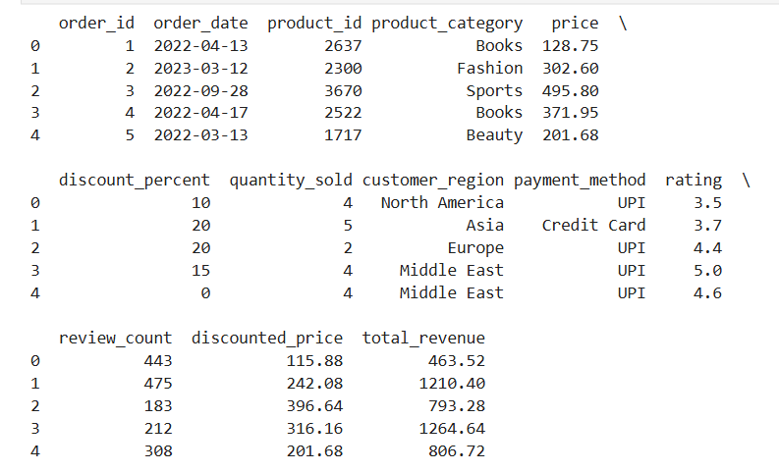
ALGORITHM 4:
- Specify URL
- Load data using read_csv()
- Display imported records

Code and Output:

url="C:/Users /ramya/Downloads/archive (4).zip"
df=pd.read_csv(url)
df.head()
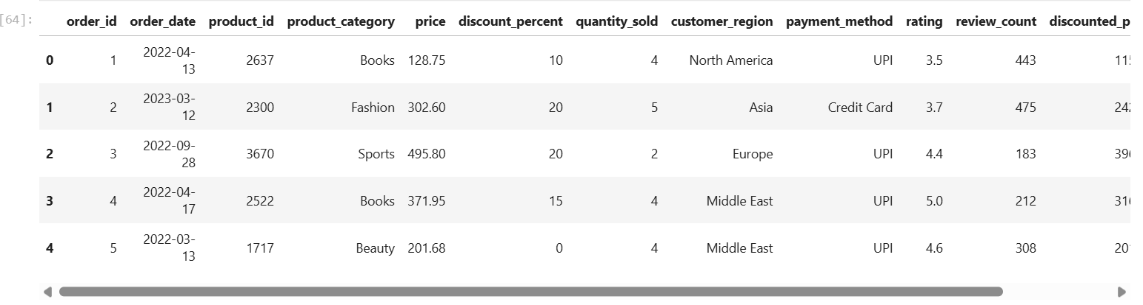
df=pd.read_csv("C:/Users/ramya/Downloads/archive (4).zip")
df.to_csv("Amazon_output.csv",index=False)
print("CSV File Exported successfully")

df=pd.read_csv("C:/Users/ramya/Downloads/archive (4).zip")
df.to_excel("Amazon_output.xlsx",index=False)
print("Excel File Exported")
df=pd.read_csv("C:/Users/ramya/Downloads/archive (4).zip")
df.to_json("Amazon_output.json",orient="records")
print("JSON File Exported")
import matplotlib.pyplot as plt
df=pd.read_csv("C:/Users/ramya/Downloads/archive (4).zip")
category_count=df["product_category"].value_counts()
category_count.plot(kind="bar",figsize=(10,5))
plt.title("Number of Products by Category")
plt.xlabel("Product Category")
plt.ylabel("Count")
plt.show()
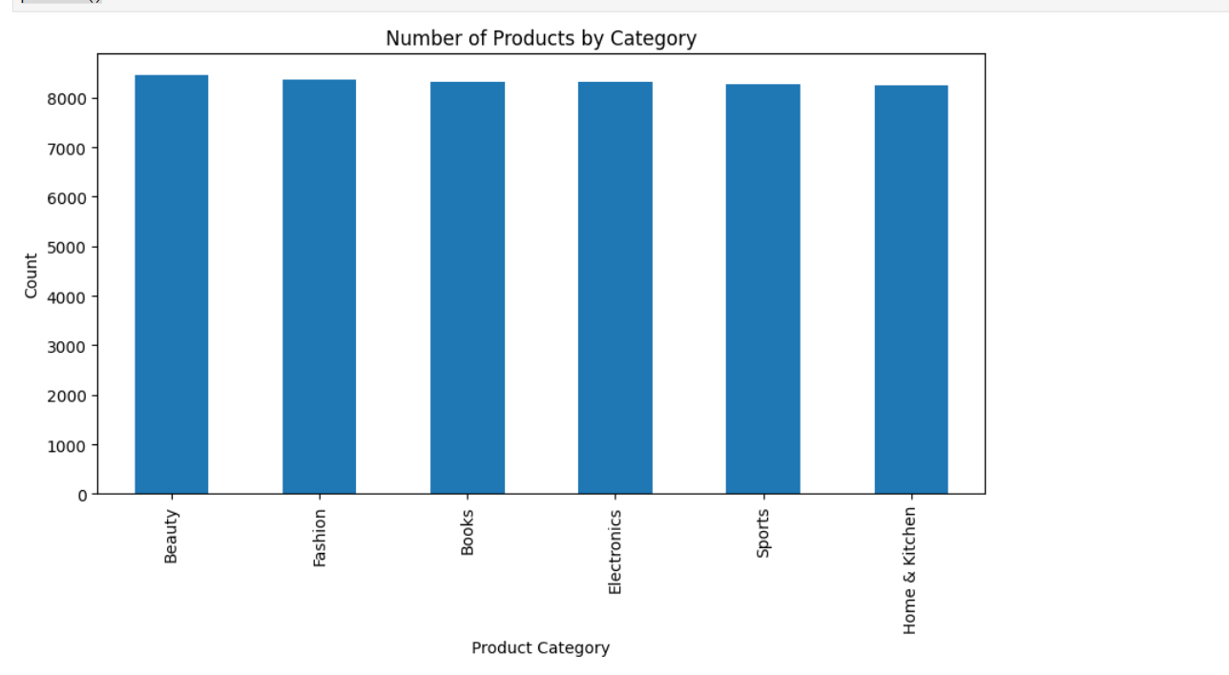

RESULT
Thus, data was successfully imported from CSV, Excel, SQL, and Web sources using Pandas, and exported into different formats. The imported data was analyzed and visualized successfully.

