EXPT : 3 | EXPLORATORY DATA ANALYSIS (EDA) – DATA CLEANING AND DATA TRANSFORMATION
DATE :

AIM
To identify and handle missing values, duplicate records, outliers, inconsistent data, and perform data transformation techniques such as normalization and encoding using Python Pandas.
ALGORITHM 1 :
- Import pandas library
- Load dataset
- Use isnull() function
- Count missing values
- Display result
Code and Output:

import pandas as pd
df=pd.read_csv("C:/Users/ramya/Downloads/archive (4).zip")
df.isnull()
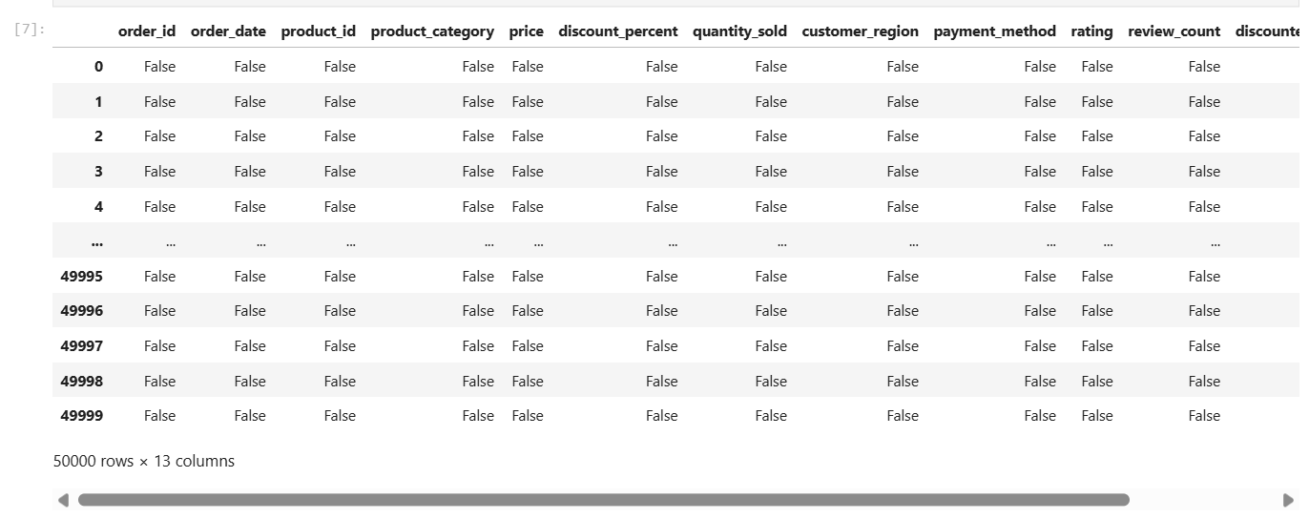
df.isnull().sum()
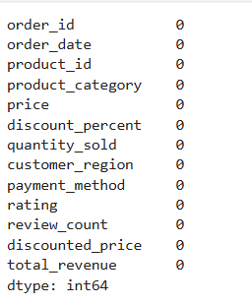

ALGORITHM 2 :
- Use duplicated()
- Count duplicate records
- Remove duplicates
- Verify dataset

Code and Output :
df.duplicated()
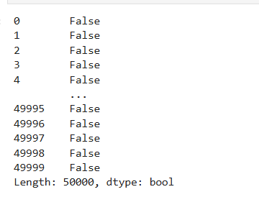
df.drop_duplicates(inplace=True)
print(df)
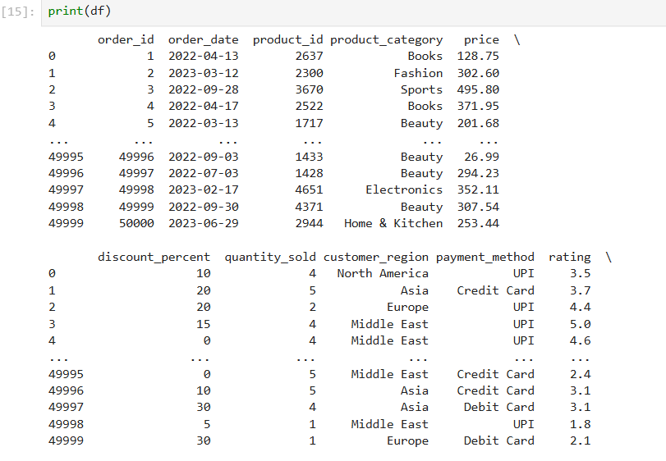
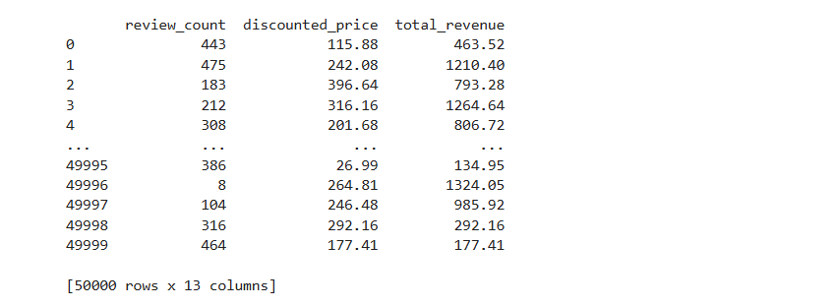

ALGORITHM 3 :
Detecting Outliers
- Calculate Quartiles
- Compute IQR
- Calculate lower and upper limits
- Identify outliers

Code and Output :
Q1 = df['total_revenue'].quantile(0.25)
Q3 = df['total_revenue'].quantile(0.75)
IQR = Q3 - Q1
lower = Q1 - 1.5 * IQR
upper = Q3 + 1.5 * IQR
outliers = df[(df['total_revenue'] < lower) |
(df['total_revenue'] > upper)]
print(outliers)

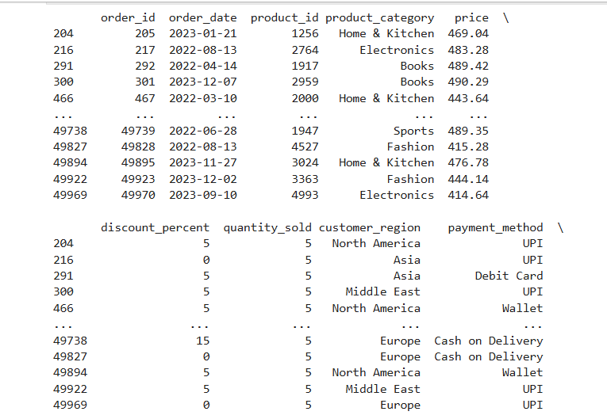
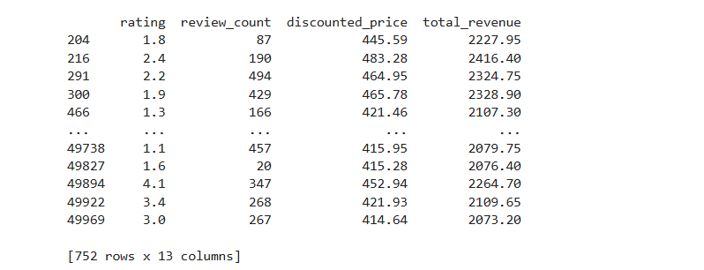

print("Number of outliers:", len(outliers))

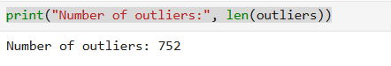

import matplotlib.pyplot as plt
plt.figure(figsize=(8,5))
plt.boxplot(df["total_revenue"])
plt.title("Outlier Detection in Total Revenue")
plt.ylabel("Total Revenue")
plt.show()

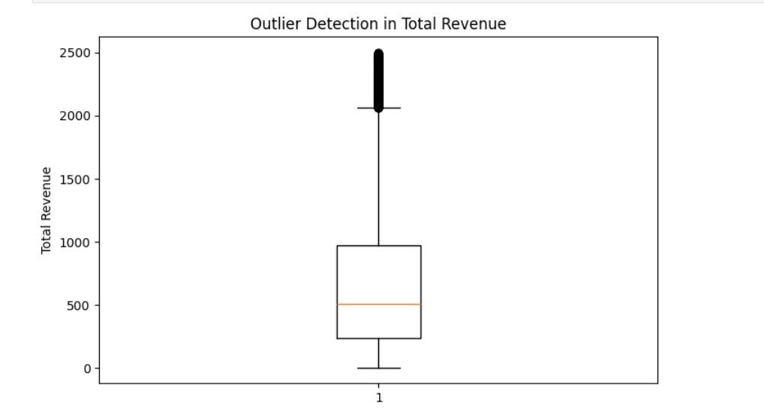

Algorithm 4
Normalization
Purpose
- Convert numerical values into a common scale.

Formula
$$X_{norm}=\frac{X-X_{min}}{X_{max}-X_{min}}$$
Code and Output :

from sklearn.preprocessing import MinMaxScaler
scaler = MinMaxScaler()
df[['total_revenue']] = scaler.fit_transform(df[['total_revenue']])
print(df[['total_revenue']])
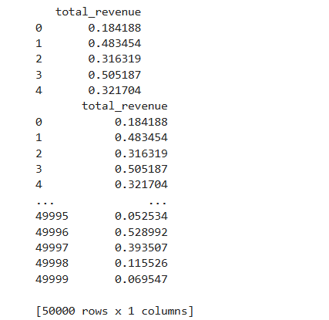

Algorithm 5
Label Encoding
Purpose
- Convert categorical data into numerical format.

Code and Output :
import pandas as pd
from sklearn.preprocessing import LabelEncoder
df = pd.read_csv("C:/Users/ramya/Downloads/archive (4).zip", compression="zip")
encoder = LabelEncoder()
df["product_category"] = encoder.fit_transform(df["product_category"])
print(dict(zip(encoder.classes_, encoder.transform(encoder.classes_))))

import pandas as pd
df = pd.read_csv("C:/Users/ramya/Downloads/archive (4).zip", compression="zip")
one_hot = pd.get_dummies(df["product_category"])
print(one_hot.head())
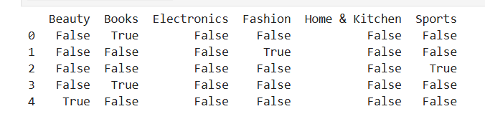
one_hot = pd.get_dummies(df["product_category"], dtype=int)
print(one_hot.head())
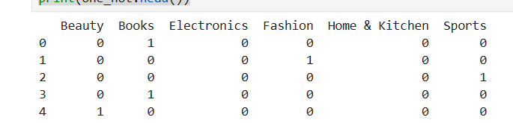

RESULT
Thus, missing values, duplicate records, and outliers were identified and handled successfully. Data transformation techniques such as normalization and encoding were performed, and the dataset was prepared for further exploratory data analysis and machine learning applications.

