Ex.NO: | DATA VISUALIZATION USING MATPLOTLIB
DATE:

Aim
To create and analyze various data visualizations such as Line Charts, Bar Charts, Pie Charts, Histograms, Scatter Plots, and Box Plots using Matplotlib for effective data interpretation.
Algorithm

Code and Output
import matplotlib.pyplot as plt
months = ["Jan","Feb","Mar","Apr","May","Jun"]
sales = [120,150,180,170,220,250]
plt.plot(months,sales)
plt.title("Monthly Sales")
plt.xlabel("Months")
plt.ylabel("Sales")
plt.show()
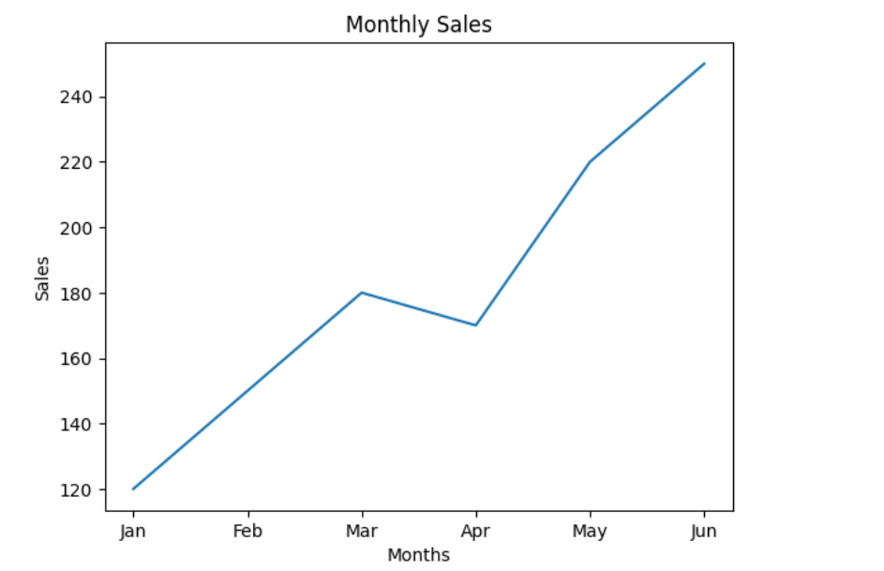
plt.bar(months,sales)
plt.title("Monthly Sales")
plt.xlabel("Months")
plt.ylabel("Sales")
plt.show()

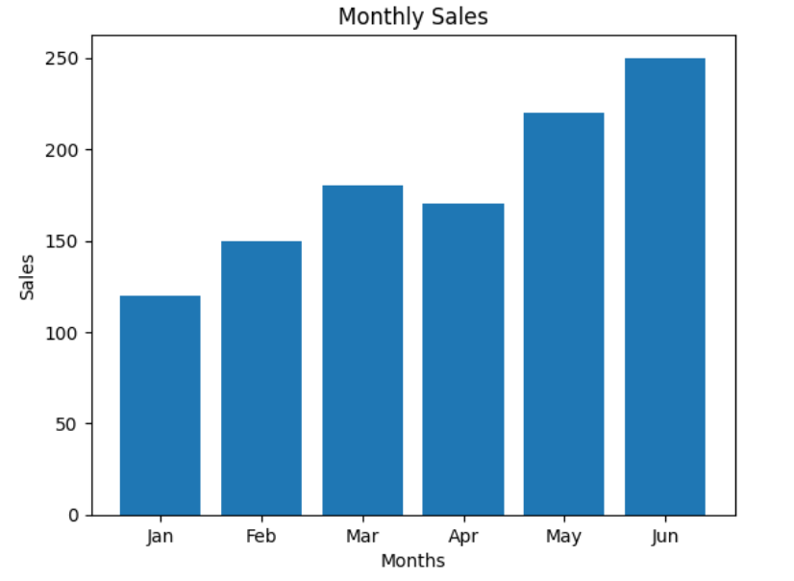
departments = ["HR","IT","Finance","Sales"]
employees = [25,40,20,15]
plt.pie(employees,
labels=departments,
autopct='%1.1f%%')
plt.show()
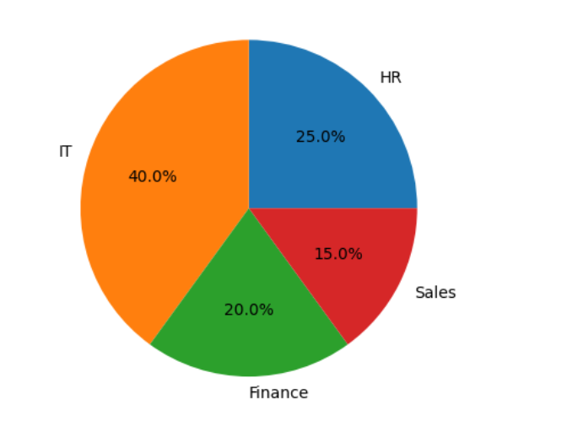
salary=[25000,27000,30000,
32000,35000,
40000,150000]
plt.boxplot(salary)
plt.show()
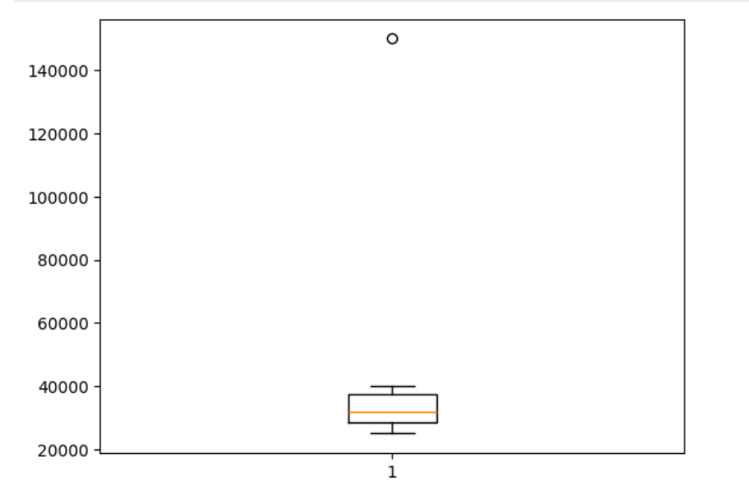
months=["Jan","Feb","Mar","Apr"]
sales=[120,150,180,200]
profit=[20,30,40,50]
plt.plot(months,sales,label="Sales")
plt.plot(months,profit,label="Profit")
plt.legend()
plt.show()

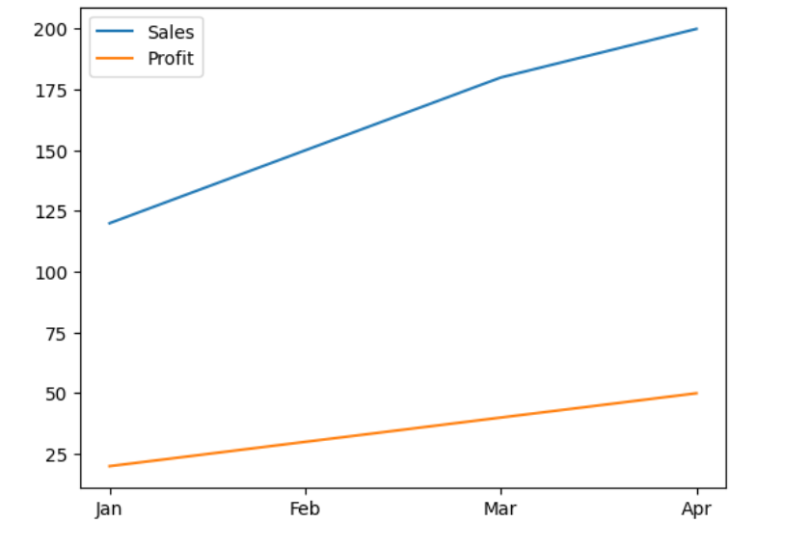

Result
Thus, various visualization techniques such as Line Charts, Bar Charts, Pie Charts, Histograms, Scatter Plots, and Box Plots were successfully created using Matplotlib. The graphical representations helped in understanding trends, distributions, comparisons, and relationships within the dataset.

