Ex.No: 6.A | DATA VISUALIZATION USING POWER BI
Date :

AIM
To import, transform, analyze, and visualize data using Power BI Desktop and create interactive dashboards and reports for decision-making.

ALGORITHM :
- Open Power BI Desktop
- Importing Data set into Power BI
- Select Transform Data , Remove duplicates and Handle null values
- Creating a Bar Chart, Pie Chart, KPI card, Slicers, DAX Calculations
- Creating Final Dashborad for Retail Dataset
OUTPUT :

Importing Data into Power BI :

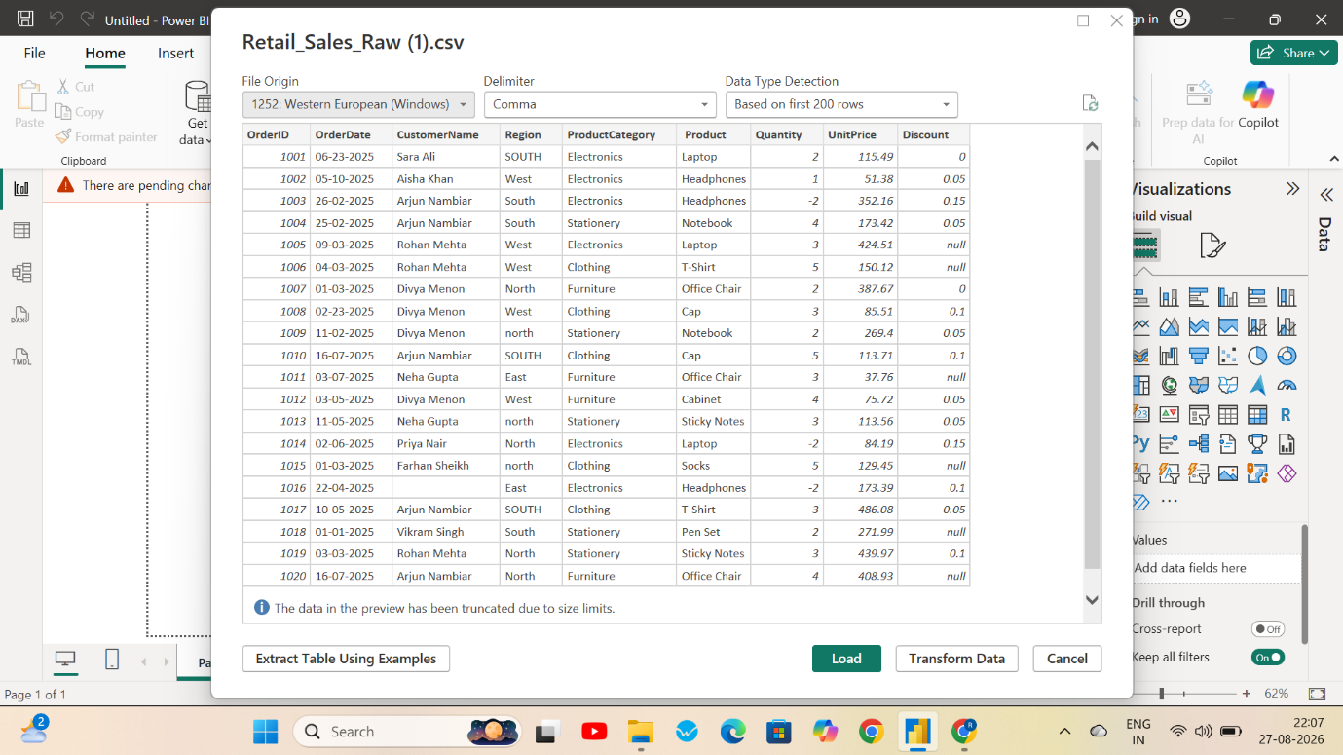

Handling Missing Values :
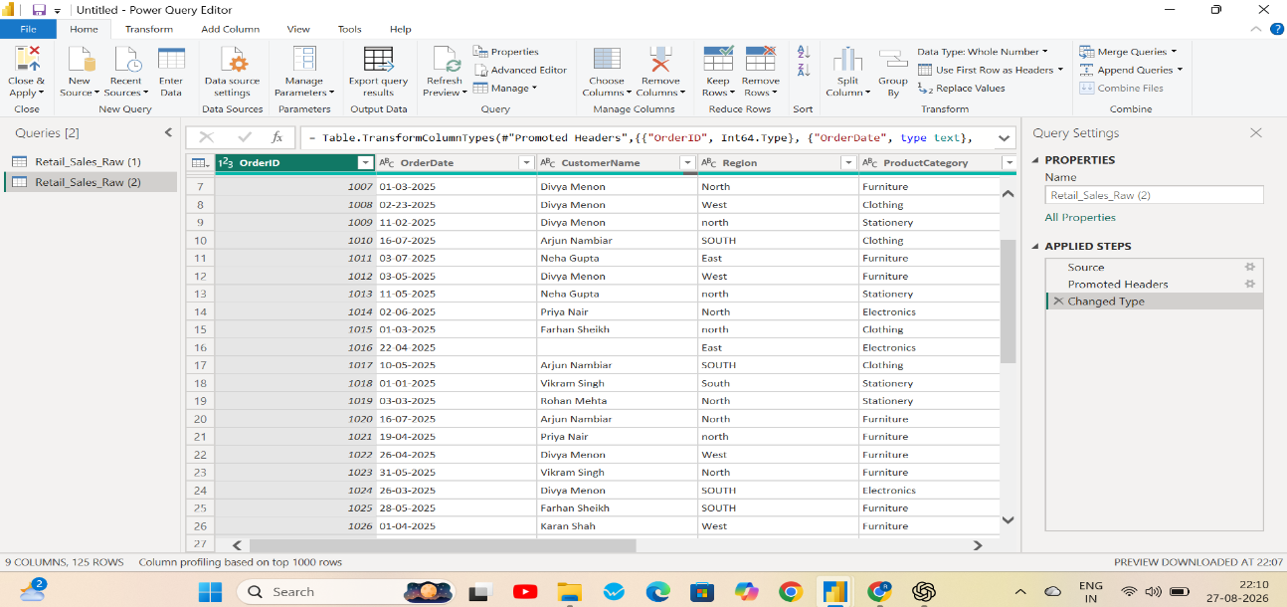

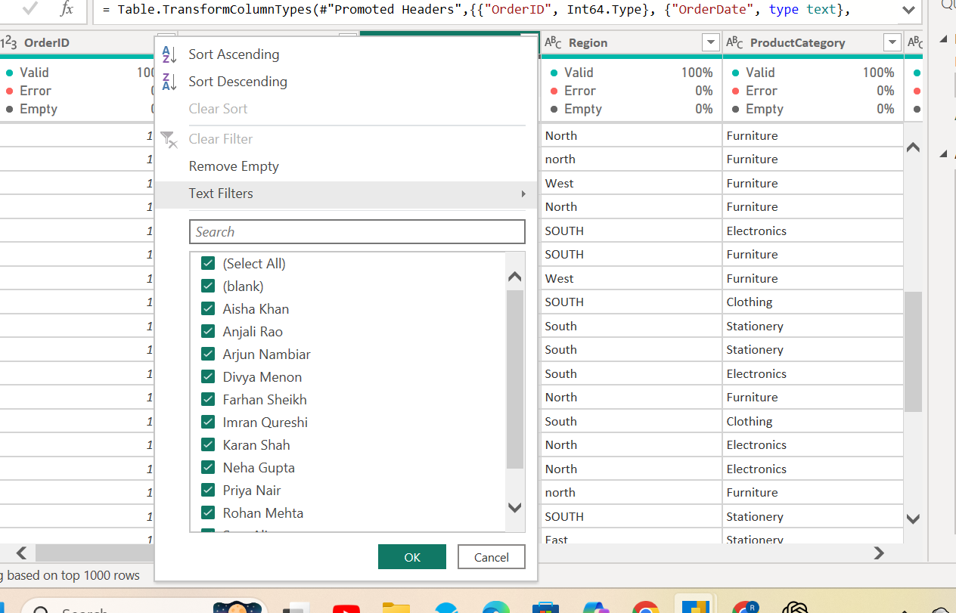

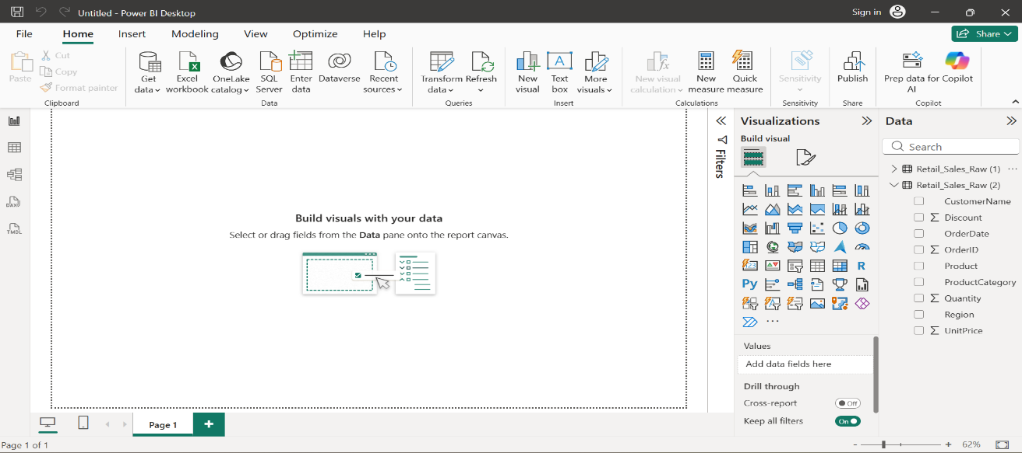
Creating Bar Chart :
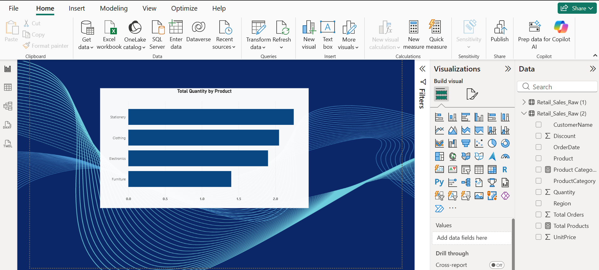
Creating Pie Chart:
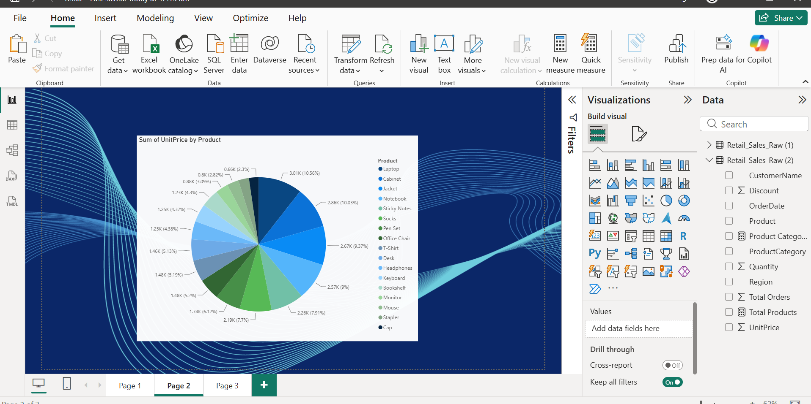
Creating Slicers:
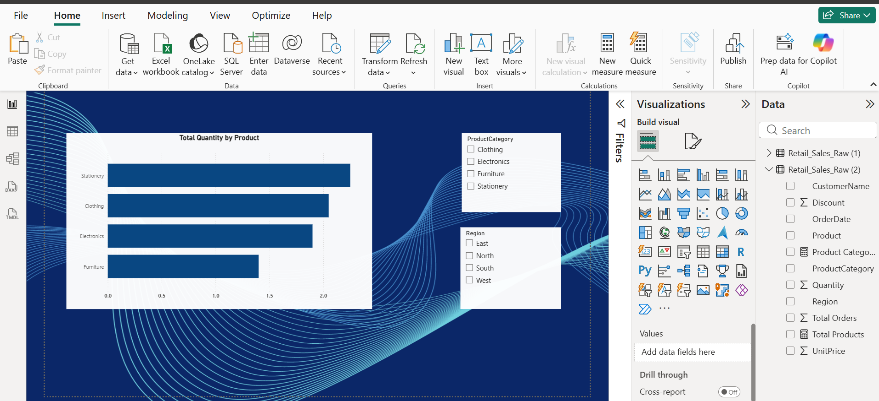
Creating KPI Cards using DAX Calculations:
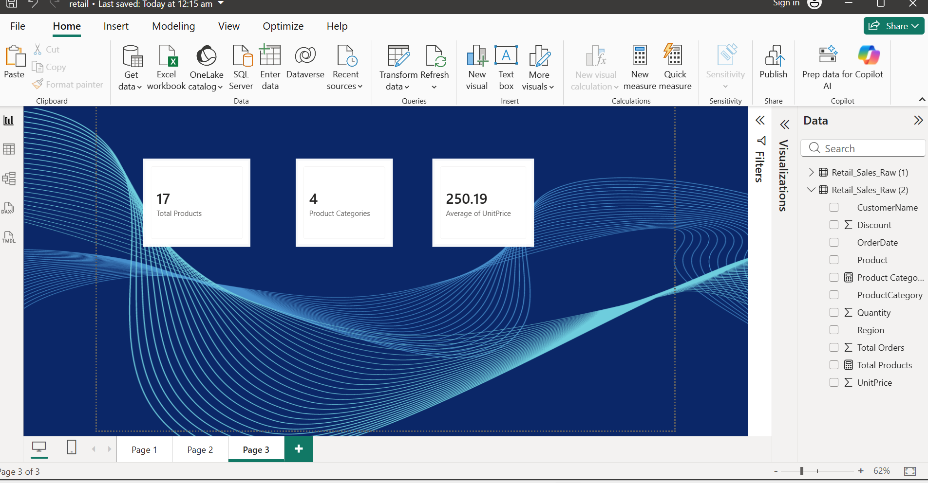
Creating Dashboard :
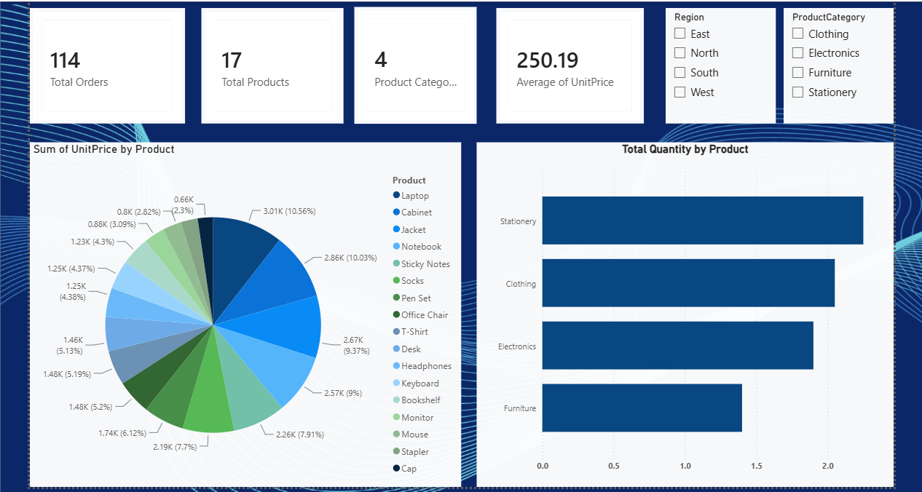

RESULT :
Thus, The Dashboard for Retail Dataset was successfully Created using Power Bi.

