Ex.No: 6.B | DATA VISUALIZATION USING POWER BI
Date :

AIM
To import, transform, analyze, and visualize data using Power BI Desktop and create interactive dashboards and reports for decision-making.

ALGORITHM :
- Open Power BI Desktop
- Importing Data set into Power BI
- Select Transform Data , Remove duplicates and Handle null values
- Creating a Bar Chart, Pie Chart, KPI card, Slicers, DAX Calculations
- Creating Final Dashborad for Retail Dataset

OUTPUT :
Open Power BI Desktop:

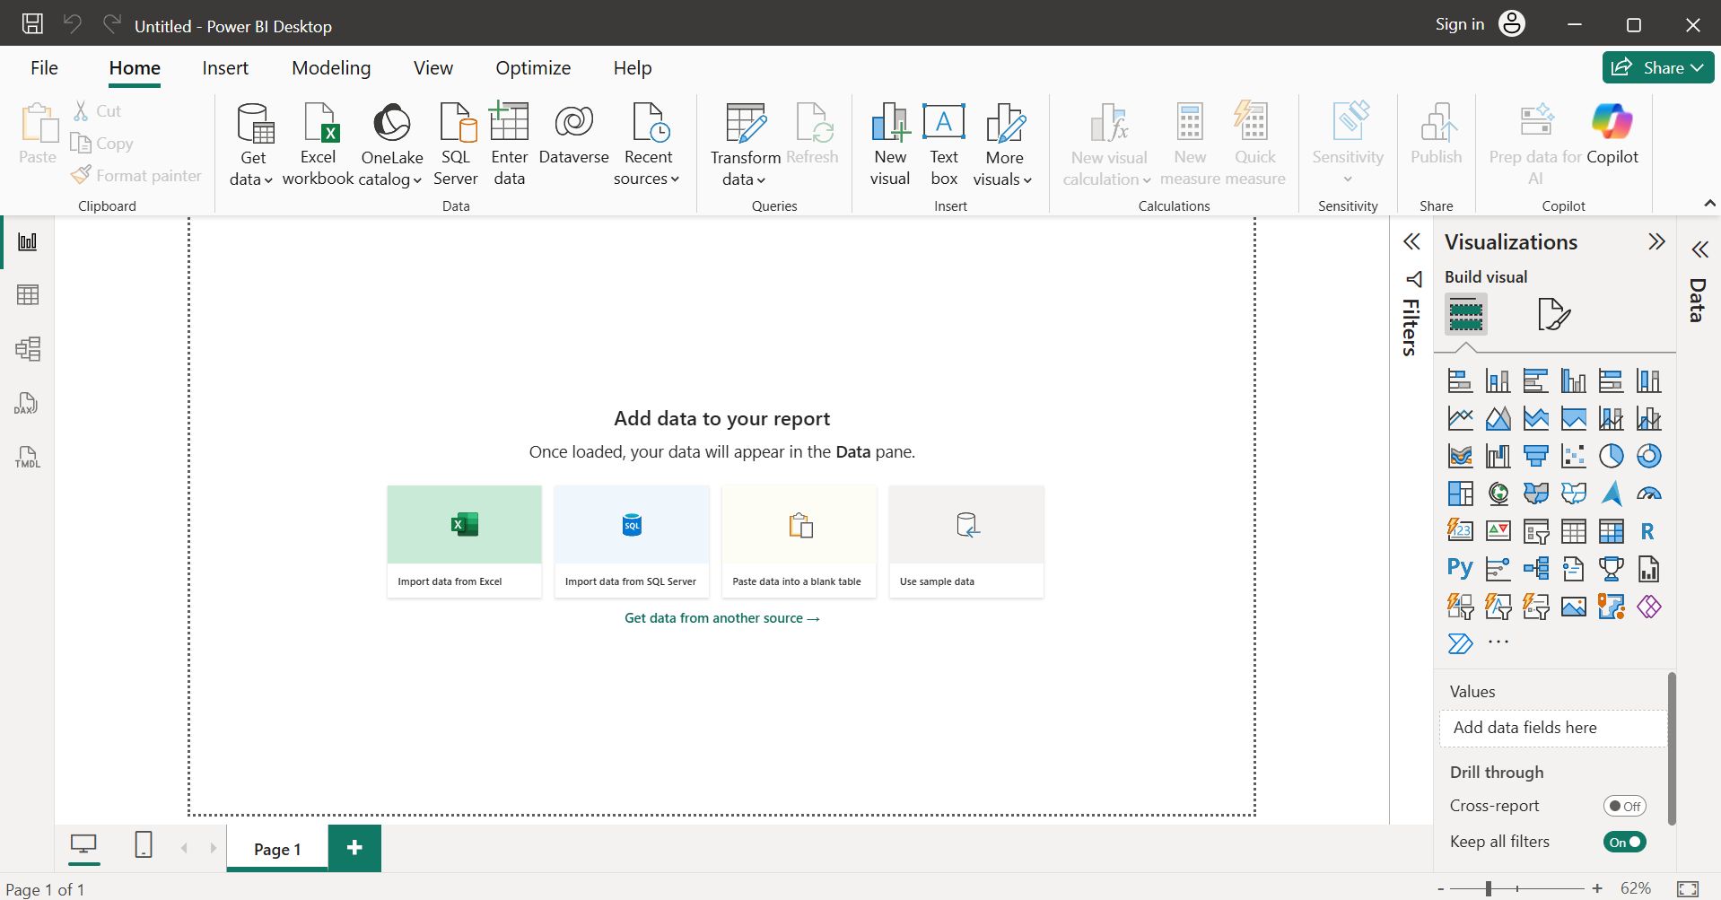

Importing Data into Power BI :

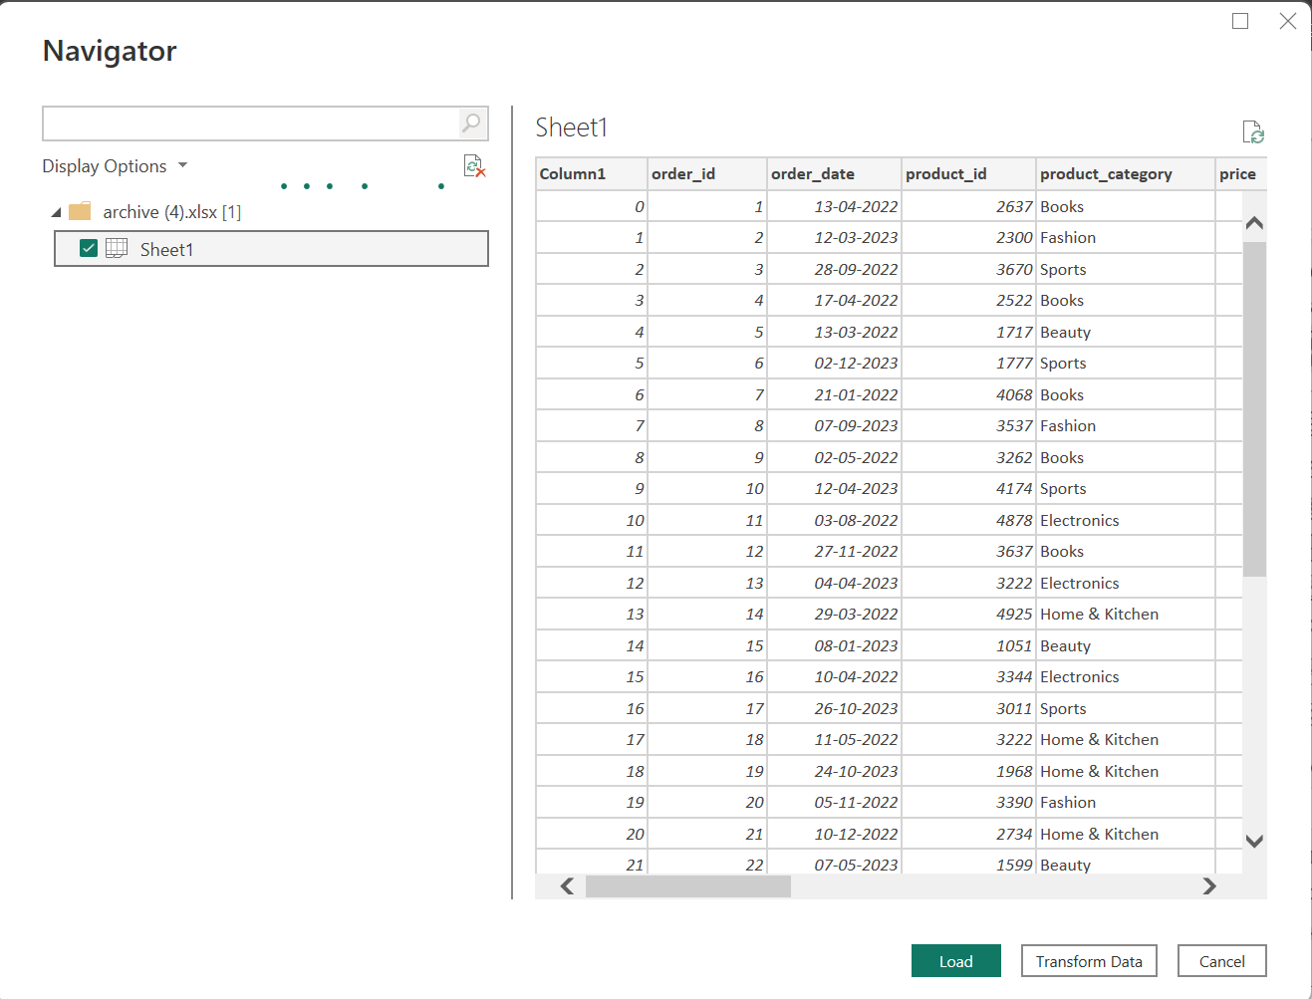
Creating Bar Chart – Total orders by category & Total orders by payment method :
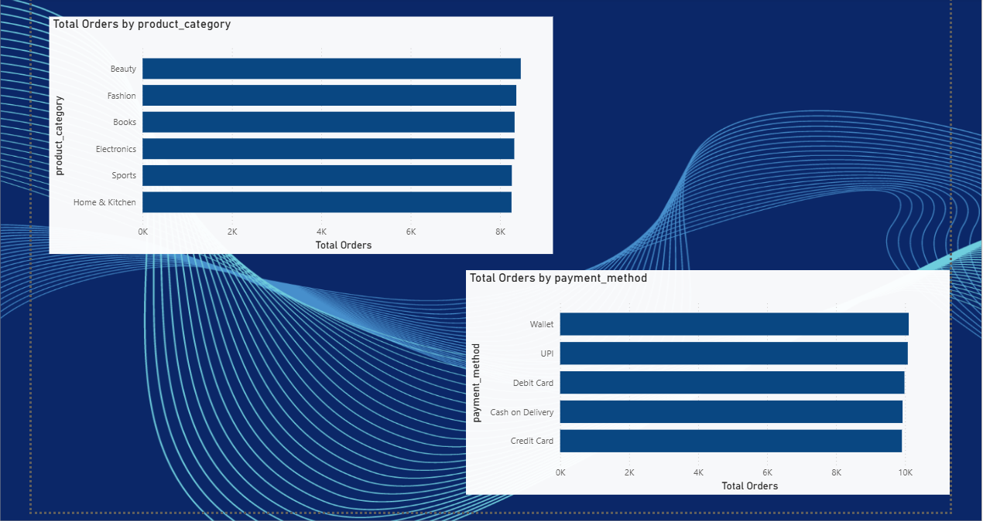

Creating Pie Chart – Total orders by region & Quantity sold by category :
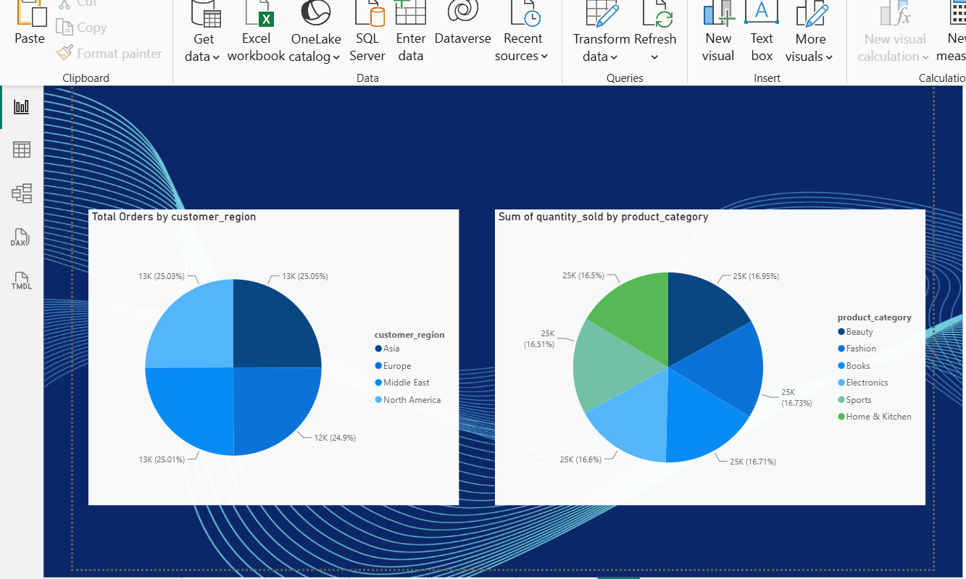
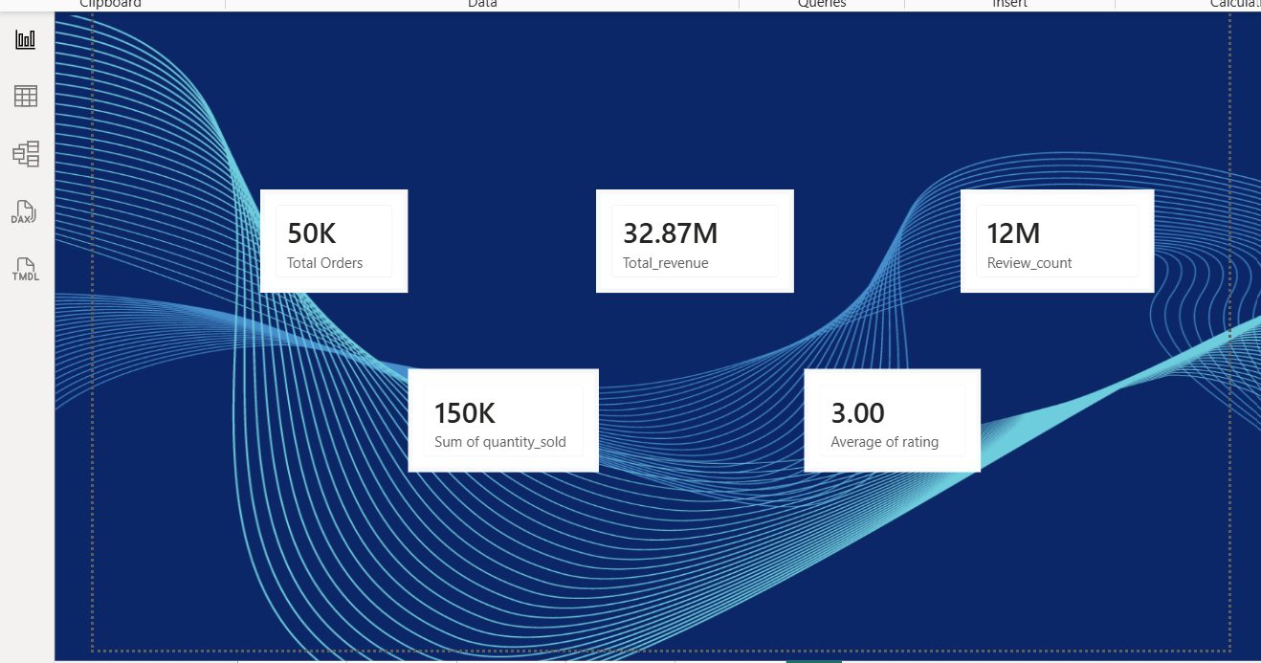
Creating Slicers for Month, Customer region, Payment method :
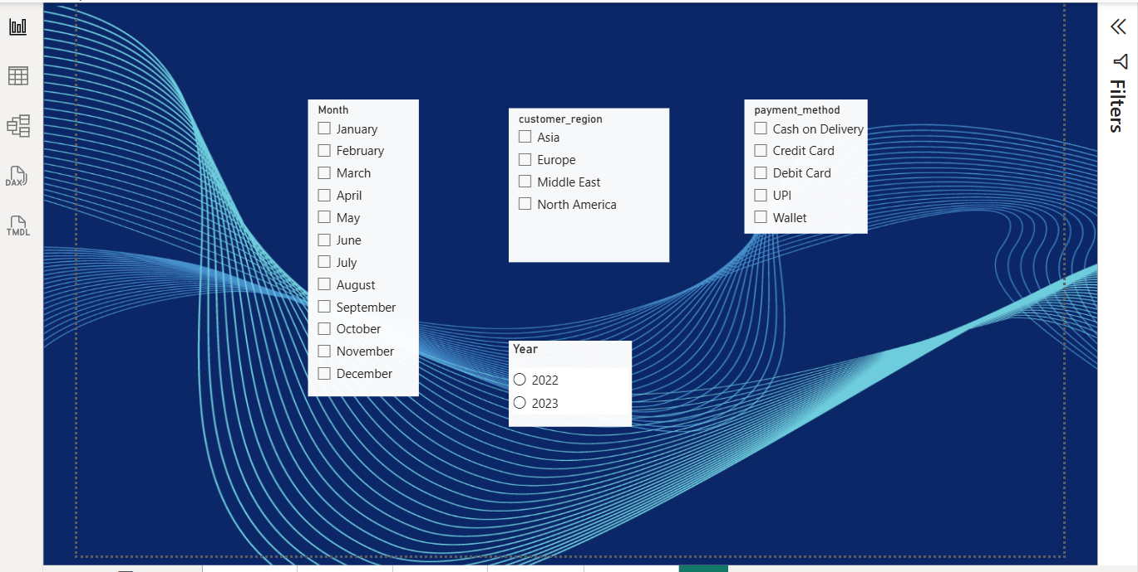
Creating Dashboard :

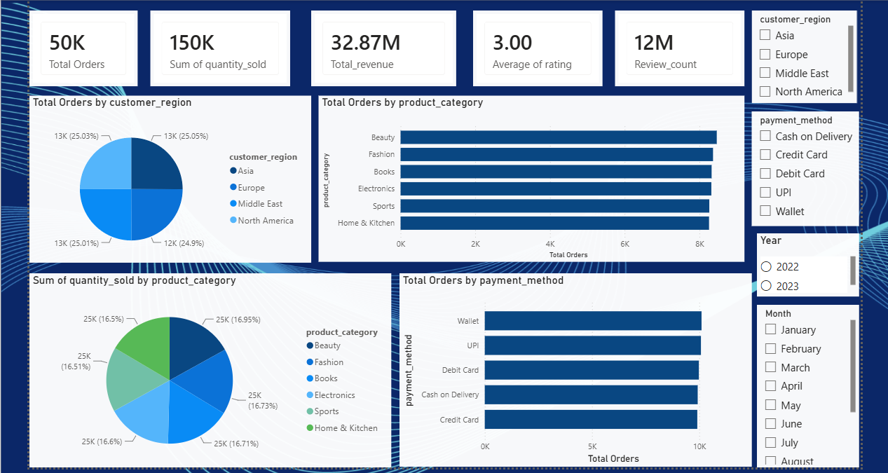

Result :
Thus, The Dashboard for Sales Dataset was successfully Created using Power Bi.

