EX: 01
DATE:

AIM

ALGORITHM

CODE AND OUTPUT
Program 1:
Program 2:
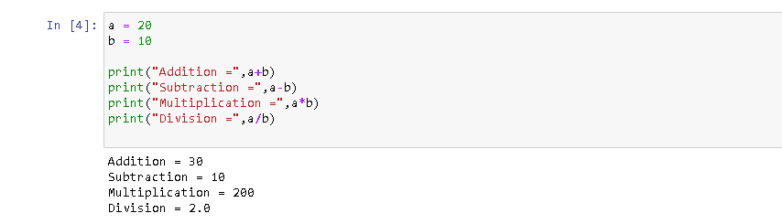
Program 3:
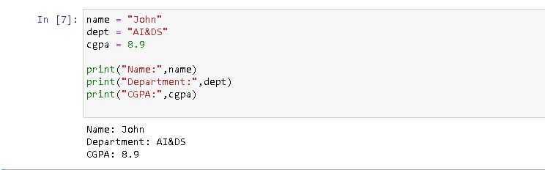
Program 4:
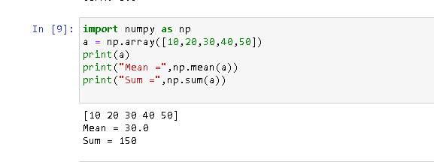

Program 5:

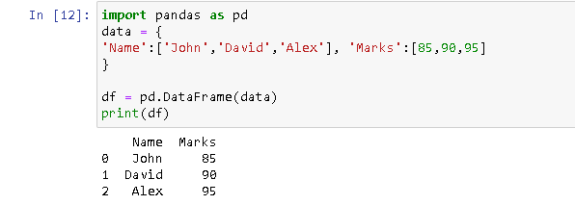

Program 6:
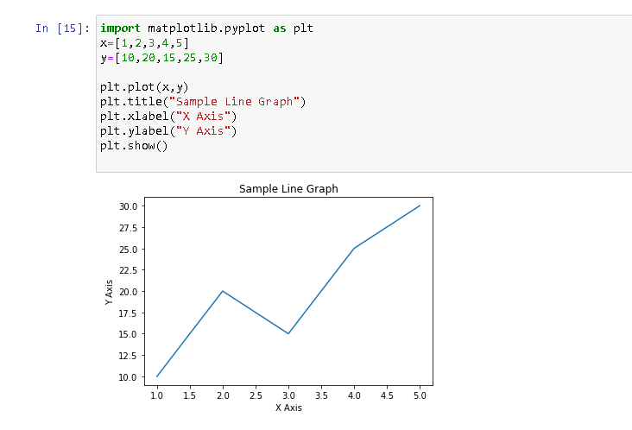

RESULT:

