Digital Baseband (DBB)
Module Documentation
ISO/IEC 14443A Type A, 106 kbit/s Manchester receive path with a Mode 1 loopback test path. System clock 50 MHz.
System overview
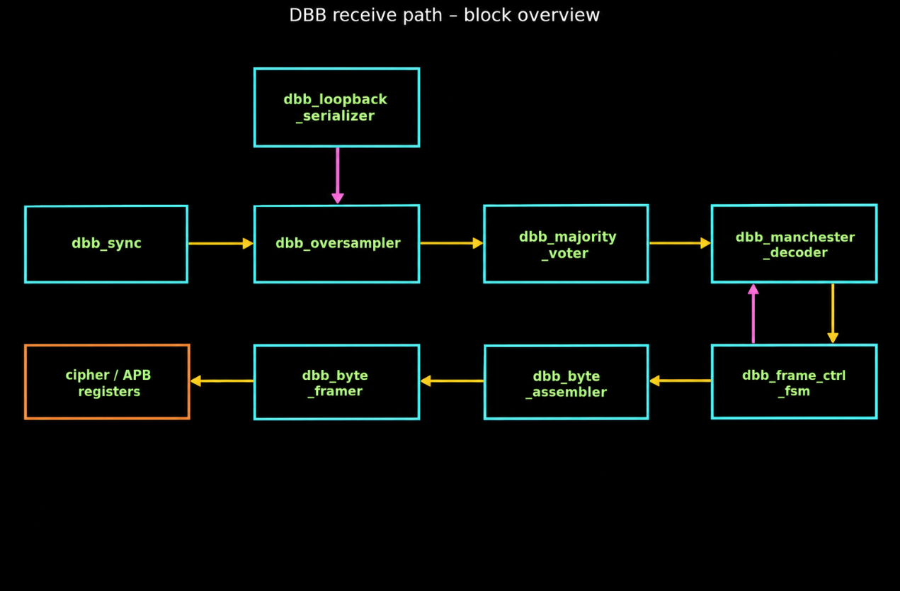

Key timing (default parameters)
- OSR = 8 samples per half-bit; HALF_BIT_CYCLES = 236 clocks.
- Sample intervals: 29, 30, 29, 30, 29, 30, 29, 30 = 236 clocks.
- Full Manchester bit = 472 clocks (two half-bits).
- os_shreg_full pulses at clk 237, bit_out_valid at clk 238, decoder unit_done after the second half-bit (~clk 475).
Modes
- Mode 0 (Live): rfid_rx_bit → sync → receive path → cipher_data_in.
- Mode 1 (DBB loopback): lb_data0/1 → loopback serializer → receive path → frame_data_out0/1 + data_ready.
- dbb_sync
2-flop synchronizer that brings the asynchronous rfid_rx_bit into the clk domain. Live path only; loopback data bypasses it.
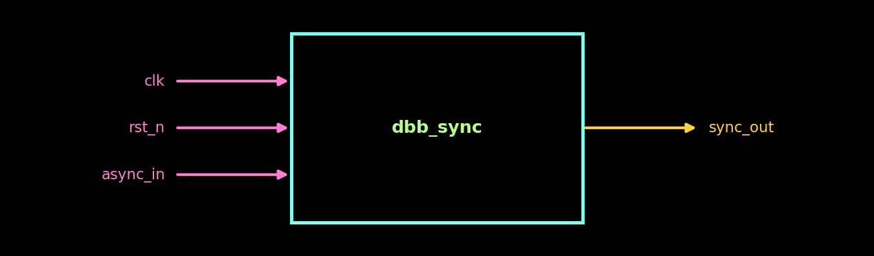

Ports
Port | Dir | Description
clk | Input | System clock
rst_n | Input | Asynchronous active-low reset
async_in | Input | Asynchronous input (rfid_rx_bit)
sync_out | Output | Synchronized output, 2-cycle latency

Behaviour
- async_in → meta_ff → sync_out on each rising clock edge.
- Reset clears both flops.
2. dbb_oversampler
Samples bit_in at a fixed rate, 8 times per half-bit, into a shift register.
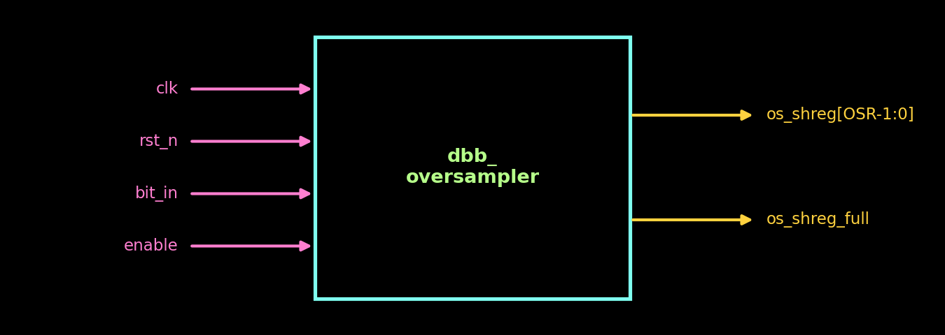

Parameters
- OSR = 8
- HALF_BIT_CYCLES = 236

Ports
Port | Dir | Description
clk | Input | System clock
rst_n | Input | Asynchronous active-low reset
bit_in | Input | Serial line bit (synchronized RF or loopback)
enable | Input | When low, counters and outputs are cleared
os_shreg[OSR-1:0] | Output | 8 samples; newest at bit 0
os_shreg_full | Output | 1-clock pulse after the 8th sample

Behaviour
- BASE_PERIOD = 236/8 = 29, REMAINDER = 236 % 8 = 4.
- remainder_acc adds REMAINDER after each sample; when remainder_acc + REMAINDER >= OSR the interval is 30 clocks (and OSR is subtracted), otherwise 29. Result: 29,30,29,30,…
- strobe_cnt counts clocks within an interval; a sample is taken when it equals current_period-1.
- sample_cnt counts 0…7; at 7 it pulses os_shreg_full and wraps to 0.

- dbb_majority_voter
Turns each 8-sample window into one clean half-bit level.
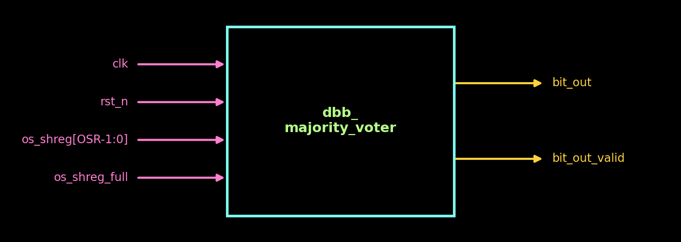

Parameters
- OSR = 8

Ports
Port | Dir | Description
clk | Input | System clock
rst_n | Input | Asynchronous active-low reset
os_shreg[OSR-1:0] | Input | Sample window
os_shreg_full | Input | Pulse: window complete
bit_out | Output | Voted level, held until next window
bit_out_valid | Output | 1-cycle pulse with each new bit_out

Behaviour
- Votes on os_shreg[VOTE_WIDTH:1] (bits 5:1 for OSR=8), skipping the outermost samples that may straddle an edge.
- VOTE_WIDTH is always odd (OSR-2 if odd, else OSR-3).
- bit_out = 1 when ones_count >= (VOTE_WIDTH+1)/2, i.e. 3 of 5.
- Result is registered on os_shreg_full; bit_out_valid is high for exactly one cycle.
4. dbb_manchester_decoder
Pairs two consecutive half-bit levels into one Manchester symbol.
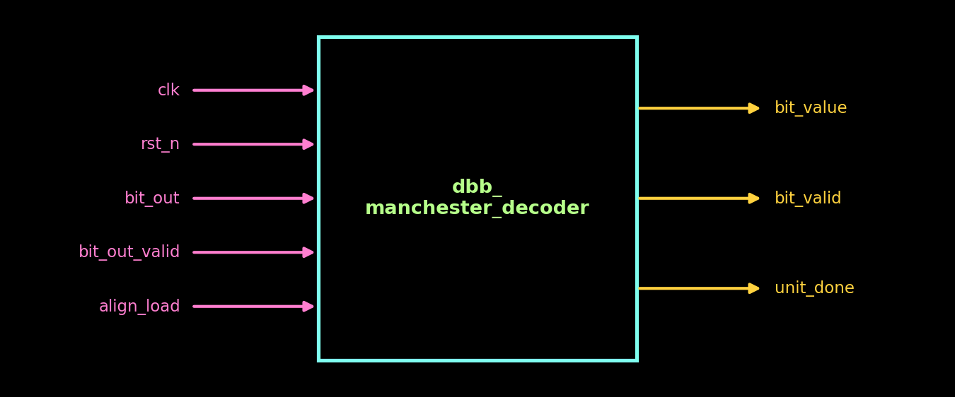

Ports
Port | Dir | Description
clk | Input | System clock
rst_n | Input | Asynchronous active-low reset
bit_out | Input | Voted half-bit level
bit_out_valid | Input | Pulse: bit_out is fresh
align_load | Input | From FSM: treat this sample as the first half of a new pair
bit_value | Output | Decoded data bit
bit_valid | Output | Pulse: symbol was legal (10 or 01)
unit_done | Output | Pulse: a pair was completed (includes both valid or not)

Behaviour
- Acts only when bit_out_valid = 1.
- align_load: store bit_out as half1_level, phase = 1.
- phase = 0: store first half, phase = 1.
- phase = 1: phase = 0, unit_done = 1, decode {half1, bit_out}.
- Decode: 10 → 1 (valid); 01 → 0 (valid); 11 / 00 → invalid (used for EOF), unit_done still pulses.
- Outputs are cleared when bit_out_valid is low, so they are single-cycle pulses.
5. dbb_frame_ctrl_fsm
Detects SOF and EOF, gates payload for the byte assembler, aborts oversize frames and aligns the decoder.
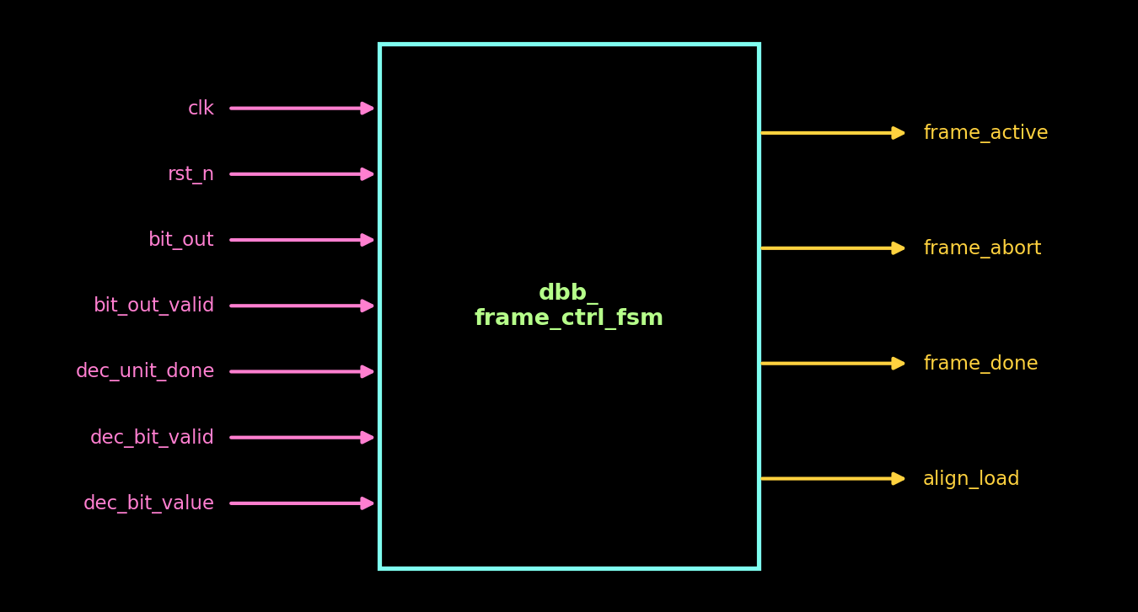

Parameters
- EOF_CONFIRM_UNITS = 2
- MAX_FRAME_BITS = 512

Ports
Port | Dir | Description
clk | Input | System clock
rst_n | Input | Asynchronous active-low reset
bit_out | Input | Raw voted half-bit (IDLE SOF search only)
bit_out_valid | Input | bit_out is fresh (IDLE only)
dec_unit_done | Input | Decoder pair completed
dec_bit_valid | Input | Decoder symbol legal
dec_bit_value | Input | Decoded bit
frame_active | Output | High while payload is collected
frame_abort | Output | 1-cycle pulse: MAX_FRAME_BITS exceeded
frame_done | Output | 1-cycle pulse: EOF confirmed
align_load | Output | To decoder: state==IDLE && bit_out_valid && bit_out

Behaviour
- IDLE: every raw 1 arms; a raw 0 while armed completes SOF "1,0" → SOF_WAIT. Works for either idle polarity.
- SOF_WAIT: one cycle to absorb the SOF pair's own decode pulse (frame_active still 0) → RECEIVING.
- RECEIVING: frame_active = 1; valid bits are counted (abort at MAX_FRAME_BITS-1); an invalid unit → EOF_CONFIRM with eof_cnt = 1.
- EOF_CONFIRM: further invalid units count up; at EOF_CONFIRM_UNITS-1 → FRAME_DONE. A valid bit returns to RECEIVING.
- FRAME_DONE: pulse frame_done, drop frame_active → IDLE.
- armed is tracked locally, in step with the decoder phase, to avoid an align_load race on the first payload sample.
6. dbb_byte_assembler
Converts decoded bits into parity-checked bytes (8 data + 1 odd-parity bit, LSB first).
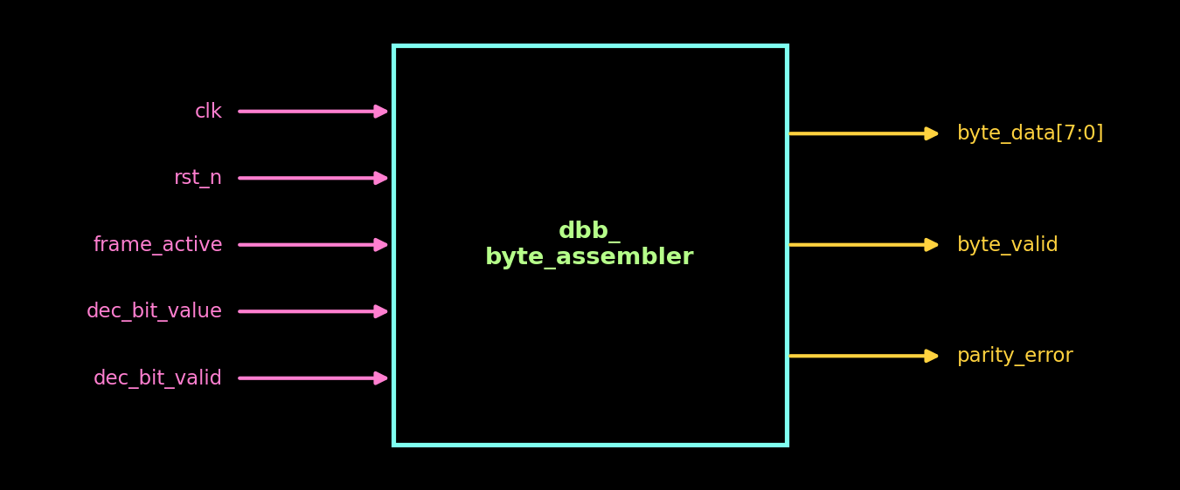

Ports
Port | Dir | Description
clk | Input | System clock
rst_n | Input | Asynchronous active-low reset
frame_active | Input | Gate from FSM
dec_bit_value | Input | Decoded bit
dec_bit_valid | Input | New decoded bit available
byte_data[7:0] | Output | Completed byte
byte_valid | Output | 1-cycle pulse: byte_data valid
parity_error | Output | Set with byte_valid if odd parity failed; held until next byte update

Behaviour
- frame_active = 0: bit_cnt and byte_valid cleared, nothing consumed.
- Bits 0–7 shift in LSB-first: shreg <= {bit, shreg[7:1]}.
- 9th bit is parity: parity_error = (^shreg == parity_bit). Odd parity requires the total number of ones to be odd.
- Then byte_data is loaded, byte_valid pulses, bit_cnt resets.
- Edge case: during EOF_CONFIRM frame_active stays high but only invalid units arrive, so no extra bits are taken.
- Out of scope: 7-bit short frames / anti-collision.
7. dbb_byte_framer
Collects bytes into a frame buffer and presents the finished frame to firmware / cipher.
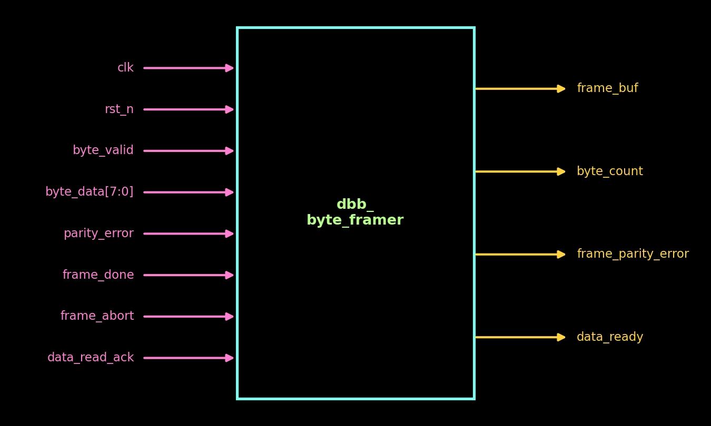

Parameters
- FRAME_BYTES = 8

Ports
Port | Dir | Description
clk | Input | System clock
rst_n | Input | Asynchronous active-low reset
byte_valid | Input | From byte assembler
byte_data[7:0] | Input | From byte assembler
parity_error | Input | From byte assembler
frame_done | Input | EOF confirmed
frame_abort | Input | Discard partial frame
data_read_ack | Input | Frame consumed
frame_buf | Output | Packed frame, byte 0 in bits [7:0]
byte_count | Output | Bytes actually received
frame_parity_error | Output | Sticky: any byte failed parity
data_ready | Output | Frame complete, waiting to be read

Behaviour
- data_read_ack clears data_ready, byte_count, frame_parity_error.
- frame_abort clears byte_count and frame_parity_error.
- Otherwise, byte_valid && !data_ready: latch parity error, write frame_buf[byte_count*8 +: 8], increment byte_count (saturates at FRAME_BYTES).
- frame_done && !data_ready → data_ready = 1.
- While data_ready = 1 new bytes are ignored, protecting the unread frame.
8. dbb_loopback_serializer
Mode 1 test source. Builds a full serial frame from two 32-bit registers. The payload is already Manchester-encoded by firmware (64 line bits = 32 decoded bits = 4 bytes); SOF, parity and EOF are inserted here.
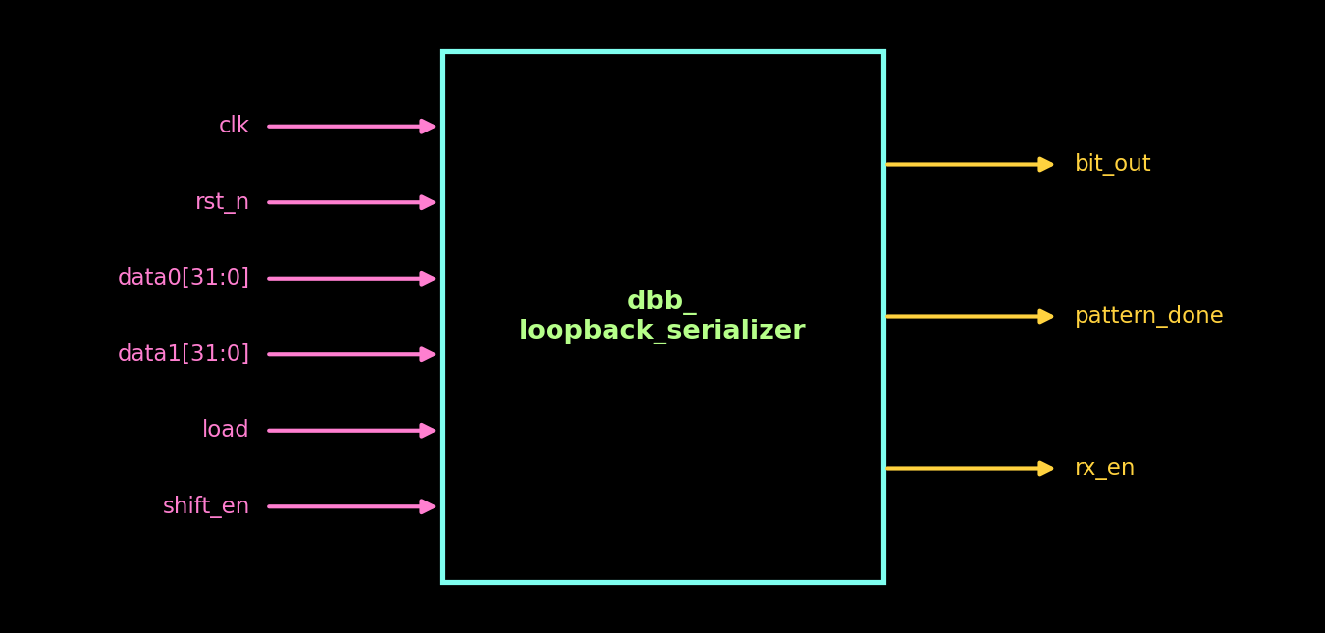

Parameters
- PATTERN_BITS = 64 (multiple of 16)

Ports
Port | Dir | Description
clk | Input | System clock
rst_n | Input | Asynchronous active-low reset
data0[31:0] | Input | Payload low word (data0[0] sent first)
data1[31:0] | Input | Payload high word
load | Input | Pulse: latch {data1,data0} and start (priority over shift_en)
shift_en | Input | Advance one line bit; tied to os_shreg_full
bit_out | Output | Line bit to oversampler bit_in
pattern_done | Output | Pulse on last EOF bit
rx_en | Output | state != S_IDLE; enables the oversampler

Behaviour
- Frame: SOF(2) | 16 payload bits | P(2) | 16 payload bits | P(2) … | EOF(4).
- S_SOF: 2 bits "10" (cnt 0 → 1, cnt 1 → 0), then S_DATA.
- S_DATA: line_bit = shreg[0]; shreg shifts right each strobe; par_acc ^= dec_bit on the first half of each symbol; cnt == 15 → S_PARITY.
- S_PARITY: odd-parity Manchester symbol (par_bit = ~par_acc); bytes_left--; last byte → S_EOF, else back to S_DATA with par_acc = 0.
- S_EOF: 4 zero bits, then S_IDLE and pattern_done = 1.
- Idle level of bit_out is 0. MANCHESTER = 1 means 1 → "10", 0 → "01".
9. dbb_top
Integrates all blocks, selects the mode, flushes on mode change and generates acknowledgements.
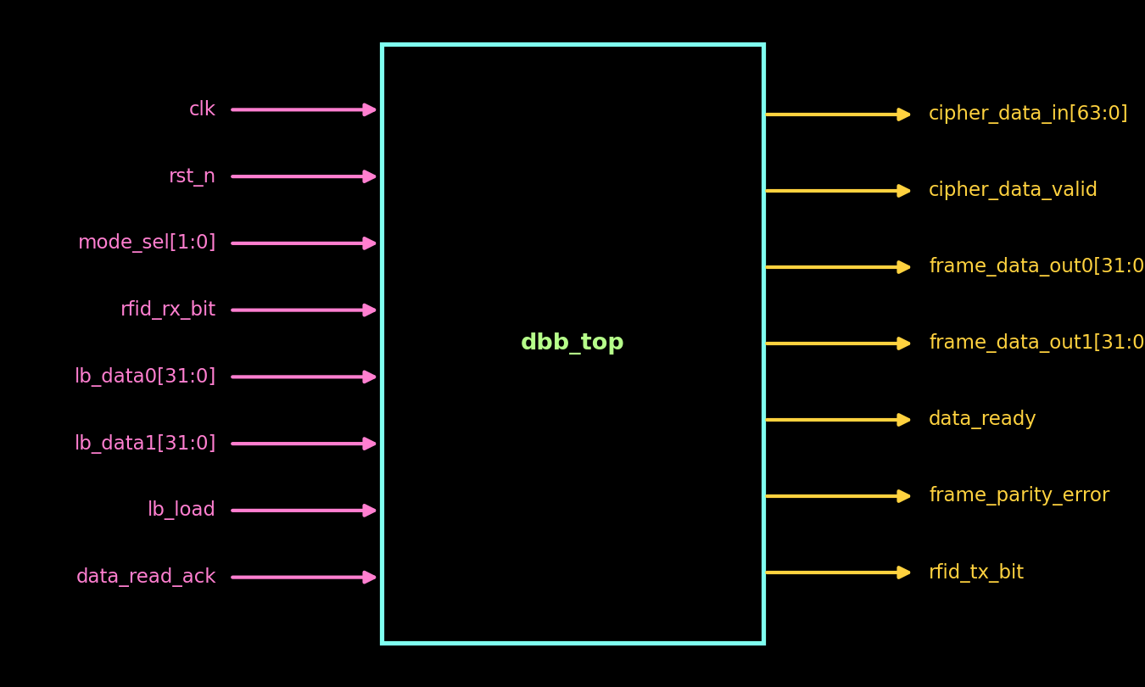

Parameters
- OSR = 8
- HALF_BIT_CYCLES = 236
- FRAME_BYTES = 8
- MAX_FRAME_BITS = 512

Ports
Port | Dir | Description
clk | Input | System clock
rst_n | Input | Asynchronous active-low reset
mode_sel[1:0] | Input | 0 Live, 1 DBB loopback, 2 Crypto loopback
rfid_rx_bit | Input | Live RF input
lb_data0[31:0] | Input | Loopback payload low word
lb_data1[31:0] | Input | Loopback payload high word
lb_load | Input | Loopback start pulse
data_read_ack | Input | Read acknowledge from APB side
cipher_data_in[63:0] | Output | frame_buf[63:0] (Mode 0)
cipher_data_valid | Output | (byte_count == FRAME_BYTES) & auto_ack_mode0
frame_data_out0[31:0] | Output | frame_buf[31:0]
frame_data_out1[31:0] | Output | frame_buf[63:32]
data_ready | Output | mode_sel & data_ready_int
frame_parity_error | Output | Sticky frame parity flag
rfid_tx_bit | Output | Tied to 0 (no TX path)

Behaviour
- Input mux: osr_bit_in = (mode_sel == 1) ? lb_bit : rx_sync.
- Oversampler enable = mode_sel ? mode1_enable : 1.
- Serializer shift_en = os_shreg_full (one line bit per half-bit).
- Mode-change flush: mode_prev / flush_q detect a change; rx_rst_n = rst_n & ~flush_q resets the receive chain for one cycle.
- framer_ack = data_read_ack | auto_ack_mode0 | mode_changed | flush_q.
- Mode 0: frame is auto-acknowledged once data_ready_int is set; Mode 1: waits for data_read_ack.

