Crypto RFID Top (APB Wrapper)
Module Documentation
Top level of the Baseband & Cryptographic Subsystem. Implements the APB slave (address decode, register file, wait-state handshake), the Mode 0/1/2 data muxes and the STATUS logic, and instantiates dbb_top and present_core. rfid_tx_bit is unused and tied to 0.

System overview
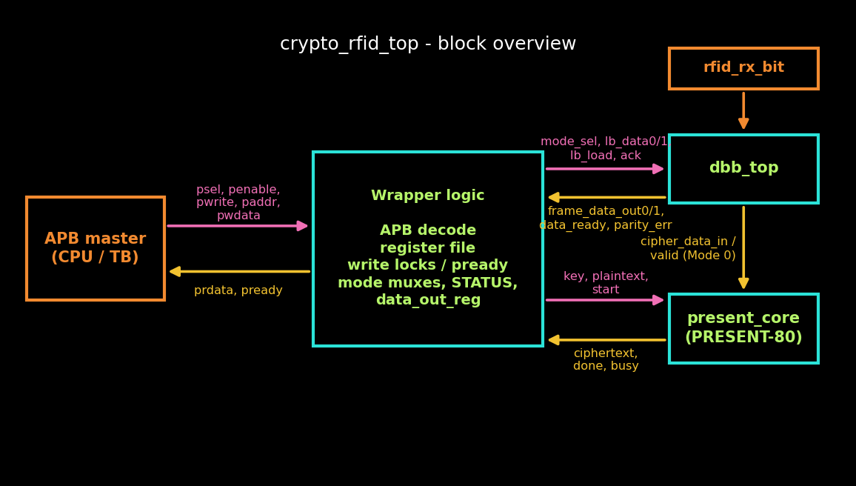

Key timing
- Register writes complete on the clock edge where pready = 1; a write to a locked register is stalled with pready = 0 (APB wait state). Reads never stall.
- Mode 1: lb_load pulses one clock after the DATA_1 write, so the DBB sees the new DATA_0/1 values. dbb_replay_busy is set at the edge that accepts the DATA_1 write.
- Mode 2: cipher_start pulses one clock after the DATA_1 write, once data1_reg has updated.
- Mode 0: cipher_start = dbb_cipher_data_valid, passed through combinationally so start and data share the same cycle.
- PRESENT-80 takes 32 clocks. A Mode 1 replay takes about 15.6k clocks (64 x 236 + EOF silence); the replay timeout is 65,535 clocks.

Modes
- Mode 0 (Live): rfid_rx_bit → dbb_top → cipher_data_in → present_core → DATA_OUT.
- Mode 1 (DBB loopback): DATA_0/1 → dbb_top loopback replay → frame_data_out0/1 → DATA_OUT, with data_ready.
- Mode 2 (Crypto loopback): DATA_0/1 → present_core → DATA_OUT.
- Mode 3 is reserved: cipher_data_in follows DATA_0/1, no start is issued and DATA_OUT holds its value.
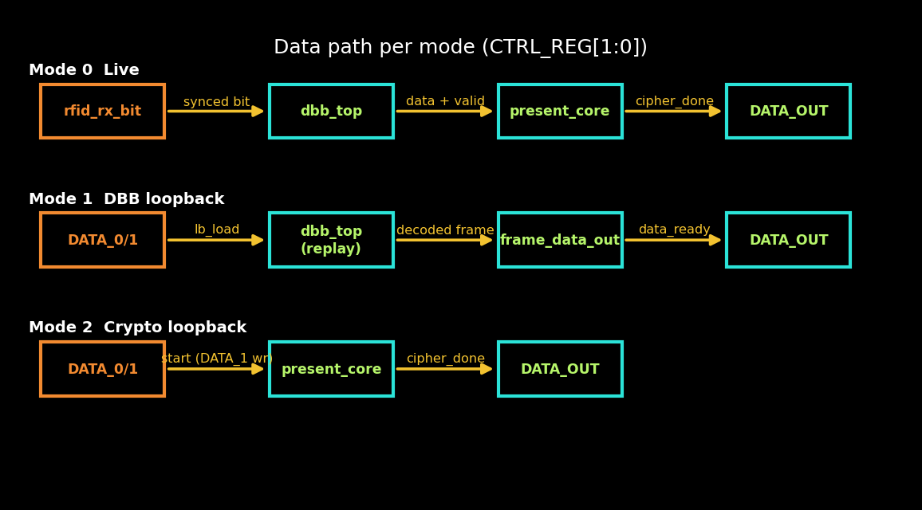

1. crypto_rfid_top
Top-level module. The port list is fixed; there are no additional ports.
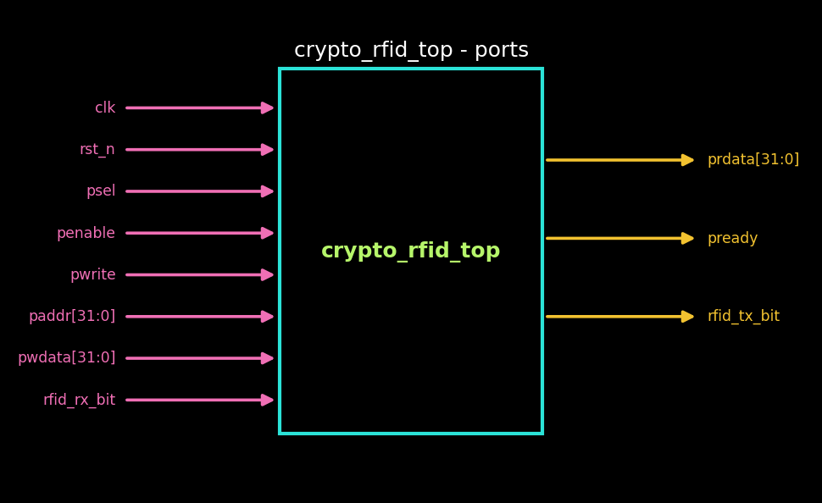

Ports
Port | Dir | Description
clk | Input | System clock
rst_n | Input | Asynchronous active-low reset
psel | Input | APB select
penable | Input | APB enable (access phase)
pwrite | Input | APB write (1) / read (0)
paddr[31:0] | Input | APB address
pwdata[31:0] | Input | APB write data
prdata[31:0] | Output | APB read data; 0 when not reading
pready | Output | Low while a write to a locked register is stalled
rfid_rx_bit | Input | Live RF input, passed to dbb_top
rfid_tx_bit | Output | Tied to 0 (no TX path)

2. Register map and file
All registers are 32 bits wide on the APB bus. Unused upper bits are ignored on write and read as 0.

Register map
Addr | Name | Access | Description
0x00 | CTRL_REG | R/W | [1:0] mode select: 0 Live, 1 DBB loopback, 2 Crypto loopback. Resets to 0.
0x04 | STATUS_REG | R | [0] DONE, [1] DATA_READY, [2] PARITY_ERROR (see below).
0x08 | KEY_0 | W | Key bits [31:0].
0x0C | KEY_1 | W | Key bits [63:32].
0x10 | KEY_2 | W | [15:0] = key bits [79:64].
0x14 | DATA_0 | W | Input data, low word (Mode 1 and 2).
0x18 | DATA_1 | W | Input data, high word. Writing it starts the operation in Mode 1 and 2.
0x1C | DATA_OUT_0 | R | Result [31:0].
0x20 | DATA_OUT_1 | R | Result [63:32]. In Mode 1, reading it acknowledges the DBB result.

Behaviour
- Write strobes wen_* = psel & penable & pwrite & address match & pready.
- The 80-bit cipher key is {KEY_2[15:0], KEY_1, KEY_0}.
- Write-only registers read back as 0.
- All registers reset to 0 (CTRL_REG = Mode 0).

3. Write locks and wait states
A block that is working owns its source registers until it finishes. A write to a locked register is stalled by holding pready low; the master keeps paddr, pwdata and pwrite stable, so no extra state machine is needed.

Lock conditions
Register | Locked while | Reason
CTRL_REG | cipher_busy or dbb_replay_busy | Mode cannot change while any block is active.
KEY_0/1/2 | cipher_busy | Key feeds PRESENT-80 in Modes 0 and 2.
DATA_0/1 | Mode 1 and dbb_replay_busy, or Mode 2 and cipher_busy | Source data for the DBB (Mode 1) and cipher (Mode 2). Not locked in Mode 0.

Behaviour
- write_must_stall = apb_write_xfer and the addressed register is locked.
- pready = ~write_must_stall.
- A new DATA_0/1 write is allowed while an earlier Mode 1 result is still unread; the unread result is overwritten when the next one arrives.

4. Mode 1 replay control
The DBB has no busy output, so the wrapper tracks the replay window itself and issues lb_load and data_read_ack.
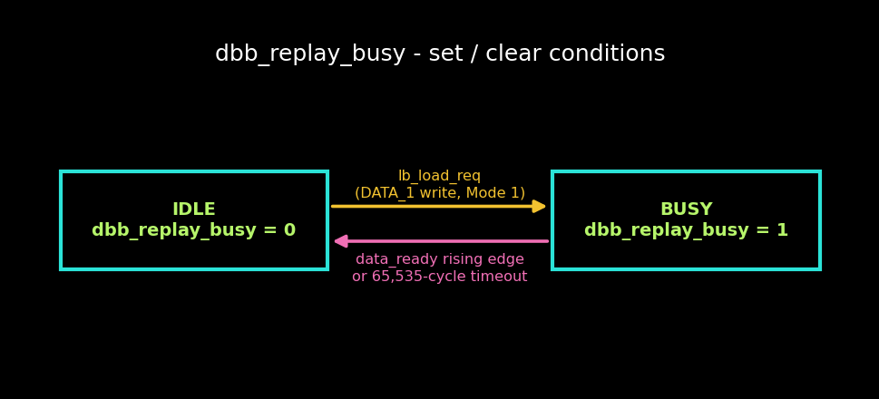

Parameters
- REPLAY_TIMEOUT_CYCLES = 65535

Signals
Signal | Description
lb_load_req | wen_data1 in Mode 1. Undelayed request used to set dbb_replay_busy.
lb_load | lb_load_req delayed one clock; drives dbb_top.lb_load.
dbb_data_ready_rise | Rising edge of dbb_data_ready; marks the end of a replay.
dbb_replay_busy | High from lb_load_req until data_ready rises or the timeout expires.
replay_timer | 16-bit counter, runs while dbb_replay_busy, cleared otherwise.
dbb_replay_timed_out | Sticky diagnostic, set on timeout, cleared on the next lb_load_req. Not visible to software.
data_read_ack | Read of DATA_OUT_1 in Mode 1; clears dbb_top data_ready.

Behaviour
- Busy clears on the rising edge of data_ready, not its level, because data_ready is sticky and may still be high from an earlier unread result.
- The timeout clears busy if data_ready never rises, so pready cannot stay low indefinitely.
- The timeout is about 4 x the nominal replay time; scale it if HALF_BIT_CYCLES or PATTERN_BITS change.
- data_read_ack assumes firmware reads DATA_OUT_0 before DATA_OUT_1.

5. Cipher input and start
Selects the data presented to present_core and generates its start pulse.

Behaviour
- cipher_data_in = dbb_cipher_data_in in Mode 0; {DATA_1, DATA_0} in Mode 2 and in reserved modes.
- Mode 0: cipher_start = dbb_cipher_data_valid, combinational. The DBB word is only guaranteed in that one cycle.
- Mode 2: cipher_start_m2 is wen_data1 registered one clock, so data1_reg holds the new value when the cipher starts.
- PRESENT-80 finishes before the DBB can assemble the next word, so cipher_busy is low at the next Mode 0 pulse.

6. Output data and STATUS_REG

DATA_OUT update
Mode | data_out_reg loads
0 Live | cipher_data_out when cipher_done.
1 DBB loopback | {frame_data_out1, frame_data_out0} while dbb_data_ready is high.
2 Crypto loopback | cipher_data_out when cipher_done.
3 (reserved) | Holds its value.

STATUS_REG
Bit | Name | Description
0 | DONE | cipher_done latched. Cleared by a STATUS_REG read; a new cipher_done in the same cycle takes priority.
1 | DATA_READY | dbb_data_ready, passed straight through. Sticky in the DBB until data_read_ack.
2 | PARITY_ERROR | dbb_frame_parity_err, sticky per frame in the DBB.
31:3 | Reserved | Read as 0.

Behaviour
- cipher_done is a single-cycle pulse, so it is latched to stop a polling read from missing it.
- Bit 2 uses a previously unused bit of STATUS_REG; the base definition covers bits [1:0] only.

7. APB read mux
Combinational read data for APB reads.

Behaviour
Address | prdata
0x00 | {30'd0, ctrl_reg}
0x04 | status_reg
0x1C | data_out_reg[31:0]
0x20 | data_out_reg[63:32]
other | 0 (write-only registers and unmapped addresses)

- prdata is 0 whenever apb_read_xfer is low.

8. Sub-module instances

dbb_top (u_dbb)
DBB port | Connected to
mode_sel | ctrl_reg
rfid_rx_bit | rfid_rx_bit
lb_data0 / lb_data1 | data0_reg / data1_reg
lb_load | lb_load
data_read_ack | data_read_ack
frame_data_out0 / 1 | dbb_frame_out0 / 1
data_ready | dbb_data_ready
cipher_data_in / cipher_data_valid | dbb_cipher_data_in / dbb_cipher_data_valid
frame_parity_error | dbb_frame_parity_err
rfid_tx_bit | dbb_tx_bit_unused (left unconnected)

present_core (u_present)
Cipher port | Connected to
start | cipher_start
plaintext | cipher_data_in
key | cipher_key = {KEY_2, KEY_1, KEY_0}
ciphertext | cipher_data_out
done | cipher_done
busy | cipher_busy

present_core contains its own key scheduler and takes the raw 80-bit key directly.

