Requirement Elicitation and Design - Task 3
Group Assignment
Group 11

Stakeholder Identification
For our software solution, we identified the following stakeholders:
- 1. End Users - Individuals who will use the software regularly.
- 2. Domain Experts - Professionals with expertise in the problem domain.
- 3. Business Owners - Sponsors or clients who require the solution.

Survey and Interview Responses
We conducted semi-structured interviews with the stakeholders to understand their pain points and expectations. The responses are summarized below:
- End Users: Need a user-friendly interface and quick access to core features.
- Domain Experts: Require accurate data modeling and integration with existing systems.
- Business Owners: Expect cost-effective implementation and scalability.

Product Requirement Document (PRD) / Software Requirements Specification (SRS)
The PRD/SRS outlines the functional and non-functional requirements of the software. It includes the following diagrams:

UML Diagrams
- Use Case Diagram
Diagram Placeholder Below

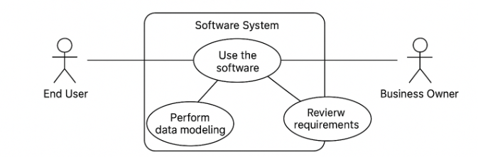
- Activity Diagram
Diagram Placeholder Below

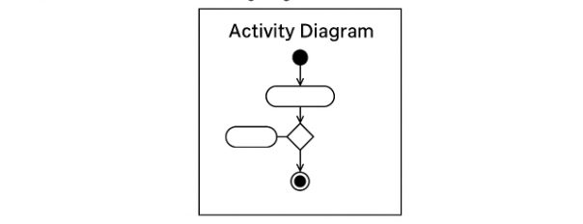
- State Machine Diagram
Diagram Placeholder Below

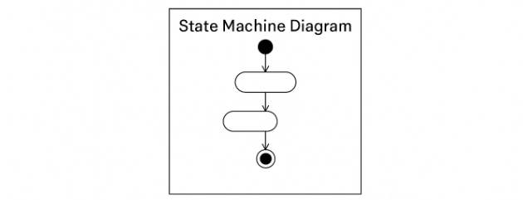
- Sequence Diagram
Diagram Placeholder Below
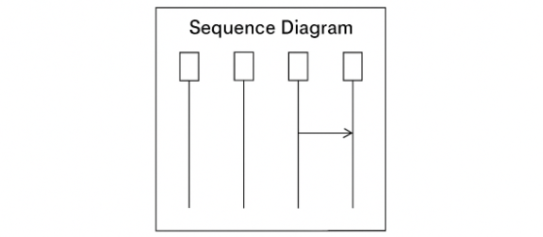

- Data Modelling
Diagram Placeholder Below

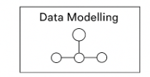

- Class Diagram
Diagram Placeholder Below

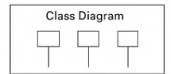

- Component Diagram
Diagram Placeholder Below

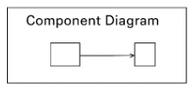
- Deployment Diagram
Diagram Placeholder Below

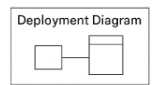

- Data Flow Diagram - Level 1
Diagram Placeholder Below
