**Exp- 7**

**7a-Architecture Diagram**

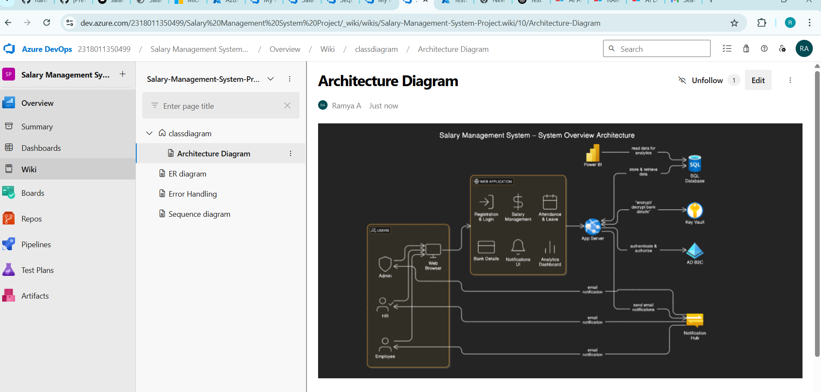

7b-ER Diagram

