https://dev.to/jakewitcher/using-env-files-for-environment-variables-in-python-applications-55a1
pip install python-dotenv

If an environment variable is not found in the .env file, load_dotenv will then search for a variable by the given name in the host environment.

Custom .env files can be loaded using dotenv_path = Path('.env_dev') and load_dotenv(dotenv_path=dotenv_path).

If multiple .env files are mentioned in the script, by defaultload_dotenv() will be given preference.

By default load_dotenv() don't overwrite the host level env variables. This was been observed when testing with IPython. Running load_dotenv() is not taking .env entries. We can resolve this issue by using override as shown below.

Run following in IPython Console:
load_dotenv(override=True)
load_dotenv(override=True,dotenv_path='C:\SUREDELETELATER\AzureB41\Python\demo1\.env_dev')
load_dotenv(override=True,dotenv_path='C:\SUREDELETELATER\AzureB41\Python\demo1\.env_prod')

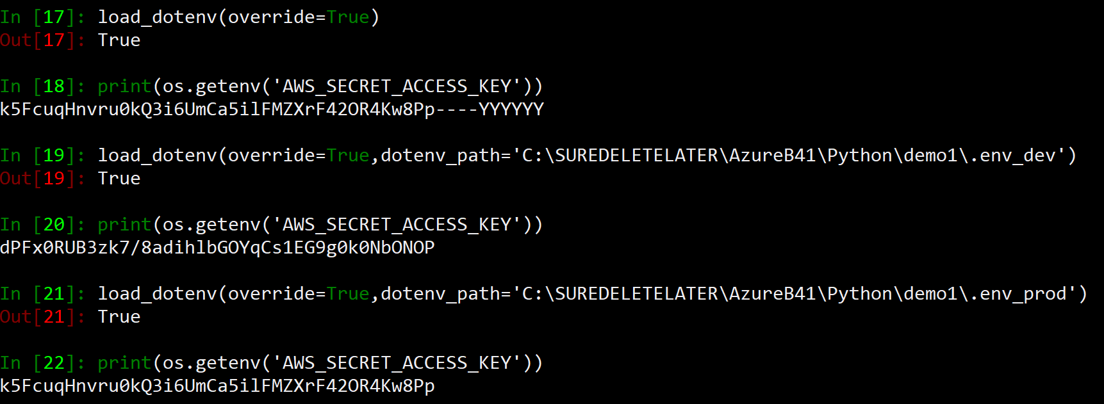

.env file:
AWS_ACCESS_KEY_ID=AAAAAAAAAAAAAAAAAAAAAAAAA
AWS_SECRET_ACCESS_KEY=lakjsdklasjdskldj
AWS_DEFAULT_REGION=us-east-2

.env_prod
AWS_ACCESS_KEY_ID=BBBBBBBBBBBBBB
AWS_SECRET_ACCESS_KEY=asdasdsadasdasdas
AWS_DEFAULT_REGION=us-east-2

.env_dev
AWS_ACCESS_KEY_ID=CCCCCCCCCCCCCCC
AWS_SECRET_ACCESS_KEY=asdasdsadasdasdsadasdasdasdsa
AWS_DEFAULT_REGION="us-east-1"

import os
import boto3
from dotenv import load_dotenv, find_dotenv, dotenv_values
from pprint import pprint
from pathlib import Path

#By default it will look for .env file in the current directory.
load_dotenv()

#Provide Custom path and load custom .env filename.
#Preferance is given to load_dotenv rather than custom path.
dotenv_path = Path('.env_dev')
load_dotenv(dotenv_path=dotenv_path)

# Prints Values from .env file in dict form.
config = dotenv_values(".env")
print(config)
print(os.getenv('AWS_ACCESS_KEY_ID'))

ec2_client = boto3.client('ec2')
vpcs = ec2_client.describe_vpcs().get('Vpcs',"NotFound")
vpcid_list = [vpc['VpcId'] for vpc in vpcs]
cidr_list = [ vpc['CidrBlock'] for vpc in vpcs]
vpc_dict = dict(zip(vpcid_list, cidr_list))
pprint(vpc_dict)

import os
from dotenv import load_dotenv, find_dotenv, dotenv_values
import boto3
from pathlib import Path

#This will load .env by default.
load_dotenv(override=True)
print(os.getenv('AWS_ACCESS_KEY_ID'))
print(os.getenv('AWS_SECRET_ACCESS_KEY'))
print(os.getenv('AWS_DEFAULT_REGION'))

#This will load .env_dev for AWS Account SREEYUTUBE
load_dotenv(override=True,dotenv_path='C:\SUREDELETELATER\AzureB41\Python\demo1\.env_dev')
print(os.getenv('AWS_ACCESS_KEY_ID'))
print(os.getenv('AWS_SECRET_ACCESS_KEY'))
print(os.getenv('AWS_DEFAULT_REGION'))
ec2_client = boto3.client('ec2',region_name="us-east-1")
vpcs = ec2_client.describe_vpcs().get('Vpcs', [])
print([vpc['VpcId'] for vpc in vpcs])

import os
from dotenv import load_dotenv, find_dotenv, dotenv_values
import boto3
from pathlib import Path

#This will load .env_prod for AWS Account SREEK8S
config = dotenv_values(".env_prod")
print(config['AWS_ACCESS_KEY_ID'])
print(config['AWS_SECRET_ACCESS_KEY'])
print(config['AWS_DEFAULT_REGION'])
access_key = config['AWS_ACCESS_KEY_ID']
secret_key = config['AWS_SECRET_ACCESS_KEY']
region = config['AWS_DEFAULT_REGION']
ec2_client = boto3.client('ec2',region_name="us-east-1",aws_access_key_id=access_key,aws_secret_access_key=secret_key)
vpcs = ec2_client.describe_vpcs().get('Vpcs', [])
print([vpc['VpcId'] for vpc in vpcs])

