TASK 01: MY FIRST MINI AGENT
AI Agentic Course - Practice Task
=========================================

GOAL
----
Check your understanding of the basics we have covered so far:
LLMs, RAG, and a basic agent using LangChain.

Time needed: about 30 to 45 minutes.

PART 1: LLM (about 10 minutes)
------------------------------
1. Write a Python script that uses LangChain to send one question to an LLM. - Yes
2. Add a system prompt that gives the model a role.
Example: "You are a friendly tutor for beginners." - Yes
3. Run the script twice, once with temperature=0 and once with temperature=1. – Yes

When Temperature is 0,

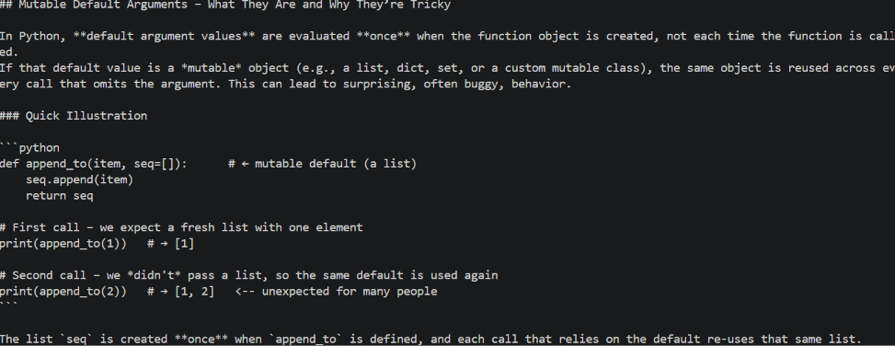

When Temperature is 1,

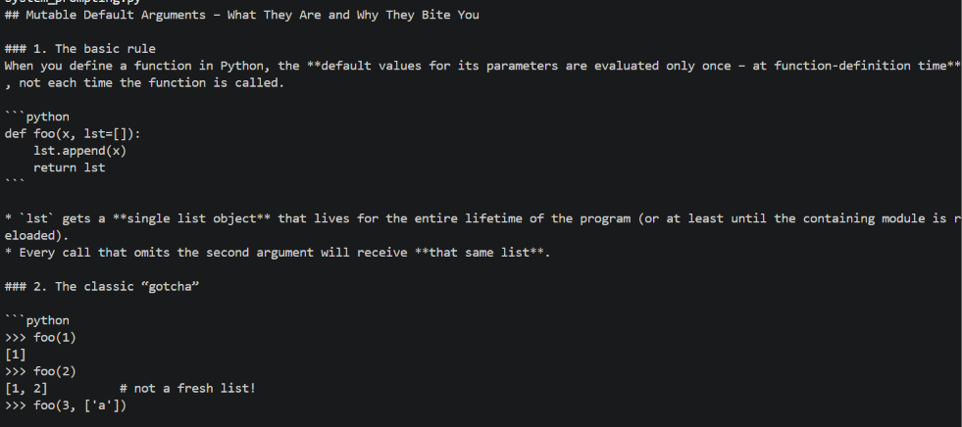

4. Write one line about what changed between the two outputs.

The temperature 1 output provides more detailed explanations and additional examples, while the temperature 0 output is more concise and focused on the core concept.

PART 2: RAG (about 15 minutes)
------------------------------
1. Create a file named notes.txt with 5 to 10 lines of facts that the
model cannot know. Use made-up details.
Example: "Our class starts at 7 PM. The mentor's favourite language is Go." - Yes
2. Write a script that does the following:
a. Load notes.txt
b. Split it into chunks
c. Create embeddings and store them in a vector store
d. Retrieve the relevant chunk and pass it to the LLM to answer - Yes
3. Ask a question whose answer exists only in notes.txt. – Yes
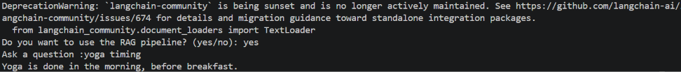
4. Ask the same question directly to the LLM without retrieval. – Yes
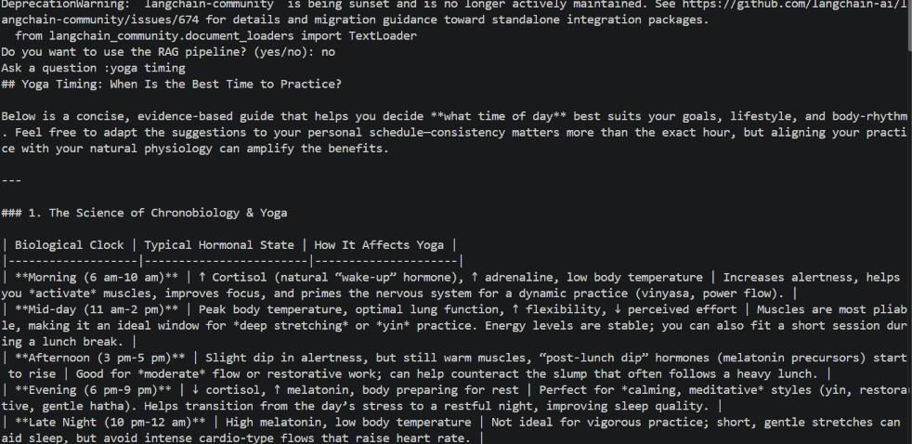
5. Compare both answers.
The non-RAG answer gives a detailed, general explanation of yoga timing, while the RAG answer gives a short answer based directly on the retrieved information: yoga is done in the morning before breakfast.

PART 3: BASIC AGENT (about 15 minutes)
--------------------------------------
1. Create one simple tool, for example:
- multiply(a, b), or
- get_time()
2. Create an agent that can use this tool.
3. Ask a question that needs the tool.
Example: "What is 47 times 89?"
4. Show the output, including the tool call if your setup displays it.
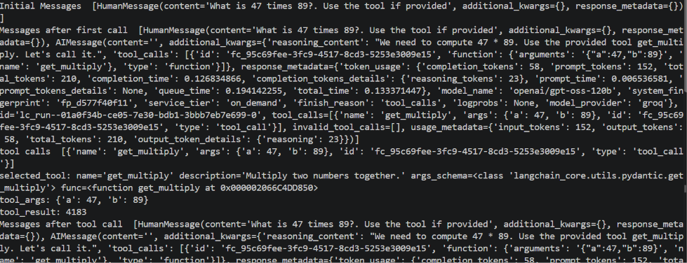

WHAT TO SUBMIT
--------------
Post the following in the group:

- A GitHub link OR screenshots of your code and output for all 3 parts.
https://github.com/Ramya-Perumal-code/AI-Agents-Projects/tree/main/mini_task

2. Answer these 3 questions in your own words (1 to 2 lines each):
Q1. What does the system prompt do?
It instructs the LLM on how it should behave throughout the conversation by defining rules such as constraints, tone, etc.
Q2. Why did RAG answer correctly when the plain LLM did not?
RAG retrieves information from a database that contains the relevant or updated information and uses it to generate the answer.
Q3. How did the agent decide to use the tool?
The agent checked the tool_calls attribute in the LLM response to determine whether a tool should be used.

RULES
-----
- Keep your API keys in a .env file. Never paste them in the code or
in screenshots.
- Write the explanations yourself. Do not copy them from anywhere.
- It is fine to ask for help if you get stuck. Mention which part
you are stuck on.

