HOME WORK ON GINI IMPURITY CALCULATION:
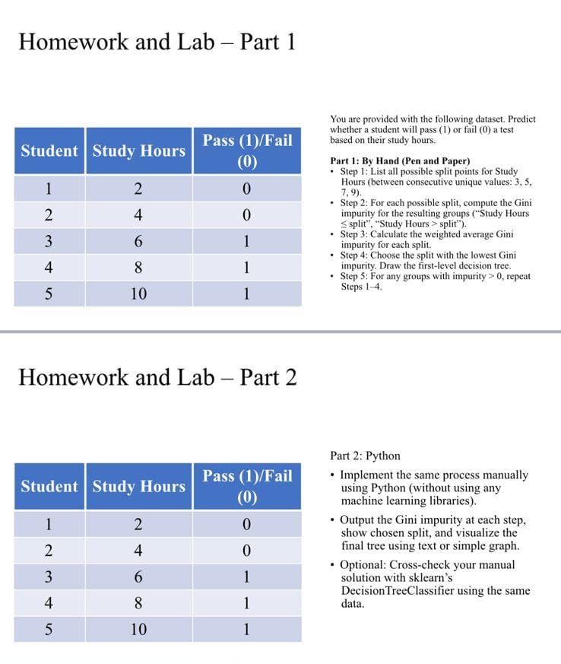

PART I: GINI IMPURITY CALCULATION:
