RETAIL INVENTORY AND PRODUCT REVIEWS
Database Design, Normalisation, SQL Server and MongoDB

1. Business scenario and requirements
A retailer initially stores SKU, product name, category, supplier name, supplier phone, warehouse, quantity and reorder level in one spreadsheet. Customer reviews are collected as free text. The goal is to normalize the inventory data to Third Normal Form (3NF), enforce data integrity in SQL Server, and store customer reviews in MongoDB.
SQL Server entities: Suppliers, Categories, Warehouses, Products and Inventory.
MongoDB collection: RetailReviewsDB.reviews.

2. Normalisation to 3NF

First Normal Form (1NF)
Each column must contain atomic (single) values, with no repeating groups or lists stored in one cell. Each row must be uniquely identifiable. Each customer review should be represented as an individual record rather than several reviews combined in one spreadsheet field.

Second Normal Form (2NF)
The design must already satisfy 1NF, and every non-key attribute must depend on the whole candidate key. In Inventory, the composite primary key is (ProductID, WarehouseID). Quantity and ReorderLevel depend on the complete product-and-warehouse combination.

Third Normal Form (3NF)
The design must satisfy 2NF and contain no transitive dependencies of non-key attributes on a key. SupplierName and SupplierPhone are stored in Suppliers; CategoryName is stored in Categories; WarehouseName and Location are stored in Warehouses. Products stores SupplierID and CategoryID as foreign keys. Inventory stores ProductID and WarehouseID as foreign keys.

3. Anomalies in the original spreadsheet
Anomaly | Problem in the original spreadsheet | How 3NF prevents/reduces it
Insert anomaly | A supplier may not be recorded until a product is entered for that supplier. | Insert the supplier independently into Suppliers.
Update anomaly | A supplier phone repeated on multiple product rows must be changed in every row. | Store the supplier phone once in Suppliers.
Delete anomaly | Deleting the last product row for a supplier may accidentally remove supplier details. | Supplier details remain in Suppliers when a product is deleted.

4. Entity-Relationship diagram
Relationships: Suppliers 1:M Products; Categories 1:M Products; Products 1:M Inventory; Warehouses 1:M Inventory. Inventory is the associative entity that resolves the many-to-many relationship between Products and Warehouses.
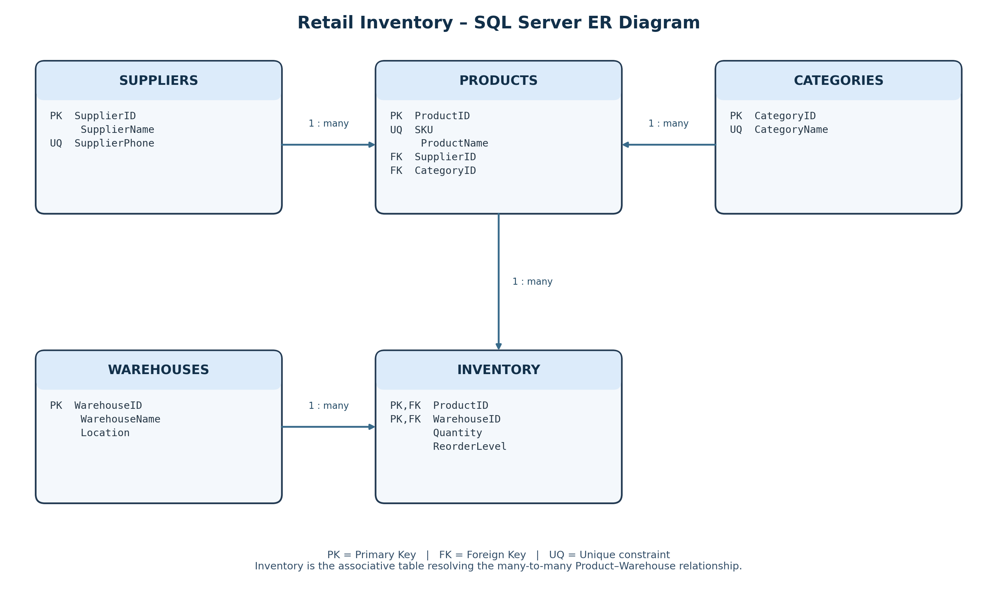
PK = Primary Key; FK = Foreign Key; UQ = Unique constraint.

5. SQL Server schema.sql
Run this script first in SQL Server Management Studio (SSMS). It creates the database and five normalized tables with keys and constraints.
/*
Project: Retail Inventory and Product Reviews
File: schema.sql
Purpose: Create the SQL Server database and normalized tables.
Run this file first in SSMS.
*/

IF DB_ID(N'RetailInventoryDB') IS NULL
BEGIN
CREATE DATABASE RetailInventoryDB;
END;
GO

USE RetailInventoryDB;
GO

-- Suppliers: one supplier can supply many products.
IF OBJECT_ID(N'dbo.Suppliers', N'U') IS NULL
BEGIN
CREATE TABLE dbo.Suppliers (
SupplierID INT NOT NULL CONSTRAINT PK_Suppliers PRIMARY KEY,
SupplierName VARCHAR(100) NOT NULL,
SupplierPhone VARCHAR(15) NOT NULL,
CONSTRAINT UQ_Suppliers_SupplierPhone UNIQUE (SupplierPhone)
);
END;
GO

-- Categories: one category can contain many products.
IF OBJECT_ID(N'dbo.Categories', N'U') IS NULL
BEGIN
CREATE TABLE dbo.Categories (
CategoryID INT NOT NULL CONSTRAINT PK_Categories PRIMARY KEY,
CategoryName VARCHAR(50) NOT NULL,
CONSTRAINT UQ_Categories_CategoryName UNIQUE (CategoryName)
);
END;
GO

-- Warehouses: inventory is held at one or more warehouses.
IF OBJECT_ID(N'dbo.Warehouses', N'U') IS NULL
BEGIN
CREATE TABLE dbo.Warehouses (
WarehouseID INT NOT NULL CONSTRAINT PK_Warehouses PRIMARY KEY,
WarehouseName VARCHAR(100) NOT NULL,
Location VARCHAR(100) NULL
);
END;
GO

-- Products: each product belongs to one supplier and one category.
IF OBJECT_ID(N'dbo.Products', N'U') IS NULL
BEGIN
CREATE TABLE dbo.Products (
ProductID INT NOT NULL CONSTRAINT PK_Products PRIMARY KEY,
SKU VARCHAR(20) NOT NULL,
ProductName VARCHAR(100) NOT NULL,
SupplierID INT NOT NULL,
CategoryID INT NOT NULL,
CONSTRAINT UQ_Products_SKU UNIQUE (SKU),
CONSTRAINT FK_Products_Suppliers
FOREIGN KEY (SupplierID)
REFERENCES dbo.Suppliers(SupplierID)
ON UPDATE CASCADE
ON DELETE NO ACTION,
CONSTRAINT FK_Products_Categories
FOREIGN KEY (CategoryID)
REFERENCES dbo.Categories(CategoryID)
ON UPDATE CASCADE
ON DELETE NO ACTION
);
END;
GO

-- Inventory resolves the many-to-many relationship between Products and Warehouses.
IF OBJECT_ID(N'dbo.Inventory', N'U') IS NULL
BEGIN
CREATE TABLE dbo.Inventory (
ProductID INT NOT NULL,
WarehouseID INT NOT NULL,
Quantity INT NOT NULL
CONSTRAINT DF_Inventory_Quantity DEFAULT (0),
ReorderLevel INT NOT NULL
CONSTRAINT DF_Inventory_ReorderLevel DEFAULT (5),
CONSTRAINT PK_Inventory PRIMARY KEY (ProductID, WarehouseID),
CONSTRAINT CK_Inventory_Quantity CHECK (Quantity >= 0),
CONSTRAINT CK_Inventory_ReorderLevel CHECK (ReorderLevel >= 0),
CONSTRAINT FK_Inventory_Products
FOREIGN KEY (ProductID)
REFERENCES dbo.Products(ProductID)
ON UPDATE CASCADE
ON DELETE NO ACTION,
CONSTRAINT FK_Inventory_Warehouses
FOREIGN KEY (WarehouseID)
REFERENCES dbo.Warehouses(WarehouseID)
ON UPDATE CASCADE
ON DELETE NO ACTION
);
END;
GO

-- Verify the five project tables.
SELECT name AS TableName
FROM sys.tables
WHERE name IN ('Suppliers', 'Categories', 'Warehouses', 'Products', 'Inventory')
ORDER BY name;
GO

6. SQL Server seed_data.sql
Run this script after schema.sql on an empty project database. It inserts ten rows per table, demonstrates four intentionally failing inserts, updates a supplier phone number and deletes discontinued product P105 and its dependent inventory row.
/*
Project: Retail Inventory and Product Reviews
File: seed_data.sql
Purpose: Insert 10 rows per SQL table, demonstrate four rejected inserts,
then demonstrate UPDATE and DELETE.
Prerequisite: Run schema.sql first.
Run this file once on a fresh/empty project database.
*/

USE RetailInventoryDB;
GO

-- 1. Parent tables first.
INSERT INTO dbo.Suppliers (SupplierID, SupplierName, SupplierPhone) VALUES
(1, 'ABC Suppliers', '9876543210'),
(2, 'XYZ Traders', '9876543211'),
(3, 'Global Distributors', '9876543212'),
(4, 'Tech World', '9876543213'),
(5, 'Smart Supply', '9876543214'),
(6, 'Prime Wholesale', '9876543215'),
(7, 'City Suppliers', '9876543216'),
(8, 'Best Products', '9876543217'),
(9, 'Star Traders', '9876543218'),
(10, 'Metro Supplies', '9876543219');
GO

INSERT INTO dbo.Categories (CategoryID, CategoryName) VALUES
(1, 'Electronics'),
(2, 'Furniture'),
(3, 'Clothing'),
(4, 'Groceries'),
(5, 'Accessories'),
(6, 'Sports'),
(7, 'Books'),
(8, 'Home Appliances'),
(9, 'Toys'),
(10, 'Stationery');
GO

INSERT INTO dbo.Warehouses (WarehouseID, WarehouseName, Location) VALUES
(1, 'Central Warehouse', 'Chennai'),
(2, 'North Warehouse', 'Coimbatore'),
(3, 'South Warehouse', 'Madurai'),
(4, 'East Warehouse', 'Salem'),
(5, 'West Warehouse', 'Trichy'),
(6, 'City Warehouse', 'Dindigul'),
(7, 'Main Store', 'Erode'),
(8, 'Storage Unit 1', 'Karur'),
(9, 'Storage Unit 2', 'Tirunelveli'),
(10, 'Backup Warehouse', 'Thanjavur');
GO

-- 2. Child table: Products.
INSERT INTO dbo.Products (ProductID, SKU, ProductName, SupplierID, CategoryID) VALUES
(1, 'P101', 'Laptop', 1, 1),
(2, 'P102', 'Office Chair', 2, 2),
(3, 'P103', 'T Shirt', 3, 3),
(4, 'P104', 'Rice Bag', 4, 4),
(5, 'P105', 'Headphones', 5, 5),
(6, 'P106', 'Football', 6, 6),
(7, 'P107', 'Python Book', 7, 7),
(8, 'P108', 'Refrigerator', 8, 8),
(9, 'P109', 'Toy Car', 9, 9),
(10, 'P110', 'Notebook', 10, 10);
GO

-- 3. Inventory: one row per product/warehouse combination.
INSERT INTO dbo.Inventory (ProductID, WarehouseID, Quantity, ReorderLevel) VALUES
(1, 1, 50, 10),
(2, 2, 30, 5),
(3, 3, 100, 20),
(4, 4, 75, 15),
(5, 5, 40, 10),
(6, 6, 60, 10),
(7, 7, 90, 15),
(8, 8, 25, 5),
(9, 9, 45, 10),
(10, 10, 120, 25);
GO

-- 4. Demonstrate four deliberately failing INSERT statements.
-- Each TRY/CATCH lets the script continue after the expected error.

PRINT 'Test 1: Duplicate primary key (expected failure)';
BEGIN TRY
INSERT INTO dbo.Suppliers (SupplierID, SupplierName, SupplierPhone)
VALUES (1, 'Duplicate Supplier', '9000000001');
END TRY
BEGIN CATCH
SELECT 'Expected duplicate-key error' AS TestResult, ERROR_MESSAGE() AS ErrorMessage;
END CATCH;
GO

PRINT 'Test 2: Missing parent supplier (expected failure)';
BEGIN TRY
INSERT INTO dbo.Products (ProductID, SKU, ProductName, SupplierID, CategoryID)
VALUES (99, 'P999', 'Test Product', 999, 1);
END TRY
BEGIN CATCH
SELECT 'Expected foreign-key error' AS TestResult, ERROR_MESSAGE() AS ErrorMessage;
END CATCH;
GO

PRINT 'Test 3: Negative inventory quantity (expected failure)';
BEGIN TRY
INSERT INTO dbo.Inventory (ProductID, WarehouseID, Quantity, ReorderLevel)
VALUES (1, 2, -10, 5);
END TRY
BEGIN CATCH
SELECT 'Expected CHECK-constraint error' AS TestResult, ERROR_MESSAGE() AS ErrorMessage;
END CATCH;
GO

PRINT 'Test 4: NULL mandatory supplier name (expected failure)';
BEGIN TRY
INSERT INTO dbo.Suppliers (SupplierID, SupplierName, SupplierPhone)
VALUES (11, NULL, '9000000022');
END TRY
BEGIN CATCH
SELECT 'Expected NOT NULL error' AS TestResult, ERROR_MESSAGE() AS ErrorMessage;
END CATCH;
GO

-- 5. UPDATE: show the supplier phone before and after.
SELECT * FROM dbo.Suppliers WHERE SupplierID = 1;

UPDATE dbo.Suppliers
SET SupplierPhone = '9999999999'
WHERE SupplierID = 1;

SELECT * FROM dbo.Suppliers WHERE SupplierID = 1;
GO

-- 6. DELETE: inventory is deleted first because it references Products.
SELECT * FROM dbo.Products WHERE SKU = 'P105';

DELETE FROM dbo.Inventory
WHERE ProductID = (SELECT ProductID FROM dbo.Products WHERE SKU = 'P105');

DELETE FROM dbo.Products
WHERE SKU = 'P105';

SELECT * FROM dbo.Products WHERE SKU = 'P105';
GO

-- Final counts after the requested DELETE: Products = 9, Inventory = 9;
-- all other SQL tables remain at 10 rows.
SELECT 'Suppliers' AS TableName, COUNT(*) AS RowCount FROM dbo.Suppliers
UNION ALL SELECT 'Categories', COUNT(*) FROM dbo.Categories
UNION ALL SELECT 'Warehouses', COUNT(*) FROM dbo.Warehouses
UNION ALL SELECT 'Products', COUNT(*) FROM dbo.Products
UNION ALL SELECT 'Inventory', COUNT(*) FROM dbo.Inventory;
GO

7. MongoDB design and collections.js
Customer product reviews are suitable for MongoDB because reviews are document-shaped, contain flexible free-text content, and may evolve to include optional attributes such as images, helpful votes or moderation status. Search activity is also suitable because event metadata can vary by event type.
The reviews collection uses a $jsonSchema validator. Required fields are reviewId, productSKU, customerName, rating and reviewText. The rating must be an integer from 1 through 5.
Run collections.js in mongosh against RetailReviewsDB. The insertMany section is intended for an empty collection and should be run once.
/*
Project: Retail Inventory and Product Reviews
File: collections.js
Run in mongosh after connecting to the MongoDB server.
This script is intended for a fresh RetailReviewsDB.reviews collection.
If you already inserted the 10 sample documents during practice, do not
run the insertMany section again unless you first clear the collection.
*/

use("RetailReviewsDB");

// Apply JSON Schema validation to the existing reviews collection.
db.runCommand({
collMod: "reviews",
validator: {
$jsonSchema: {
bsonType: "object",
required: ["reviewId", "productSKU", "customerName", "rating", "reviewText"],
properties: {
reviewId: { bsonType: "int" },
productSKU: { bsonType: "string" },
customerName: { bsonType: "string" },
rating: { bsonType: "int", minimum: 1, maximum: 5 },
reviewText: { bsonType: "string" }
}
}
},
validationLevel: "strict",
validationAction: "error"
});

// Optional unique index so a reviewId cannot be duplicated.
db.reviews.createIndex({ reviewId: 1 }, { unique: true });

// INSERT MANY: insert 10 sample product reviews.
// Run this section once on an empty reviews collection.
db.reviews.insertMany([
{ reviewId: NumberInt(1), productSKU: "P101", customerName: "Arun", rating: NumberInt(5), reviewText: "Excellent laptop" },
{ reviewId: NumberInt(2), productSKU: "P102", customerName: "Priya", rating: NumberInt(4), reviewText: "Comfortable chair" },
{ reviewId: NumberInt(3), productSKU: "P103", customerName: "Kumar", rating: NumberInt(3), reviewText: "Good T shirt" },
{ reviewId: NumberInt(4), productSKU: "P104", customerName: "Divya", rating: NumberInt(5), reviewText: "Good quality rice" },
{ reviewId: NumberInt(5), productSKU: "P105", customerName: "Rahul", rating: NumberInt(4), reviewText: "Good headphones" },
{ reviewId: NumberInt(6), productSKU: "P106", customerName: "Meena", rating: NumberInt(5), reviewText: "Excellent football" },
{ reviewId: NumberInt(7), productSKU: "P107", customerName: "Vijay", rating: NumberInt(4), reviewText: "Useful Python book" },
{ reviewId: NumberInt(8), productSKU: "P108", customerName: "Anu", rating: NumberInt(5), reviewText: "Excellent refrigerator" },
{ reviewId: NumberInt(9), productSKU: "P109", customerName: "Ravi", rating: NumberInt(3), reviewText: "Nice toy car" },
{ reviewId: NumberInt(10), productSKU: "P110", customerName: "Sneha", rating: NumberInt(5), reviewText: "Good notebook" }
]);

// FIND: retrieve all reviews.
db.reviews.find();

// UPDATE ONE: update Arun's review.
db.reviews.updateOne(
{ reviewId: NumberInt(1) },
{ $set: { reviewText: "Excellent laptop with great performance" } }
);

// DELETE ONE: delete Sneha's review.
db.reviews.deleteOne({ reviewId: NumberInt(10) });

// Verify final document count (expected: 9 after the delete).
db.reviews.countDocuments();

8. SQL Server and MongoDB comparison
Purpose | SQL Server | MongoDB
Database creation | CREATE DATABASE | use("DatabaseName") / database materializes on write
Data structure | Tables, rows and columns | Collections and BSON documents
Primary identity | PRIMARY KEY constraint | Automatic _id; unique index can enforce reviewId
Relationships | FOREIGN KEY constraints | References or embedded documents
Insert | INSERT INTO | insertMany()
Retrieve | SELECT ... WHERE | find()
Update | UPDATE ... SET ... WHERE | updateOne() with $set
Delete | DELETE FROM ... WHERE | deleteOne()
Validation | NOT NULL, UNIQUE, CHECK, DEFAULT, FK | $jsonSchema validator
Best use in this project | Structured inventory and master data | Flexible customer reviews and search events

10. Practical execution screenshots

10.1 SQL Server tables created
Object Explorer shows RetailInventoryDB and the five created tables: Categories, Inventory, Products, Suppliers and Warehouses.
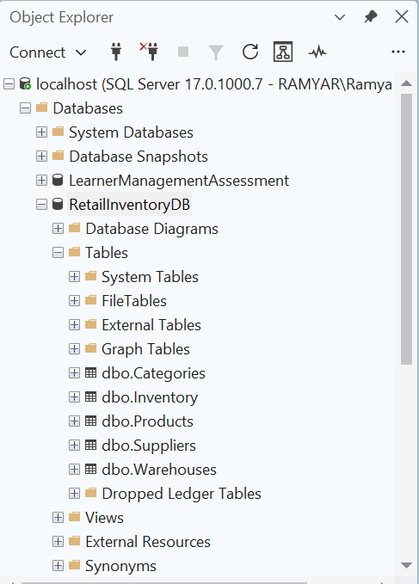

10.2 SQL Server sample records
SSMS result grids show sample records in Suppliers, Categories, Warehouses, Products and Inventory.
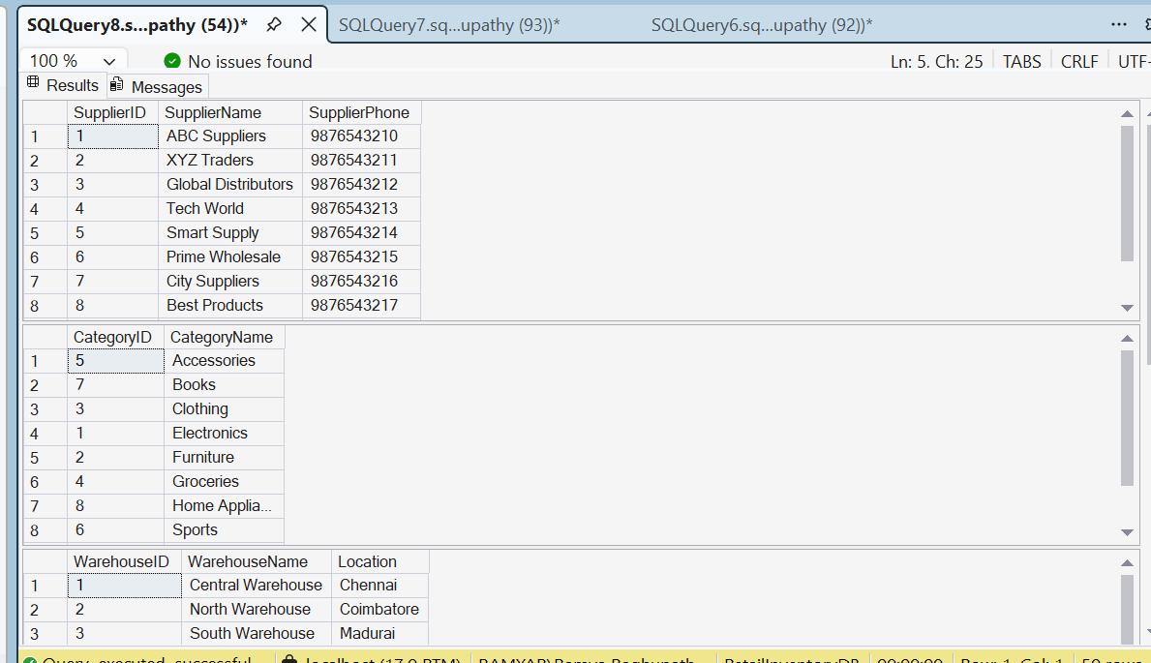

10.3 Four deliberately failing INSERT statements
The Messages pane shows the expected constraint failures for duplicate primary key, missing parent/foreign key, negative quantity/CHECK constraint and NULL in a mandatory column.
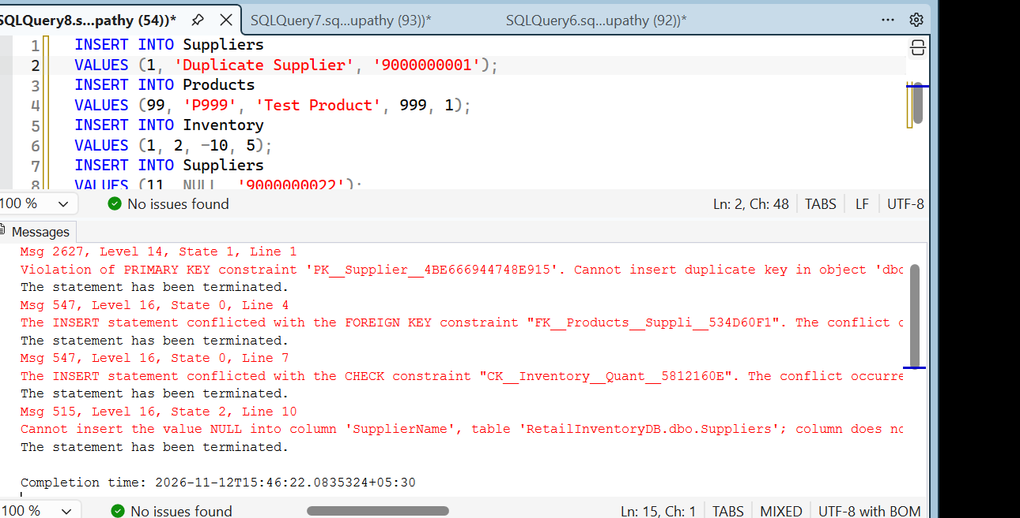

10.4 Supplier phone UPDATE
The before-and-after SELECT results show SupplierID 1's phone number changed from 9876543210 to 9999999999.
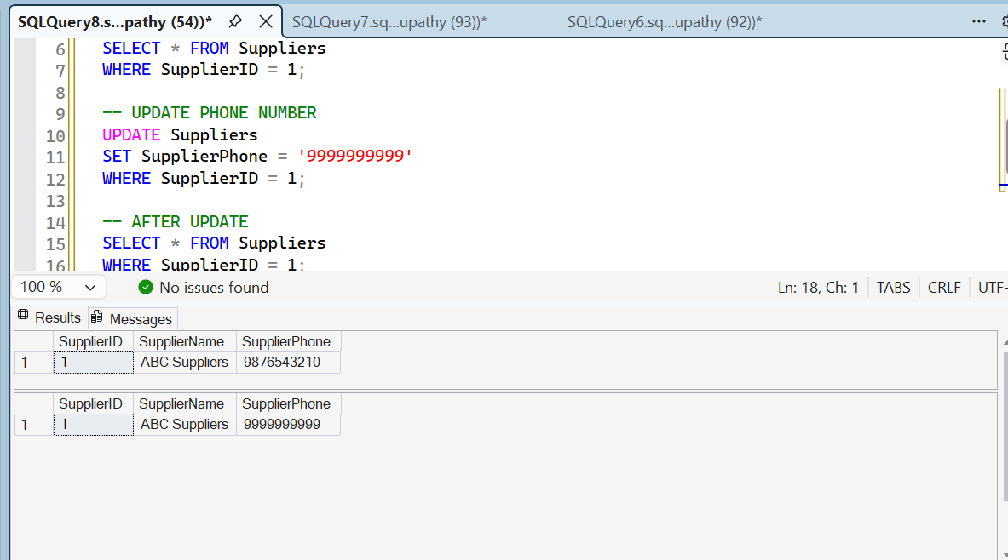

10.5 Discontinued product DELETE
The before-and-after SELECT results show SKU P105 before deletion and no matching row after deletion.
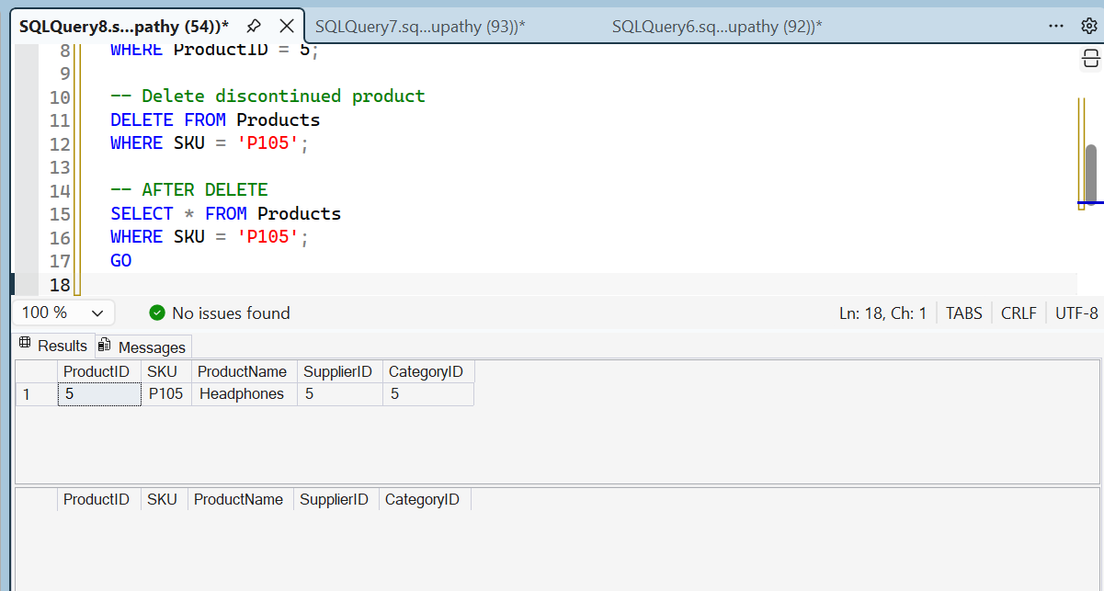

10.6 MongoDB database and collection
MongoDB Compass shows the RetailReviewsDB database and reviews collection created successfully.
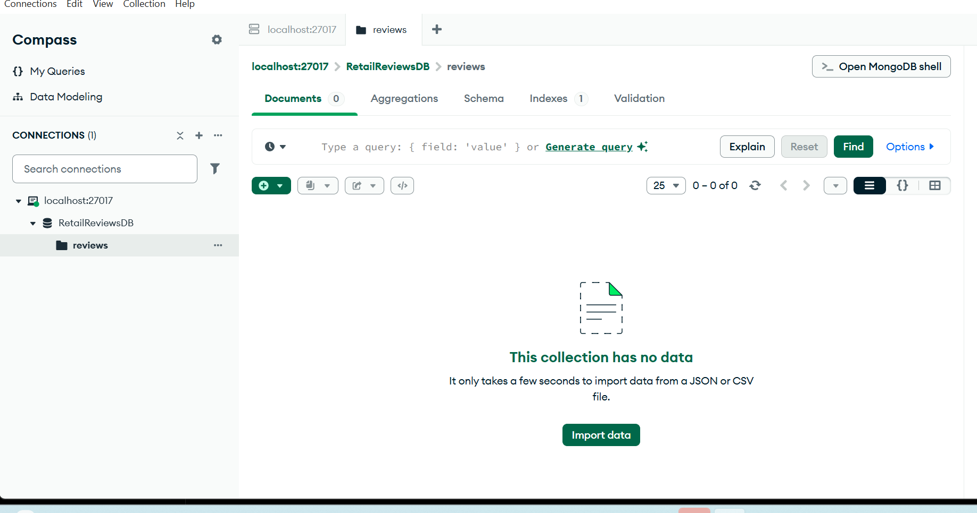

10.7 MongoDB insertMany()
mongosh output shows acknowledged: true and ten generated insertedIds, confirming that ten review documents were inserted.
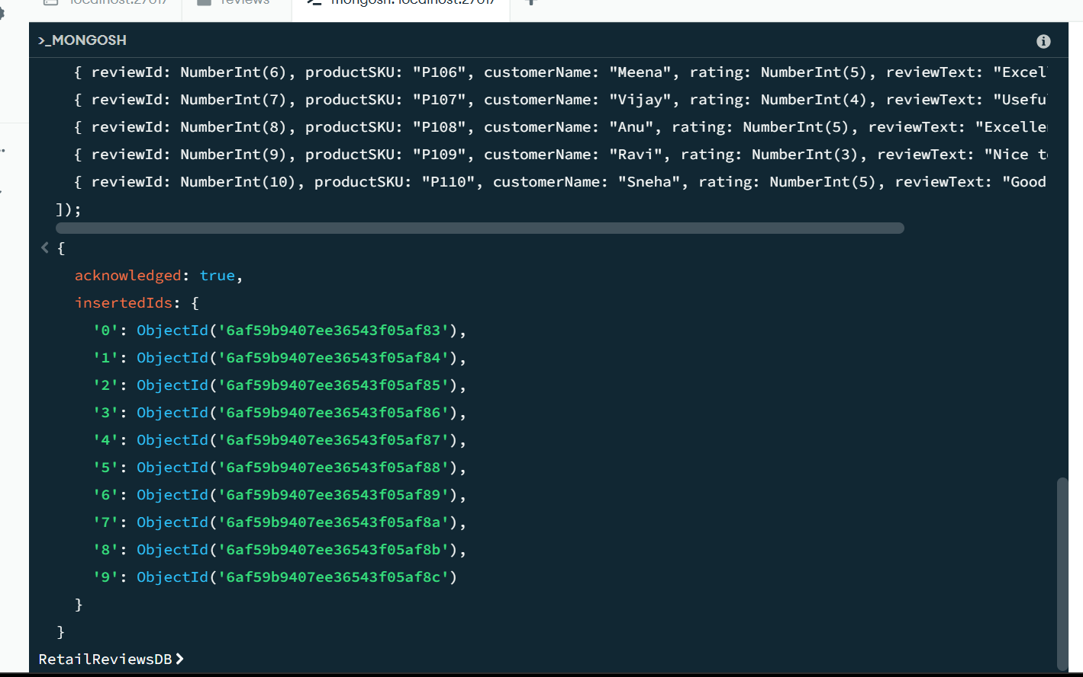

10.8 MongoDB updateOne() and deleteOne()
mongosh output shows matchedCount: 1 and modifiedCount: 1 for updateOne(), followed by deletedCount: 1 for deleteOne().
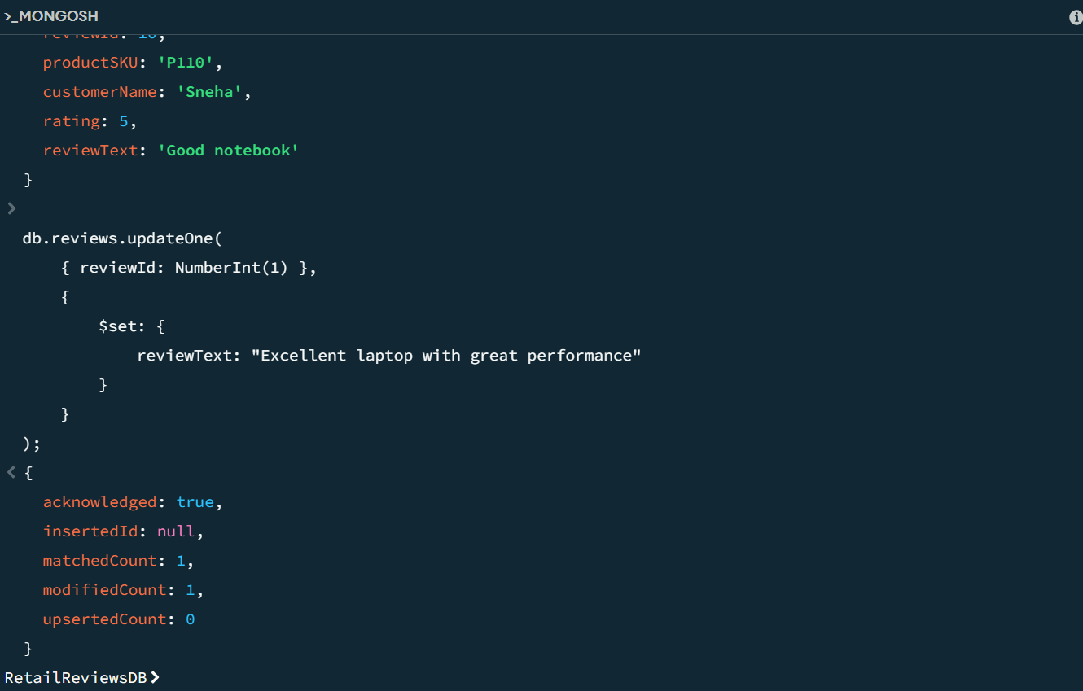

10.9 MongoDB find() verification
mongosh find() output displays the review documents, including Arun's updated review text.
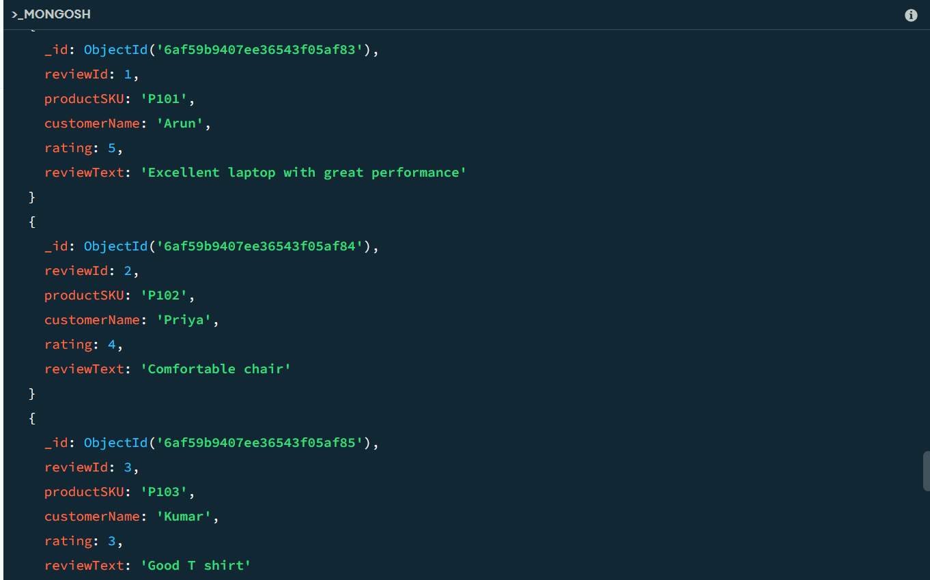

Evidence note
The MongoDB JSON Schema validator definition is included in collections.js. A separate screenshot showing the validator command's successful { ok: 1 } response was not available among the screenshots supplied, so no validator-success screenshot is claimed here.

