**Developer Name** : Ramya S

**Project Name:** Learner’s Academy

# Project Details:

Learner’s Academy is a school that has an online management system. The system keeps track of its classes, subjects, students, and teachers. It has a back-office application with a single administrator login. The admin can create master list of classes, subjects, teachers, students, and view the details.

There is an option to view Class Report which will show all the information about the class, like the list of students, subjects, and teachers for the particular class selected.

# Sprint Planning :

Number of Sprints Planned: 3

# Sprint 1:

1. The Objective of this sprint was to develop a admin login page with a servlet, Data access object classes, Data transfer object classes.
2. Admin login page and Homepage successfully developed that takes username and password as input which is then validated by Login Servlet.
3. The Data transfer and access object classes successfully developed.
4. A new Database Phase created using MySQL successfully.

# Sprint 2:

1. The Objective of this sprint was to develop web pages, Servlets, for the main operations like to setup master list of classes, teachers, students and subjects.
2. Web Pages, Servlets were successfully developed.
3. Successfully configured hibernate.cfg.xml file.

# Sprint 3:

1. The Objective of this sprint was to test the application by entering the Data and checking data from the database.

The application is working as per the requirement given and ready for Release.

# Flowchart and Algorithms:

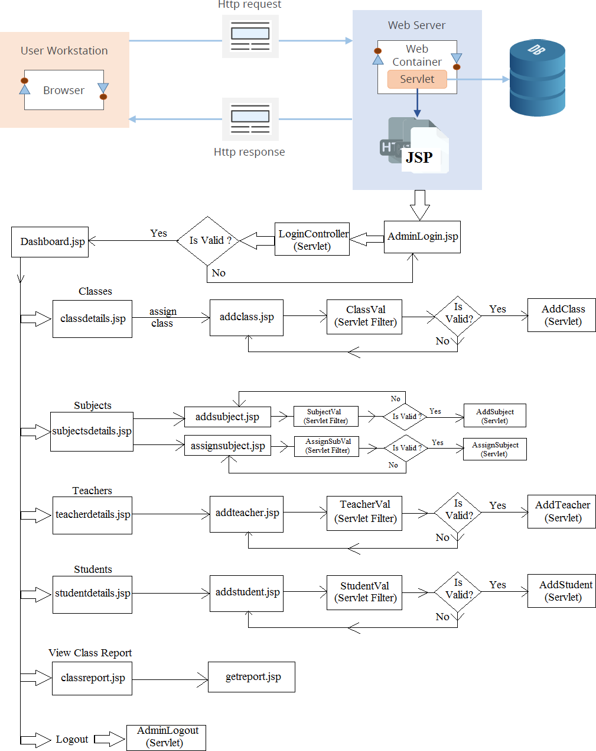

# Core Concepts Used:

* Java Servlets.
* Java Server Pages (JSP).
* Java Classes, Objects, Methods.
* Hibernate.
* MySQL8
* HTML.
* List.
* XML.
* Apache Tomcat Server.
* Annotations.
* Servlet API Interface.
* Exception handling.

# GitHub Link: