TASK 1(Beginner)
MATPLOTLIB:
Matplotlib is a widely-used Python library for creating static, animated, and interactive visualizations. It is particularly popular in data science, machine learning, and scientific computing due to its versatility and ease of use.

Unique Features:
- Wide Range of Plots: Matplotlib supports various types of plots, such as line plots, scatter plots, bar charts, histograms, and pie charts.
- Customization: Users can customize nearly every aspect of a plot, including colors, labels, grids, ticks, and fonts.
- Integration with Other Libraries: It works seamlessly with other libraries like NumPy, Pandas, and SciPy, making it convenient for scientific computing and data analysis.
- Interactive Plots: With extensions like mpl_toolkits and integrations with backends (e.g., Tkinter, Qt, Jupyter), it supports interactive visualizations.
- Subplots: Allows the creation of complex, multi-plot layouts through subplots and grids.

Typical Use Cases:
- Data Analysis and Visualization: Plotting datasets to gain insights, such as trends or distributions.
- Scientific Computing: Visualizing simulation results, mathematical functions, and scientific models.
- Machine Learning: Plotting learning curves, loss functions, and other metrics during model training.
- Financial Data: Creating time series plots for stock prices, market trends, and other financial metrics.
GRAPH TYPES:
BAR GRAPH:
A bar plot or bar chart is a graph that represents the category of data with rectangular bars with lengths and heights that is proportional to the values which they represent. The bar plots can be plotted horizontally or vertically. A bar chart describes the comparisons between the discrete categories. It can be created using the bar() method.
import matplotlib.pyplot as plt
x = [3, 1, 3, 12, 2, 4, 4]
y = [3, 2, 1, 4, 5, 6, 7]
plt.bar(x, y)
plt.title("Bar Chart")
plt.show()
OUTPUT:
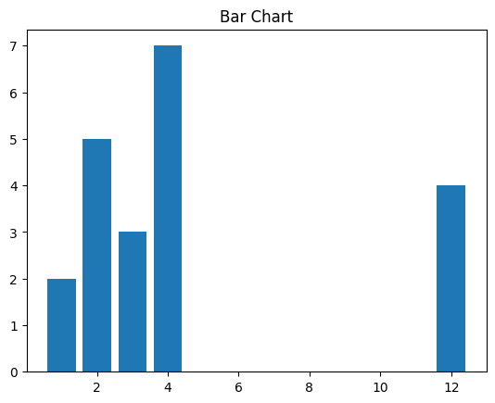
LINE GRAPH:
Line graphs are commonly used to visualize trends over time or relationships between variables. We’ll learn how to create visually appealing line graphs to represent such data.
import matplotlib.pyplot as plt
x = [3, 1, 3]
y = [3, 2, 1]
plt.plot(x, y)
plt.title("Line Chart")
plt.show()
OUTPUT:
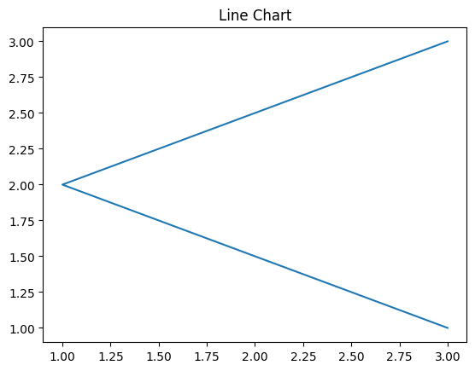
HISTOGRAM:
A histogram is basically used to represent data in the form of some groups. It is a type of bar plot where the X-axis represents the bin ranges while the Y-axis gives information about frequency. To create a histogram the first step is to create a bin of the ranges, then distribute the whole range of the values into a series of intervals, and count the values which fall into each of the intervals. Bins are clearly identified as consecutive, non-overlapping intervals of variables.
import matplotlib.pyplot as plt
x = [1, 2, 3, 4, 5, 6, 7, 4]
plt.hist(x, bins = [1, 2, 3, 4, 5, 6, 7])
plt.title("Histogram")
plt.show()
OUTPUT:
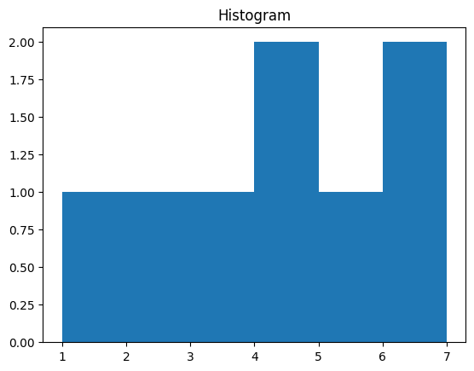
SCATTER PLOT:
Scatter plots are ideal for visualizing the relationship between two continuous variables. We’ll see how scatter plots help identify patterns, correlations, or clusters within data points.
import matplotlib.pyplot as plt
x = [3, 1, 3, 12, 2, 4, 4]
y = [3, 2, 1, 4, 5, 6, 7]
plt.scatter(x, y)
plt.title("Scatter chart")
plt.show()
OUTPUT:
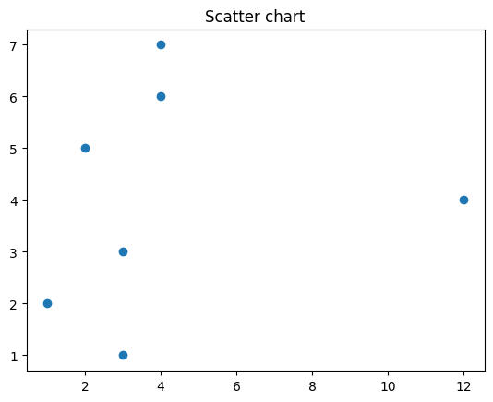
PIE CHART:
A Pie Chart is a circular statistical plot that can display only one series of data. The area of the chart is the total percentage of the given data. The area of slices of the pie represents the percentage of the parts of the data. The slices of pie are called wedges. The area of the wedge is determined by the length of the arc of the wedge.
import matplotlib.pyplot as plt
x = [1, 2, 3, 4]
e =(0.1, 0, 0, 0)
plt.pie(x, explode = e)
plt.title("Pie chart")
plt.show()

OUTPUT
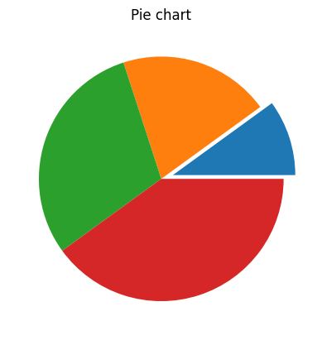

STEM PLOT:
A stem plot, also known as a stem-and-leaf plot, is a type of plot used to display data along a number line. Stem plots are particularly useful for visualizing discrete data sets, where the values are represented as “stems” extending from a baseline, with data points indicated as “leaves” along the stems.

import matplotlib.pyplot as plt
import numpy as np
x = np.linspace(0.1, 2 * np.pi, 41)
y = np.exp(np.sin(x))
plt.stem(x, y, use_line_collection = True)
plt.show()

OUTPUT:

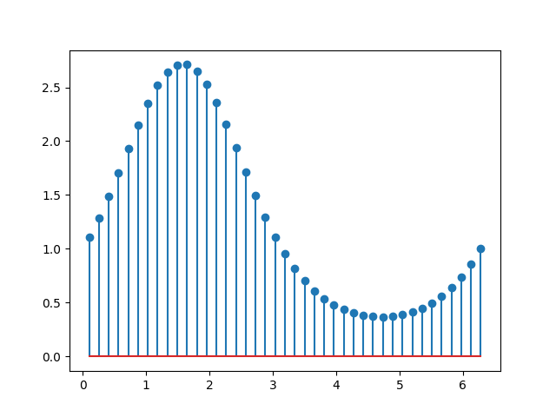

ERROR PLOT:

Error plots display the variability or uncertainty associated with each data point in a dataset. They are commonly used in scientific research, engineering, and statistical analysis to visualize measurement errors, confidence intervals, standard deviations, or other statistical properties of the data. By incorporating error bars into plots, we can convey not only the central tendency of the data but also the range of possible values around each point
import matplotlib.pyplot as plt
x =[1, 2, 3, 4, 5, 6, 7]
y =[1, 2, 1, 2, 1, 2, 1]
y_error = 0.2
plt.plot(x, y)
plt.errorbar(x, y,
yerr = y_error
fmt ='o')

OUTPUT:

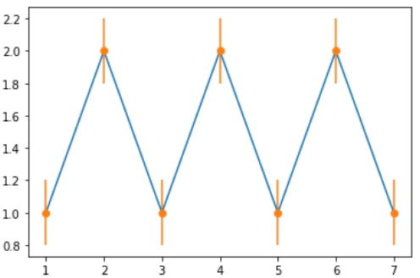

SEABORN:
Seaborn is a Python data visualization library built on top of Matplotlib. It is designed to make it easier to create informative and attractive statistical graphics. Seaborn provides high-level abstractions for creating complex plots, making it especially popular for data exploration and analysis in fields like data science and machine learning.

Unique Features:
- High-level Interface: Seaborn simplifies complex visualizations, allowing users to create aesthetically pleasing plots with less code compared to Matplotlib.
- Built-in Themes: It comes with default color palettes and styles, making plots more visually appealing with minimal effort.
- Statistical Plotting: Seaborn provides specialized plots for statistical analysis, such as distribution plots, pair plots, and categorical plots (e.g., box plots, violin plots).
- Integration with Pandas: Seaborn works well with Pandas DataFrames, automatically handling labeled data and making it easy to create plots directly from DataFrame objects.
- Multivariate Plots: It provides tools for visualizing relationships between multiple variables, such as heatmaps and pairwise joint plots.

Typical Use Cases:
- Data Exploration: Seaborn is ideal for exploring and understanding the relationships between variables, such as distributions, correlations, and group comparisons.
- Statistical Analysis: Creating plots for regression analysis, correlation matrices, and statistical summaries.
- Time Series Analysis: Visualizing temporal data, trends, and periodicity.
- Categorical Data Visualization: Visualizing categorical variables through bar plots, count plots, and violin plots.
GRAPH TYPES:
LINE PLOT:
A line plot is a type of graph that displays data points connected by straight lines, showing trends over a continuous interval or time period. It is useful for visualizing changes and trends in data over time.

import seaborn as sns
import matplotlib.pyplot as plt
sns.lineplot(data=tips, x="size", y="tip")
plt.show()

OUTPUT:
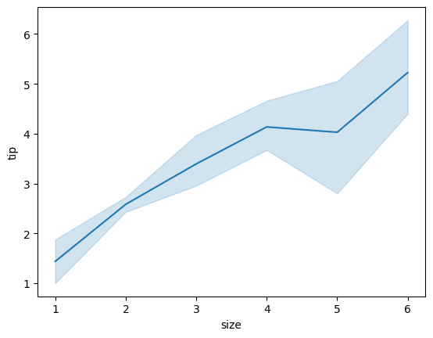

BOX PLOT:
A box plot (boxplot) displays the distribution of a dataset through its quartiles, highlighting the median, inter quartile range, and potential outliers. It provides a visual summary of the data’s central tendency, dispersion, and skewness.
import seaborn as sns
import matplotlib.pyplot as plt
sns.boxplot(data=tips, x="day", y="total_bill")
plt.show()
OUTPUT
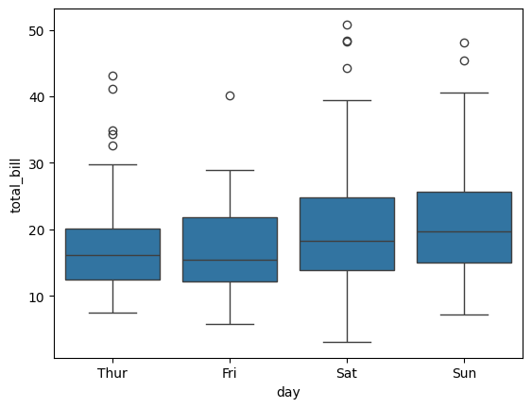

PAIR PLOT:
A pair plot (pairplot) creates a grid of scatterplots and histograms for each pair of variables in a dataset, allowing for visual exploration of relationships and distributions between variables. It’s particularly useful for identifying patterns and correlations in multivariate data.
import seaborn as sns
import matplotlib.pyplot as plt
tips = sns.load_dataset("tips")
sns.pairplot(tips, hue="smoker", palette="coolwarm")
plt.show()
OUTPUT:
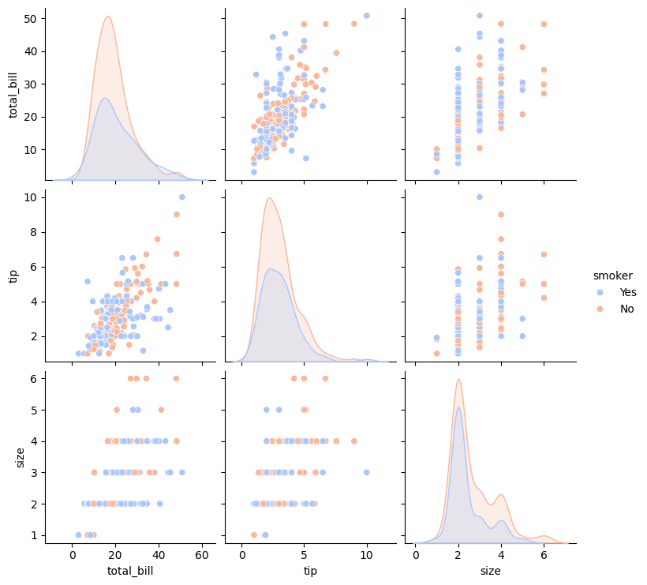

COUNTPLOT:
A count plot (countplot) is a bar plot that shows the frequency of occurrences for each category in a categorical variable. It visualizes the count of each unique value in the data.
import seaborn as sns
import matplotlib.pyplot as plt
sns.countplot(data=tips, x="day")
plt.show()

OUTPUT:
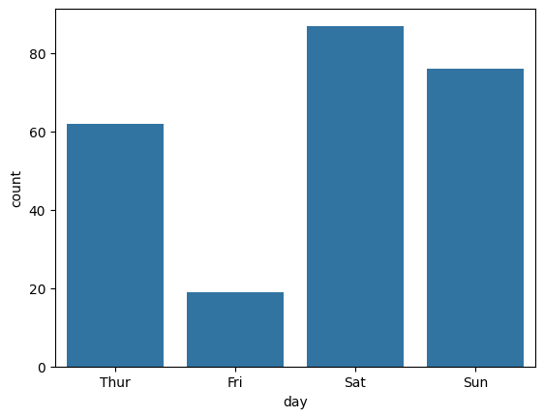

RELATIONAL PLOT:
Relational plot (relplot) is a versatile function in seaborn for creating scatter and line plots, with additional capabilities for faceting data into multiple subplots. It simplifies the creation of complex visualizations by handling various plot types and layouts automatically.
A relational plot using Seaborn to visualize some data. This code creates a relational plot that uses total_bill and tip from the tips dataset, with points colored by the smoker variable.

import seaborn as sns
import matplotlib.pyplot as plt
tips = sns.load_dataset("tips")
sns.relplot(data=tips, x="total_bill", y="tip", hue="smoker")
plt.show()

OUTPUT

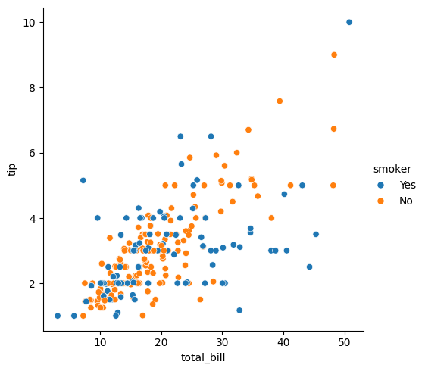

Comparison of Matplotlib and Seaborn

1. Ease of Use
- Matplotlib:
  - Strengths: Highly flexible, allowing detailed control over every element of the plot. Suitable for creating custom and intricate plots.
  - Weaknesses: Can be verbose and requires more lines of code for basic visualizations. Users often need to adjust many parameters manually.
- Seaborn:
  - Strengths: Offers a higher-level interface, making it easier and faster to create aesthetically pleasing and complex plots with minimal code. Ideal for rapid data exploration.
  - Weaknesses: Limited flexibility for highly customized plots. It relies on Matplotlib under the hood, so advanced customization might require reverting to Matplotlib commands.

2. Customization Options
- Matplotlib:
  - Strengths: Extremely customizable. Users can modify virtually any aspect of the plot, including ticks, labels, colors, legends, grids, and figure sizes.
  - Weaknesses: While it provides granular control, the complexity of customization can make it more cumbersome for less experienced users.
- Seaborn:
  - Strengths: Provides default styles and color palettes that are visually appealing, saving time for users who need well-designed, standardized plots. Easier to create polished plots with limited effort.
  - Weaknesses: Although Seaborn is customizable, it does not offer the same depth of customization as Matplotlib, and some advanced users may find it restrictive.

3. Interactivity
- Matplotlib:
  - Strengths: Supports interactive visualizations through tools like mpl_toolkits, integration with backends such as Tkinter, and Jupyter Notebook widgets (e.g., %matplotlib notebook). It can be extended for interactivity, though it requires additional setup.
  - Weaknesses: By default, it focuses more on static plots, so users must actively enable interactive functionality.
- Seaborn:
  - Strengths: Since Seaborn is built on top of Matplotlib, it can inherit its interactive features if used in combination with the appropriate tools (like Jupyter widgets).
  - Weaknesses: Seaborn itself does not focus on interactivity; it is primarily designed for static and statistical plots.

4. Performance with Large Datasets
- Matplotlib:
  - Strengths: Handles large datasets well if optimized with techniques like simplifying the plot or reducing the number of plotted points. Can be used in conjunction with other libraries to handle big data.
  - Weaknesses: Rendering large datasets can be slower due to its detailed plotting approach, especially when creating highly customized plots.
- Seaborn:
  - Strengths: Similar to Matplotlib in performance since it is built on it, but typically more efficient for basic statistical plots and exploratory data visualization.
  - Weaknesses: For very large datasets, Seaborn might face performance bottlenecks because of the overhead added by its higher-level abstractions. It relies on Matplotlib’s rendering, so performance tuning is limited to optimizations in Matplotlib.

