TASK 2(Intermediate)
QUESTION 2:
Undertake a sentiment analysis of X data to gain insights into the prevailing sentiments expressed on the platform. Define research questions focusing on specific topics, trends, or events, and leverage natural language processing techniques to categorize tweets as positive, negative, or neutral. Employ statistical analyses and visualizations to discern patterns in sentiment over time, contributing to a comprehensive understanding of public opinion on X regarding diverse subjects.
Data Set Link: https://drive.google.com/file/d/1cJlTwbx7mUxKCZS32uduCX0_850UiNKv/view
SOLUTION:
A sentiment analysis of data from X (formerly Twitter) involves using Natural Language Processing (NLP) techniques to assess the sentiment or emotion expressed in the text of posts (tweets). The goal is to understand the overall mood of users on specific topics, events, or trends, by classifying tweets into categories like positive, negative, or neutral. The process can provide valuable insights into public opinion, help businesses gauge brand sentiment, or assess responses to current events.

1. Importing Libraries and Downloading NLTK Resources
- The required Python libraries are imported, including pandas (for data manipulation), NumPy (for numerical operations), matplotlib and seaborn (for visualization), NLTK's Vader and TextBlob (for sentiment analysis), and WordCloud (for generating word clouds).
- nltk.download('vader_lexicon') downloads the VADER sentiment lexicon used by the SentimentIntensityAnalyzer.

# Importing necessary libraries
import pandas as pd
import numpy as np
import matplotlib.pyplot as plt
import seaborn as sns
from nltk.sentiment.vader import SentimentIntensityAnalyzer
from textblob import TextBlob
import nltk
from wordcloud import WordCloud
import re

2. Loading and Displaying the Data
- The CSV file is loaded into a pandas DataFrame (df) using the path provided.
- df.head() displays the first few rows of the data to give a quick preview of the dataset. Missing values are identified using df.isnull().sum(). The code then removes rows that contain missing values in the text column i.e.,clean_text.

# Download VADER lexicon
nltk.download('vader_lexicon')

[nltk_data] Downloading package vader_lexicon to /root/nltk_data...
[nltk_data] Package vader_lexicon is already up-to-date!
True

# Load the dataset
file_path = 'X data.csv'
df = pd.read_csv(file_path)
df.head()

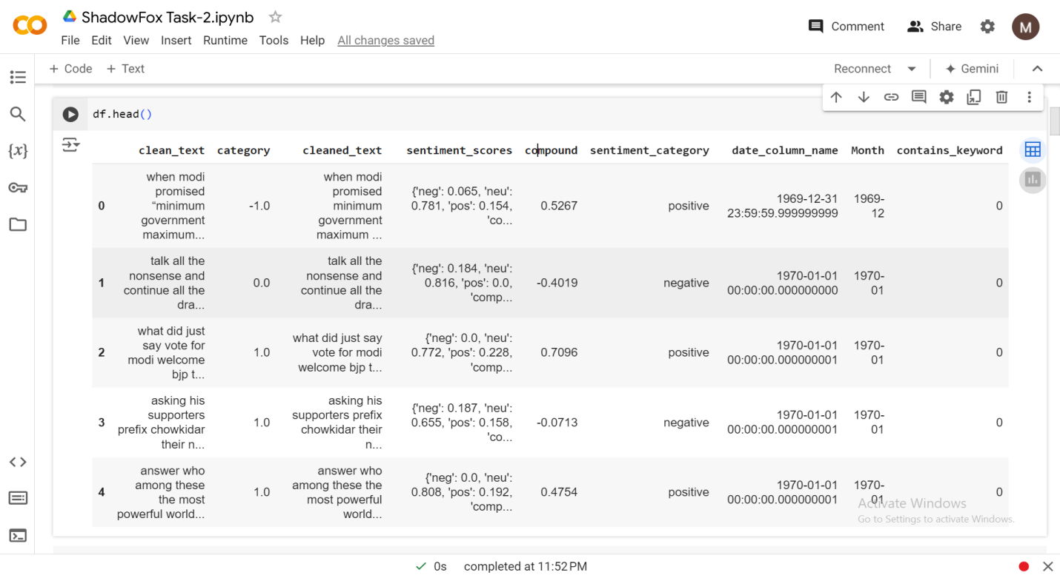
# Check for missing values
print(df.isnull().sum())

clean_text 0
category 0
cleaned_text 0
sentiment_scores 0
compound 0
sentiment_category 0
date_column_name 0
Month 0
contains_keyword 0
dtype: int64
# Data Cleaning: Dropping rows with missing values in important columns (e.g., text or date columns)
df.dropna(subset=['clean_text'], inplace=True)

3. Text Preprocessing:
- The function clean_text is defined to preprocess the text data:
  - Converts the text to lowercase.
  - Removes URLs using regular expressions.
  - Removes non-alphabetic characters (special characters and digits).
- This function is applied to the text column of the DataFrame, creating a new column cleaned_text that contains the processed text. Preprocessing is crucial for ensuring the sentiment analysis is performed on clean and uniform text data.

# Preprocessing Text: Lowercasing, removing special characters, and links
def clean_text(text):
text = text.lower()
text = re.sub(r'http\S+', '', text) # remove links
text = re.sub(r'[^a-zA-Z\s]', '', text) # remove special characters
return text

df['cleaned_text'] = df['clean_text'].apply(clean_text)

4. Sentiment Analysis using VADER:
- VADER (Valence Aware Dictionary and sEntiment Reasoner) is a lexicon and rule-based sentiment analysis tool specifically attuned to social media sentiment. The SentimentIntensityAnalyzer is initialized.
- The function get_sentiment_vader is defined to calculate sentiment scores using VADER, which returns a dictionary with 4 sentiment scores: negative, neutral, positive, and compound (an aggregated score).
- This function is applied to the cleaned text, and the sentiment scores are stored in the sentiment_scores column.
- The compound score (a normalized score between -1 and 1) is extracted and used to categorize each tweet as positive, negative, or neutral. This classification is stored in the sentiment_category column.

# Initialize the VADER sentiment analyzer
sid = SentimentIntensityAnalyzer()

# Function to get sentiment scores
def get_sentiment_vader(text):
score = sid.polarity_scores(text)
return score
# Apply sentiment analysis
df['sentiment_scores'] = df['cleaned_text'].apply(get_sentiment_vader)

# Extract compound score and categorize as positive, negative, or neutral
df['compound'] = df['sentiment_scores'].apply(lambda x: x['compound'])
df['sentiment_category'] = df['compound'].apply(lambda score: 'positive' if score >= 0.05 else ('negative' if score <= -0.05 else 'neutral'))

5. Sentiment Distribution:
- The distribution of the different sentiment categories (positive, negative, neutral) is displayed using value_counts().
- A count plot is generated using Seaborn's countplot() to visualize the number of positive, negative, and neutral tweets. This provides insights into the general sentiment distribution in the dataset.
# Display sentiment distribution
print(df['sentiment_category'].value_counts())

sentiment_category
positive 76484
negative 50985
neutral 35500
Name: count, dtype: int64
addCode
addText

# Visualize the sentiment distribution
plt.figure(figsize=(8, 6))
sns.countplot(x='sentiment_category', data=df, palette='coolwarm')
plt.title('Sentiment Distribution')
plt.show()
<ipython-input-48-91db83b16726>:3: FutureWarning:

Passing `palette` without assigning `hue` is deprecated and will be removed in v0.14.0. Assign the `x` variable to `hue` and set `legend=False` for the same effect.

sns.countplot(x='sentiment_category', data=df, palette='coolwarm')
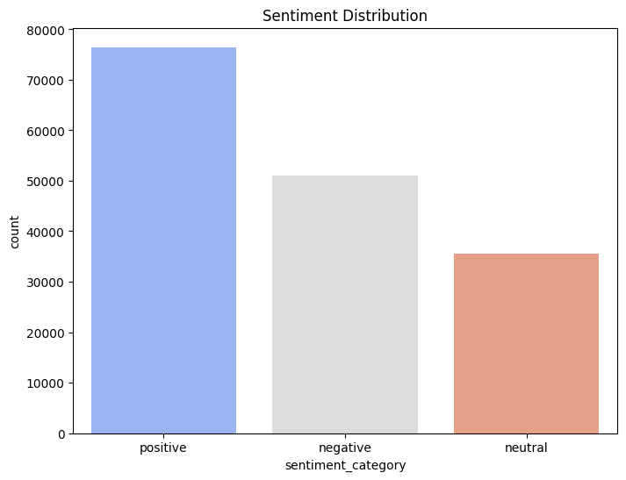

6. Sentiment Over Time
- The date_column_name is assumed to hold the dates of the tweets, which is converted to a datetime format using pd.to_datetime().
- The data is then aggregated by month (dt.to_period('M')), and the sentiment is grouped by time.
- A line plot is created to show how sentiment changes over time. This can be used to identify trends in public opinion, such as whether a topic gained more positive or negative reactions during specific periods.

# Sentiment analysis over time (assuming a 'date_column_name' exists)
df['date_column_name'] = pd.to_datetime(df['category']) # Replace with actual date column name
df['Month'] = df['date_column_name'].dt.to_period('M')

# Group sentiment by time
sentiment_over_time = df.groupby(['Month', 'sentiment_category']).size().unstack()

# Plot sentiment over time
plt.figure(figsize=(10, 6))
sentiment_over_time.plot(kind='line', marker='o')
plt.title('Sentiment Over Time')
plt.ylabel('Count')
plt.xlabel('Month')
plt.xticks(rotation=45)
plt.show()

<Figure size 1000x600 with 0 Axes>

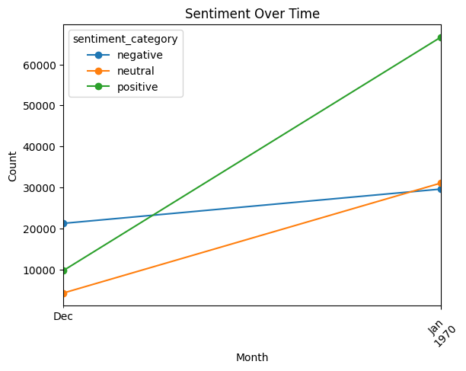
# Filter the tweets with negative sentiment
negative_tweets = df[df['sentiment_category'] == 'negative']['cleaned_text'].values

# Join all negative tweets into a single string
negative_text = ' '.join(negative_tweets)

7. Word Cloud Generation
- Word clouds are created to visualize the most frequent words associated with positive and negative tweets.
  - Positive word cloud: The text from tweets classified as positive is combined and passed to the WordCloud generator. The result is a word cloud with the most frequently used words in positive tweets, helping to identify common themes or topics.
  - Negative word cloud: Similarly, a word cloud is generated for negative tweets, with red hues to represent negative sentiment.
# Generate the Word Cloud for negative sentiment
negative_wordcloud = WordCloud(width=800, height=400, background_color='black', colormap='Reds').generate(negative_text)

# Display the word cloud for negative sentiment
plt.figure(figsize=(10, 6))
plt.imshow(negative_wordcloud, interpolation='bilinear')
plt.axis('off')
plt.title('Negative Sentiment Word Cloud')
plt.show()

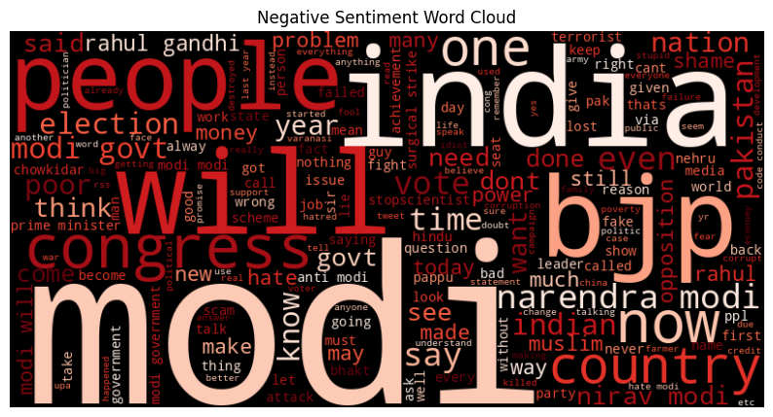

8. Keyword-Specific Sentiment Analysis
- The code identifies tweets containing a specific keyword (e.g., "climate change") and analyzes the sentiment of those tweets.
- A new column, contains_keyword, is created to indicate whether the keyword appears in the cleaned text.
- The sentiment distribution for tweets mentioning the keyword is calculated and visualized using a bar plot. This analysis is particularly useful for gauging public opinion on specific topics.
# Analyzing specific keywords/topics (e.g., "climate change")
keyword = 'climate change'
df['contains_keyword'] = df['cleaned_text'].apply(lambda x: 1 if keyword in x else 0)
keyword_sentiment = df[df['contains_keyword'] == 1]['sentiment_category'].value_counts()

# Visualize keyword-specific sentiment
plt.figure(figsize=(8, 6))
sns.barplot(x=keyword_sentiment.index, y=keyword_sentiment.values, palette='coolwarm')
plt.title(f'Sentiment for "{keyword}" Mentions')
plt.show()

<ipython-input-52-a685e8e0720a>:3: FutureWarning:

Passing `palette` without assigning `hue` is deprecated and will be removed in v0.14.0. Assign the `x` variable to `hue` and set `legend=False` for the same effect.

sns.barplot(x=keyword_sentiment.index, y=keyword_sentiment.values, palette='coolwarm’)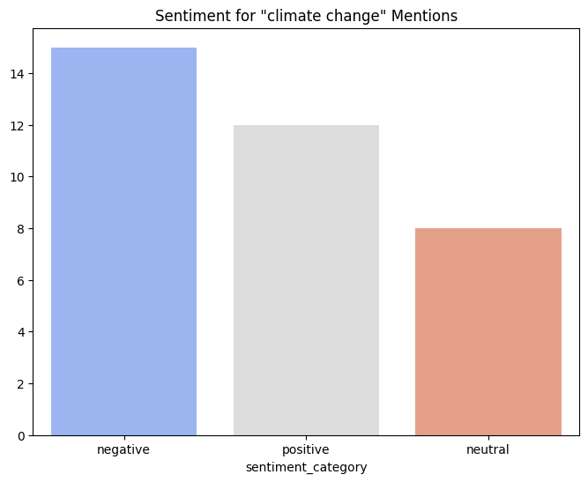
9. Conclusion: Deriving Insights from the Analysis
- Sentiment Distribution Overview:
  - The analysis showed a distribution of sentiments among the tweets analyzed. By categorizing the sentiments into positive, negative, and neutral, you can assess overall public opinion on various topics. The results from the sentiment distribution count provided insights into how many users expressed positive, negative, or neutral sentiments in their tweets.
- Trends Over Time:
  - The sentiment analysis over time revealed how public opinion fluctuated across different months. This temporal analysis allows you to identify specific periods where sentiment may have shifted significantly, which could correlate with real-world events, policy changes, or public debates. For instance, a spike in negative sentiment during a particular month might indicate heightened public concern over an issue, such as environmental policies or significant events affecting the community.
- Keyword-Specific Insights:
  - By focusing on specific keywords, such as "climate change," the analysis provided a deeper understanding of how public sentiment relates to certain topics. The visualization of sentiment for tweets mentioning the keyword revealed whether the discourse around that topic was largely positive, negative, or neutral. This is particularly useful for policymakers, advocacy groups, or businesses that want to gauge public sentiment on issues that matter to them.
- Word Cloud Visualizations:
  - The word clouds generated for positive and negative sentiments visually represent the most frequently mentioned words in the respective categories. These visualizations can help identify common themes, concerns, or praises expressed by users, facilitating a more nuanced understanding of public sentiment. For example, if words like "happy," "great," and "improvement" dominate the positive word cloud, it suggests strong approval among users, while words like "concern," "disappointment," or "crisis" in the negative word cloud highlight areas of public discontent.
- Potential Implications:
  - The findings from the sentiment analysis can have significant implications for various stakeholders. For example:
    - Public Health Initiatives: Understanding sentiments around health-related issues can guide health authorities in crafting effective communication strategies.
    - Marketing Strategies: Businesses can leverage sentiment insights to tailor their marketing campaigns, addressing consumer concerns and emphasizing positive aspects.
    - Policy Making: Policymakers can benefit from these insights to make informed decisions, address public concerns, and foster community engagement on important issues.
- Future Directions:
  - The analysis highlights the importance of ongoing sentiment monitoring, particularly in dynamic environments where public opinion can change rapidly. Future analyses could expand to include:
    - Comparative Analysis: Compare sentiments across different topics or demographic segments.
    - Sentiment and Engagement: Investigate how sentiment correlates with user engagement metrics (likes, shares, retweets).
    - Geographic Sentiment Variations: Analyzing sentiment based on geographical data (if available) could provide insights into regional differences in public opinion.

