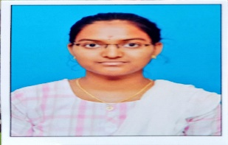**RAMYA.S**

Mob: 9345274114,9626057898

Mail: [ramya96260@gmail.com](mailto:ramya96260@gmail.com)

**CAREER OBJECTIVE:**

To have a career in a progressive organization that gives scope to apply my knowledge and skills and to work dynamically for personal and organizational growth.

**ACADEMIC RECORDS:**

|  |  |  |  |  |
| --- | --- | --- | --- | --- |
| **Course name** | **Institution** | **Board/University** | **Year of passing** | **Marks**  **(%)** |
| BCA | Navarasam Arts and Science College,  Arachalur | Bharathiyar University | 2024 | 93% |
| HSC | Thenmalar Higher Secondary School, Dharapuram | State Board | 2021 | 91% |
| SSLC | Thenmalar Higher Secondary School, Dharapuram | State Board | 2019 | 89.5% |

**SKILLS:**

* Technical Skills : Java, Python
* Web Language : HTML

**AREA OF INTEREST:**

* Gaderning
* Cooking

**PERSONAL DETAILS:**

Date of Birth : 02-07-2003

Gender : Female

Language Known : Tamil, English

Father’s name : Mr. Soundarrajan. V

Mother’s name : Mrs. Vallinayaki. S

Address : 3/296,Thoppu Thottam,Kethalrev(Po)

Dharapuram(TK)-638657,Tirupur(DT).

**Declaration:**

I hereby confirm that all the above information is true to the best of my knowledge and belief.

Date :

Place:Dharapuram. [RAMYA.S]