1. How many missing values were present in each column?
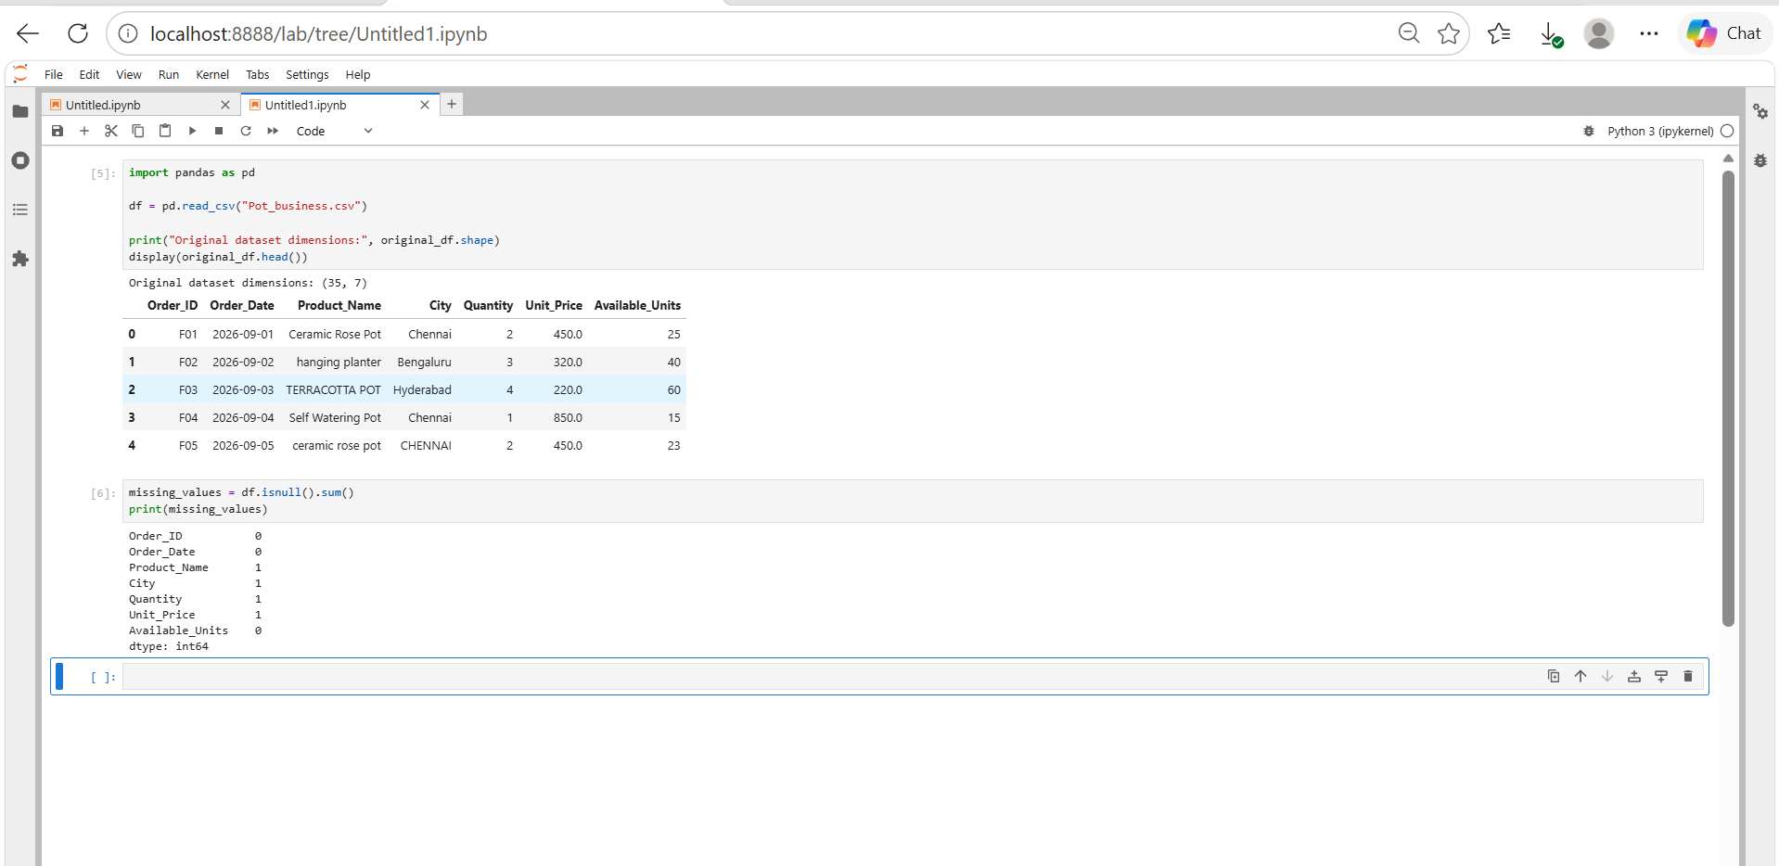
Impact: Missing data can lead to incomplete or misleading business reports.
Solution: Identify the affected records, validate the original values where possible, and apply an appropriate treatment.
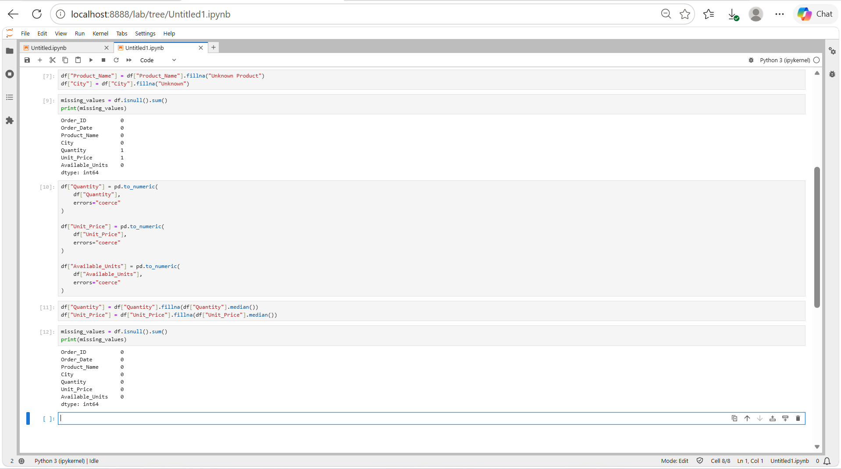

2. Are any orders repeated in the flower pot business dataset?
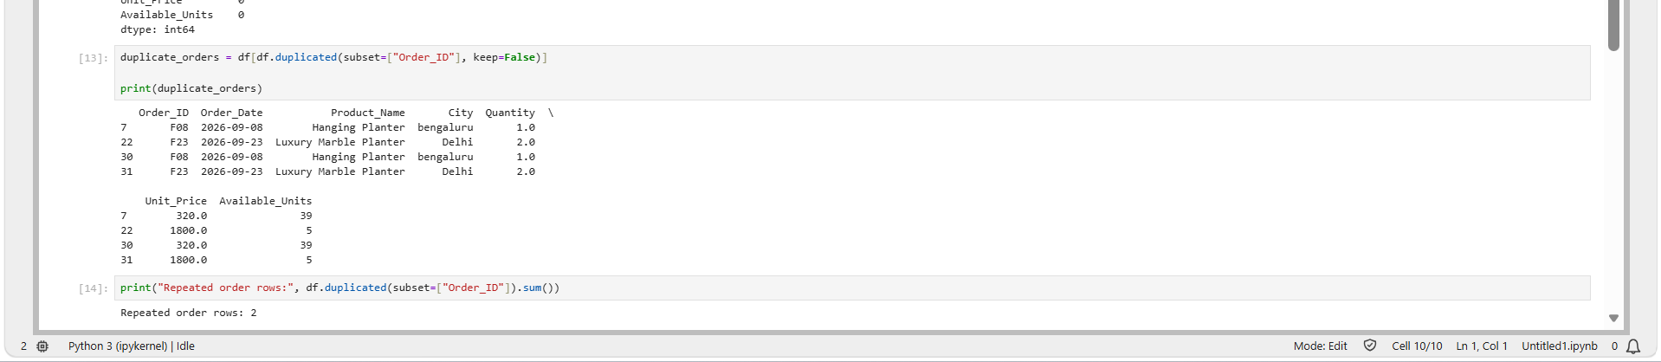
Impact: Repeated orders can cause:
- Inflated revenue: The same order may be counted twice.
- Incorrect sales reports: Order counts may be higher than the actual number of orders.
- Inventory errors: Stock movement may be recorded incorrectly if a duplicated transaction is processed twice.
Solution: Inspect the repeated records before removing anything. If two rows represent the same transaction, retain one valid record. If they represent separate items belonging to the same order, preserve both and use a suitable transaction identifier.
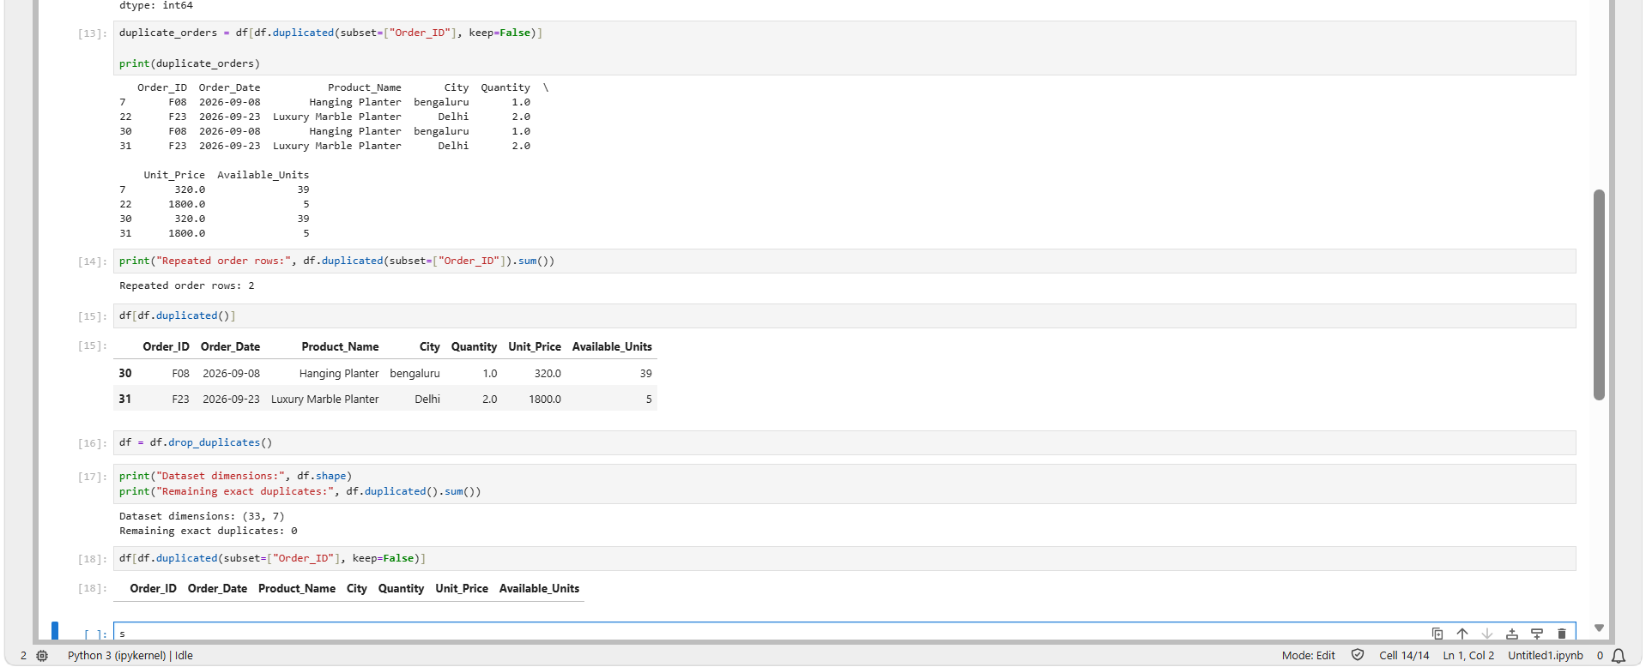

3. Which flower pot product has the highest unit price?
Impact: Identifying the highest-priced product helps the business:
- Identify premium products.
- Review pricing strategies.
- Understand which products contribute more revenue per unit.
- Investigate unusually high prices that might be data-entry errors.

Solution: Your dataset originally contained a Luxury Marble Planter priced at ₹18,000, while other records listed it at ₹1,800. This could be a data-entry error, but you should verify it against the original product price before changing it.
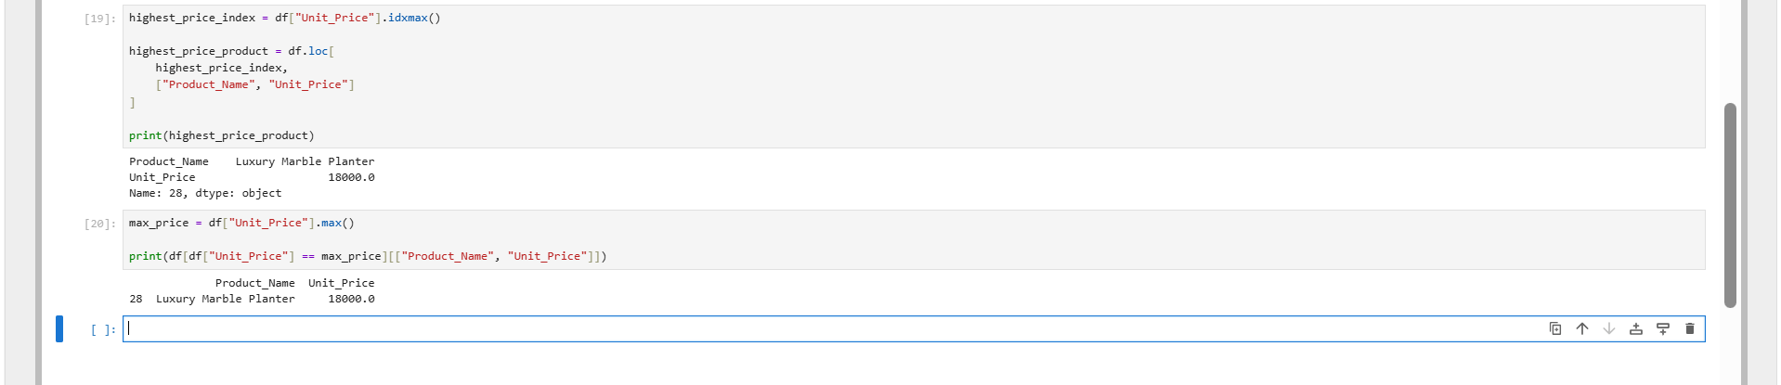

4. Which product has the highest number of available units?
Impact:
- Helps identify products with large inventory levels.
- Helps identify premium products and review pricing.
- Helps inform inventory allocation and purchasing decisions.
Solution:
- Excess stock: Consider promotions or discounts if inventory is high relative to demand.
- Low stock: Monitor products with limited availability to avoid stockouts.
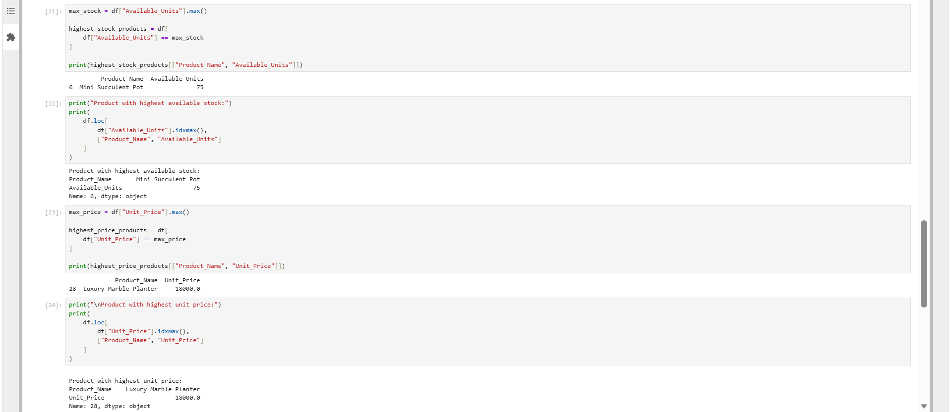

5. Which city generates the highest total sales revenue?
Impact:
- Identifies the strongest-performing sales locations.
- Helps prioritize marketing and promotional campaigns.
- Supports regional inventory planning.
- Enables comparisons between sales markets.
Solution:
- High-revenue cities: Maintain sufficient inventory and analyse which products drive sales.
- Low-revenue cities: Investigate customer demand, product availability, and marketing effectiveness.
