DATA ANALYTICS DAY 12 TASK 2
Pot_business.csv
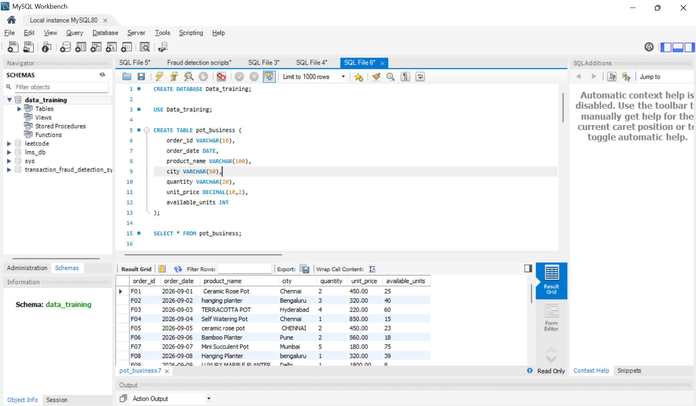

FIND EXPENSIVE FLOWER POTS
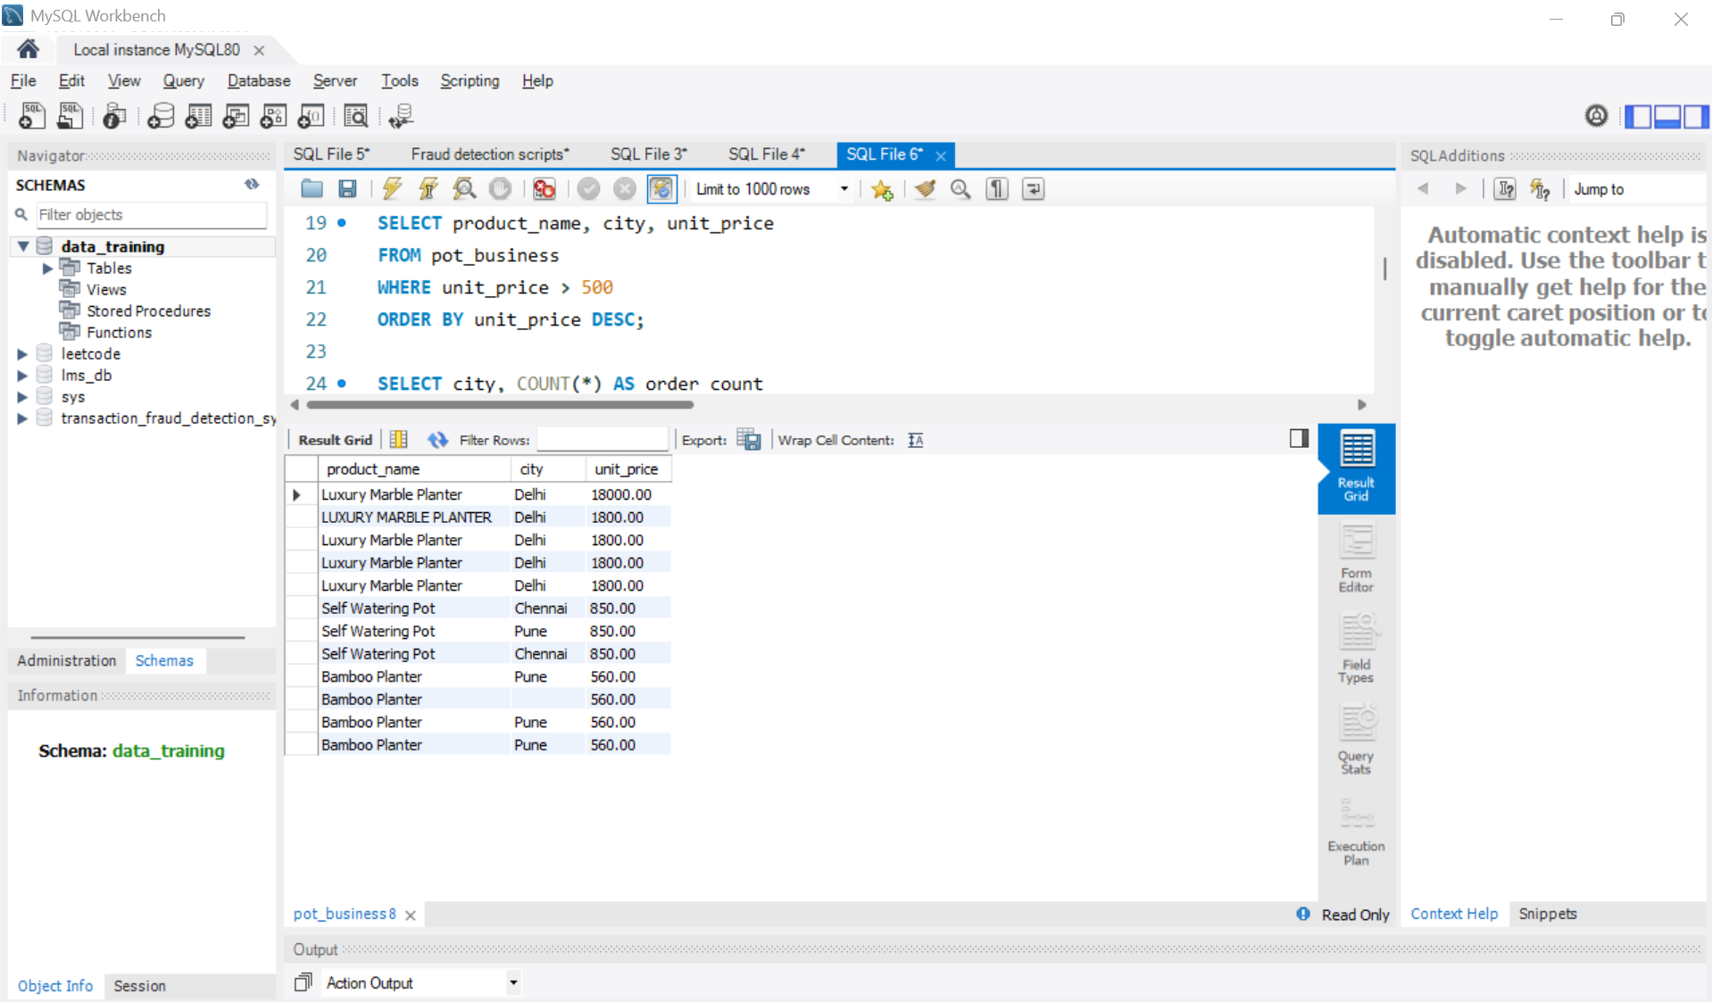

COUNT RECORDS BY CITY

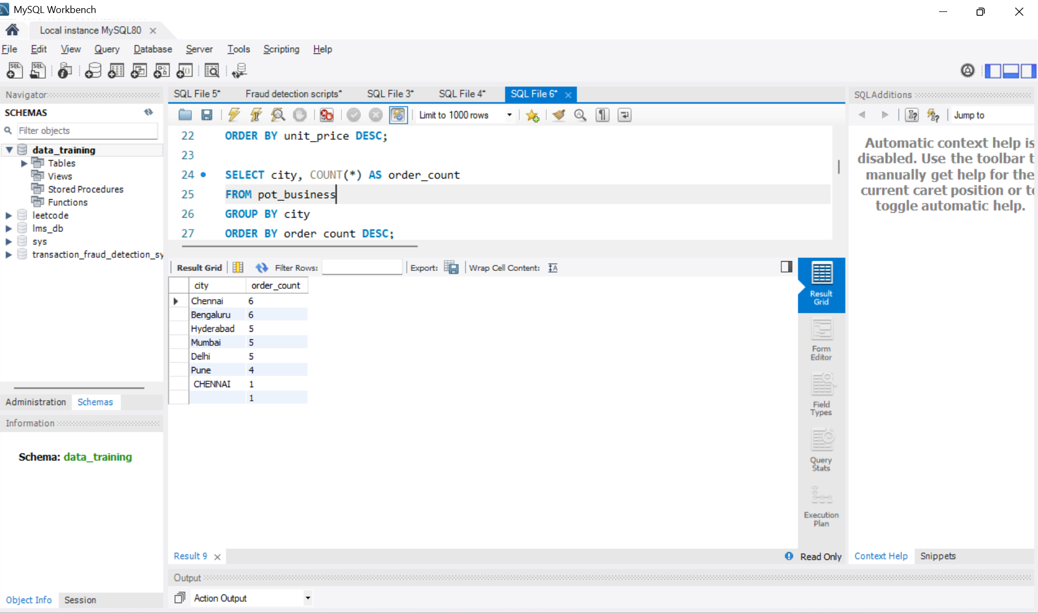

CALCULATE REVENUE BY CITY
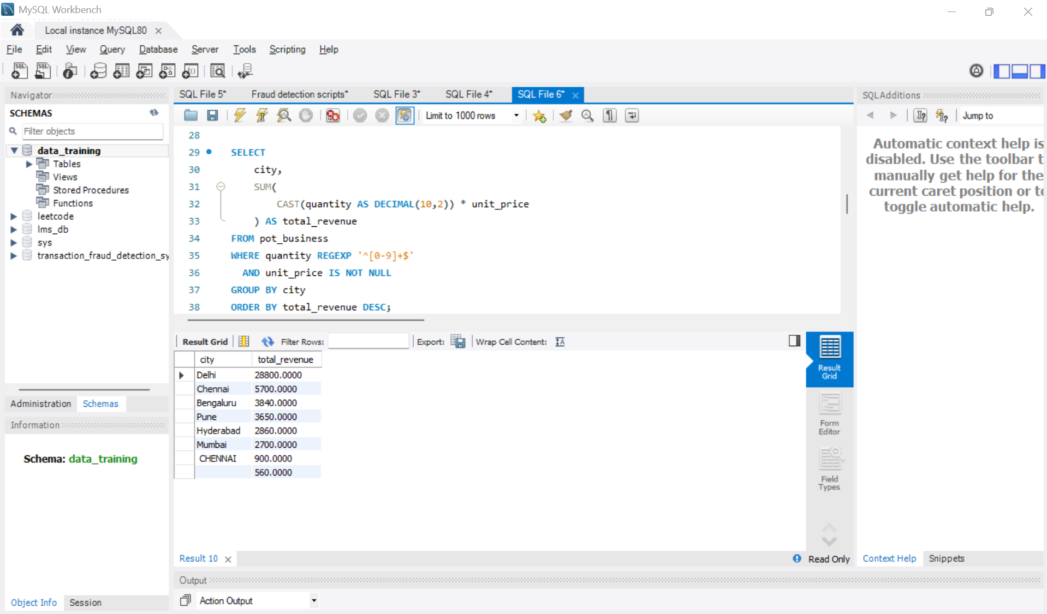

FIND CITIES WITH AN AVERAGE UNIT PRICE ABOVE ₹500
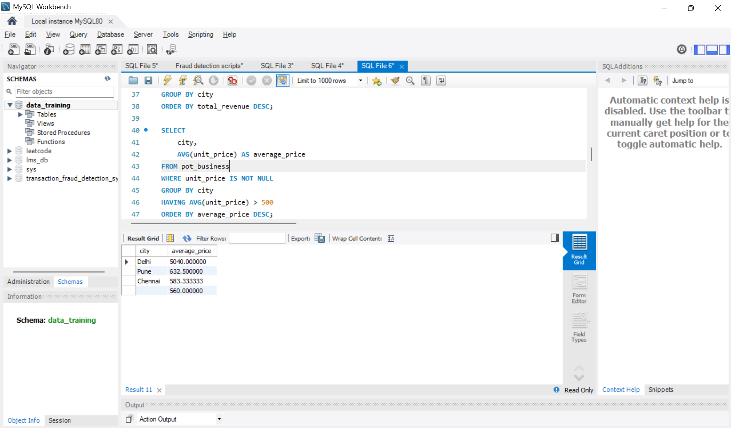

FIND PRODUCTS PRICED ABOVE THE OVERALL AVERAGE
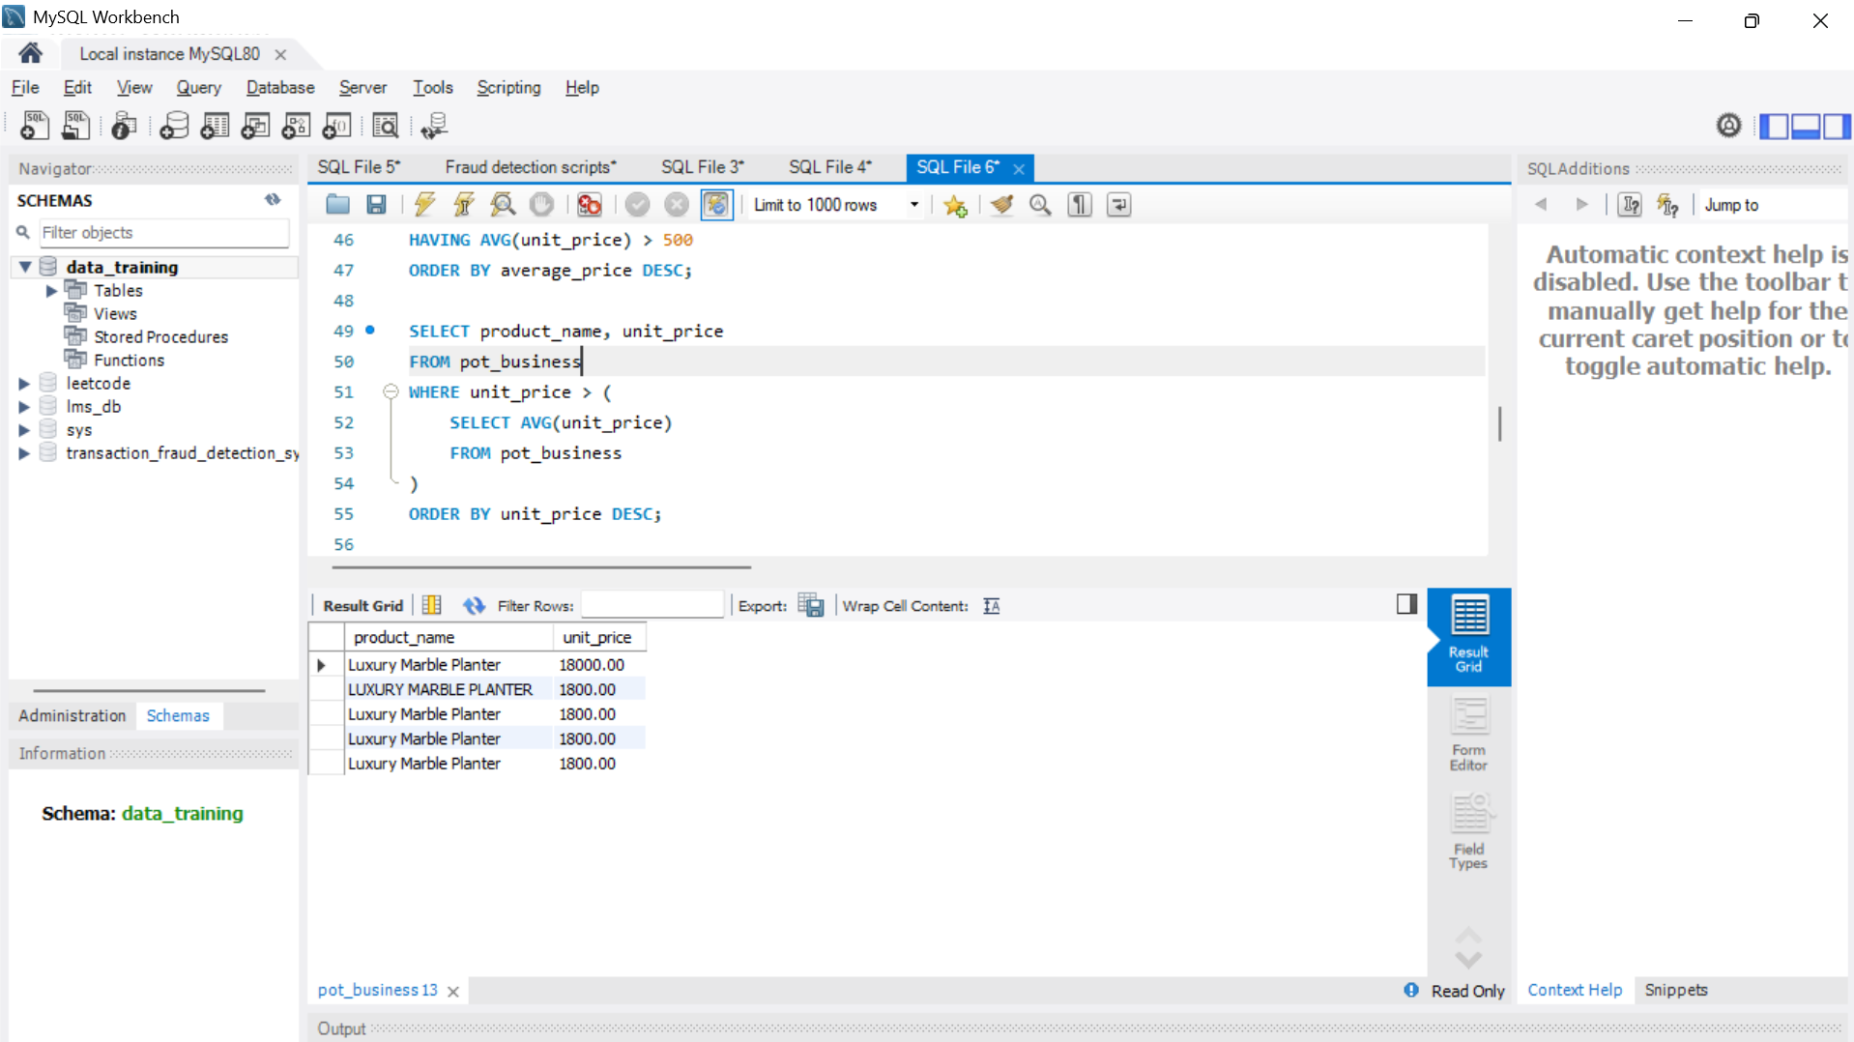

FIND THE MOST EXPENSIVE PRODUCT IN EACH CITY
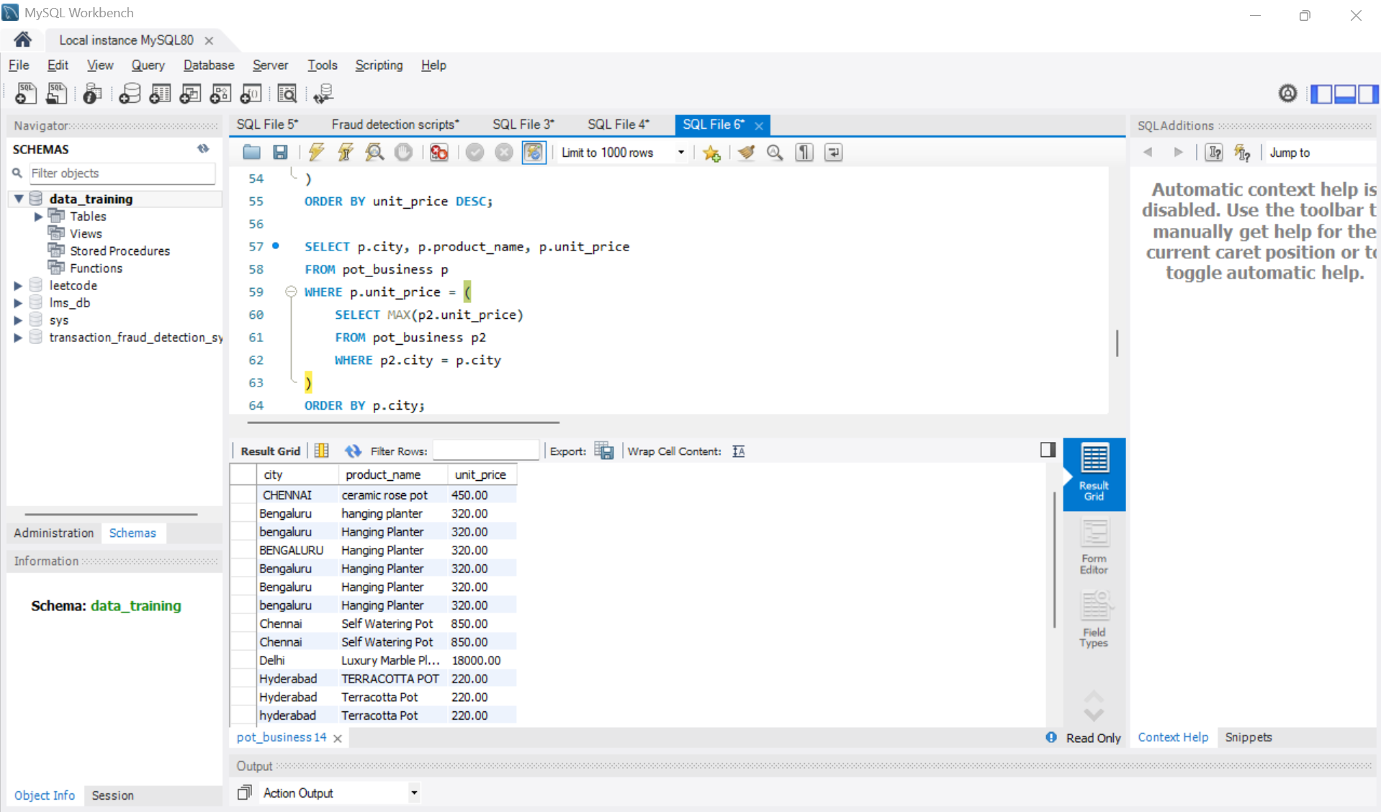

CLASSIFY PRODUCTS BY PRICE
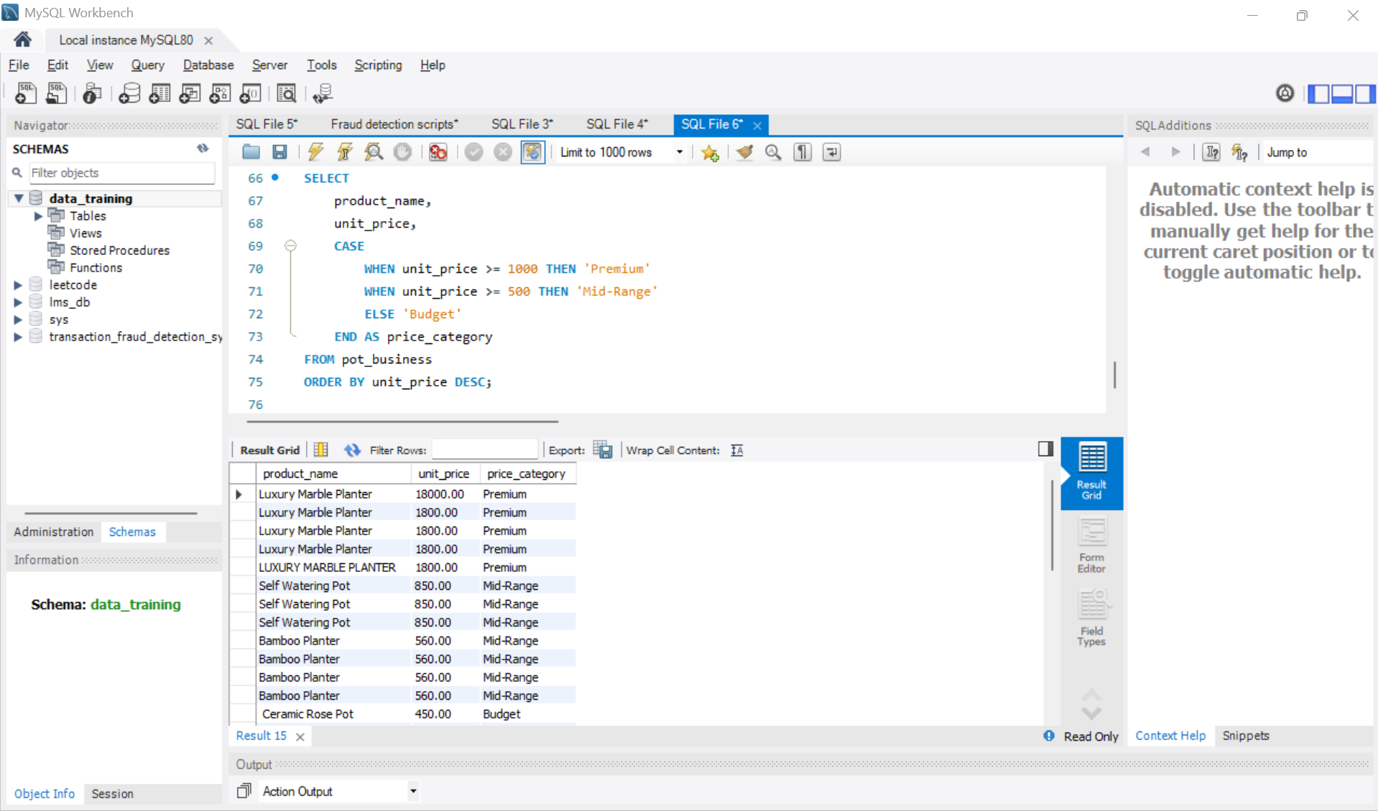

Cloud_infrastructure.csv
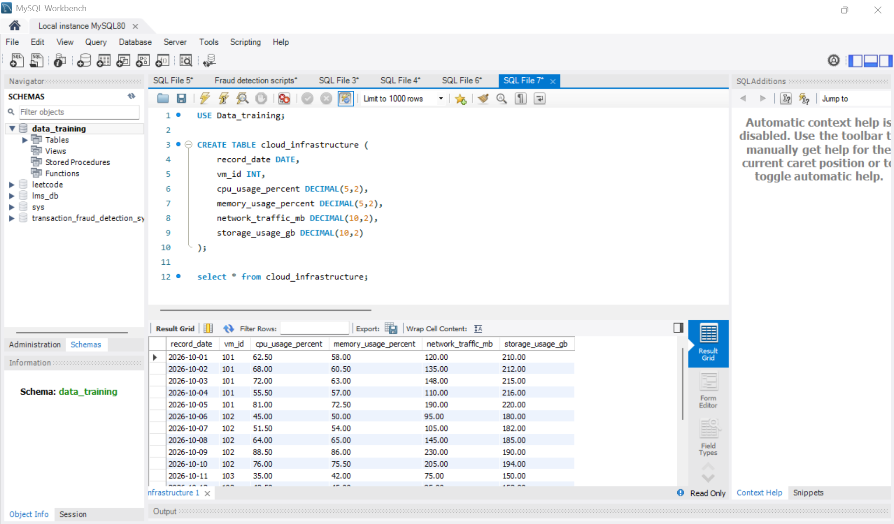
FIND VIRTUAL MACHINES WITH HIGH CPU OR MEMORY USAGE
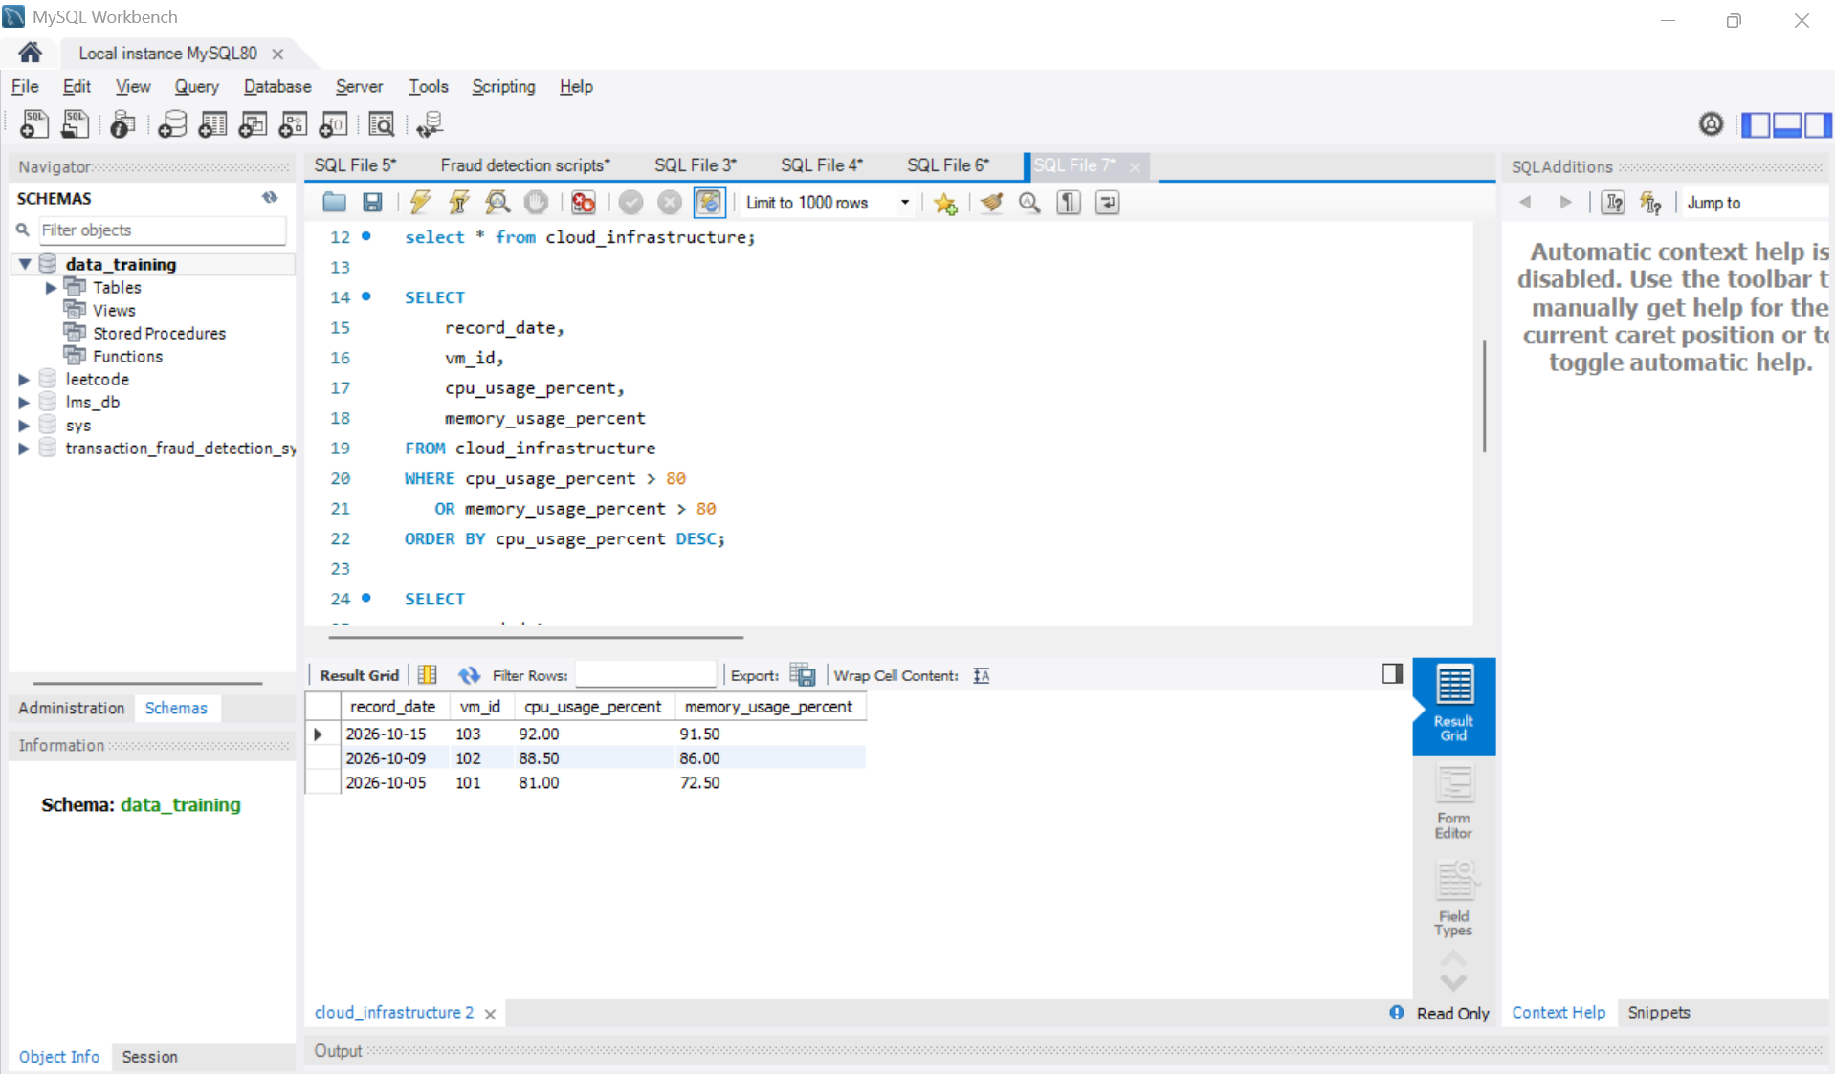
CLASSIFY VIRTUAL MACHINE RESOURCE USAGE
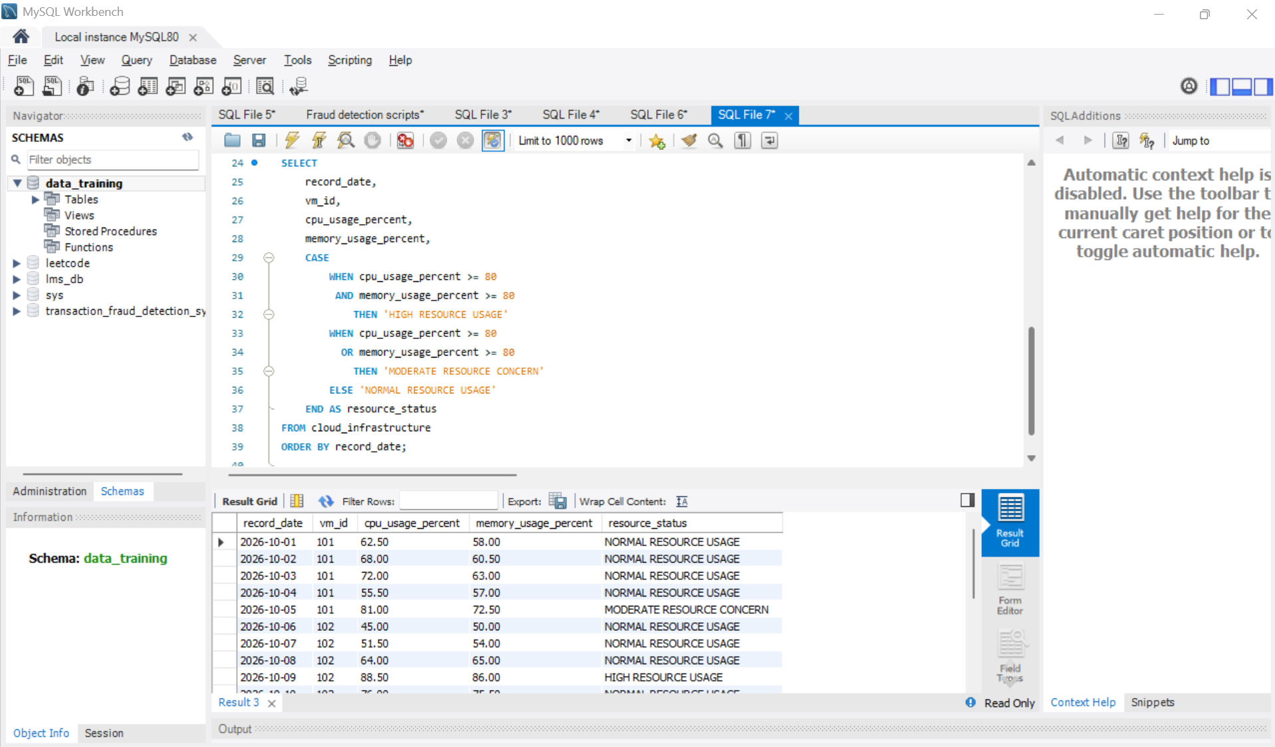
CALCULATE AVERAGE RESOURCE USAGE FOR EACH VM
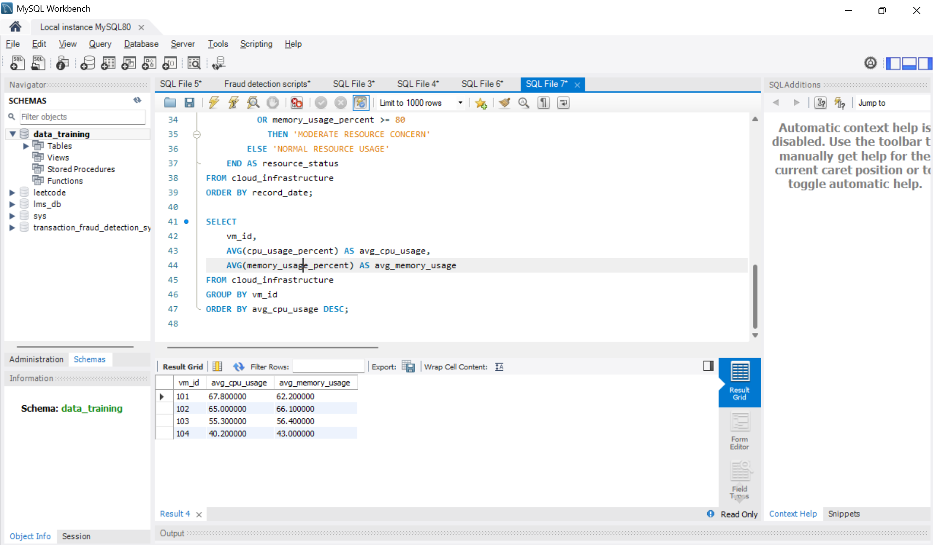

FIND RECORDS WITH ABOVE-AVERAGE NETWORK TRAFFIC
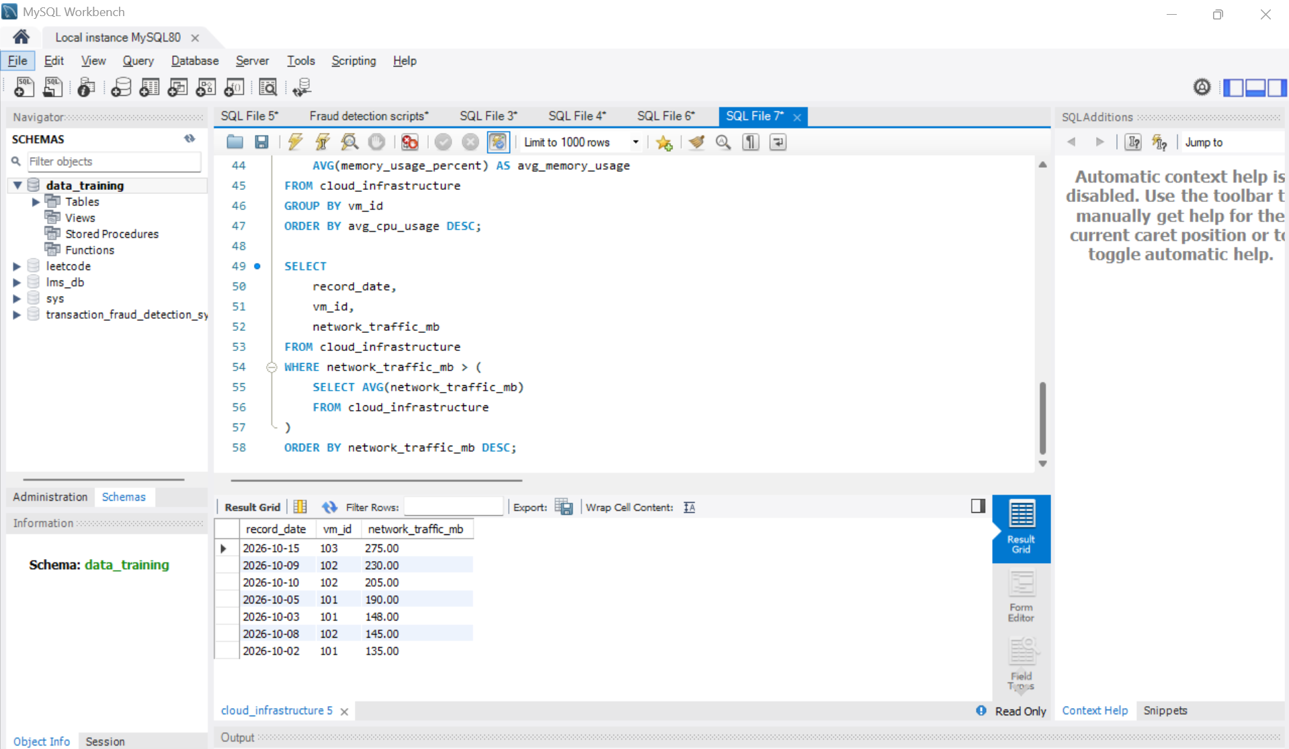
FIND VMS WITH HIGH CPU AND MEMORY USAGE
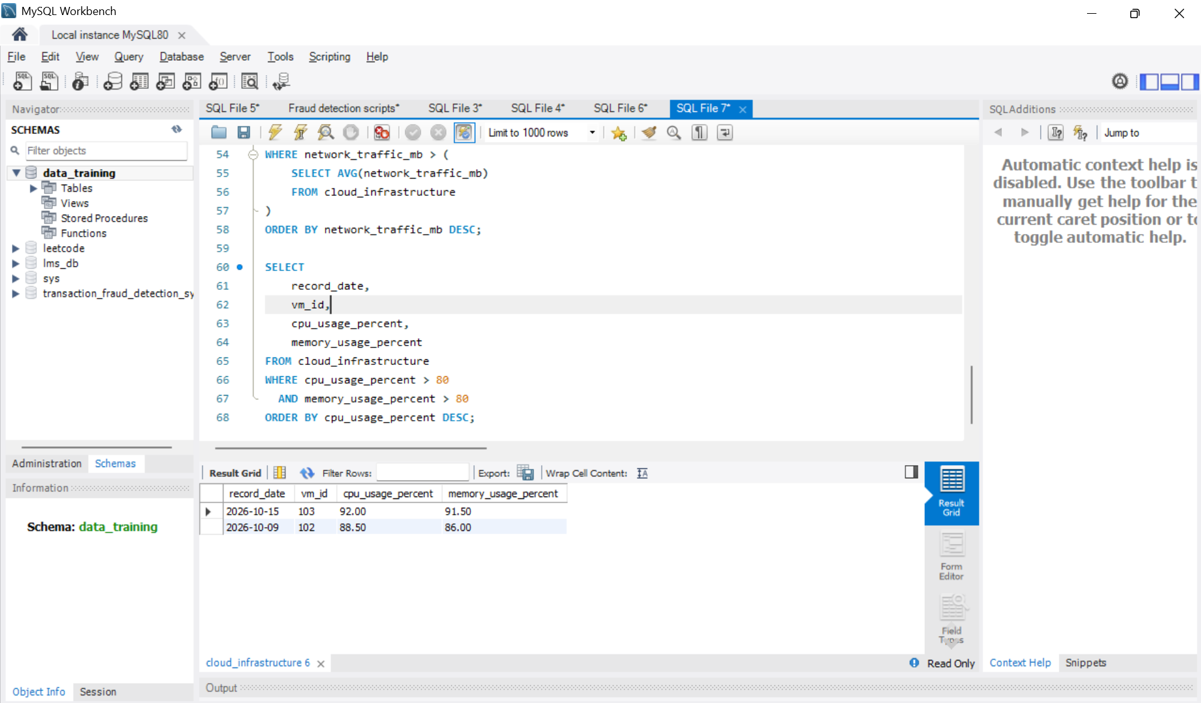
CLASSIFY STORAGE UTILIZATION
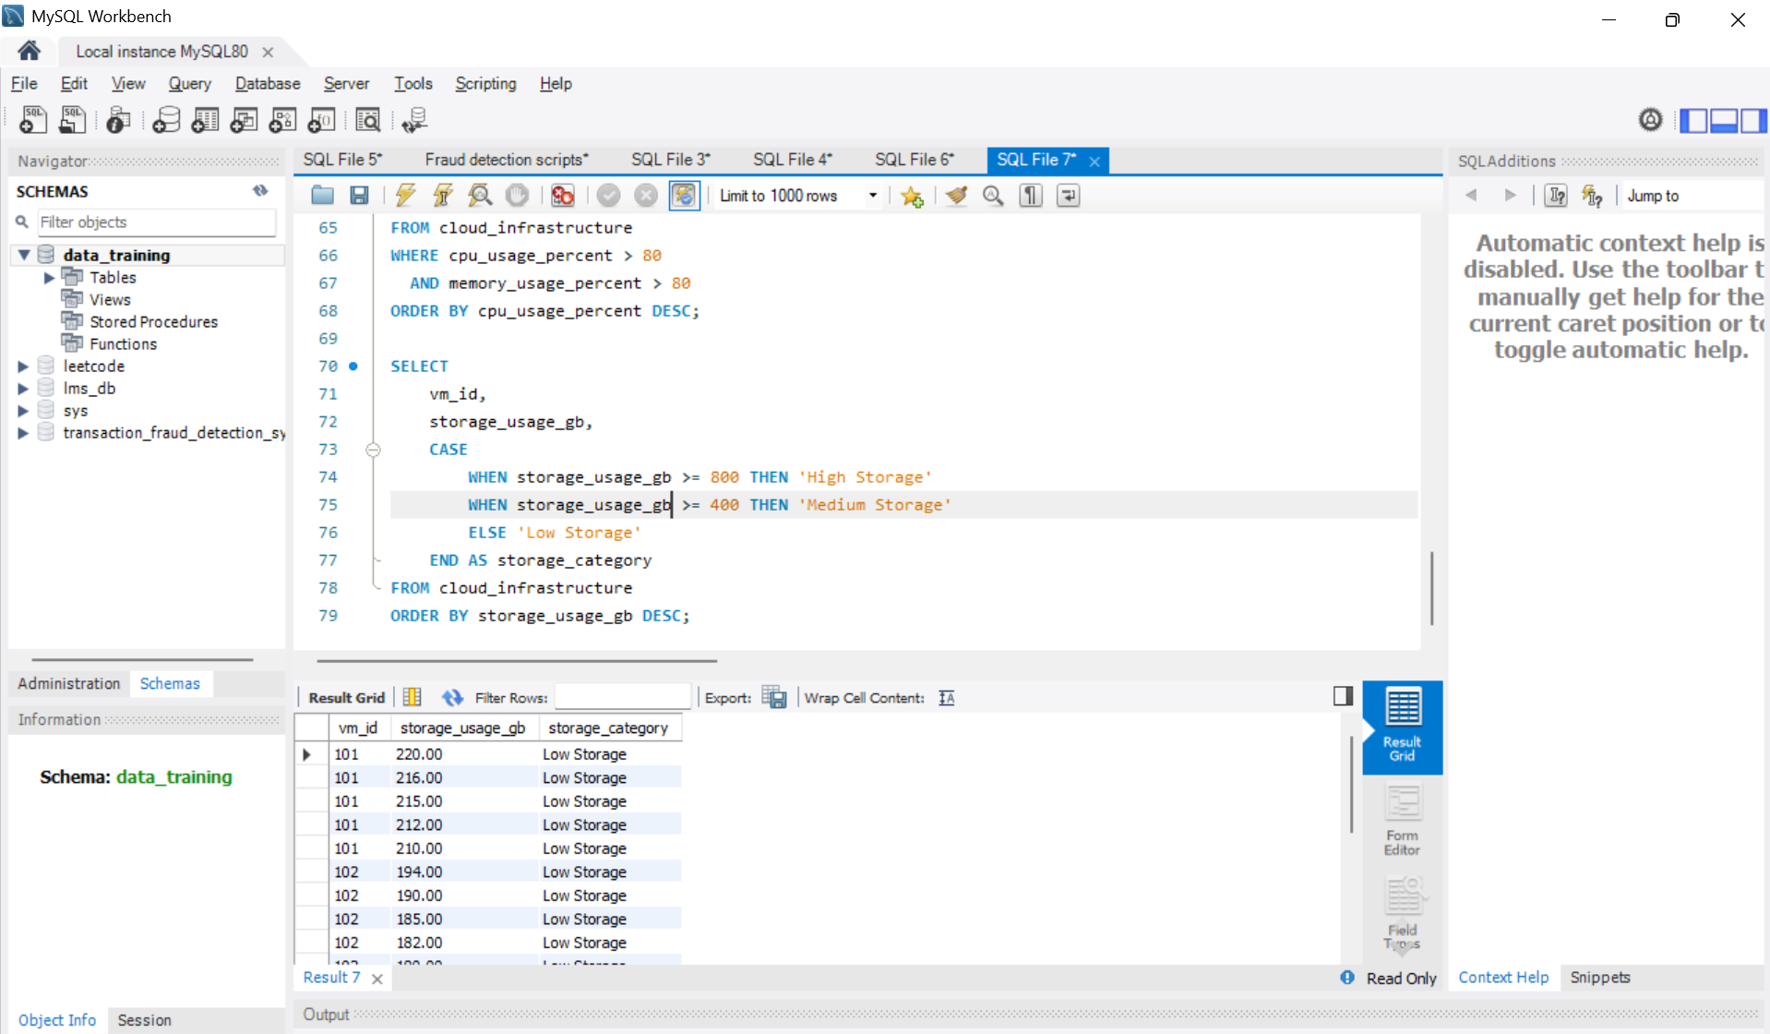

CALCULATE TOTAL NETWORK TRAFFIC AND MAXIMUM CPU USAGE BY DATE
