“PG Match – Comprehensive PG Accommodation Platform”
A Project Report
Submitted in the partial fulfillment of the requirements for the award of the degree of
Master of Technology in Department of Computer Science and Engineering
By

T.RAMYA SRI (2501050209)
For the Course Frontend Development
Frameworks under the
supervision of

Dr.B.Chaitanya Krishna



Department of Computer Science & Engineering
K L E F, Green Fields,
Vaddeswaram- 522502, Guntur (Dist), Andhra Pradesh, India. November,2025

DECLARATION

The Project Report entitled “PG Match – Comprehensive PG
Accommodation Platform” (PG MATCH )” is a record of Bonafide work of T.RAMYA SRI (2501050209) submitted partial fulfillment for the award of MTech in Computer Science and Engineering to the KL University. The results embodied in this report have not been copied from any other departments/University/Institute.

Name of the Student

T.RAMYA SRI (2501050209)

Signature of the student
CERTIFICATE

This is to certify that the Project Report entitled “PG Match – Comprehensive PG Accommodation Platform”
is being submitted by T.RAMYA SRI(2501050209) submitted in partial fulfillment for the award of MTech in Computer Science and Engineering to the K L University. The results embodied in this report have not been copied from any other departments/University/Institute.
The results embodied in this report have not been copied from any other departments/ University/Institute.

Signature of the Supervisor
Name and Designation

Signature of the HOD

Name & Signature of the

External Examiner

Date:

Abstract
Finding safe and convenient PG accommodations is challenging for students and professionals in India. PG Match is a digital platform that connects PG seekers with verified property owners, offering a secure, user-friendly, and efficient solution. Users can search by city, price, room type, and amenities, while owners can manage listings and monitor inquiries.
The platform uses a FastAPI backend, MongoDB database, and React frontend with Tailwind CSS and Shadcn UI for responsive design. Features like dashboards, PG detail pages, reviews, and notifications improve usability and trust. PG Match simplifies PG hunting, ensures transparency, and provides a scalable solution for urban housing challenges.
Keywords: PG Accommodation, Digital Platform, PG Match, Tenant Verification, User Experience
Chapter 1: Introduction to PG Match

PG Match is a cutting-edge digital platform designed to bridge the gap between PG (Paying Guest) seekers and verified property owners across India. With the rapid urbanization and the migration of students and professionals to metro and tier-2 cities, finding safe, affordable, and convenient accommodation has become a major challenge. Traditional PG hunting often involves multiple visits, reliance on word-of-mouth, and exposure to fraudulent listings. PG Match solves this problem by offering a centralized, secure, and highly interactive platform that streamlines the entire process.

1.1 Purpose and Need

The primary goal of PG Match is to simplify the PG search process for seekers while providing property owners with an efficient way to manage listings. Key challenges addressed by the platform include:
Difficulty in finding verified PG accommodations

Lack of transparency in amenities, pricing, and location

Time-consuming communication between seekers and owners

Limited availability of real-time updates on vacancies

By providing verified listings, real-time updates, and an intuitive interface, PG Match reduces uncertainty and ensures a smooth user experience.

1.2 Features That Make PG Match Unique

PG Match combines advanced technology and user-centric design to deliver several unique advantages:

Centralized Database: All PG listings are verified and updated regularly.

Real-Time Search: Users can instantly view available PGs in their city of choice.

Amenity Details: Each listing includes comprehensive amenities, images, and pricing.

Safety Features: Tenant verification, owner verification, and messaging systems ensure a secure environment.

Notifications: Real-time alerts for new listings, inquiries, and responses keep users informed.

1.3 Target Audience

PG Match caters to multiple user groups:

Students: Especially those relocating for higher education in metro cities.

Working Professionals: Individuals seeking affordable, convenient accommodations near workplaces.

Property Owners: Owners of PGs, hostels, or rental homes who want to efficiently manage and advertise their properties.

1.4 Benefits to Users

For PG Seekers:

Access to verified listings with detailed descriptions and images

Filters for city, price, room type, and amenities

Ability to track inquiries and communicate directly with owners

For Owners:

Easy management of multiple listings

Analytics and insights on user interest and inquiries

Reduced dependency on third-party agents or platforms

1.5 Future Scope

PG Match is designed to be scalable and adaptable:

Expansion to additional cities and regions

Integration of AI-based recommendations for personalized PG suggestions

Virtual tours and interactive maps for enhanced decision-making

Predictive analytics for occupancy trends and pricing insights

1.6 Case Study / Example

Scenario: A student moving from Vijayawada to Bangalore searches for a PG with WiFi, AC, and attached bathroom. Using PG Match, she can filter listings within her budget, view photos, check reviews, and contact the owner directly. The platform saves her multiple site visits and provides reliable, verified information.
.

Chapter 2: Platform Overview and Importance

PG Match functions as a two-sided digital marketplace, connecting PG seekers with verified property owners across multiple cities in India. Unlike traditional PG search methods, the platform provides real-time access, verified listings, and detailed property information, all in one centralized location.

2.1 Two-Sided Marketplace Concept

A two-sided marketplace connects service seekers (PG tenants) and service providers (PG owners). This ensures a direct, transparent interaction between users and property owners.

Key Benefits of this Model:

Eliminates middlemen and reduces brokerage costs

Enhances trust via verified listings

Supports dynamic pricing based on occupancy and amenities

Provides analytics for owners to track inquiries and tenant trends
Flowchart showing PG seeker → PG Match platform → PG owner interaction

2.2 Features Highlighting Platform Importance

Verified Listings: Every PG listing is verified for authenticity, amenities, and safety.

City-Wise Coverage: The platform currently operates in 15+ cities, including Mumbai, Delhi, Bangalore, Hyderabad, Pune, Chennai, Vijayawada, Guntur, and Visakhapatnam.

Detailed PG Information: Each listing contains room type, occupancy, pricing, photos, amenities, reviews, and availability status.

Search Optimization: Advanced search filters and dynamic sorting improve user efficiency.

Notifications & Alerts: Users receive updates on new listings, inquiry responses, and availability changes.

2.3 Integration with Third-Party Services

PG Match integrates several third-party tools to improve functionality:

Maps: Visual representation of PG locations and nearby facilities

Payment Gateways: Secure transactions for booking confirmation

Messaging & Notifications: Real-time communication between tenants and owners

2.4 Efficiency Compared to Traditional Methods

Traditionally, finding a PG involves:

Contacting multiple owners via phone or email

Visiting multiple locations to confirm availability

Risk of fraud or misinformation

PG Match streamlines this process:

Verified information reduces fraud risk

Digital dashboards allow tracking of inquiries and responses

Filters allow instant discovery of suitable PGs within budget and preferences

Example Scenario:
A working professional moving to Mumbai can search PGs in his preferred locality, filter by rent and amenities, view photos, check reviews, and contact the owner—all without leaving home.

2.5 Owner Benefits

For PG owners, the platform provides:

Listing Management: Add, edit, or remove properties easily

Analytics: Track tenant interest and inquiries

Occupancy Trends: Data-driven insights on pricing and availability

Communication: Direct messaging to respond to tenant queries quickly

Example Scenario:
An owner in Pune managing multiple PGs can upload photos, update availability, and respond to 50+ tenant inquiries simultaneously using PG Match’s dashboard.

2.6 Scalability and Future Scope

PG Match is designed to scale across:

Geographies: Expand to additional metro and tier-2 cities

Features: Incorporate AI-based suggestions, predictive occupancy trends, and dynamic pricing models

Technology: Enhance infrastructure for larger user bases, faster search, and real-time updates

2.7 Case Study

Scenario:
A student from Vijayawada moves to Bangalore for an internship. She wants a PG with AC, WiFi, and a female-only environment. Using PG Match:

Filters are applied for location, price, and amenities

Available PGs appear with photos, reviews, and pricing

She contacts the owner directly and confirms the booking online

She saves time and avoids visiting multiple PGs physically

Outcome: Efficient, safe, and transparent PG search experience.

Chapter 3: Detailed Features

PG Match provides a rich set of features designed to meet the needs of both PG seekers and owners. The platform combines technology, user experience, and operational efficiency to ensure seamless interactions. Each feature has been designed with usability, reliability, and security in mind.

3.1 Advanced Search and Filters

One of PG Match’s most powerful features is its advanced search and filtering system. Users can search for PGs using multiple parameters:

City and Locality: Mumbai, Delhi, Bangalore, Hyderabad, Vijayawada, Guntur, Visakhapatnam, Tirupati, and more.

Room Type: Single, double, triple sharing, or dormitory-style rooms.

Price Range: ₹4,500 to ₹50,000 per month.

Gender Preference: Male, Female, or Any.

Amenities: WiFi, AC, Security, Power Backup, TV, Fridge, Washing Machine, Hot Water, Parking, Attached Bathroom.

Example:
A student in Pune looking for a PG with AC and WiFi within ₹10,000/month can filter results to display only matching listings, with real-time updates as availability changes.

3.2 Verified PG Listings

All PG listings on the platform undergo strict verification processes:

Ownership verification using legal documents

Physical property verification to confirm amenities and room conditions

Photo verification to ensure authenticity

Reviews and ratings from past tenants

Benefits:

Reduces fraud risk

Builds trust for new tenants

Provides accurate pricing and facility details

Example Table:

City Listings Verified Avg Rent Amenities Verified
Mumbai 20 ₹12,000 WiFi, AC, Hot Water
Vijayawada 14 ₹6,500 WiFi, Security, Parking
Bangalore 18 ₹10,500 AC, Washing Machine, TV

3.3 User Authentication and Role-Based Access

PG Match uses JWT-based authentication to ensure secure access for both users and owners.

PG Seekers: Can browse listings, apply filters, send inquiries, save favorites, and manage profiles.

PG Owners: Can create, edit, delete listings, respond to inquiries, track tenant interest, and view analytics.

3.4 Dashboard Functionalities

The platform offers separate dashboards for owners and seekers:

User Dashboard: Inquiry tracking, favorite PGs, profile management, and notification alerts.

Owner Dashboard: Listing management, occupancy tracking, response management, analytics reports.

Benefits:
Consolidates critical information in one view
Reduces manual follow-ups
Provides actionable insights for decision-making

3.5 Review and Rating System

PG Match has a 5-star review system to provide transparency:

Tenants rate PGs based on cleanliness, safety, amenities, and owner responsiveness

Verified reviews ensure authenticity

Ratings influence search visibility and trustworthiness of listings

Example:
A PG with 4.8 stars based on 25 verified reviews shows higher engagement and trust among users.

3.6 Notifications and Alerts

The platform supports real-time notifications:

New PG listings matching user preferences

Responses to inquiries

Updates on vacancy and occupancy

Benefits:

Keeps users engaged

Reduces response time

Helps owners manage inquiries efficiently

3.7 Sorting and Personalized Recommendations

Advanced features include:
Sorting: By price, ratings, proximity, and availability
Recommendations: AI-driven suggestions based on user behavior, previous searches, and preferences
Example Scenario:
A user frequently searching for PGs in Chennai with AC and WiFi may receive automated suggestions for newly listed PGs matching these criteria
.
3.8 Future Enhancements

Planned updates for PG Match include:
AI-Powered Predictive Analytics: Predicting PG availability trends based on demand and seasonality
Dynamic Pricing: Adjusting rates based on occupancy and market trends
Virtual Tours: 360° property walkthroughs for online decision-making
Interactive Map Integration: Showing nearby amenities, public transport, and neighborhood info

Chapter 4: Search & Filtering System

PG Match’s search and filtering system is one of its core features, designed to make the process of finding suitable PGs fast, precise, and user-friendly. With hundreds of listings across multiple cities, it is essential to allow users to quickly narrow down options based on their preferences.

4.1 Overview of Search Functionality

The search system is optimized for:

Speed: Quick response even with large datasets

Accuracy: Relevant listings based on user queries

Flexibility: Multiple filters to customize search results

Users can search by:

City or Locality: Selecting a specific city or neighborhood

Price Range: ₹4,500 – ₹50,000/month

Room Type: Single, double, triple sharing

Gender Preference: Male, Female, Any

Amenities: WiFi, AC, Hot Water, Security, Parking, Attached Bathroom, and more

Example:
A student in Bangalore can search for a single-sharing PG under ₹10,000 with WiFi and AC. The platform immediately displays matching listings with photos, pricing, and review ratings.

4.2 Filtering Logic

The system uses backend optimizations to ensure fast and accurate filtering:

Database Indexing: Ensures quick retrieval of relevant listings

Caching: Frequently used queries are cached to reduce response time

Query Optimization: Complex filters are processed efficiently

Flow of Filtering:

User selects filters →

Backend processes query →

Listings matching criteria are retrieved →

Results are sorted based on relevance or rating →

Displayed to the user

4.3 Sorting and Ranking

Filtered results can be sorted by multiple parameters:

Price: Low to High or High to Low

Ratings: Highest to Lowest

Distance: Nearest PGs to specified location

Availability: Earliest move-in date

Example Table of Sorting Options:

Parameter Example Result Benefit
Price ₹4,500 – ₹10,000 Affordable options first
Rating 4.8-star PGs displayed first High-quality PGs prioritized
Distance PGs within 2 km of user location Convenience for commuting
Availability PGs with immediate move-in Saves time and planning

4.4 Amenity Filtering

Users can select specific amenities to refine search results. Popular amenities include:

AC

WiFi

Hot Water

Security

Attached Bathroom

Parking

TV

Fridge

Washing Machine

Power Backup

Example Scenario:
A working professional in Mumbai wants a PG with AC, WiFi, and 24/7 security. He applies filters, and only relevant PGs appear.
4.5 Dynamic Search and Real-Time Updates

PG Match supports dynamic search results, meaning:

Availability status is updated in real-time

Newly added listings matching filters appear instantly

Removed or booked listings are automatically excluded

Example:
If a PG in Chennai is booked while a student is browsing, it is immediately removed from the filtered results to prevent disappointment.

4.6 AI and Predictive Enhancements (Future Scope)

Planned enhancements include:

Predictive Recommendations: Suggest PGs based on previous searches and preferences

Occupancy Prediction: Indicate likely availability based on historical trends

Personalized Sorting: AI ranks listings based on user behavior and reviews

Example:
A student who previously searched for PGs in Pune with WiFi and AC may receive notifications for new PGs matching those criteria.

4.7 Case Study

Scenario:
A student from Hyderabad plans to move to Bangalore. She needs a PG under ₹12,000 with AC and WiFi. Using PG Match:

She applies city, price, room type, and amenity filters.

Filtered results display 10 verified PGs.

She sorts results by rating, selects top 3, checks reviews, and contacts owners.

She finalizes a booking without visiting multiple locations physically.

Outcome: Efficient, reliable, and stress-free search process.

Chapter 5: PG Listings and City Coverage

PG Match hosts over 118 verified PG listings across metro and tier-2 cities in India. Each listing provides detailed information to help PG seekers make informed decisions. City coverage ensures users from various regions can find accommodations suitable to their requirements.

5.1 Overview of Listings

Each PG listing on PG Match contains:

Property Name and Address: Exact or approximate location

Room Types: Single, double, triple sharing

Occupancy: Number of beds and current availability

Pricing: Monthly rent with details on utilities

Amenities: WiFi, AC, Hot Water, Security, Parking, etc.

Photos: 8–10 high-quality images of rooms and property

Ratings and Reviews: Verified feedback from previous tenants

Example:

City: Bangalore

PG Name: Green Stay Residency

Room Type: Single Sharing

Rent: ₹9,500/month

Amenities: WiFi, AC, Hot Water, Security, Fridge

Rating: 4.7/5

Image Suggestion: Screenshot of PG listing card

5.2 City Coverage

PG Match currently serves 15+ cities with verified listings:

City No. of Listings Avg Rent (₹) Popular Room Type Popular Amenity
Mumbai 20 12,000 Single AC, WiFi
Delhi 15 10,500 Double WiFi, Hot Water
Bangalore 18 10,500 Single AC, Security
Hyderabad 10 8,000 Single WiFi, Parking
Pune 12 9,000 Double AC, WiFi
Chennai 10 8,500 Single AC, Hot Water
Vijayawada 14 6,500 Double WiFi, Security
Guntur 12 6,000 Single AC, Parking
Visakhapatnam 7 7,000 Single WiFi, Hot Water
Tirupati 5 5,500 Double AC, Security

5.3 Types of PGs
PGs are categorized based on:

Sharing Type: Single, Double, Triple

Target Audience: Male, Female, Mixed

Facilities Provided: Basic, Premium, Luxury

Example Pie Chart: Distribution of PG types by percentage across cities

Single Sharing – 45%

Double Sharing – 35%

Triple Sharing – 20%

5.4 Amenities Distribution

Each city has a unique pattern of popular amenities:

Amenity Mumbai Delhi Bangalore Hyderabad Vijayawada
WiFi 90% 85% 88% 80% 75%
AC 80% 70% 85% 65% 50%
Hot Water 75% 60% 70% 55% 45%
Security 60% 65% 70% 60% 55%
Parking 50% 45% 60% 50% 40%

5.5 Listing Management for Owners

PG Match provides owners tools to:

Create and Edit Listings: Add images, update pricing, and modify amenities

Track Inquiries: View tenant interest in real-time

Analytics: Occupancy trends, popular amenities, and city demand insights

Example:
An owner in Bangalore manages 5 PGs and tracks which PGs have the highest inquiries to adjust pricing and availability.

5.6 Comparative City Analysis

PG Match allows users to compare listings across cities based on:

Average rent

Popular amenities

Room availability

Ratings

Example Scenario:
A student moving from Vijayawada to Bangalore can compare average rents, amenities, and ratings before deciding. This ensures cost-effectiveness and convenience.

5.7 Case Study

Scenario:
A student from Guntur is relocating to Chennai. She wants a PG with AC, WiFi, and female-only sharing under ₹9,000/month. Using PG Match:

She filters city, amenities, room type, and budget.

6 listings appear with ratings 4.5–4.8.

She compares amenities and selects the top-rated PG.

She contacts the owner directly via the platform and confirms the booking.

Outcome: Transparent, fast, and safe PG search and booking process.

Chapter 6: User Roles and Flows

PG Match defines two primary user roles—PG Seekers and PG Owners—to ensure a secure, organized, and efficient platform. Each role has distinct functionalities, dashboards, and access levels. This separation ensures that users can focus on their specific needs without confusion or overlap.

6.1 PG Seeker Role

PG Seekers are primarily students, working professionals, or temporary residents looking for PG accommodations.

Key Functionalities:

Browse Listings: Search PGs using city, price, room type, and amenity filters.

Save Favorites: Add preferred PGs to a personal list for comparison.

Send Inquiries: Contact PG owners directly through the platform.

Track Responses: View status of inquiries in the user dashboard.

Reviews: Submit verified reviews and ratings after staying.

Example Scenario:
A student moving from Hyderabad to Bangalore can filter listings by AC, WiFi, and single-sharing rooms. After selecting 3 preferred PGs, she sends inquiries and monitors responses via the dashboard.

6.2 PG Owner Role

PG Owners are property managers, hostel owners, or individuals renting out rooms.

Key Functionalities:

Create Listings: Add PG details, images, pricing, and amenities.

Edit/Delete Listings: Update or remove listings as required.

Respond to Inquiries: View tenant queries and reply efficiently.

Occupancy Tracking: Monitor vacancy and occupancy trends.

Analytics Dashboard: Gain insights on listing performance, inquiries, and demand.

6.3 Authentication and Authorization

PG Match uses JWT (JSON Web Token) based authentication to manage user access securely.

Process:

User registers and verifies identity

Login credentials are verified

JWT is issued to maintain session securely

Role-based access controls enforce permission levels

Benefits:

Ensures secure data transmission

Prevents unauthorized access

Differentiates PG seekers and owners efficiently

6.4 User Flow Diagram

PG Seeker Flow:

Login/Register

Select city and filters

Browse PG listings

Send inquiries to owners

Track responses and finalize booking

Submit reviews

PG Owner Flow:

Login/Register

Create/Edit listings

Monitor inquiries

Respond to tenants

Track occupancy and analytics

Update amenities or pricing

6.5 Notifications and Alerts

Each user role benefits from real-time notifications:

PG Seekers: Alerts for inquiry responses, new listings matching preferences, and reminders for pending actions.

PG Owners: Notifications for new inquiries, upcoming bookings, and tenant messages.

6.6 Security and Data Privacy

Role-based access ensures that:

PG seekers can only view available listings and not other user data.

PG owners cannot access confidential tenant data beyond inquiry responses.

All interactions are encrypted to maintain privacy.

6.7 Case Study

Scenario:
A student from Vijayawada wants a single-sharing PG in Bangalore with AC and WiFi. Using PG Match:

She logs in as a PG seeker

Applies city, room type, and amenity filters

Sends inquiries to 3 owners

Each owner responds promptly

She finalizes a PG and later submits a verified review

Outcome: Efficient communication, secure transactions, and transparent process for both seeker and owner

Chapter 7: Dashboard Functionalities

PG Match provides role-specific dashboards to streamline platform interaction for both PG Seekers and PG Owners. Dashboards consolidate critical information, actionable insights, and notifications in a single interface, ensuring smooth and efficient platform usage.

7.1 User Dashboard (PG Seekers)

The PG Seeker dashboard is designed to simplify the accommodation search and management process.

Key Components:

Saved Listings: Quick access to favorited PGs for comparison.

Inquiry Status: Track which PG owners have responded, pending responses, and rejected inquiries.

Profile Management: Update personal details, preferences, and password.

Notification Panel: Receive alerts about new PG listings matching filters or responses from owners.

Booking History: View past and upcoming PG bookings.

7.2 Owner Dashboard (PG Owners)

The PG Owner dashboard allows property owners to manage listings efficiently and analyze tenant engagement.

Key Components:

Listing Management: Add, edit, or remove PG listings with photos, pricing, and amenities.

Inquiry Management: View incoming tenant inquiries, respond directly, and track communication history.

Occupancy Overview: Monitor room availability and booking trends.

Analytics & Reports: Insights into listing popularity, most requested amenities, and city-wise demand.

Notifications: Alerts for new inquiries, pending responses, and feedback received.
7.3 Key Functionalities Across Dashboards

Real-Time Updates: Both dashboards display live data for listings, inquiries, and notifications.

User-Friendly Layout: Clean interface with clear navigation ensures ease of use.

Interactive Charts & Graphs: Visual representation of occupancy trends, inquiries per listing, and tenant preferences.

Filter & Sort Options: Users can sort inquiries or listings by date, status, or rating.

Security & Privacy: Role-based access ensures that seekers cannot view other seekers’ data and owners cannot access confidential tenant details beyond inquiries.

7.4 Notifications and Alerts

Notifications play a critical role in dashboard functionality:

PG Seeker Notifications:

New PGs matching filters

Responses from owners

Booking confirmations

Reminder alerts for follow-ups

PG Owner Notifications:

New inquiries

Tenant messages

Review submissions

Listing expiration or vacancy alerts

7.5 Analytics and Insights

Dashboards provide data-driven insights to improve decision-making:

PG Seekers: Can identify popular PGs, view average ratings, and compare prices across cities.

PG Owners: Can analyze inquiry trends, most requested amenities, occupancy percentage, and revenue insights.

Example Table:

Metric PG Seeker Dashboard PG Owner Dashboard
Inquiry Status Pending / Responded / Rejected Incoming / Responded / Closed
Occupancy Trends N/A Room availability & booking trends
Popular Amenities View in search results Report on most requested amenities
Booking History Past & Upcoming PGs Historical inquiries & occupancy data

7.6 Customization Options

Both dashboards allow customization based on user preferences:

Theme: Light or dark mode

Widget Placement: Rearrange components based on priority

Notification Settings: Enable/disable alerts for specific actions

7.7 Case Study

Scenario:
A student in Pune is using PG Match to find a PG with WiFi, AC, and hot water.

Chapter 8: PG Detail Pages

PG Detail Pages in PG Match are designed to provide comprehensive and transparent information about each PG. These pages aim to give PG seekers all the details they need to make informed decisions, while also enabling owners to showcase their property effectively.

8.1 Overview of PG Detail Pages

Each PG Detail Page contains:

Property Name and Address: Exact or approximate location

Room Types and Occupancy: Single, double, or triple sharing

Monthly Rent: Including or excluding utilities

Amenities: Detailed checklist (WiFi, AC, Hot Water, Security, Parking, Fridge, TV, etc.)

Photos: 8–10 high-quality images

Reviews & Ratings: Verified tenant feedback

Inquiry Form: Quick contact form for tenants to reach owners

Example:

PG Name: Green Stay Residency

City: Bangalore

Room Type: Single Sharing

Rent: ₹9,500/month

Amenities: AC, WiFi, Hot Water, Security

Rating: 4.7/5

8.2 Photo Gallery

The photo gallery provides visual clarity and improves user trust:

Room interiors

Common areas (kitchen, lounge)

Bathrooms

Entrance and security features

Benefits:

Helps tenants assess cleanliness and space

Reduces the need for multiple visits before booking

8.3 Amenities Checklist

Amenities are displayed in a user-friendly checklist format for quick assessment:

Amenity Availability
WiFi ✅ Available
AC ✅ Available
Hot Water ✅ Available
Security ✅ Available
Parking ✅ Available
TV ❌ Not Available
Fridge ✅ Available
Washing Machine ❌ Not Available

8.4 Reviews and Ratings

PG Detail Pages integrate a 5-star review system:

Verified tenants provide ratings and written feedback

Ratings influence search visibility and trustworthiness

Moderation ensures authenticity and prevents spam

8.5 Inquiry Form

The inquiry form allows tenants to contact PG owners directly:

Fields include Name, Email, Phone, Move-in Date, and Message

Owner receives real-time notifications for new inquiries

Allows secure and efficient communication

Benefits:

Streamlines booking requests

Reduces miscommunication

Keeps a record of all inquiries for future reference

8.6 Map and Location Integration (Future Enhancement)

PG Match plans to integrate interactive maps:

Display exact PG location with nearby amenities

Highlight public transport options

Show distance from workplaces or universities

Benefits:

Helps users make location-based decisions

Improves convenience and travel planning

8.7 Interactive Elements

Interactive features on PG Detail Pages enhance user experience:

Photo carousel: Navigate through room and facility images

Amenity icons: Hover or click for detailed descriptions

Favorite button: Save PG to user dashboard

Scroll-to-inquiry: Quick access to contact owner

8.8 Case Study

Scenario:
A professional moving from Delhi to Pune needs a PG with AC, WiFi, and security:
Chapter 9: Review and Rating System

The Review and Rating System in PG Match is a critical component that ensures transparency, trust, and quality control across all PG listings. Verified reviews help PG seekers make informed decisions, while motivating owners to maintain high standards.

9.1 Overview of Review System

PG Match implements a 5-star rating system:

Ratings are given by verified tenants

Tenants provide written feedback about cleanliness, amenities, safety, and owner responsiveness

Average ratings are displayed on PG Detail Pages and in search results

Example Rating Display:

“Green Stay Residency” – ⭐⭐⭐⭐½ (4.5/5) based on 35 reviews

Highlights key feedback: “Clean rooms, reliable WiFi, and friendly owner.”
9.2 Categories of Reviews

Reviews are categorized for clarity:

Cleanliness: Hygiene of rooms and common areas

Safety & Security: Presence of security measures, CCTV, and guards

Amenities: Availability and quality of WiFi, AC, hot water, etc.

Owner Responsiveness: Speed and helpfulness of owner communication

Overall Experience: General satisfaction with stay

Example Table of Reviews by Category:

Category Average Rating Sample Feedback
Cleanliness 4.6/5 “Rooms and bathrooms were spotless.”
Safety & Security 4.8/5 “24/7 security and CCTV gave me peace of mind.”
Amenities 4.5/5 “AC, WiFi, and hot water were reliable.”
Owner Responsiveness 4.7/5 “Owner replied to inquiries within 2 hours.”
Overall Experience 4.6/5 “Highly recommended for professionals and students.”

9.3 Verified Reviews

To maintain authenticity, only verified tenants can submit reviews:

Verification requires a confirmed booking

Tenants can submit reviews only after moving in

Prevents spam, fake reviews, or bias
9.4 Review Moderation

PG Match implements a moderation system to ensure compliance with guidelines:

Checks for inappropriate language

Verifies authenticity of tenant identity

Confirms alignment with booking records

Benefits:

Builds trust among PG seekers

Encourages owners to maintain quality standards

Protects the platform’s reputation

Image Suggestion: Flowchart showing moderation process

Chapter 10: Technical Stack

Sample API request-response illustration

PG Match leverages a modern, scalable, and robust technology stack to ensure fast performance, secure data handling, and seamless interaction between PG seekers and owners. The stack has been carefully selected for efficiency, maintainability, and flexibility for future enhancements.

10.1 Backend Technology

Framework: FastAPI

A modern, high-performance Python framework

Supports asynchronous requests, providing fast API responses

Handles CRUD operations, authentication, and data validation efficiently

Database: MongoDB

NoSQL database optimized for storing JSON-like documents

Provides flexibility for dynamic PG listing data

Scalable for large datasets and multiple city listings

API Endpoints:
18 working endpoints covering:
User registration and login
Listing creation, update, and deletion
Inquiry submission and management
Review submission and retrieval
Search and filter functionalities

10.2 Frontend Technology

Framework: React

Component-based architecture ensures reusable UI components

Supports dynamic rendering and interactive user experiences

Works seamlessly with backend APIs

Styling: Tailwind CSS

Utility-first CSS framework

Allows fast, responsive, and consistent styling

Supports customization of colors, spacing, typography, and layouts

UI Components: Shadcn UI

Prebuilt components for faster UI development

Includes buttons, cards, modals, and form elements

10.3 Frontend-Backend Interaction

Flow: User sends request from frontend (search, inquiry, login)

React calls FastAPI endpoints via HTTP requests

FastAPI processes request, interacts with MongoDB

Response is sent back to frontend for rendering

Example: A PG seeker searches for single-sharing PGs in Bangalore.

Frontend sends a GET request to /api/listings?city=Bangalore&room=single

Backend queries MongoDB, filters listings, and returns results in JSON

Frontend renders filtered listings with images and amenities

10.4 Security Measures

JWT Authentication: Ensures secure, token-based user sessions

Role-Based Access: Separates PG Seekers and Owners for secure operations

Data Validation: Ensures only valid data is stored in MongoDB

HTTPS & SSL: Encrypts all data communication between client and server

10.5 Scalability and Performance

PG Match is designed for future growth and high traffic:

Horizontal Scaling: Can add servers to handle increased user load

Database Sharding: MongoDB allows distribution of data across multiple nodes

Caching: Frequently accessed data can be cached for faster retrieval

Asynchronous Requests: FastAPI supports async calls to reduce latency

Example:
During peak season, Bangalore listings experience heavy search traffic. Caching and async endpoints ensure that users still receive fast search results.
10.6 Testing and Maintenance

Unit Testing: Ensures each endpoint and frontend component works independently

Integration Testing: Validates interaction between frontend, backend, and database

Performance Testing: Confirms fast response times for search and filter operations

Maintenance: Modular code structure enables quick updates, bug fixes, and feature additions

10.7 Summary of Technical Stack
Layer Technology Purpose
Backend FastAPI API endpoints, authentication, CRUD
Database MongoDB Stores PG listings, inquiries, reviews
Frontend React Dynamic UI, component-based rendering
Styling Tailwind CSS Responsive design, utility-first CSS
UI Components Shadcn UI Prebuilt interactive components
Security JWT, HTTPS Authentication, secure communication
Deployment Cloud servers / VPS Scalable and reliable hosting

10.8 Case Study

Scenario:
A PG seeker in Hyderabad searches for a double-sharing PG with WiFi and hot water.

Frontend sends a request to FastAPI endpoint /api/listings

MongoDB filters listings based on criteria

FastAPI returns results with JSON including images, pricing, and amenities

Chapter 11: Frontend Design and UX

PG Match’s frontend design emphasizes clarity, accessibility, and responsiveness to provide a seamless experience for both PG seekers and owners. Modern UI/UX principles have been applied to ensure intuitive navigation, quick interaction, and aesthetic appeal.

11.1 Design Principles

The platform follows key design principles:

Consistency: Uniform typography, color schemes, and button styles

Simplicity: Minimalist design to avoid clutter

Accessibility: Ensures readability, screen reader compatibility, and mobile responsiveness

Interactivity: Smooth animations and hover effects improve engagement

Responsiveness: Layout adapts for desktops, tablets, and smartphones

11.2 Color Scheme and Typography

Colors:

Moss Green (#2D4A3E): Primary branding color, evokes trust and calmness

Sunset Orange (#FF6B35): Accent color for buttons, highlights, and alerts

Neutral Backgrounds (#F5F5F5, #FFFFFF): Maintain readability

Typography:

Manrope Font: Modern, clean, and highly readable

Font sizes adjusted for hierarchy: headings, subheadings, body text

11.3 Navigation

Header Navigation: Links to Home, Search, Dashboard, and Profile

Sidebar (Owner Dashboard): Quick access to listings, inquiries, analytics

Breadcrumbs: Helps users track their navigation path

Search Bar & Filters: Prominently displayed for quick access

Example Scenario:
A user in Delhi wants to filter PGs by price and amenities. The header search bar and sidebar filters allow them to refine results efficiently without navigating multiple pages.

11.4 Interactive Components

Buttons:
Primary actions: “Send Inquiry,” “Save Listing,” “Book Now”
Hover animations and color changes improve click feedback
Forms:
Login/Register forms with real-time validation
Inquiry forms with auto-complete fields
Responsive forms that adapt to device size
Cards and Modals:
PG listings displayed in card format for clarity
Modals used for confirmation, alerts, and notifications

11.5 User Feedback and Notifications

Toasts & Pop-ups: Inform users of successful actions like inquiry submission or profile update

Inline Errors: Validation messages for forms to guide users

Dashboard Alerts: Highlights new inquiries, responses, and booking confirmations
11.6 Responsive Design

Grid Layouts: Flexbox and Tailwind CSS grids ensure proper spacing and alignment

Breakpoints: Adjusts layout for mobile (<640px), tablet (640–1024px), and desktop (>1024px)

Touch-Friendly Elements: Buttons and filters are large enough for mobile interaction

11.7 Accessibility

High contrast between text and background for readability

Screen reader-compatible labels for forms and buttons

Keyboard navigable elements

ARIA attributes for interactive components

11.8 UI/UX Best Practices

Hierarchy and Layout:

Headings, subheadings, and content blocks create a clear reading flow

Important actions like “Send Inquiry” and “Book Now” are highlighted

User Testing Insights:

Users prefer minimal clicks to complete actions

Card-based listing display improves scanability

Real-time feedback reduces uncertainty and enhances trust

11.9 Case Study

Scenario:
A professional moving from Chennai to Bangalore uses PG Match:

Opens homepage → clear search bar for city selection

Uses filters → sorts by price and amenities

Views listings in card format → clicks a PG for details

Scrolls through photo gallery → submits inquiry via interactive form
Chapter 12: Backend Implementation

The backend implementation of PG Match ensures secure, scalable, and reliable operations for all functionalities including user management, PG listings, inquiries, reviews, and analytics. Using FastAPI and MongoDB, the backend handles data storage, business logic, authentication, and integration with the frontend seamlessly.

12.1 Backend Architecture

The architecture follows a modular, service-oriented approach:

API Layer: FastAPI handles HTTP requests, routing, and responses

Business Logic Layer: Implements platform rules for bookings, inquiries, and reviews

Data Layer: MongoDB stores PG listings, user data, inquiries, and reviews

Security Layer: JWT-based authentication, role-based access control, and data validation

12.2 Database Schema
MongoDB stores dynamic JSON-like documents for flexible data management:

Users Collection:

Fields: user_id, name, email, password_hash, role (seeker/owner), preferences

Listings Collection:

Fields: listing_id, owner_id, city, room_type, price, amenities, photos, availability

Inquiries Collection:

Fields: inquiry_id, listing_id, seeker_id, message, status (pending/responded)

Reviews Collection:

Fields: review_id, listing_id, user_id, rating, comments, verified

12.3 API Endpoints

The backend exposes 18 working endpoints for CRUD operations, authentication, and filtering:

User Endpoints:

POST /api/register – Create new user

POST /api/login – Authenticate user

GET /api/profile – Fetch user profile

Listings Endpoints:

POST /api/listings – Add new PG listing (Owner)

GET /api/listings – Fetch listings with filters

PUT /api/listings/{id} – Update listing

DELETE /api/listings/{id} – Remove listing

Inquiry Endpoints:

POST /api/inquiries – Submit inquiry

GET /api/inquiries/{user_id} – Fetch user inquiries

Reviews Endpoints:

POST /api/reviews – Submit review (verified tenants)

GET /api/reviews/{listing_id} – Fetch reviews for PG

12.4 CRUD Operations

Create:

Owners create listings with details and photos

Backend validates input and stores in MongoDB

Read:

Seekers retrieve listings filtered by city, price, and amenities

Reviews and ratings fetched dynamically for PG detail pages

Update:

Owners update pricing, room availability, or amenities

Users update profiles and preferences

Delete:

Owners remove outdated listings

Admins may remove inappropriate reviews

12.5 Authentication & Security

JWT Tokens: Each user receives a token upon login for secure session management

Role-Based Access Control:

Seekers: Can view listings, submit inquiries, and reviews

Owners: Can create/update listings, respond to inquiries

Password Hashing: Secure storage of user credentials

Validation: Input validation for forms and endpoints prevents malicious data entry

12.6 Business Logic

Search & Filter Logic: Applies multiple conditions (city, room type, amenities, price) for accurate results

Inquiry Processing: Tracks status (pending/responded/rejected) and notifies relevant users

Review Verification: Ensures only verified tenants can submit reviews, updates average ratings

Analytics Computation: Backend calculates occupancy trends, most requested amenities, and popular PGs for dashboards

12.7 Error Handling and Logging

Error Handling: Standardized responses for failed operations (e.g., 404 for missing listings, 400 for invalid input)

Logging: Tracks requests, errors, and key events for maintenance and debugging

Alerts: Backend can send error notifications to administrators for critical failures

12.8 Performance Optimization

Indexing: MongoDB indexes on city, price, and amenities for faster searches

Asynchronous Endpoints: FastAPI async support improves response times

Pagination: Returns limited listings per request to reduce server load

Caching: Frequently accessed queries are cached for faster retrieval

12.9 Case Study

Scenario:
A PG owner in Hyderabad updates a listing:

Sends PUT request to /api/listings/{id} with new photos and amenities

Backend validates input, updates MongoDB

Updated data reflected in frontend dashboard and search results
Chapter 13:RESULT
13.1 Home page

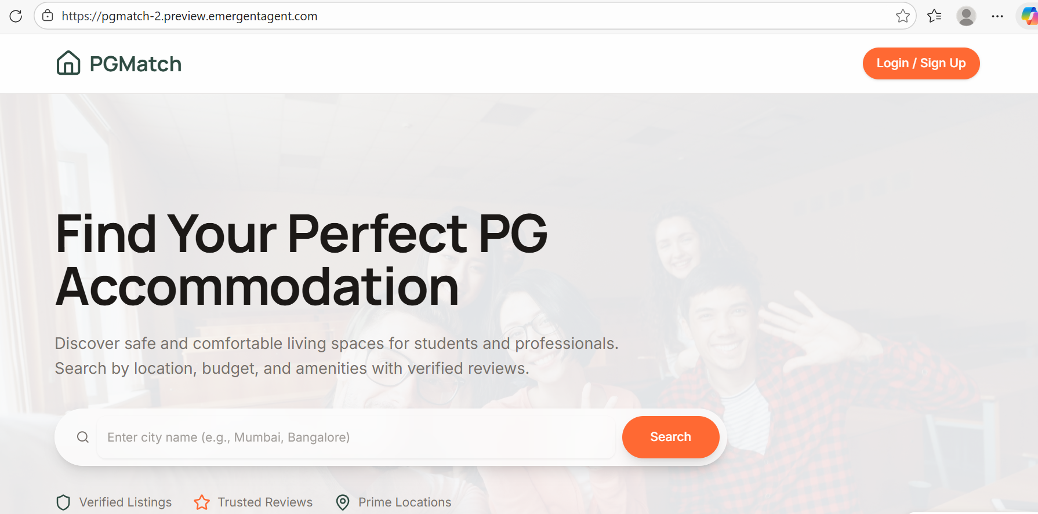

13.2 login & signup page
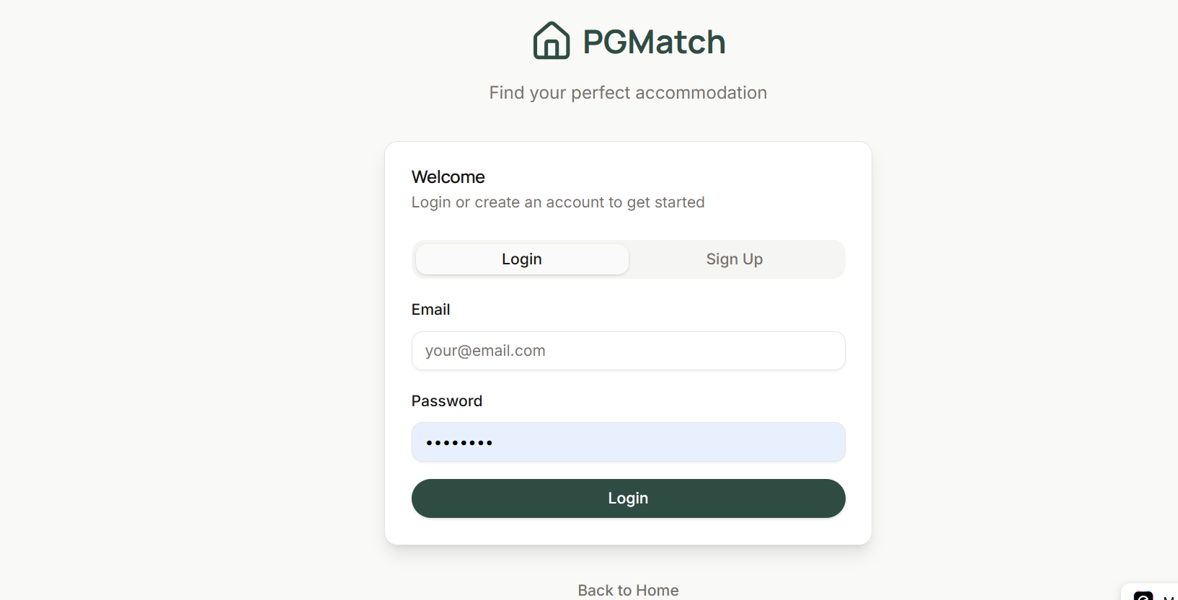

13.3 signup page
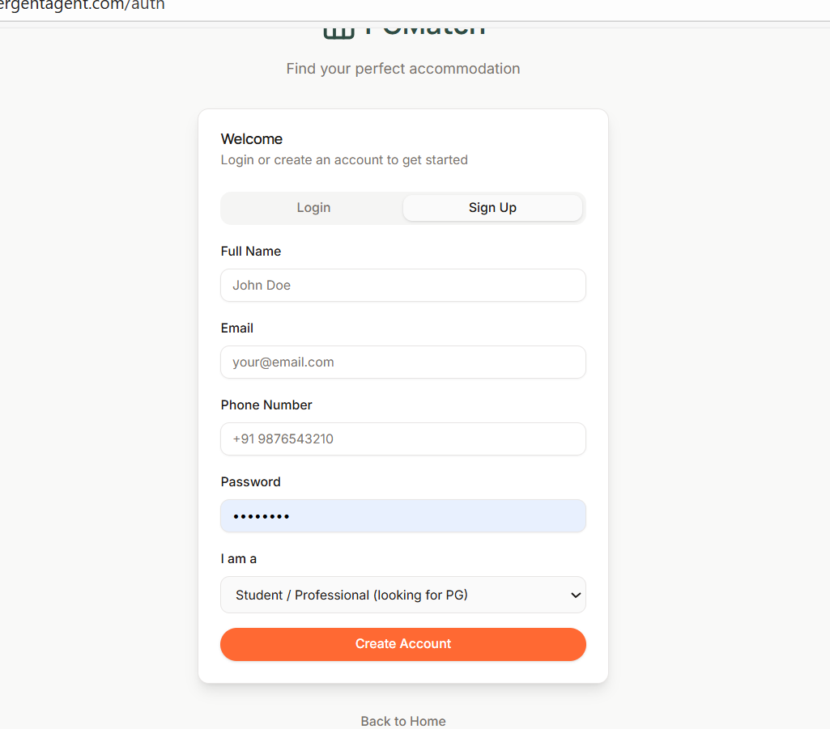
13.4 Home page find pg
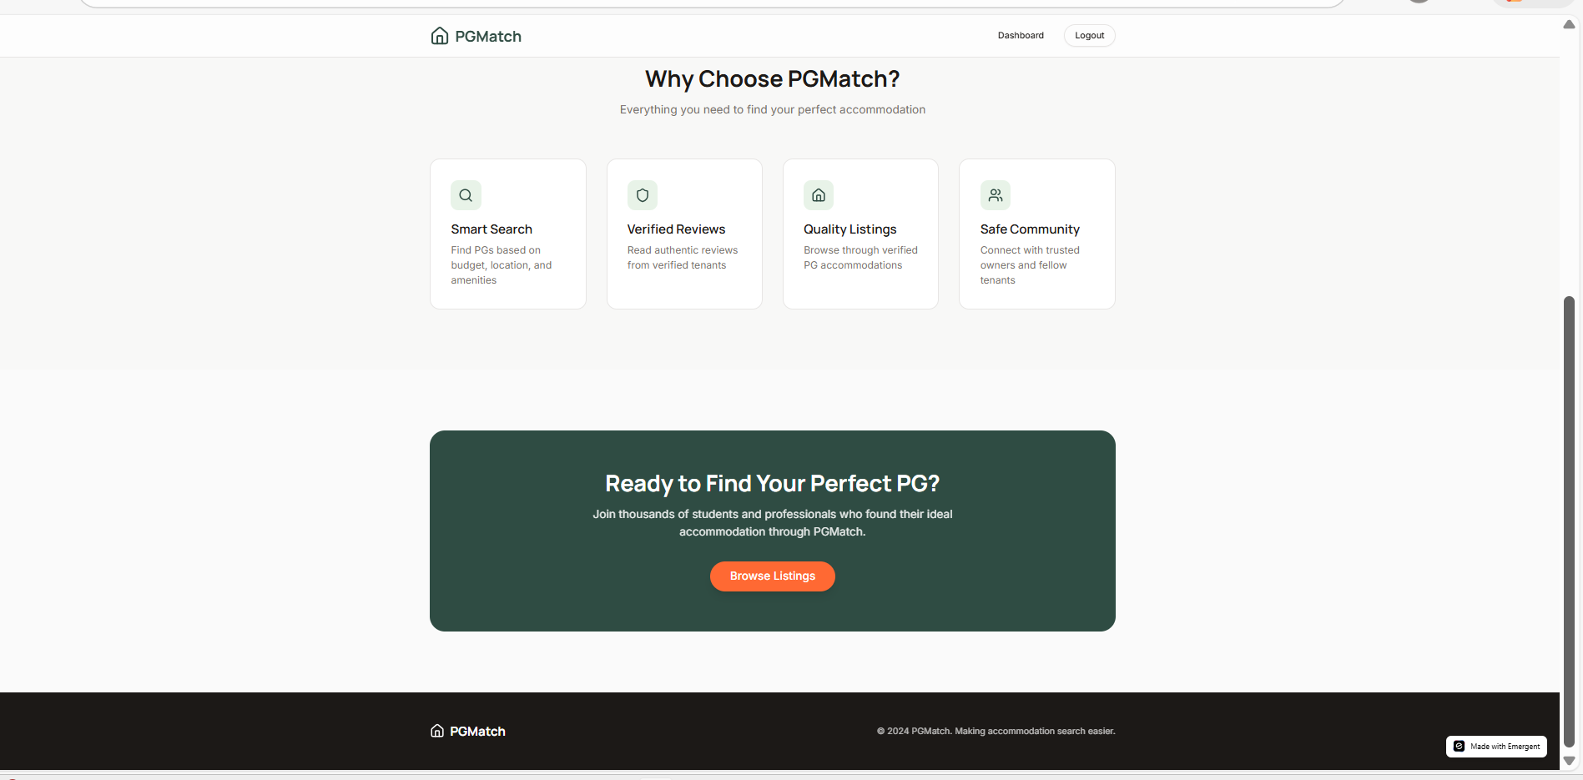

13.5 List of pg & Filters
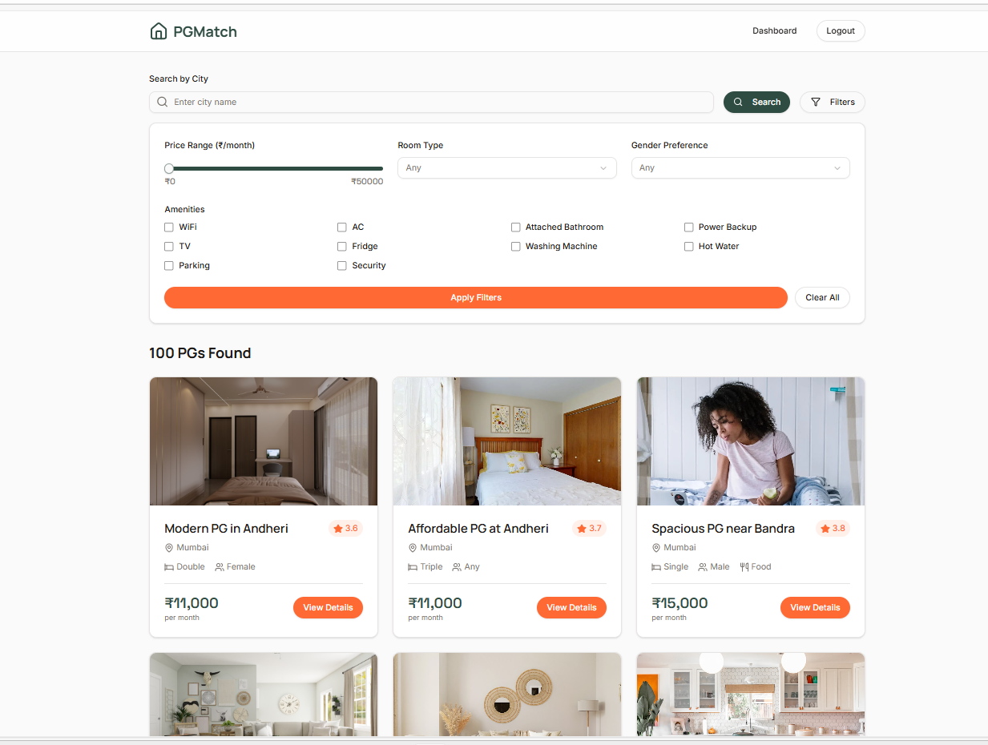

13.6 Details of pg
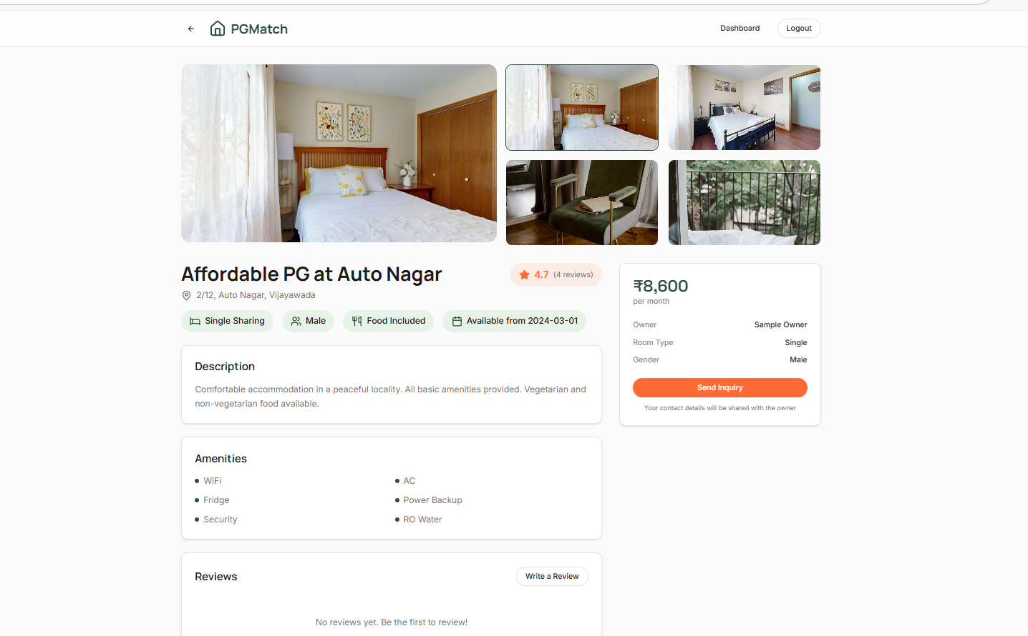

13.7 Sending inquiry
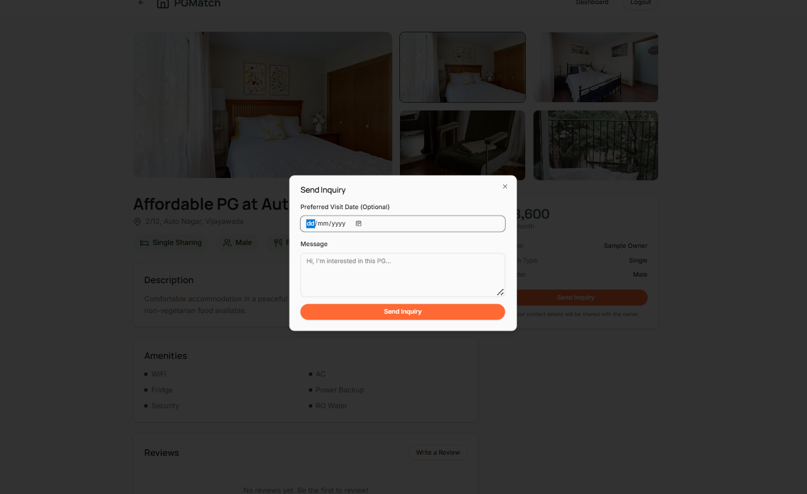

13.7.1 User checking inquiries in dashboard
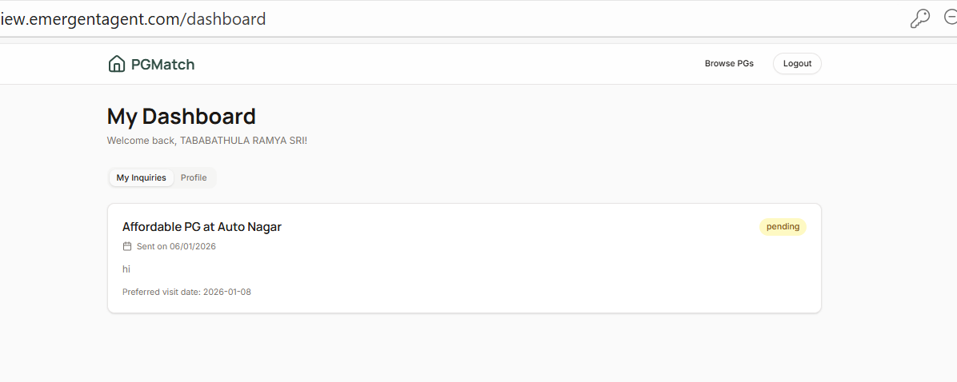

13.7.2 User profile

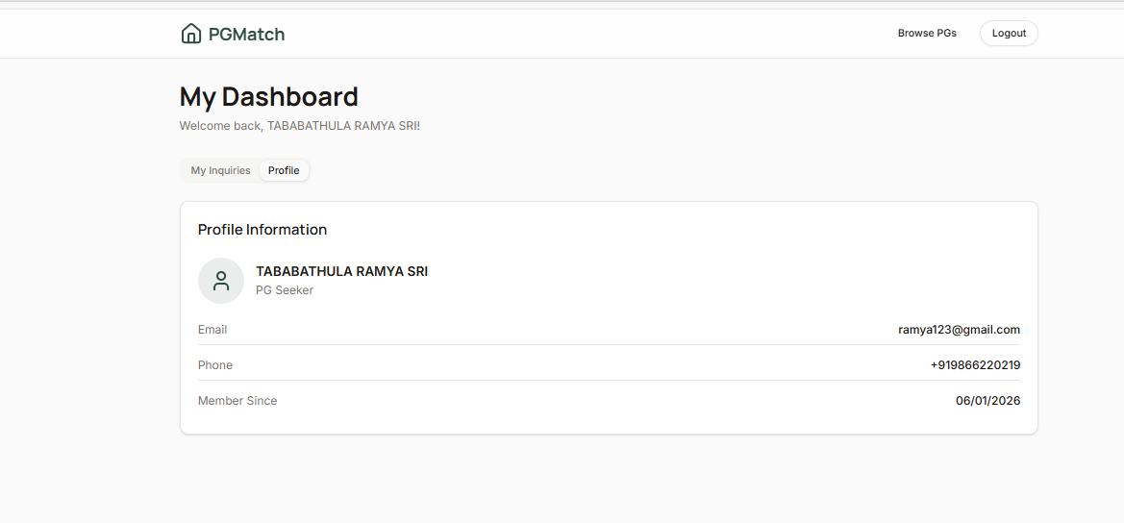

13.8 OWNER LOGIN

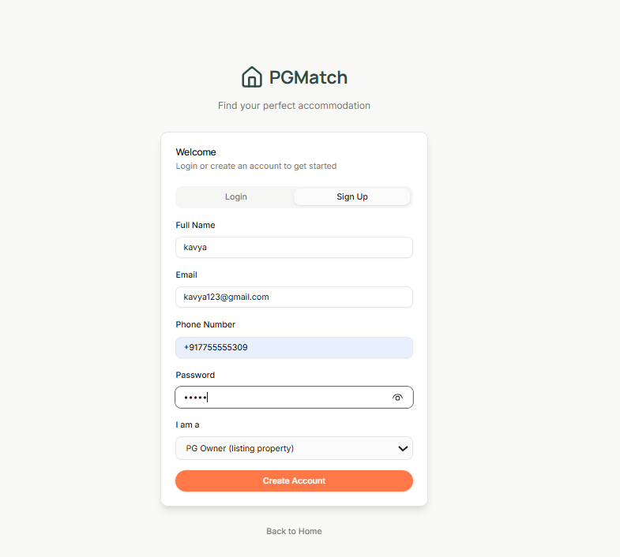

13.9 OWNER Dashboard
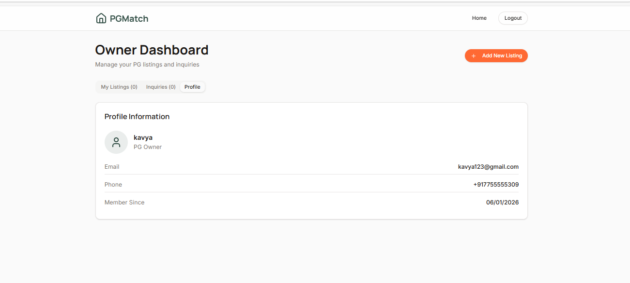

13.10 Adding pg
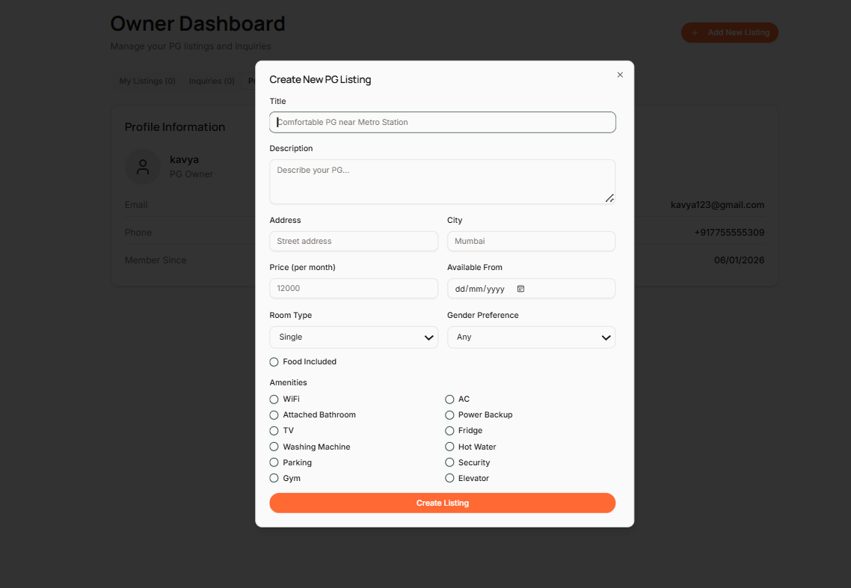

13.10.1 Owner pg in dashboard
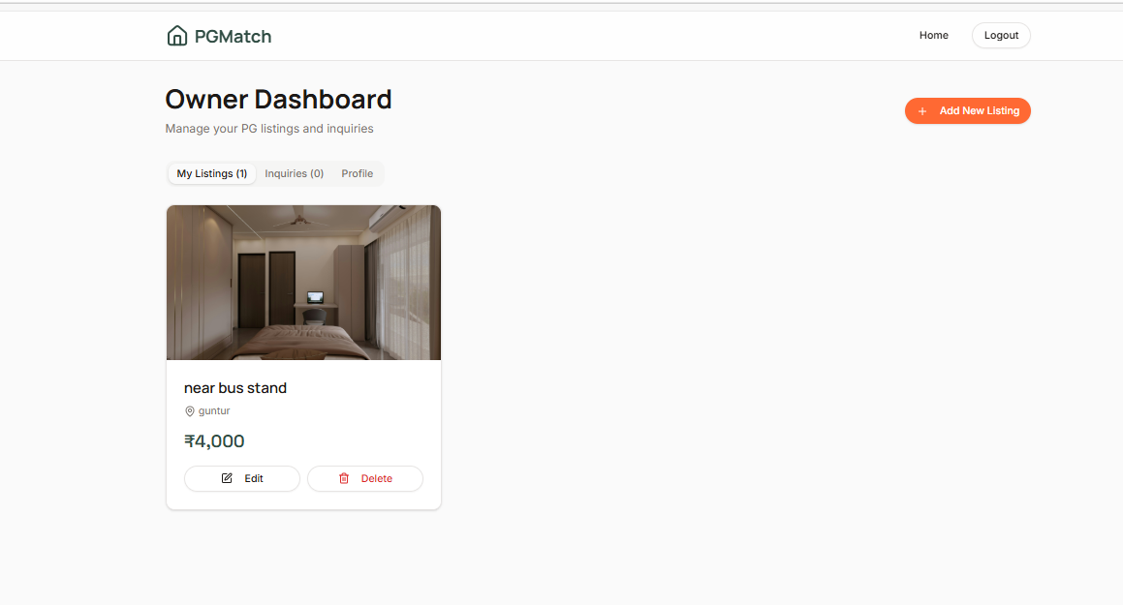

13.10.2 Add to list
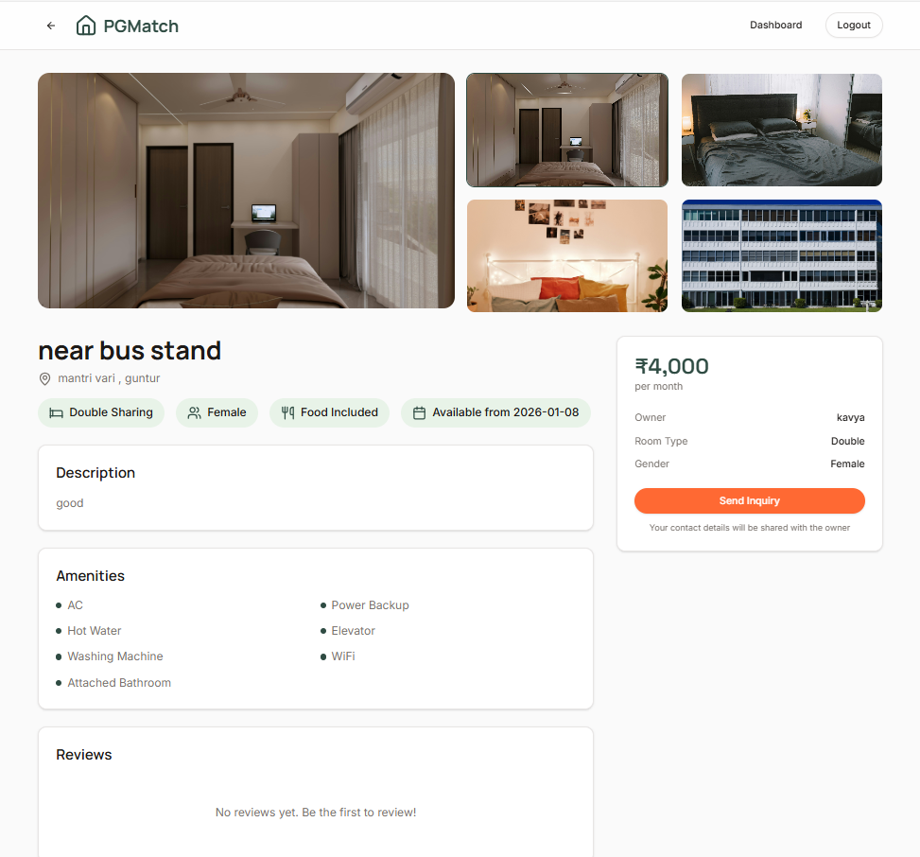

13.10.3 Got request
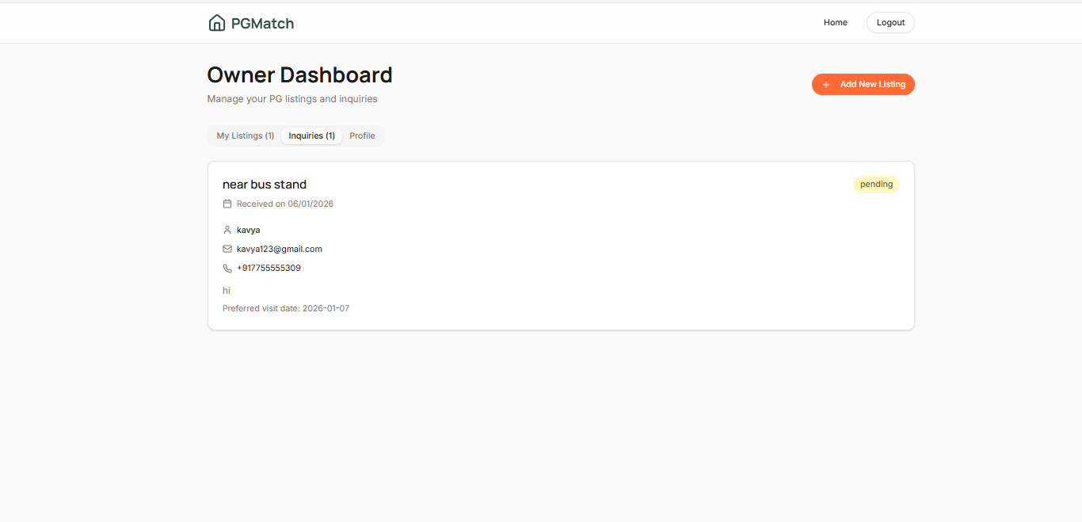

Chapter 14: Conclusion

PG Match provides a secure, reliable, and efficient platform for connecting PG seekers with verified property owners. It integrates advanced search filters, dashboards, review systems, and modern technology to address challenges in urban accommodation. Future enhancements like AI recommendations, map integration, dynamic images, and notifications will further improve usability and scalability.

Chapter 15: References

General References
- Zolo, PG Accommodation Platform Documentation, 2025.
- NoBroker, Online PG Marketplace Insights, 2025.
- MagicBricks, PG Listings & Analytics Reports, 2025.
- Urban Housing Reports, National Real Estate Development Council, 2025.
- Co-living & Shared Accommodation Trends, India, 2025.
Tool & Technology References
- FastAPI Official Documentation, 2024. [https://fastapi.tiangolo.com/]
- MongoDB Manual, 2024. [https://www.mongodb.com/docs/]
- ReactJS Documentation, 2024. [https://react.dev/]
- Tailwind CSS Guide, 2024. [https://tailwindcss.com/docs]
- Shadcn UI Components, 2024. [https://ui.shadcn.com/]

