Smart Waste Management, Disposal and Sanitization Monitoring AI System

JOYSON C H
Computer Science and Engineering
Presidency University
Bengaluru
joysonred855@gmail.com
TEJAS N B
Computer Science and Engineering
Presidency University
Bengaluru
tejasnb26@gmail.com

Ms. Shet Reshma Prakash
Assistant Professor
Dept. of Computer Science Engineering
Presidency University
Bengaluru
reshma.prakash@presidencyuniversity.in
RAMYA S V
Computer Science and Engineering
Presidency University
Bengaluru
ramyasv275@gmail.com

Abstract—In this paper, we will present smart waste management which utilizes technology to ensure waste is sorted, disposed, and sanitized properly. Smart waste management manages waste handling in cities and college campuses. Furthermore, smart waste management is able to provide real-time tracking of the collection and cleaning process. This process helps people take ownership, increases community engagement, and ensures that waste is being managed in an environmentally-friendly manner.
Keywords—Smart Waste Management, Sanitization Monitoring.

Introduction
Rapid urbanization and population growth yield excessive waste, which negatively impacts the environment and public health it could lead to contamination and wasted resources. Manual collection and disposal do not lend themselves to either efficiency, cleanliness, or accuracy, and can be too time-consuming, or simply overlook valuable waste. In addition, not keeping proper track of sanitation after waste removal can reduce a sense of responsibility, as well as increase the risk of illness. To lessen that burden, this paper presents the initial version of a centralized for managing waste.
Rapid population growth and shifting consumption patterns are making the growing amount of waste in urban environments problematic. Due to inadequate waste management, resources are being wasted, landfills are overflowing, collection is delayed, and the streets are littered. Resources are wasted and environmental pollution rises.

literature survey
Urban sustainability has a significant issue with waste management for reasons related to waste production and existing gaps with traditional manual collection methods. Traditional systems are often associated with delays, overfill, and a lack of transparency in monitoring systems. As digital technology continues to improve, researchers have been interested in combining IoT, AI, and machine learning in a more effective and accountable manner.
For instance, Navghane et al. [1] had an early IoT-based smart bin equipped with sensors to monitor the waste levels of the bin. While it automated the detection of bin status, the model did not incorporate any features for waste segregation or sanitisation. Sultan et al. [2] proposed an IoT waste collection framework that provided more effective tracking in real-time. However, the IoT framework imposed significant infrastructure costs.
Sharma and Kumar [3] presented AI-based waste classification which demonstrated that deep learning could distinguish organic, recyclable, and hazardous waste with great accuracy. However, their AI system did not monitor disposal, nor was public engagement was associated with this study. Hannan et al. [4] summarised a number of studies across different cities with smart waste management solutions, but noted challenges with sensor calibration, data privacy, and issues with scalability of research findings to ensure smart waste and conservancy systems are accessible to all users in cities.
Kumar and Shanthini [5] suggested that utilizing machine learning along with IoT technology would be an approach for optimal route or scheduling of collecting waste, and improving waste classification. Chowdhury and Hossain [6] considered big data analytics and prediction of waste generation trends as further improvements to sustainability planning for consideration by the city authority during pre-emptive planning. Recent works Machine learning applications such as EcoTrack[11], smart sanitation frameworks [12] and Edge-AI monitoring [9][14] focused on live optimization aspects, operational fuel efficiency, or operational sustainability perspectives. Tracking waste by facilitating trustworthy accountability by blockchain [10][13] technology has positioned a strong aspect of new monitoring technology and trust factor needed for collection and disposal accountability workflows.
But we are lacking supporting features of research and or developed systems in these areas of post-disposal sanitation verification, citizen engagement platforms, or role-based dashboards for monitoring the workflows or collection too for crucial insights. The proposed monitoring system will cover these features and further opportunities based on passenger transition and situational opportunity. This will include a verifiable measure of sanitation tracking, predictive collection analytics, awareness modules to educate and inform users into the technology, thinking and use toward the public good of sustainable work along with our innovations.

methodology
In this section, we will describe the architectural structure, flow of data and evaluation done

Functional Modules:
The approach will enable the support of various crucial functional modules. The disposal tracking is the one that guarantees and shows to be monitoring of waste collections on-site and the logs for the finishing of waste collections being done at the same time. Sanitization logging enhances the conformity and cleanliness by having the finished cleanup processes confirmed and digitally logged after the waste has been tracked. Through data, the planned analytics predicts waste generation, finds new waste patterns, and foresees missed collections that can be used in planning hence improving. The Community Engagement Hub takes sustainability one step further by providing educational resources and entertaining features that lure citizens in. Finally, Role-Based Access ensures that the system is utilized and performed correctly by offering secure, role-specific dashboards for the staff, administrators, and citizens.

Environment Deployment:
The application, which is intended for online use only, had its design and development done through a blend of web technologies such as Tailwind CSS, HTML5, CSS3, and JavaScript, thus providing a very user-friendly and responsive interface. To make the API operations run smoothly, the backend is built on top of Node.js and Express.js frameworks. GitHub Pages is the selected platform for the deployment and hosting since it not only makes the deployment process easier but also allows for proper version control to be done effectively.

System Architecture:
The The architecture of the proposed system intends to create a waste management and hygiene monitoring system that is smart, automated, transparent, and above all, easy to use. It consists of six major layers that interact with one another and thus, the data is processed invisibly, tasks are managed effectively, and good decisions are made reliably.
- User/Stakeholders Layer:
In this layer, the administrators, workers, and the public are included, and their specific roles and access rights characterize them. The administrators do the monitoring and management of the system, the workers do the duties related to waste collection and sanitation, and finally, the citizens are the ones who report the problems and check the cleanliness of their areas.

User Interface Layer:
The interactive web and mobile dashboard are a remarkable feature of the system that makes it user-friendly. The users will be able to view the schedules, report their activities, monitor their waste collection, and receive location-based analytics through the interface.

Backend Services Layer:
It guarantees secure connections between the user interface and the database, and at the same time, it conducts the allocation of tasks and real-time updates of their statuses.
Operational Modules Layer:
I. Waste Disposal Management Module: It helps in waste collection by efficiently planning the routes, scheduling the pickups, and tracking the tasks thereby ensuring the timely pick-ups and providing good resource utilization.
II. Sanitization Monitoring AI Module: It checks the conditions post-disposal for confirming the clean conditions, creating alerts and it is also doing the sanitization abilities analysis by using AI based analytical methods..

Data Management Layer:
All operational data such as waste collection logs, sanitization records, and user activity are kept in a database. The system has a provision for maintaining historical data that will help in performance evaluation, accountability, and future planning.
Figure 1: Architecture / flowchart Support
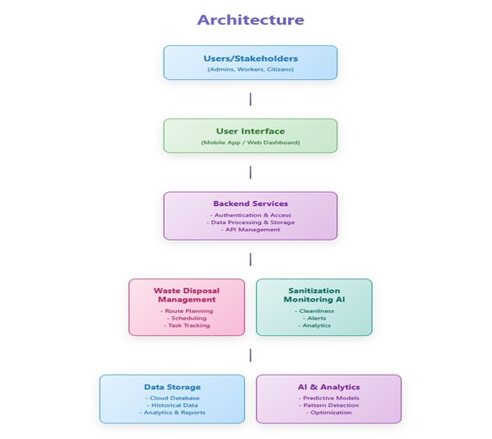

Clean City Reporter:

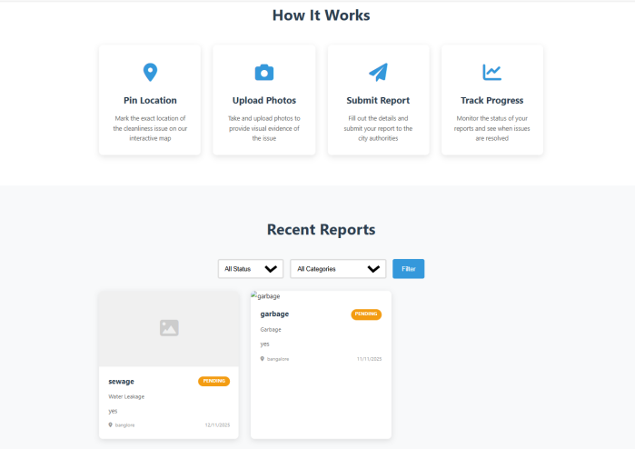

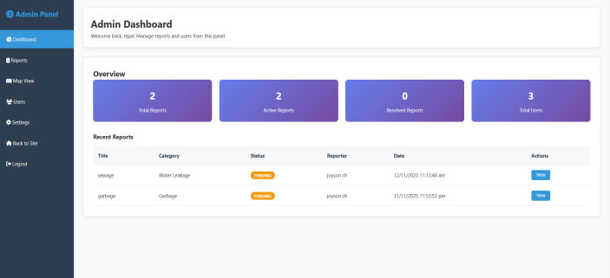

a) System Overview:
The arrangement of the system is comprised of three primary strata:
I. Frontend (User Interface): The user interface is developed using state-of-the-art web technologies and provides the users with an option to report a problem via a simple and inviting form.
II. Map Integration Layer: The location selector (for instance, Google Maps) helps the users to identify the exact spot on the map where the issue is noticed visually.
III. Backend (Data Handling): Handles the form submission, stores the data, and tracks the reported issue. In demo mode, all data can be saved locally. For full functionality it operates through Node.js and uses MongoDB to synchronize and retrieve data in real-time.

b) Workflow of the Module:
The following sequence represents the data flow and operational model of the Clean City Reporter:
- Issue Reporting: The user will enter the title, category, and description of the issue. The user could optionally attach photographs to provide further context.
- Location Selection: The user uses the integrated map interface to pin the exact geographic location of the issue to ensure the matter is tracked and assigned to the right area.
- Data Processing: The input data is validated and then either stored in the local Mongo database.
- Administrative Dashboard: The reported issue is now visible in the admin panel and can be reviewed, assigned, or marked as closed by the concerned authority.

c) Implementation Details:
The system is modular and can be expanded to include AI-based components used in waste detection and sanitation monitoring.

Workflow, Deployment and Security:
i. The user logs into the system and submits a complaint, including a photo, if possible, and a geotag.
ii. The admin, or designee(s), is alerted of the complaint via the dashboard. They review incoming complaints and assign a task to a worker.
iii. The worker receives notification of the new task and accepts the task. The worker then completes the task and updates the status by providing notes and photos.
iv. All users track the task status until the task reaches completion.
v. The system keeps a log of the activities performed in the system for accountability and reporting.
vi. The system is hosted on a cloud-based solution for scalability and data security. A HTTPS, encrypted communication channel, is utilized to maintain data security and role-based driven restrictions on the data exist to prevent unauthorized access..

related survey

EcoTrack:TheSmart Waste Collection Navigator:[11]
EcoTrack proved to be effective at waste collection routes, fuel usage optimization, and real-time tracking and predictive analytics which all together eliminated what used to be wrong operational decisions. User satisfaction was significantly improved as indicated by the results in terms of fewer overflow incidents and lower operational costs. Even though a small investment of money is necessary, the survey feedback collected from the users has emphasized the urban viability, sustainability, and EcoTrack's scalability.

Smart Waste Management Systems: Iot And AI Approaches To Sustainable Urban Sanitation:[12]
The study suggests that through the integration of IoT sensors together with artificial intelligence algorithm, waste management could be improved significantly. Real-time monitoring, dynamic routing and predictive analytics would all be used to reduce operational costs as well as carbon emissions by a very large margin. Thus, even though issues concerning scalability, sensor calibration and hardware security still prevail, the suggested method can be seen as an essential initial step to the realization of smart cities in the future. In the end, it is IoT and AI that would help us have a cleaner environment and more efficient waste management practices.

IoT-Enabled Smart Waste Management System Using Edge AI for Real-Time Monitoring and Optimization:[9][14]
This article's results lead to the conclusion that the combination of IoT and Edge AI adds up to excellent waste management by allowing real-time monitoring and optimization of collection. The prototype proved to be more efficient by spending less on fuel, emitting fewer carbon gases, and recycling more. It does not come without difficulties, however, as the system still needs to resolve its scalability and privacy concerns, yet it is clearly the right choice for urban scenarios. The model could be there for future cities using AI to manage the trade-offs between cost, efficiency, and sustainability.

AI and IoT-Enabled Smart Urban Waste Management System for Efficient Collection, Segregation, and Disposal:[10][13]
The research indicates that the combination of Internet of Things, Artificial Intelligence and blockchain technologies can make urban waste management systems open, automated and eco-friendly. Intelligent waste containers, forecasting analysis and tamper-proof data monitoring increase efficiency, responsibility, trustworthiness and lower the operating expenses. Communication protocols provide uniformity and reduce energy consumption scalability.

ADVANTAGES AND LIMITATION

ADVANTAGES:
i Easily adaptable and scalable: With MongoDB not enforcing a set structure for data, it isn't difficult to add new for new things without needing to start from scratch. For example, if you want to store some new type of data related to a cleanliness report of a city tomorrow, you can easily define a new schema and add it.
ii. Natural to think about for JavaScript developers: Given your app is built using Node.js and MongoDB uses a JSON-like document format, it feels more natural to think and write code for the app as there is less translation between how the data is stored, retrieved, and manipulated.
iii. Built for scalability and speed: MongoDB can handle many users and simultaneous reports at the same time, so the application won't slow down with additional users or pictures being submitted.
iv. Clean separation of concerns: Your project has cleanly separated out responsibilities such as authentication, reports, and admin functionality, making it easier to understand the code for each and be able to fix any code that breaks if necessary.
v. Protection for security and performance: Tools such as Helmet are utilized to guard the application from common internet vulnerabilities, while the rate limiting feature of Express prevents a single user from spamming the server too much..

LIMITATIONS:
i. More relaxed data rules: Since MongoDB does not enforce strict rules for every report, occasionally, there may be messy or inconsistent data in your MongoDB if they don’t check for those rules effectively.
ii. More complicated for complex actions: If you want to make a large impact in one transaction across many reports and users (such as a bank transaction), it can become very complicated and require complex coding.
iii. Takes some getting used to: If you are used to using a traditional database, such as SQL, the NoSQL situation may take some getting used to.
iv. A performance hit for secure or real time: Adding security and real-time (live communication updates) enhancements is great, but can be an added performance hit if nothing is done to scale that performance- especially for limited server usage, as discussed above.
v. Contains risk if MongoDB goes down: If your MongoDB server were to go down and become unreachable, your entire application’s database would go down and stop working, until your MongoDB becomes operational again for database functions- unless you planned for optional backups or replication systems, which can become complicated.
vi. A cumbersome set up process: The set up for a MongoDB can feel complicated if you are not careful to install, and get the database connected properly, or your application will not be able to store user information appropriately, and will not scale as expected.

conclusion and future work
The study introduced an AI System for Smart Waste Management, Disposal, and Sanitization Monitoring that leverages AI, and web technologies to reduce the inefficiencies associated with the traditional waste handling system. The proposed system automates waste segregation by using deep learning models, logs disposal locations in real-time, and instills a post-disposal sanitization logging feature to increase accountability and clean disposal for the first time. Further, role-based dashboards and predictive analytics improve efficiencies, transparency, and public involvement.
The proposed approach has the potential to reduce the number of missed collections, improve the accuracy of waste segregation, and increase community-led sustainability, although it has only been designed and tested in a laboratory-controlled context for now. Future work will look to deploy the system across urban municipalities at scale, connect to other smart city infrastructures, and implement advanced AI models for improved performance. We can consider extending the platform to a mobile application and leveraging big data analytics to process weekly patterns city-wide over time for further scaling.

References

[1] S. S. Navghane, M. S. Killedar, and V. M. Rohokale, "IoT-based intelligent garbage and waste collection bin," International Journal of Advanced Research in Electronics and Communication Engineering (IJARECE), vol. 5, no. 5, May 2016.
[2] A. F. M. Sultan, M. R. I. Faruque, and M. A. Rashid, "Smart waste management system using IoT," in Proceedings of the 3rd International Conference on Electrical Engineering and Information Communication Technology (ICEEICT), Dhaka, Bangladesh, 2016.
[3] N. Sharma and A. Kumar, "AI-enabled waste segregation and recycle management," IEEE Access, 2020.
[4] M. A. Hannan, M. Akhtar, R. A. Begum, H. Basri, A. Hussain, and R. M. Abdullah, "Smart waste management: A review of issues, challenges, and opportunities," IEEE Access, vol. 6, pp. 70881-70901, 2018.
[5] K. R. S. Kumar and P. Shanthini, "Waste management using IoT and machine learning techniques," Journal of Environmental Research and Development (JERD), 2021.
[6] S. Chowdhury and S. Hossain, "Big data analytics for waste management," Environmental Technology & Innovation, vol. 25, 2022.
[7] World Bank, What a Waste 2.0: A Global Snapshot of Solid Waste Management to 2050, Washington, DC: World Bank, 2018.
[8] S. Gupta, R. Mehta, and A. Kumar, "Smart Waste Management Systems: IoT and AI Approach," International Journal of Environmental Sciences, vol. 11, no. 17s, pp. 232-240, 2025..
[[9] V. Punia, "IoT-Enabled Smart Waste Management System Utilizing Edge AI for Real-Time Monitoring and Optimization," International Journal of Research and Review in Applied Science, Humanities and Technology, vol. 2, no. 3, pp. 195-200, Jul.-Sep. 2025.
[10] A. Devi, N. Singh, N. Thandra, N. Gupta, Z. N. Salman and K. Natarajan, "AI and IoT-Enabled Smart Urban Waste Management System for Efficient Collection, Segregation, and Disposal," E3S Web of Conferences, vol. 619, p. 03002, 2025. DOI: 10.1051/e3sconf/202561903002.
[11] S. M. Shashank, K. T. Vishva, Padmavathy and S. Janani, "EcoTrack: The Smart Waste Collection Navigator," International Research Journal on Advanced Engineering and Management, vol. 2, no. 12, pp. 3474-3478, Dec. 2024. DOI: 10.47392/IRJAEM.2024.513.
[12] H. L. Yadav, T. Elango, L. Banakar, S. N. A. Chakravarthy, V. K. Kanthan, and N. Sudha, “Smart Waste Management Systems: IoT and AI Approaches to Sustainable Urban Sanitation,” International Journal of Civil and Environmental Engineering, vol. 14, no. 3, pp. 112-118, 2025.
[13] A. Devi, N. Singh, N. Thandra, N. Gupta, Z. N. Salman and K. Natarajan, "AI and IoT-Enabled Smart Urban Waste Management System for Efficient Collection, Segregation, and Disposal," E3S Web of Conferences, vol. 619, p. 03002, 2025.
[14] V. Punia, "IoT-Enabled Smart Waste Management System Utilizing Edge AI for Real-Time Monitoring and Optimization," International Journal of Research.

This project entitled "Smart Waste Management, Disposal and Sanitization Monitoring AI System" was conducted under the honored affiliation of Presidency University, Bengaluru. The authors would like to sincerely thank the Vision and Learning Lab, Department of Computer Science and Engineering, for their gracious guidance and support and providing computational resources for the research.

