Write a C program to simulate the following CPU scheduling
algorithm to find turnaround time and waiting time.

a) FCFS b) SJF non preemptive c) SJF preemptive

a) #include <stdio.h>

int main() {
int n, i;
printf("Enter number of processes: ");
scanf("%d", &n);

int bt[n], wt[n], tat[n];

for(i = 0; i < n; i++) {
printf("Enter Burst Time for P%d: ", i+1);
scanf("%d", &bt[i]);
}

wt[0] = 0; // First process waiting time is 0

for(i = 1; i < n; i++) {
wt[i] = wt[i-1] + bt[i-1];
}

for(i = 0; i < n; i++) {
tat[i] = wt[i] + bt[i];
}

float avg_wt = 0, avg_tat = 0;

printf("\nProcess\tBT\tWT\tTAT\n");
for(i = 0; i < n; i++) {
printf("P%d\t%d\t%d\t%d\n", i+1, bt[i], wt[i], tat[i]);
avg_wt += wt[i];
avg_tat += tat[i];
}

printf("\nAverage Waiting Time = %.2f", avg_wt/n);
printf("\nAverage Turnaround Time = %.2f\n", avg_tat/n);

return 0;
}
Output:
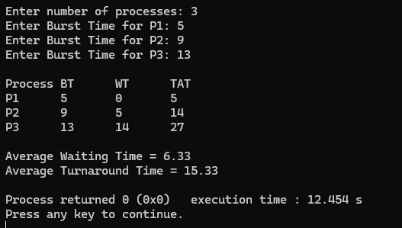

b) #include <stdio.h>

int main() {
int n, i, j;
printf("Enter number of processes: ");
scanf("%d", &n);

int bt[n], wt[n], tat[n], temp;

for(i = 0; i < n; i++) {
printf("Enter Burst Time for P%d: ", i+1);
scanf("%d", &bt[i]);
}

// Sorting burst time
for(i = 0; i < n; i++) {
for(j = i+1; j < n; j++) {
if(bt[i] > bt[j]) {
temp = bt[i];
bt[i] = bt[j];
bt[j] = temp;
}
}
}

wt[0] = 0;

for(i = 1; i < n; i++) {
wt[i] = wt[i-1] + bt[i-1];
}

for(i = 0; i < n; i++) {
tat[i] = wt[i] + bt[i];
}

float avg_wt = 0, avg_tat = 0;

printf("\nProcess\tBT\tWT\tTAT\n");
for(i = 0; i < n; i++) {
printf("P%d\t%d\t%d\t%d\n", i+1, bt[i], wt[i], tat[i]);
avg_wt += wt[i];
avg_tat += tat[i];
}

printf("\nAverage Waiting Time = %.2f", avg_wt/n);
printf("\nAverage Turnaround Time = %.2f\n", avg_tat/n);

return 0;
}

Output
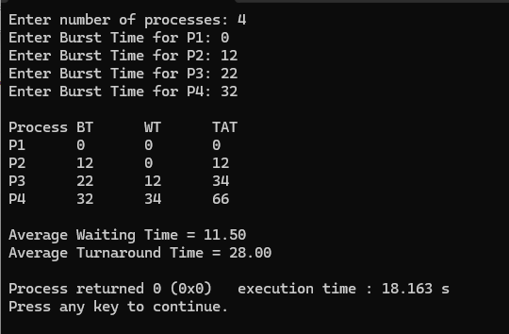

c) #include <stdio.h>
#include <limits.h>

int main() {
int n, i, time = 0, completed = 0, min, shortest = 0;
printf("Enter number of processes: ");
scanf("%d", &n);

int bt[n], rt[n], wt[n], tat[n], at[n];
int finish_time;
int check = 0;

for(i = 0; i < n; i++) {
printf("Enter Arrival Time and Burst Time for P%d: ", i+1);
scanf("%d%d", &at[i], &bt[i]);
rt[i] = bt[i]; // remaining time
}

while(completed != n) {
min = INT_MAX;
check = 0;

for(i = 0; i < n; i++) {
if((at[i] <= time) && (rt[i] > 0) && (rt[i] < min)) {
min = rt[i];
shortest = i;
check = 1;
}
}

if(check == 0) {
time++;
continue;
}

rt[shortest]--;
min = rt[shortest];

if(min == 0)
min = INT_MAX;

if(rt[shortest] == 0) {
completed++;
finish_time = time + 1;

wt[shortest] = finish_time - bt[shortest] - at[shortest];
if(wt[shortest] < 0)
wt[shortest] = 0;
}
time++;
}

float avg_wt = 0, avg_tat = 0;

printf("\nProcess\tAT\tBT\tWT\tTAT\n");
for(i = 0; i < n; i++) {
tat[i] = bt[i] + wt[i];
printf("P%d\t%d\t%d\t%d\t%d\n", i+1, at[i], bt[i], wt[i], tat[i]);
avg_wt += wt[i];
avg_tat += tat[i];
}

printf("\nAverage Waiting Time = %.2f", avg_wt/n);
printf("\nAverage Turnaround Time = %.2f\n", avg_tat/n);

return 0;
}

Output
